Feasibility Study and Infrastructure Design for an Inter-basin Diversion from the Missouri River at Leavenworth, KS to Upper Colorado River at Grand Junction, CO.

Background

The U.S. Bureau of Reclamation and the states of Arizona, California, Colorado, Nevada, New Mexico, Utah, and Wyoming have been considering ways to provide water for growing populations in the West. One idea is a pipeline to ship water west from the Missouri River.

A portion of the river will be diverted into a treatment plant at Leavenworth, KS then lifted by a series of high capacity lift stations. The pipeline would roughly follow I-70. Grand Junction, CO, downstream of the Gunnison River, is a likely end point of such a diversion. Once water is in the Colorado River system, existing infrastructure can carry the diverted water as far west as Los Angeles. Wyoming would not receive any diversion water, but would obtain its share by reduced releases to the Colorado basin from its existing reservoirs. The goal is to provide water for about 1.2 million households in the western states.

Generic Problem Statement

Conduct a feasibility study of the proposed concept, including a conceptual design of the diversion system to include a hydraulic assessment, energy requirements, firm water availability, trenching requirements, pumping requirements, and estimated construction costs, construction schedule, and operations costs for a 30-year operation period. The study should further include an assessment of environmental issues associated with the loss of the diverted water from the Missouri River Basin and the added flows into the Upper Colorado Basin.

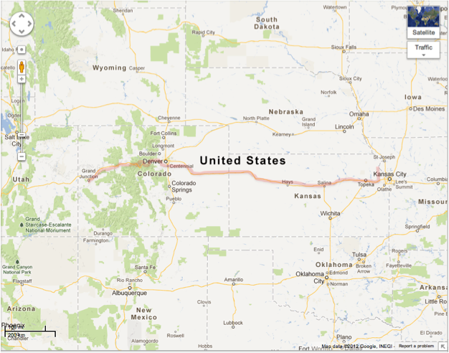

Figure 1. Missouri River Diversion Alignment

Scope of Work

The project scope of work is to be conducted in a series of Task Orders, each to be completed as a technical memorandum. The final task order will be the project report. Individual teams may be asked to present intermediate findings.