Feasibility Study and Infrastructure Design for an Inter-basin Diversion from the Missouri River at Leavenworth, KS to Upper Colorado River at Grand Junction, CO.

Background

The U.S. Bureau of Reclamation and the states of Arizona, California, Colorado, Nevada, New Mexico, Utah, and Wyoming have been considering ways to provide water for growing populations in the West. One idea is a pipeline to ship water west from the Missouri River.

A portion of the river will be diverted into a treatment plant at Leavenworth, KS then lifted by a series of high capacity lift stations. The pipeline would roughly follow I-70. Grand Junction, CO, downstream of the Gunnison River, is a likely end point of such a diversion. Once water is in the Colorado River system, existing infrastructure can carry the diverted water as far west as Los Angeles. Wyoming would not receive any diversion water, but would obtain its share by reduced releases to the Colorado basin from its existing reservoirs. The goal is to provide water for about 1.2 million households in the western states.

Problem Statement

Prepare a feasibility study of the proposed concept, including a conceptual design of the diversion system to include a hydraulic assessment, energy requirements, firm water availability, trenching requirements, pumping requirements, and estimated construction costs, construction schedule, and operations costs for a 30-year operation period. The study should further include an assessment of environmental issues associated with the loss of the diverted water from the Missouri River Basin and the added flows into the Upper Colorado Basin.

Exercises

Exercise 1: Obtain a map of the Colorado River Basin. Identify the existing reservoirs on the system (e.g. Lake Mead, Glen Canyon, etc.). Identify the major diversions on the system (e.g. Central Arizona Project, Colorado River Aqueduct).

Identify the metropolitan areas served by the existing system. Cite your data sources.

Solution: Figure is a map of the Colorado River Basin (U.S.B.R.). The basin includes the Colorado River as well at the major tribiutaries; the Salt, Gila, Virgin, San Juan, Gunnison, and Green Rivers.

Figure is an annotated map of the basin showing the approximate location of major population centers and the dams on the system. The two primary reservoirs on the system are Lake Mead, created by Hoover (Boulder Canyon) Dam and Lake Powell, created by Glen Canyon Dam. Parker Dam impounds water in the river and creates the Colorado-Havasu recreation area that forms the Arizona-California border.

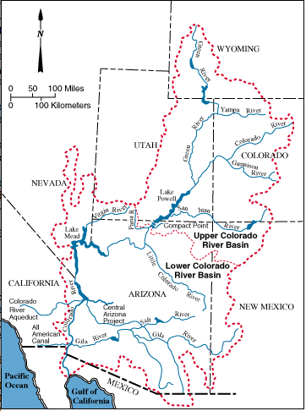

Figure 1. Colorado River Basin (U.S. Bureau of Reclaimation)

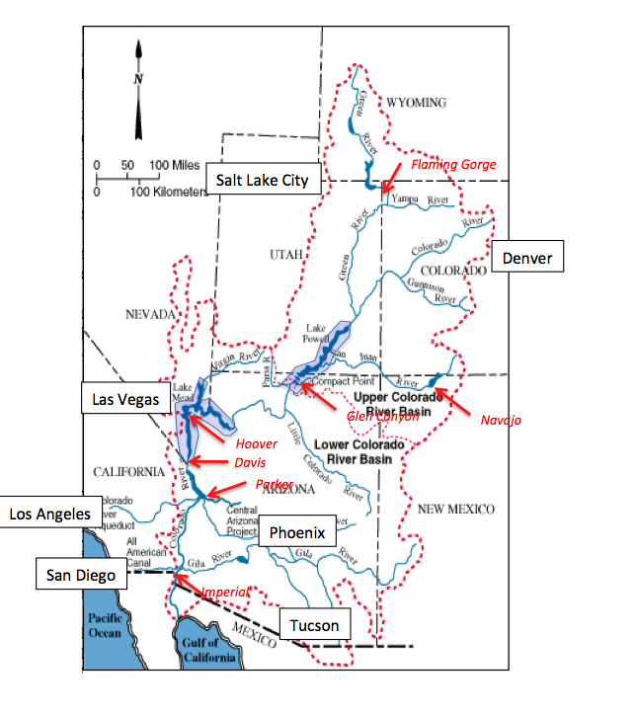

Figure 2. Annotated Basin Map -- Major Population Centers and Large Dams Shown.

References

U.S.B.R., <http://www.usbr.gov/lc/region/g4000/contracts/watersource.html> accessed 6 Jan 2013.

Exercise 2: Estimate the typical water use by a household in these metropolitan areas. Estimate the required diversion flow rate to serve 1.2 million such households. Report the required rate in cubic feet per second. Cite your data sources.

Exercise 3: Obtain the 55+ year daily flow record for the Missouri River at Kansas City (USGS Gaging Station 06893000). Analyze the record and prepare a Flow-Duration curve for the Missouri River at Kansas City. Examine the flow duration curve, is there enough flow to divert water 50% of the time? 70% of the time? 90% of the time?

Exercise 4: Suppose that the diversion is allowed at the 70% location on the flow duration curve (about where the slope of the curve in log space changes considerably, probably indicative of low flow and drought conditions). Obtain the rating curve for the Missouri River at Leavenworth Kansas (USGS Gaging Station 06820475). At what stage should the diversion inlet works be set? (i.e. If the stage drops below the 70% value, the inlets should not be able to intake water).