Exercise 1: Obtain a map of the Colorado River Basin. Identify the existing reservoirs on the system (e.g. Lake Mead, Glen Canyon, etc.). Identify the major diversions on the system (e.g. Central Arizona Project, Colorado River Aqueduct).

Identify the metropolitan areas served by the existing system. Cite your data sources.

Solution: Figure is a map of the Colorado River Basin (U.S.B.R.). The basin includes the Colorado River as well at the major tribiutaries; the Salt, Gila, Virgin, San Juan, Gunnison, and Green Rivers.

Figure is an annotated map of the basin showing the approximate location of major population centers and the dams on the system. The two primary reservoirs on the system are Lake Mead, created by Hoover (Boulder Canyon) Dam and Lake Powell, created by Glen Canyon Dam. Parker Dam impounds water in the river and creates the Colorado-Havasu recreation area that forms the Arizona-California border.

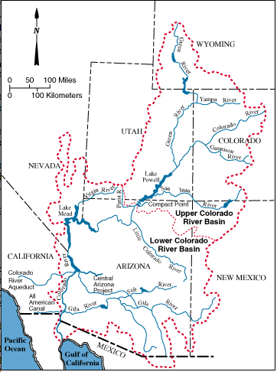

Figure 1. Colorado River Basin (U.S. Bureau of Reclaimation)

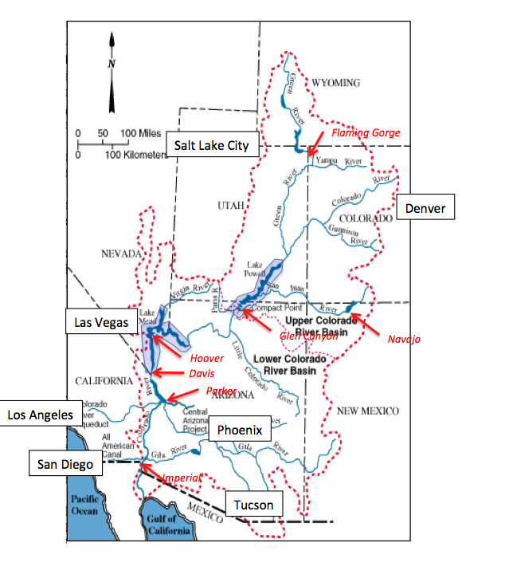

Figure 2. Annotated Basin Map -- Major Population Centers and Large Dams Shown.

References

U.S.B.R., <http://www.usbr.gov/lc/region/g4000/contracts/watersource.html> accessed 6 Jan 2013.