Exercise 2: Estimate the typical water use by a household in these metropolitan areas. Estimate the required diversion flow rate to serve 1.2 million such households. Report the required rate in cubic feet per second. Cite your data sources.

Solution: Used an internet survey to find self-reported water use in the major cities in the diversion destination service area. Figure 1 is a clip of an article in the May 8, 2012 Los Angeles Times that states the per capita water use for the area served by the Los Angeles Department of Water and Power is about 123 gallons per day.

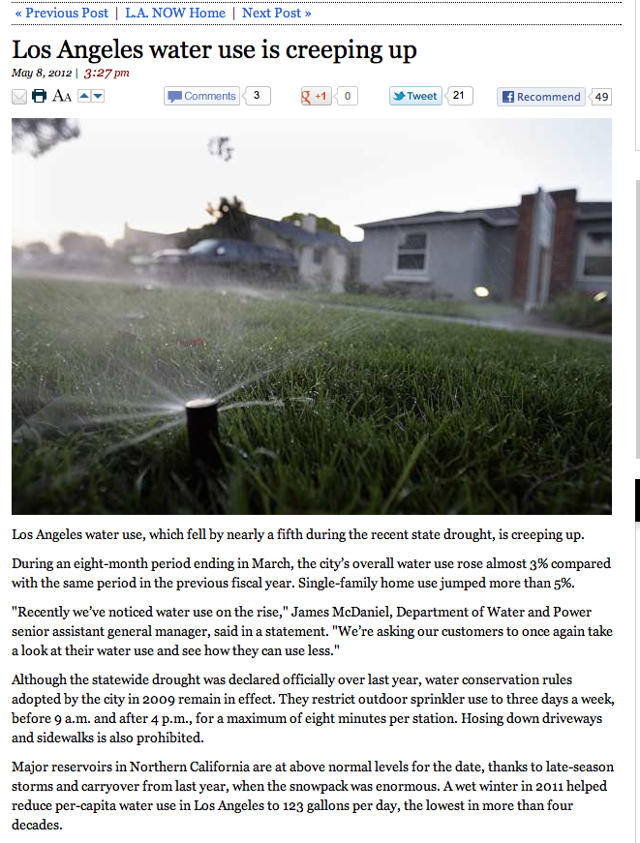

Figure 1. LA Times, May 8 2012. Water Use 123 gpcd.

Figure 2 is a screen capture of the City of Phoenix website that states a water use per person of about 190 gallons.

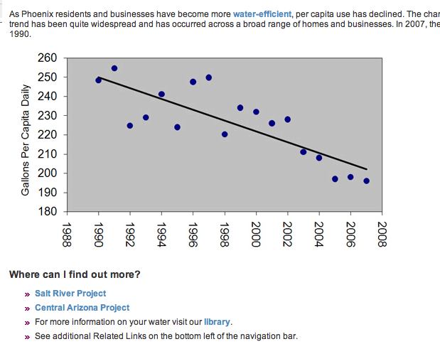

Figure 2. Water Use from City of Phoenix Web Site. 190 gpcd.

Figure 3 is a screen capture of the City of Tucson website that reports a daily water use of 136 gallons per person.

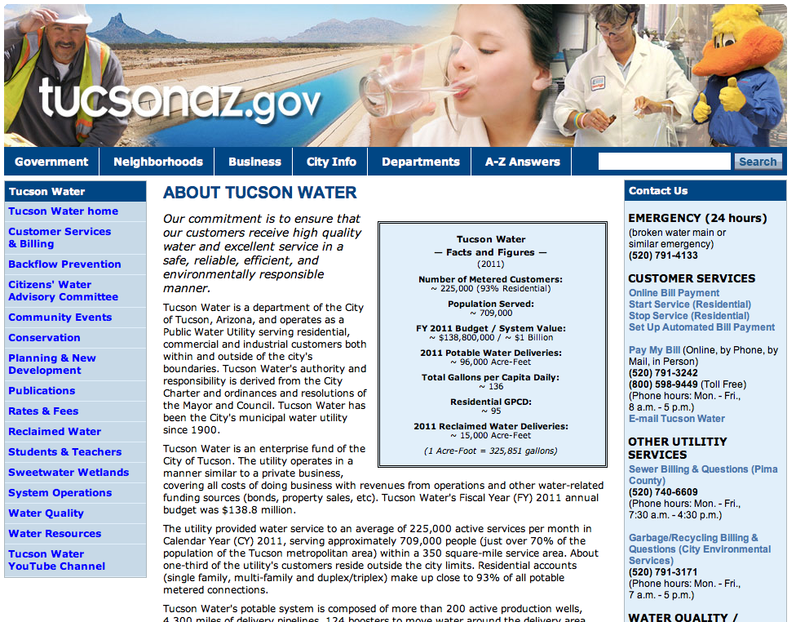

Figure 3. City of Tucson Water Use. 136 gpcd.

Figure 4 is a screen capture of the City of Las Vegas website that reports a daily water use of 265 gallons per person.

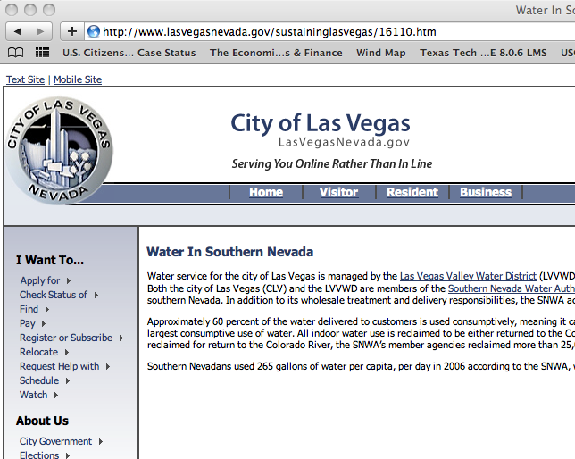

Figure 4. City of Las Vegas water use; 265 gpcd.

Figure 4 is a screen capture of the San Diego Water Authority website that reports a daily water use of 143 gallons per person.

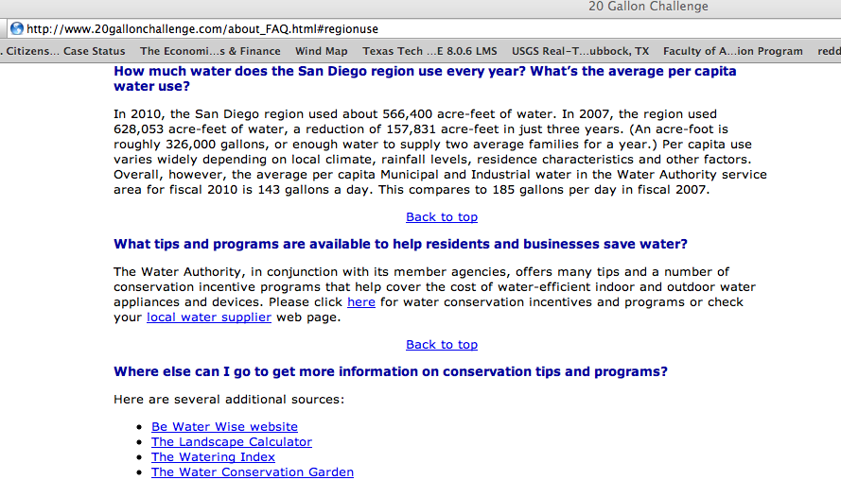

Figure 5. San Diego water use. 143 gpcd.

The results of the rapid internet survey for water use are listed in the table below. The populations for each metropolitan area were obtained by Google search using the following SQL entry “city name + metropolitan area.” The population is listed to construct a population weighted average use for the feasibility study to estimate the required diversion rate.

|  |  |  |  |
| --- | --- | --- | --- |
| Region | Water Use Per Capita | Population |  |
| Los Angeles | 123 gal | 9.8 million |  |
| San Diego | 143 gal | 3.1 million |  |
| Las Vegas | 265 gal | 1.4 million |  |
| Phoenix | 190 gal | 3.2 million |  |
| Tucson | 136 gal | 1.0 million |  |
|  |  |  | Avg. Use |
| Total |  | 18.5 million | 149.4 gpcd |

The population weighted average use is 150 gallons per day.

MSNBC reports that the average household size in the USA is 2.6 persons per household (MSNBC 2102). Thus the product of the 1.2 million households, 2.6 persons per household, and 150 gallons per day produces the estimated diversion rate of

Converting to cubic feet per second, divide by 86400 sec/day to produce the diversion estimate of

Q=724 cfs.

References

City of Phoenix, <http://phoenix.gov/waterservices/wrc/yourwater/histuse.html> accessed 6 Jan 13.

City of Las Vegas, <http://www.lasvegasnevada.gov/sustaininglasvegas/16110.htm>

City of Tucson, http://cms3.tucsonaz.gov/water/about-us

San Diego County Water Authority, <http://www.20gallonchallenge.com/about_FAQ.html>

Los Angeles Times, <http://latimesblogs.latimes.com/lanow/2012/05/los-angeles-water-use-creeping-up-.html>

MSNBC, http://www.msnbc.msn.com/id/14942047/ns/technology_and_science-science/t/census-us-household-size-shrinking/#.UOn3jRyTmgg