Exercise 3: Obtain the 55+ year daily flow record for the Missouri River at Kansas City (USGS Gaging Station 06893000). Analyze the record and prepare a Flow-Duration curve for the Missouri River at Kansas City. Examine the flow duration curve, is there enough flow to divert water 50% of the time? 70% of the time? 90% of the time?

Solution: Figure 1 is a screen capture of the USGS NWIS web server for Missouri River at Kansas City. At the bottom of the screen capture is a query set to retrieve 55+ years of daily gage height and discharge data from the server.

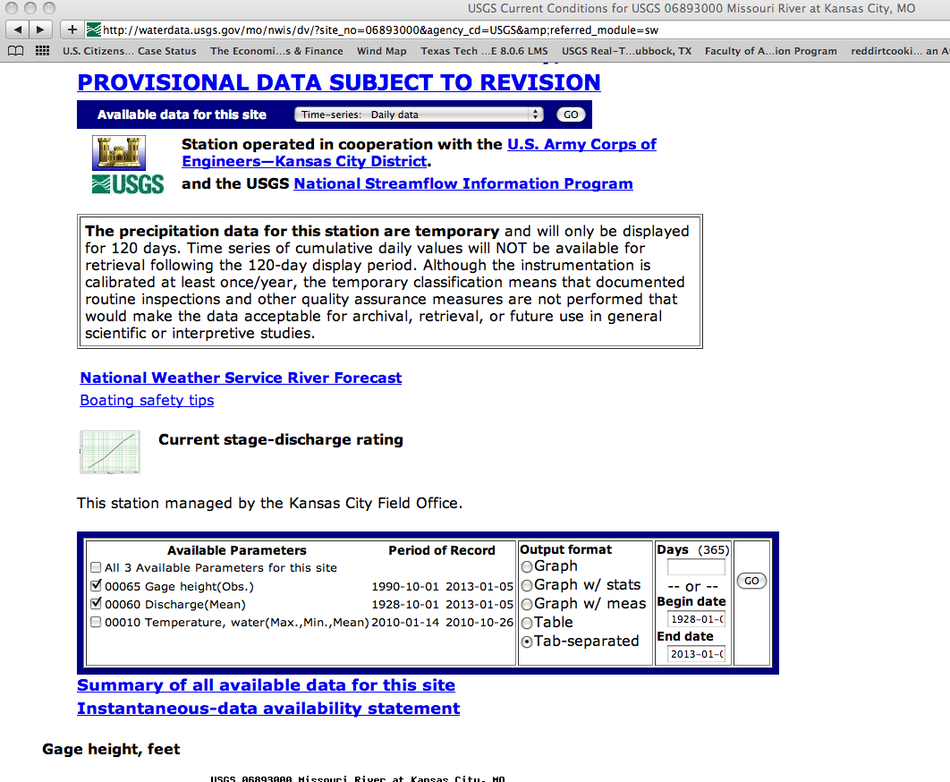

Figure 1. NWIS Server Interface for Gage 06893000.

Figure 2 is the result of the query, an ASCII file of the daily records. This file is then copied into a suitable tool for generating a Flow-Duration curve. The contents of this file were pasted into Excel, Figure 3 is a screen capture of the Excel worksheet.

An empirical flow-duration curve was created following the guidelines on pages 448-451 of Textbook. The flow data were ranked from small to large, and a Weibull plotting position was created based upon the rank. This plotting position represents the fraction of the time that one would expect to observe a specific flow value or greater. Hence the smallest flow in the record is exceeded 100% of the time (we always expect to observe flows equal to or larger than the smallest flow), and the largest flow is almost never exceeded (we never expect to observe a flow larger than the largest).

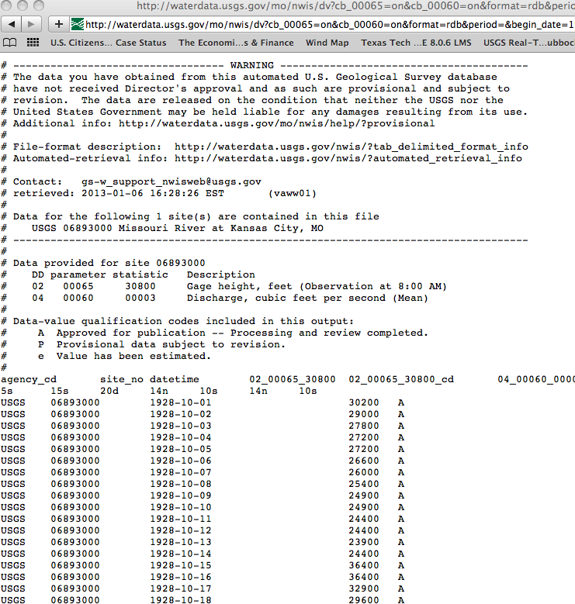

Figure 2. Gage Data from NWIS Server for Station 06893000.

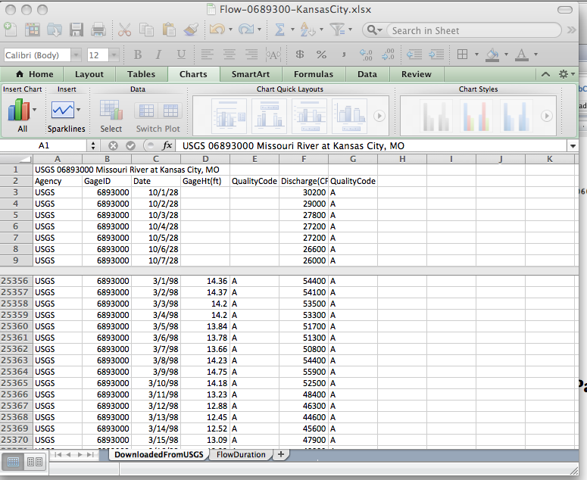

Figure 3. Excel File with USGS Data Imported

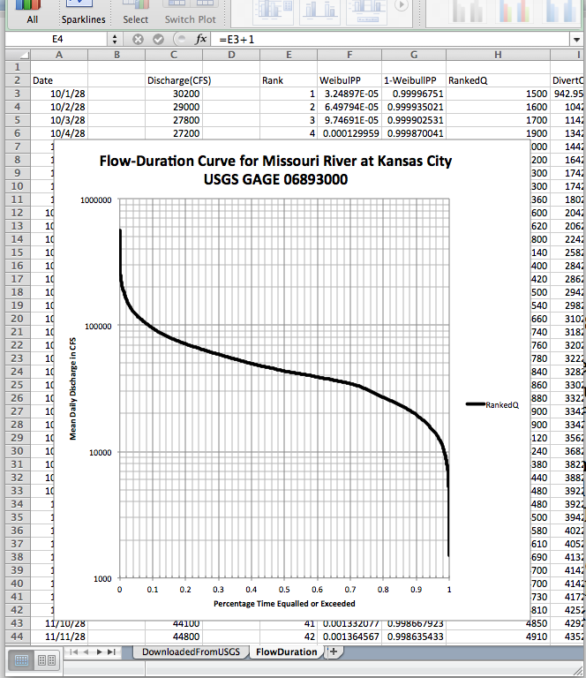

Figure 4. Flow Duration Curve for Missouri River at Kansas City

Assuming the diversion rate is on the order of 750 cubic feet per second or smaller (approximately the required rate for 4.8 million persons at 200 gpdc) the flow duration curve indicates that this amount of water is always available based on the historical record. Thus there is sufficient quantity for diversion at the 50%, 70% and 90% exceedance probabilities. It is likely that at the lower flows there are other competing uses and the diversion while feasible would not be without controversy. There is a slope change at the 70% exceedance which is probably diagnostic of drought conditions. Hence the diversion system could anticipate that the water for diversion is available 70% of the time and storage for the other 30% would be required.

The 30% storage represents about 100 days. Thus to build up a reasonably firm supply about 2 years of water would need to be stored in the system (likely in Lake Powell) before we could expect to make firm daily withdrawls. Such a requirement is typical of large water supply projects.