Task Order 1: Obtain a map of the Colorado River Basin. Identify the existing reservoirs on the system (e.g. Lake Mead, Glen Canyon, etc.). Identify the major diversions on the system (e.g. Central Arizona Project, Colorado River Aqueduct).

Identify the metropolitan areas served by the existing system. Cite your data sources. Estimate the typical water use by a household in these metropolitan areas. Estimate the minimum required diversion flow rate to serve 1.2 million such households. Report the required rate in cubic feet per second. Cite your data sources.

Due 31 JAN 2013 (Team Technical Memorandum)

Technical Memorandum

To: Client

From: Team

Subject: Task Order 1

Purpose

The purpose of Task Order 1 is to report background information on the receiving system for the Missouri River Diversion Study (MRDS), and to estimate the diversion discharge required to serve the 1.2 million estimated new customers in major urban areas already served by the Colorado River Basin infrastructure or easily added to that system.

Discussion

Figure is a map of the Colorado River Basin (U.S.B.R.). The basin includes the Colorado River as well at the major tributaries: the Salt, Gila, Virgin, San Juan, Gunnison, and Green Rivers.

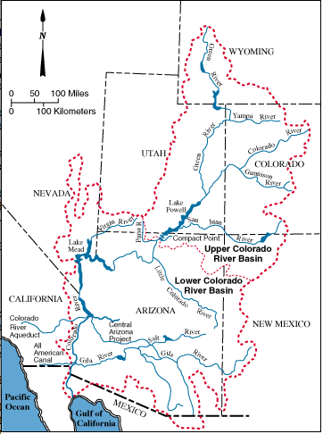

Figure 1. Colorado River Basin (U.S. Bureau of Reclaimation)

Figure is an annotated map of the basin showing the approximate location of major population centers and the dams on the system. The two primary reservoirs on the system are Lake Mead, created by Hoover (Boulder Canyon) Dam and Lake Powell, created by Glen Canyon Dam. Parker Dam impounds water in the river and creates the Colorado-Havasu recreation area that forms the Arizona-California border.

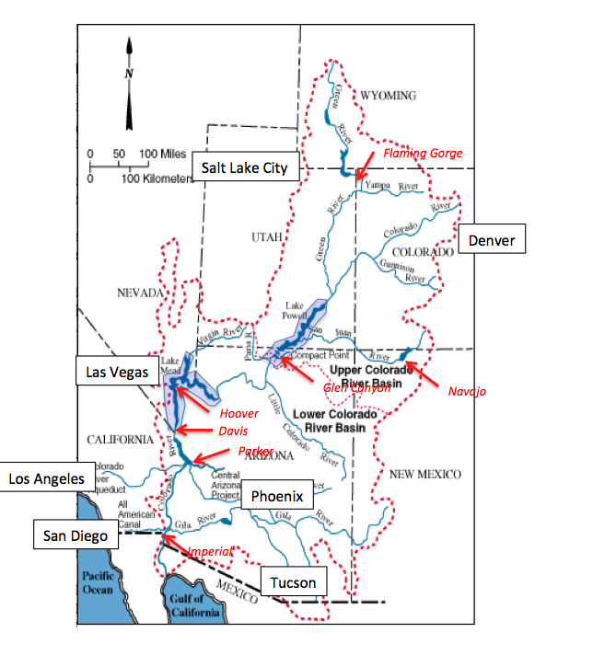

Figure 2. Annotated Basin Map -- Major Population Centers and Large Dams Shown.

The likely urban areas to contain the 1.2 million new homes are: Los Angeles, CA; Las Vegas, NV; Phoenix, and Tucson, AZ; San Diego, CA could be included with a short extension of the existing All American Canal or by wholesale water delivery from the Los Angeles area (an existing pipeline aligned with I-405 could be used to transport the additional water).

An Internet survey was conducted to find self-reported water use in the major cities in the destination service area. Figure 3 is a clip of an article in the May 8, 2012 Los Angeles Times that states the per capita water use for the area served by the Los Angeles Department of Water and Power is about 123 gallons per day.

Figure 4 is a screen capture of the City of Phoenix website that states a water use per person of about 190 gallons.

|  |  |
| --- | --- |
| Figure 3. LA Times, May 8 2012. Water Use 123 gpcd. | Figure 4. Water Use from City of Phoenix Web Site. 190 gpcd. |

|  |  |
| --- | --- |
| Figure 5. City of Tucson Water Use. 136 gpcd. | Figure 6. City of Las Vegas water use; 265 gpcd. |

Figure 5 is a screen capture of the City of Tucson website that reports a daily water use of 136 gallons per person.

Figure 6 is a screen capture of the City of Las Vegas website that reports a daily water use of 265 gallons per person.

Figure 7 is a screen capture of the San Diego Water Authority website that reports a daily water use of 143 gallons per person.

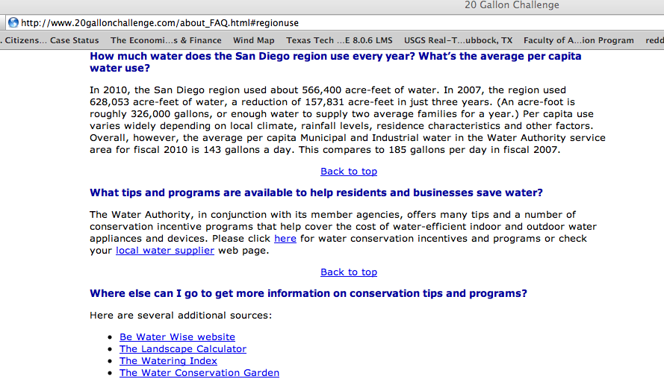

Figure 7. San Diego water use. 143 gpcd.

The results of this rapid Internet survey for water use are listed in Table 1. The populations for each metropolitan area were obtained by Google search using the following SQL entry “city name + metropolitan area.” The population is listed to construct a population weighted average use for the feasibility study to estimate the required diversion rate.

Table 1. Estimated Water Use (Population Weighted) in Destination Area

|  |  |  |  |
| --- | --- | --- | --- |
| Region | Water Use Per Capita | Population |  |
| Los Angeles | 123 gal | 9.8 million |  |
| San Diego | 143 gal | 3.1 million |  |
| Las Vegas | 265 gal | 1.4 million |  |
| Phoenix | 190 gal | 3.2 million |  |
| Tucson | 136 gal | 1.0 million |  |
|  |  |  | Avg. Use |
| Total |  | 18.5 million | 149.4 gpcd |

The population weighted average use is 150 gallons per day.

MSNBC reports that the average household size in the USA is 2.6 persons per household (MSNBC 2102). Thus the product of the 1.2 million households, 2.6 persons per household, and 150 gallons per day produces the estimated diversion rate of

Converting to cubic feet per second, divide by 86400 sec/day to produce the diversion estimate of Q=724 cfs. There is considerable uncertainty in these estimates, so as a first guess we stipulate that the estimate may be high or low by a factor of at least two, hence the estimate should be reported as a range of values. Oversupply is unlikely to be adverse, so we will estimate the required diversion to be 724 < Q < 1448 cfs as a reasonable design value.

Conclusions/Recommendations

The existing Colorado River Basin infrastructure and destination communities are identified on Figure 2. The current estimated water use in these communities was used to estimate the required diversion rate of somewhere between 720 and 1450 cubic feet per second, a substantial, but technically feasible rate using current commercially available lift pumps. These pumps will be specified in a later Task Order. This memorandum did not consider evaporation of the diverted water as it traverses the Colorado River System, and such an estimate is vital to sizing the entire diversion system for feasibility assessment.

References

City of Phoenix, <http://phoenix.gov/waterservices/wrc/yourwater/histuse.html> accessed 6 Jan 13.

City of Las Vegas, <http://www.lasvegasnevada.gov/sustaininglasvegas/16110.htm>

City of Tucson, http://cms3.tucsonaz.gov/water/about-us

San Diego County Water Authority, <http://www.20gallonchallenge.com/about_FAQ.html>

Los Angeles Times, <http://latimesblogs.latimes.com/lanow/2012/05/los-angeles-water-use-creeping-up-.html>

MSNBC, http://www.msnbc.msn.com/id/14942047/ns/technology_and_science-science/t/census-us-household-size-shrinking/#.UOn3jRyTmgg

U.S.B.R., <http://www.usbr.gov/lc/region/g4000/contracts/watersource.html> accessed 6 Jan 2013.