memorandum

|  |  |
| --- | --- |
| to: | Dr. Theodore CleAveland, P.E. |
| from: | Alaska Tanglewilde |
|  |  |
| date: | February 16, 2016 |
| Re: | Engineering calculations and pumps |
|  |  |

**Purpose:** Answer questions from ES-4

**Discussion:** The first question in the ES asks about the required unit conversions needed to make the Swamee-Jain Equation work. I first convert the inches into feet. Then I work the excel spread sheet found on the class server (<http://rtfmps.com/university-courses/ce-3372/2-Homework/ES-5/ES-5-Solution/>).

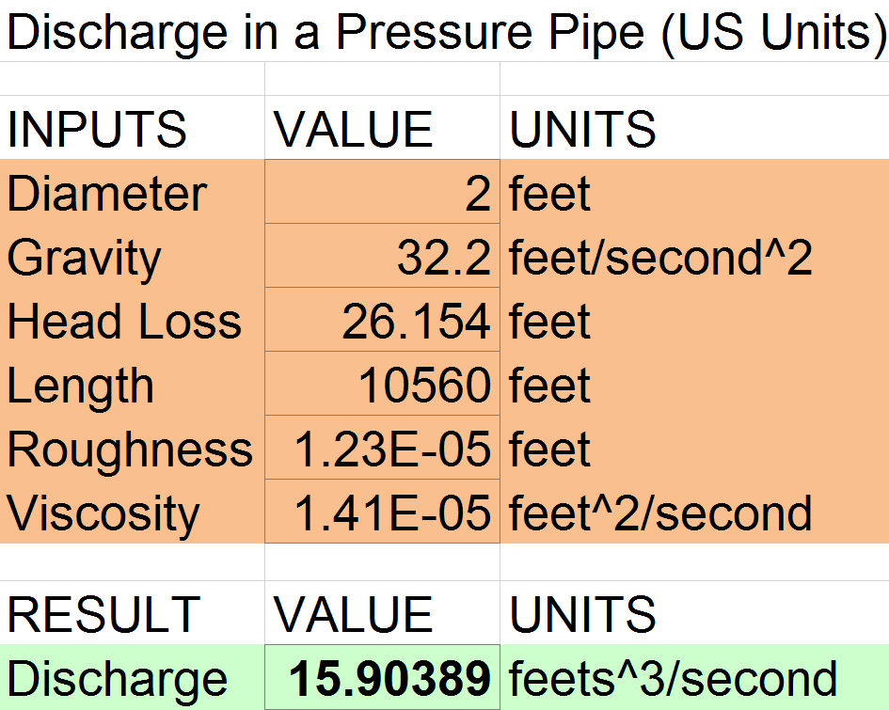

**Concluding Remarks:** From the online calculator, the result of the discharge for the pipe is 15.9 ft^3/s. IT was found that this is a normal flow rate for the pipe is with in the acceptable range.

Alaska Tanglewilde

All values and work is shown on the attached solution.