[Company name]
[Document title]
[Document subtitle]
Cleveland, Theodore
[Date]

Contents
List of Figures 2
Study Area 4
Modeling Assumptions 6
EPANET Conceptualizations 6
Transmission Pipeline 7
Wellfield Model 8
Storage Tank(s) Model 10
Terminal Storage Reservoir-Based Control Rules 10
Intermediate Storage Reservoir-Based Control Rules 13
References 25
Appendix – I Loss Coefficients for Different Materials 26
Appendix II Burst Pressure Guidance for HDPE 29

List of Figures
Figure 1. Study Area Overview Map 3
Figure 2. EPANET Model Layout on top of QGIS DEM 4
Figure 3. Model Summary 6
Figure 4. Booster Station at Terminal Storage Reservoir. 6
Figure 5. Conceptual and EPANET model representations of individual wells. 7
Figure 6. EPANET Representation of 8FAHC pump performance curve 7
Figure 7. Manufacturer Supplied Pump Data 8
Figure 8 Wellfield portion of EPANET model 8
Figure 9. Storage Tank Representation 9
Figure 10. TSR operating rules (initial simulations) 10
Figure 11. System Demand at Connection to Water Distribution System 11
Figure 12. Portion of Status Report Listing Control Rule changes to pumps and valves. 11
Figure 13 ISR operating rules (initial simulations) 12
Figure 14. ISR/TSR Storage Tank Elevations. 13
Figure 15. Representative Wellfield Pumping Rates. 14
Figure 16. Flow at Different Locations 14
Figure 17. Node Groups for min/max pressure plots 15
Figure 18. J36-J40 Node group pressure plot. 16
Figure 19. Minimum pressure locations. 17
Figure 20. J2-J5 Node group pressure plot 17
Figure 21. Head at Node J1 and Tank TSR_1 18
Figure 22. Low Pressure Location in System (Google Earth Pro) 19
Figure 23. Computed Pressures (psi) - JP6 is node with lowest pressure in this simulation. 19
Figure 24. ISR Booster Station Representation 21
Figure 25. caption 22
Figure 26. caption 23
Figure 30. Hazen-Williams Friction Factor for HDPE (from https://onlinelibrary.wiley.com/doi/pdf/10.1002/9780470168103.app1) 25
Figure 31. C Values for various materials from: "Water Distribution Systems" in Land Development Handbook, Ed. S.O. Dewberry, Dewberry Inc., McGraw-Hill 26
Figure 32. Values of C for various materials from: (http://54.243.252.9/ce-3372-webroot/3-Readings/HydraulicsNotes/hydraulics-notes-tgc.pdf) 27
Figure 33. Burst-Pressure Guidance (and another C value) from https://hdpe.ca/assets/data/technical-data/performance-pipe/FAQ-Municipal-water.pdf 28
Figure 34. Tabulated HDPE Pressure ratings from https://www.jmeagle.com/sites/default/files/HDPESpecSheet4710%20.pdf 29

Study Area

Figure XX is an annotated map of the model area. The three main parts are shown as the Terminal Storage Portion, the Transmission Pipeline Portion, and the Wellfield Portion (Collection is used interchangeably).

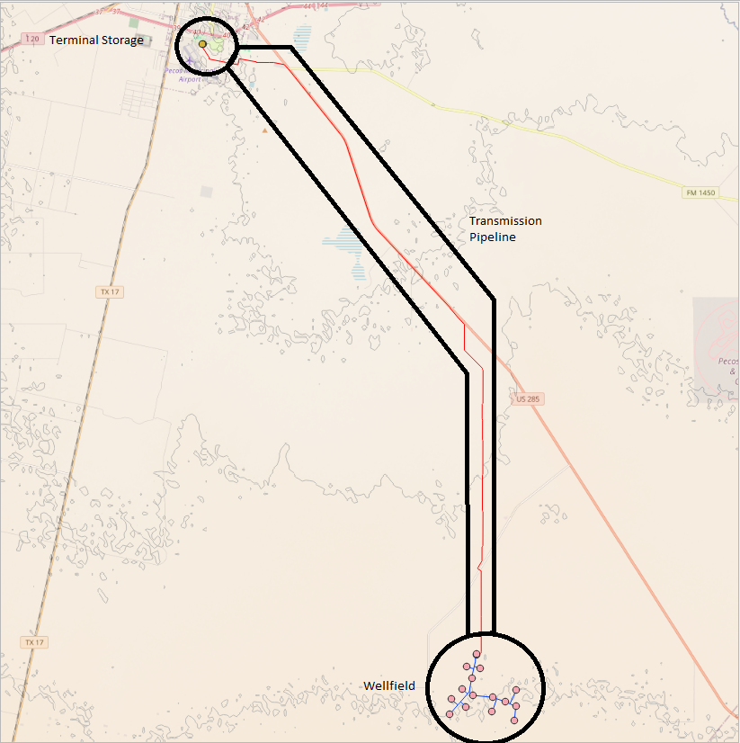
Figure 1. Study Area Overview Map

The unlabeled contour interval is 100 feet. The approximate elevation of the wellfield is 2800 feet, and the terminal storage area is approximately 2600 feet.

The KML file that contained the coordinates of the wellfield components, pipeline alignment, and terminal storage were loaded into QGIS to build an EPANET network. A 30-meter DEM was downloaded from the public STRM database. The STRM data were re-projected onto the Zone 31N UTM coordinate system (approximately Cartesian at the study scale; it will render nicely in ordinary EPANET, and the auto-length algorithm can determine pipe lengths from node locations)

A “plug-in” named “QEPANET” was used in QGIS to map nodes and tanks. The remainder of the EPANET model is built directly in the US EPA supplied software.

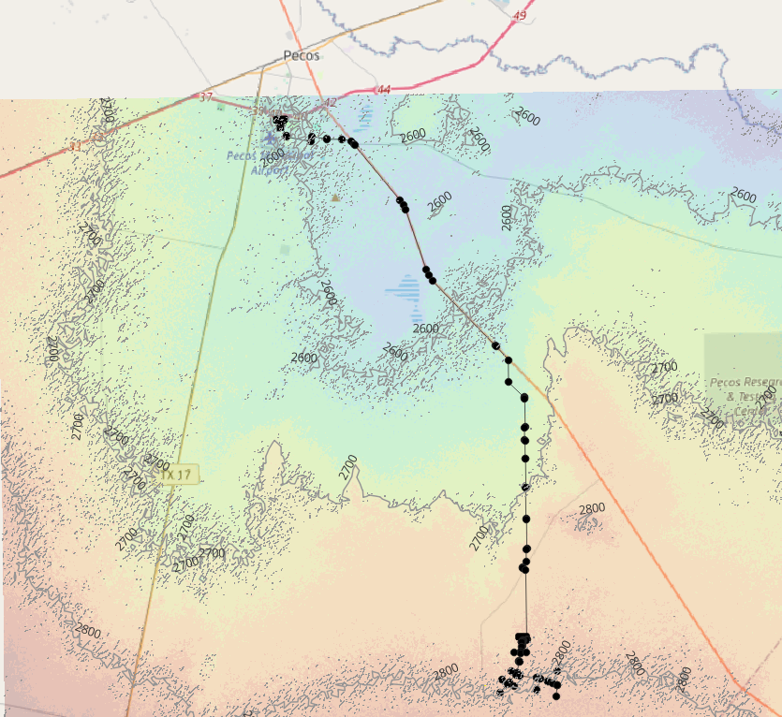
Figure 2. EPANET Model Layout on top of QGIS DEM

Figure XX is a map of the EPANET representation of the study area. As various junctions and pipeline features were built in the EPANET software the corresponding elevations were obtained either by re-importing into the QGIS and extracting the elevation or by arithmetic mean of the specific locations from nearby features.

Modeling Assumptions

Several assumptions used in the model development and implementation are listed below:

- The raw water portion of the system is not required to be maintained at 35 psi, the stipulated value in TAC 30.1.290.D§290.45 for water in a distribution system.
- Water in the Intermediate Storage Reservoirs (ISRs) is default raw water; furthermore these are atmospheric storage tanks (at-grade vertical cylinders).
- Water in the Terminal Storage Reservoirs (TSRs) is assumed to be raw; while also atmospheric reservoirs, water exiting these reservoirs is boosted into the water distribution system (WDS). All water downstream of the booster station is to be at or above 35 psi for the various discharges in accordance with TAC 30.1.290.D§290.45 for water in a distribution system.
- TSRs + ISRs total volume is 3.0 million gallons. Assuming that volume is 7 days of average discharge, the average daily demand (to empty tanks over 7 days) about 350 gpm. This value (350 gpm) is used as the ADD for time-varying hydraulic simulations.
- The entire system demand was placed (in the model) at the WDS node, which is to represent the current/future water distribution system. A pipe (in the model) named “TSR_OUT” could be adjusted to approximate the entire system loss by future model users (or the entire water distribution system could be modeled from this location-and actual pipes used).
- The control rules at the ISRs were developed to the tank receiving water from the well field nearly full. The generic rule structure was to start pumps when the tank depth approached ¾ full (22.5 feet deep), and stop pumps when the tank is 95% full (29.5 feet deep). The tank was further constrained to not be allowed below 15 feet deep – so the bottom ½ of the tank is always available. Given that the tank is to serve as a sand trap as well as storage these settings preserve ½ pf the tank for its clarifier role. The tank that feeds the pipeline was initially allowed to respond to system hydraulics.
- The TSR control rules were set such that the tanks behave in tandem, and keep water levels between 1/3 and 98% full.
- The initial pumps shut down/start-up is all pumps are on/off a more elaborate scheme is tried in subsequent simulations where the pumps are shut down from closest to the ISRs to furthest, and restarted in reverse order. – this later rule set is more complex, and may introduce model instabilities.

EPANET Conceptualizations

EPANET conceptualizations are examined below – these represent how the physical system is approximated in the hydraulic model. The model includes the wellfield pumping from the underlying aquifer. These flows are collected into two storage tanks labeled ISR-1 and ISR-2, both ½-million gallon atmospheric (at grade) storage tanks. ISR-1 serves as both a storage reservoir and a grit (sand) chamber before water is transferred to ISR-2 which feeds the 21+ mile long transmission pipeline.

Transmission Pipeline

The transmission pipeline is modeled as an approximately 110880 (21 miles) feet long, 17.43-inch ID pipe with a Hazen-Williams Loss Coefficient of 130. Figure 3 summarizes the various major components and water volumes.

Figure 3. Model Summary
The approximate total system volume is nearly 4 million gallons, and at 2100 gpm will take a little less than a day and a half to fill.

The pipeline terminates at TSR-1 which is tandem connected to TSR-2, both 1-million gallon atmospheric (at grade) storage tanks. TSR-2 is assumed to store treated water, so it is boosted into the existing water distribution system. In the hydraulic model this booster station is represented by a “pump” with the characteristics in Figure 4 below. The performance curve was obtained by trial-and-error to produce slightly greater than 35-psi at the WDS node when the demand is 2100 gpm.

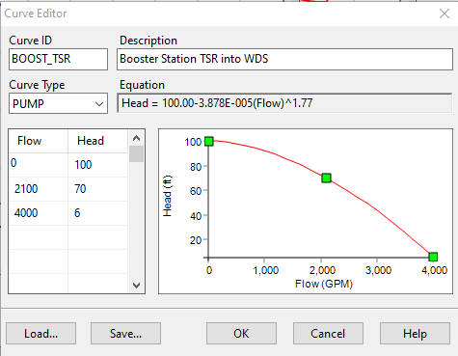
Figure 4. Booster Station at Terminal Storage Reservoir.

Wellfield Model

Individual wells in the wellfield were modeled as specified groundwater elevations on the suction side of a pump (8FAHC). The discharge side of the pump is connected to the nearest system node (in the model) through a check-valve (backflow preventer) to only allow one-way discharge, and connection pipe that includes the riser pipe length (the static lift in the diagram in Figure 5). Figure 5 depicts the conceptual model and the equivalent EPANET representations.

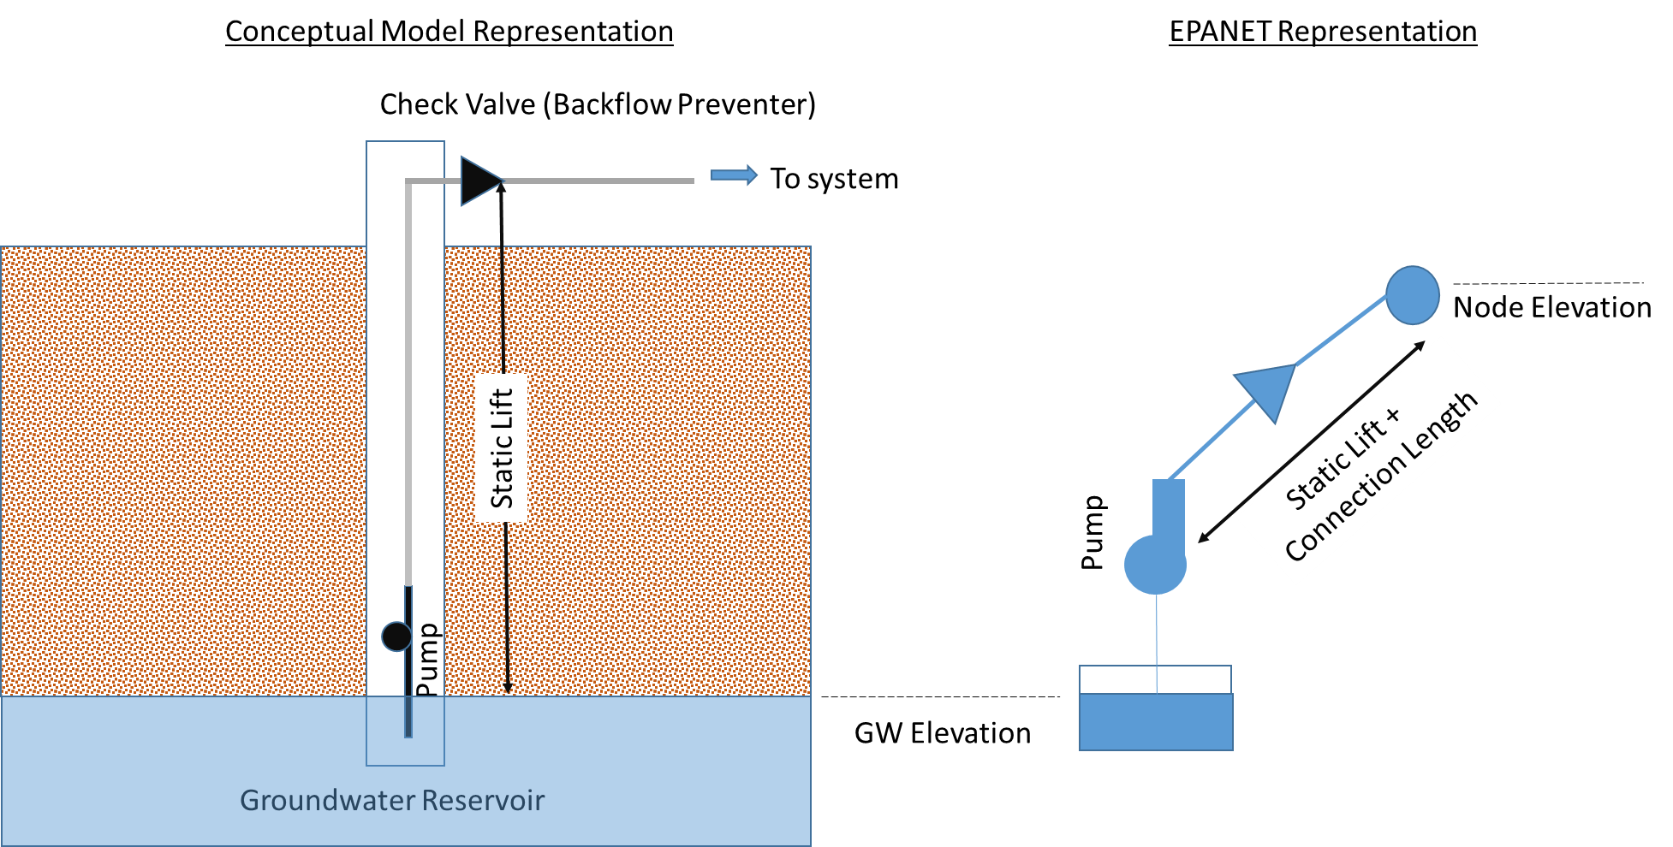
Figure 5. Conceptual and EPANET model representations of individual wells.
The groundwater elevations were specified as 2330 feet in the initial simulations. Node elevations from the CALCS[59].pdf file were used for the wellfield model. A pump curve with manufacturer specified behavior was supplied to EPANET and the input dialog box is shown below on Figure 6

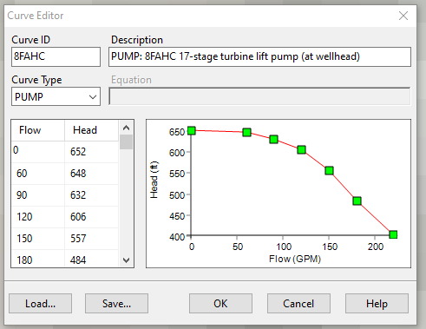
Figure 6. EPANET Representation of 8FAHC pump performance curve
Figure 7 is a screen capture of the manufacturer supplied well pump performance curve for each well.
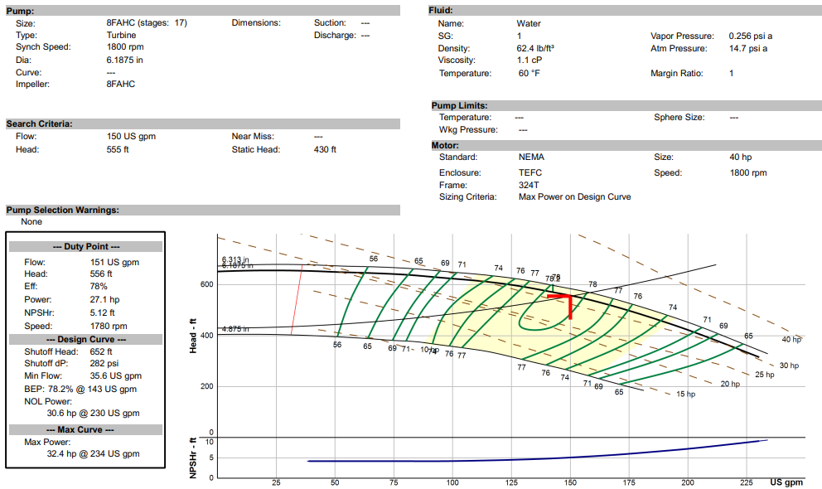
Figure 7. Manufacturer Supplied Pump Data

Figure 8 depicts the wellfield portion of the model area with the common groundwater elevation, with all wells active.

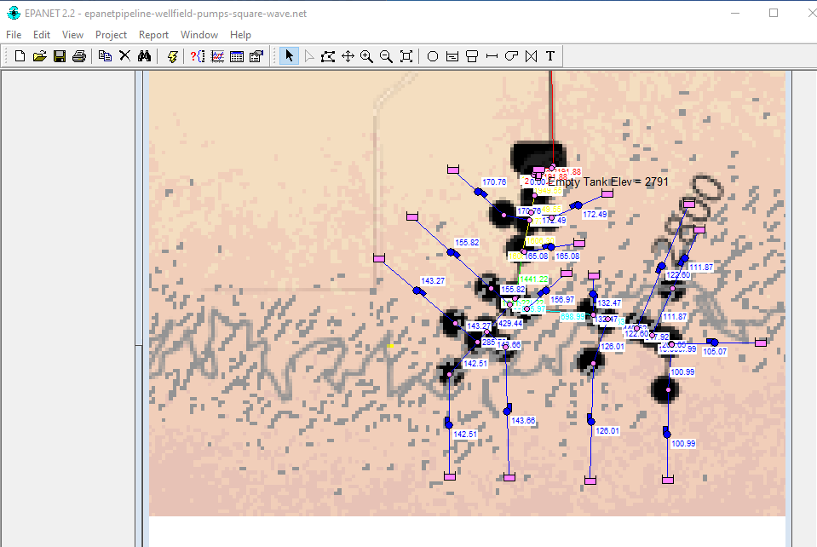
Figure 8 Wellfield portion of EPANET model
The groundwater reservoir(s) are the magenta rectangles, pumps, check valves, and connecting pipes are shown overlaid on the project base map. All the well pumps are modeled with a check valve to prevent computed (and real) backflows. In general if a well is inactive, the immediately downstream check valve should show a status of Closed in EPANET. Interestingly, check valves are not treated as separate hydraulic elements but are a pipe attribute. Other types of valves are separate entities.

Storage Tank(s) Model

Figure 9 is a schematic of a generic storage tank representation in the EPANET model. The actual system has two pairs of such tankage. In the schematic the important tank features are identified; the program requires specification of minimum, initial, and maximum depth the tank diameter and the tank bottom elevation. Non-cylindrical tanks can be modeled using a depth-volume curve. The check valve and booster pump are not part of tank specification; nor does the computer program actually air-gap the tanks as depicted, but this is a useable conceptualization.

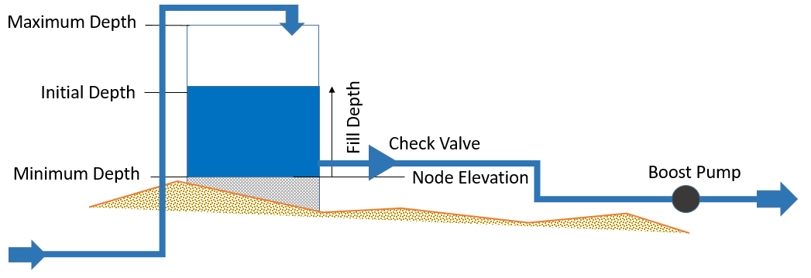
Figure 9. Storage Tank Representation

The two storage areas are the intermediate storage reservoirs (ISR) located immediately adjacent to (North of) the wellfield, and the terminal storage reservoirs (TSR) located at the city yard, where the raw water would be treated (disinfected) and boosted into the water distribution system.

The control rule(s) to stop and start pumps (ISR), and open or close valves (TSR) are based on tank depths at any moment. As the tank nears its maximum depth, pumps are stopped and/or inlet valves closed; as the tank nears a minimum depth inlet pumps are started and/or inlet valves are opened.

The initial simulations used severe rules (all pumps on/off) that would be modified in actual practice for smoother transitions as controls are requested.

Terminal Storage Reservoir-Based Control Rules

The TSR rules were developed to supply water to the WDS from TSR_2 until its level is low, then transfer from TSR_1 to maintain supply. When TSR_1 is low, then the system draws from the pipeline, which is supplied from the ISR location governed by system hydraulics.

A simple set of Rules are implemented to open and close connections based on tank water levels.

The TSR_1 rules are:
- If level > 29.5 (tank almost full) then stop inflows from pipeline, by closing valve in pipe TSR_INPUT
- If level < 10.5 (tank is 1/3 full and probably draining) then resume pipeline inflows, by opening valve in pipe TSR_INPUT

For the initial simulations these were the only rules used to control TSR_1.

The TSR_2 rules are:
- If level > 29.5 (tank almost full) then stop inflows from pipeline, by closing valve in pipe TSR_TRAN
- If level < 10.5 (tank is 1/3 full and probably draining) then resume pipeline inflows, by opening valve in pipe TSR_TRAN

For the initial simulations these were the only control rules for TSR_2. Figure 10 is a schematic of the tandem TSR tanks and the control rules implemented.

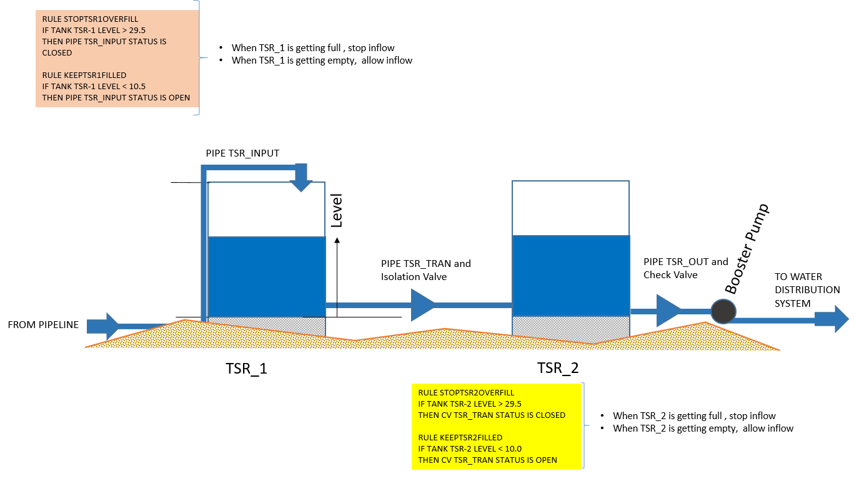
Figure 10. TSR operating rules (initial simulations)

These rules were refined by running several simulations with different set points until a relatively long (7+ days) simulation would run without errors or warnings. The system demand was a repeating pattern of 210 to 2100 gpm as depicted in Figure 11.

Warnings (as in footnote above) are useful and don’t imply something is wrong with the simulation
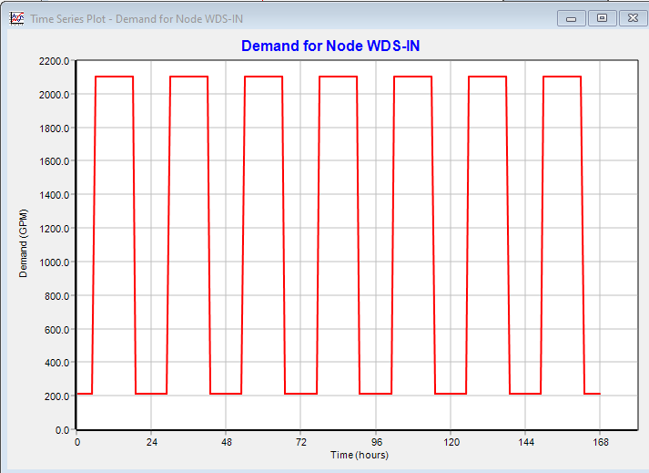
Figure 11. System Demand at Connection to Water Distribution System
Negative pressure (even if it is a consequence of elevation and possibly correct) will create a warning. Negative pressures could be normal for flow going over a hill – still probably want to avoid such situations, hence the warning. Other warnings are pumps turned off/on in response to system hydraulics – in the case where a pump cannot supply sufficient head at a required flow rate the pump is shut off (this generally identifies conceptualization problems). In other cases one can ignore the warning and proceed especially if the on/off is in response to a control rule. The status report file lists all such warnings and also lists control changes (as well as errors and related error codes).

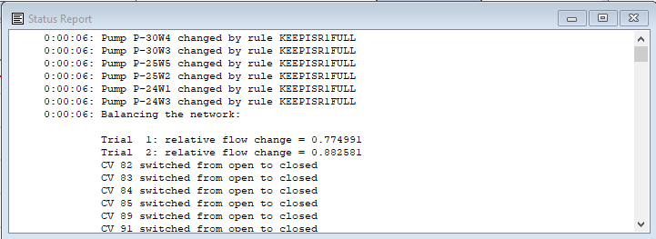
Figure 12. Portion of Status Report Listing Control Rule changes to pumps and valves.
Figure 12 is an example of a portion of the status report, illustrating acknowledgement of a rule induced change and a subsequent valve setting change. Warnings are listed in the same report and by program default the modeler has to examine the file before the program will complete a simulation.

Intermediate Storage Reservoir-Based Control Rules

The ISR rules were stipulated to supply water to the pipeline from ISR_2 until its level is low, then transfer from ISR_1 to maintain supply. When ISR_1 is low, then the system draws from the wellfield, which is supplied to the ISR location governed by system hydraulics.

These rules are slightly more complex because a stated goal is to keep ISR_1 close to full and use it as a sand trap (aka clarifier). The initial set points below are simply to get the modeled system to function.

The ISR_1 rules are:
- If level > 29 (tank is 96% full) then stop inflows from wellfield, by closing stopping all pumps.
- If level < 27 (tank is 90% full and probably draining) then resume wellfield inflows, by starting all pumps.

For the initial simulations these were the only rules used to control ISR_1.

The ISR_2 rules are:
- None; ISR_2 drains/fills as prescribed by pipeline hydraulics.

Figure 13 is a schematic of the tandem ISR tanks and the control rules implemented.

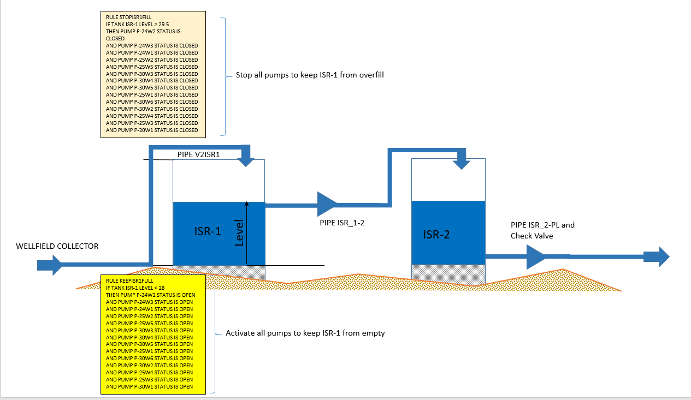
Figure 13 ISR operating rules (initial simulations)

This initial simulation showed that the ISR tanks function under the simulation conditions as a tandem tank system. The TSR tanks also function in tandem (a desired behavior). The lowest water depth in the simulation (somewhere near hour 24 and again at hour 96) is 15.37 feet above the tank bottom. The target minimum depth was 15 feet for ISR_1. Figure 14 is an annotated plot of the tank water surface elevations, which also depicts the tank bottom elevations. The upper trace is the ISR tank pair; the lower trace is the TSR tank pair. The four traces are hard to depict as the ISR and TSR tank pairs plot nearly on top of each other (anticipated for the TSR pair)

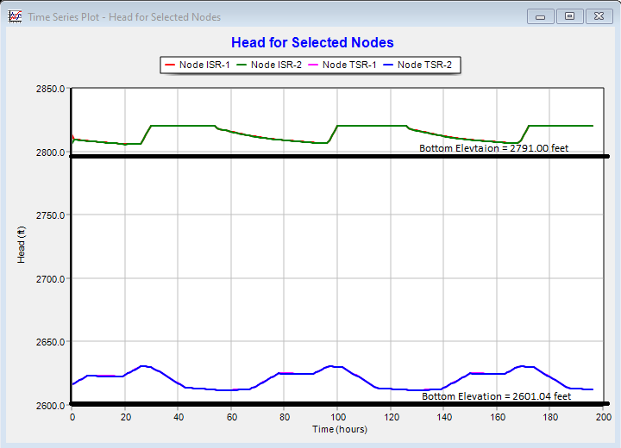
Figure 14. ISR/TSR Storage Tank Elevations.

The wellfield cycles on/off dictated by the demand pattern and control rules. The wells pump roughly 46 hours, then shut off for 24 hours, and resume pumping for another 46 hours. Figure 15 shows the pump rates for some of the wells. The time 0 behavior is truncated because the simulations were started with partially full tanks (somewhere intermediate between the set points).
Figure 16 is a graph that depicts the discharge at different locations in the entire system these locations are V2ISR1 (the input pipe to ISR_1), ISR2_PL (the input pipe from ISR_2 into the transmission pipeline), TSR_INPUT, TSR_TRAN (the transfer pipe from TSR_1 to TSR_2), and TSR_OUT (the pipe into the booster station).
The graph shows that the ISR supply input closely follows the pump cycles (it lags the pumps which is anticipated), and the behavior demonstrates that the storage is used to sustain flow and accommodate flow changes. The TSR_OUT link exactly follows the demand pattern as it should – this link is adjacent to the demand node, so there should be minimal time delay as demands change. The TSR_TRAN transfer pipe behavior is indicated by the blue curve – its behavior is the most varied in the plot, occasionally dropping to zero as TSR_2 nears full capacity, but quickly restarting as demand draws down the tank level.

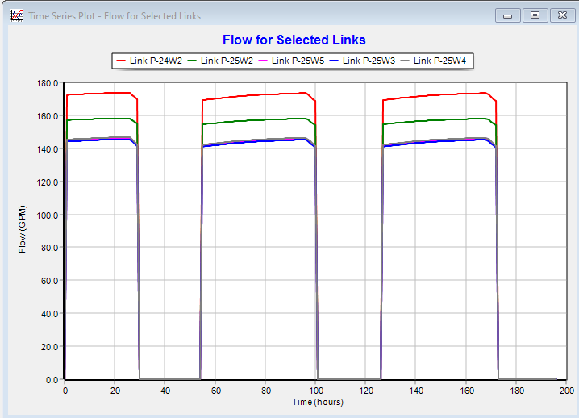
Figure 15. Representative Wellfield Pumping Rates.
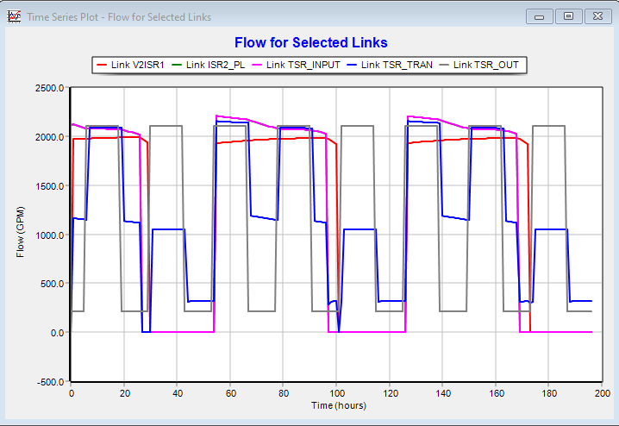
Figure 16. Flow at Different Locations
System pressures vary considerably based on location. Some representative locations are shown on X.
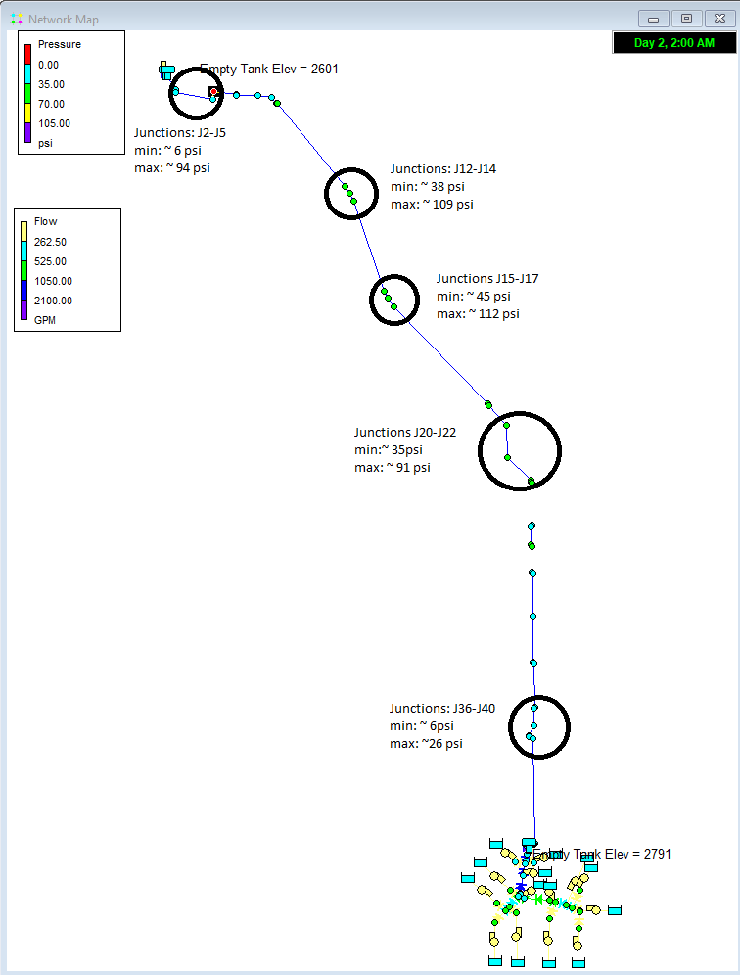
Figure 17. Node Groups for min/max pressure plots

The indicated node groups are plotted below. The J36-J40 group is shown on Figure 18

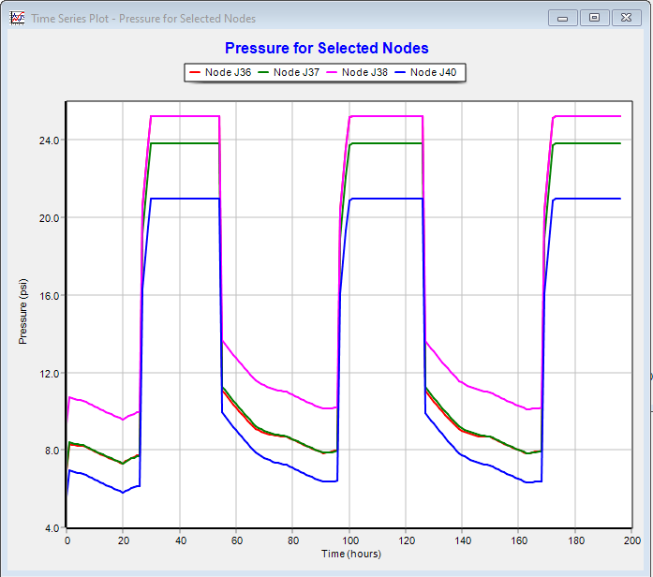
Figure 18. J36-J40 Node group pressure plot.

This node group contains the smallest pressure in the system at 2100 gpm, which coincides with the pumps being started in response to emptying tanks, is roughly 6 psi (about 13.5 feet of head) at the pipeline crossing of FM 2007, in the EPANET model it is at the node immediately south of the road shown below on the left panel of Figure 19.

The other low pressure node group is plotted on Figure 20. This node group has a similar low pressure at node J2 which is located near the input to the TSR tank system. Node J1 (not plotted) has a minimum pressure of about 5 psi. (~ 11 feet of head) It is the last node before TSR_1. A plot of the head at J1 and TSR_1 is informative and is shown on Figure 21. The location of the node is shown on the right panel of Figure 19.

The other node groups are unremarkable – the high pressures are less than 125 psi which should be manageable for HDPE (DR-17 with nominal pressure rating of 125 psi). Appendix II contains excerpts of burst-pressure guidance. If a DR-21 with nominal pressure rating of 100 psi is intended, then pressure break valves at/near junction J17 would be indicated.

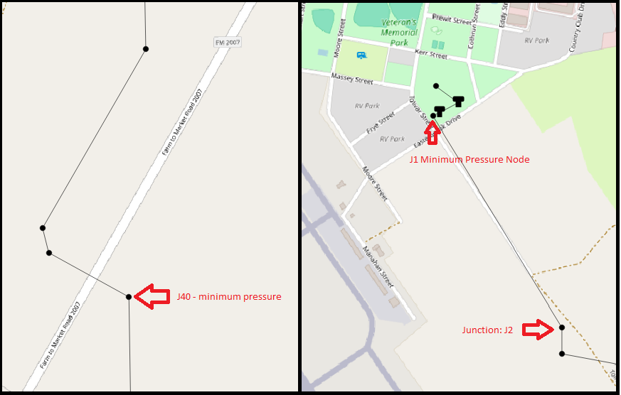
Figure 19. Minimum pressure locations.

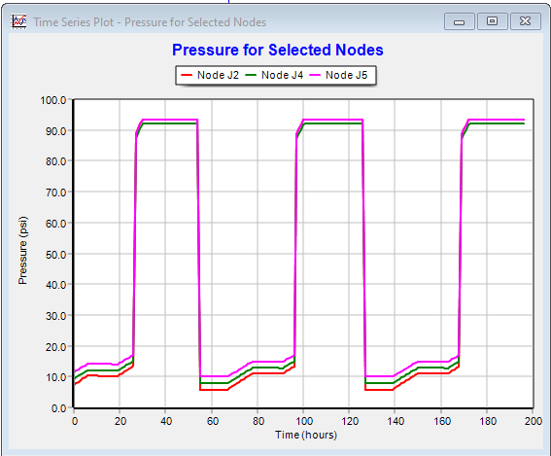
Figure 20. J2-J5 Node group pressure plot

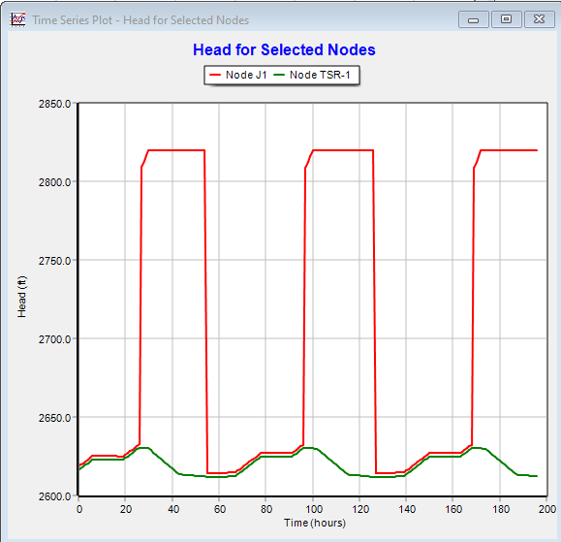
Figure 21. Head at Node J1 and Tank TSR_1

The location of the low pressure is informative – it is a consequence of a small change in elevation (as per the alignment and DEM). Figure 22 is a Google Earth Pro rendering of the location where low pressure occurs. It occurs at a small rise in the vicinity of FM 2007. Similarly at nodes J2 and J1 a small rise is apparent just before reaching the city yard.

An important consideration is the EPANET simulations have “square wave” behavior which reflects that it computes hydraulics as a sequence of steady states. The flows cannot possibly drop from 2000 gpm to 200 gpm over the entire pipeline as depicted in these plots.

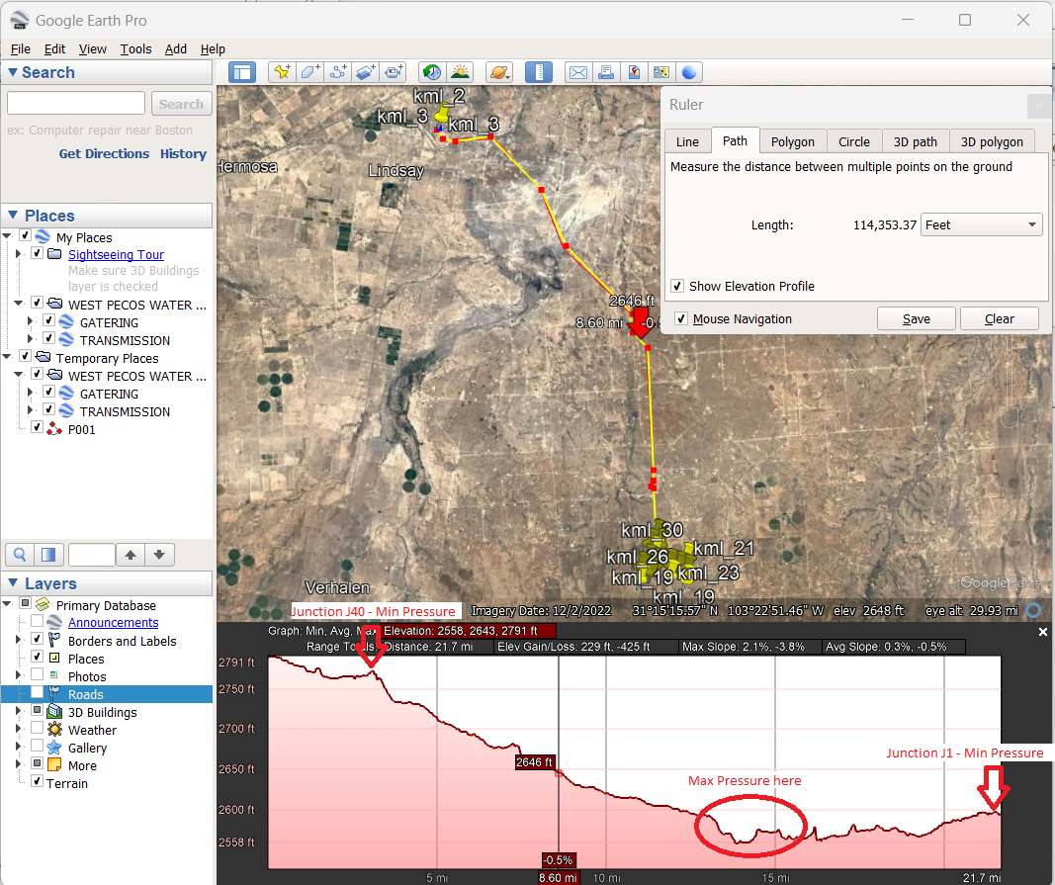
Figure 22. Low Pressure Location in System (Google Earth Pro)

Variable Demand Scenario

The model was also run with a variable demand, ranging from 300 gpm to 2100 gpm (hitting the peak only one hour per 24 hours) to understand system behavior under routine use.

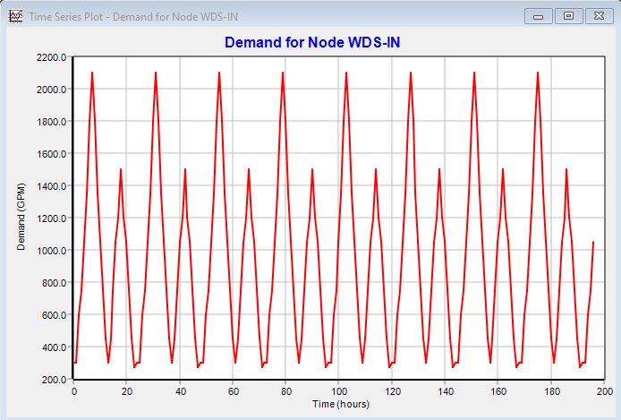
Figure 23. Demand at WDS

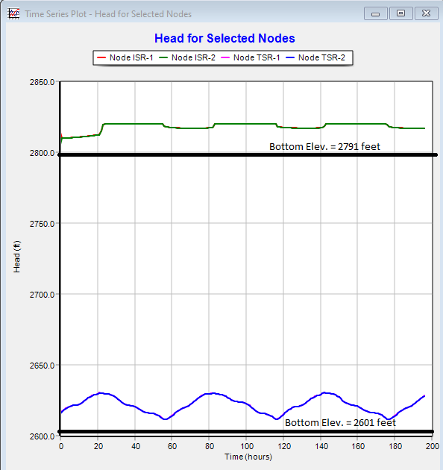
Figure 24. Water Elevations at ISR/TSR

This case the ISR perform as intended, staying mostly full during the simulation interval.

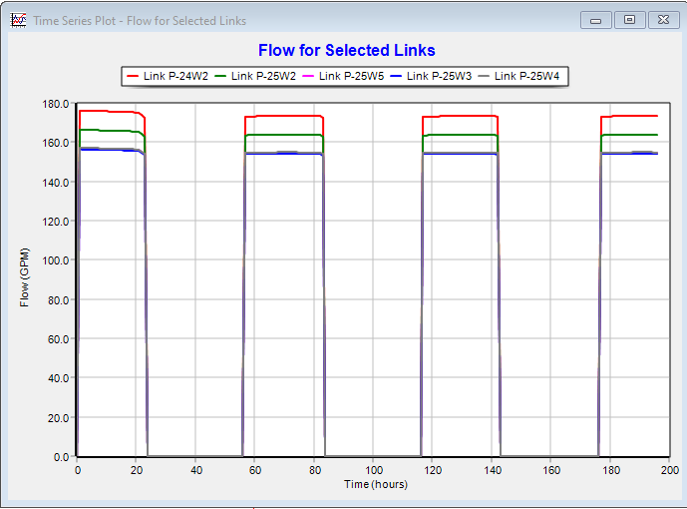
Figure 25. Selected Pumps

The pumping system idle time is lengthened somewhat.

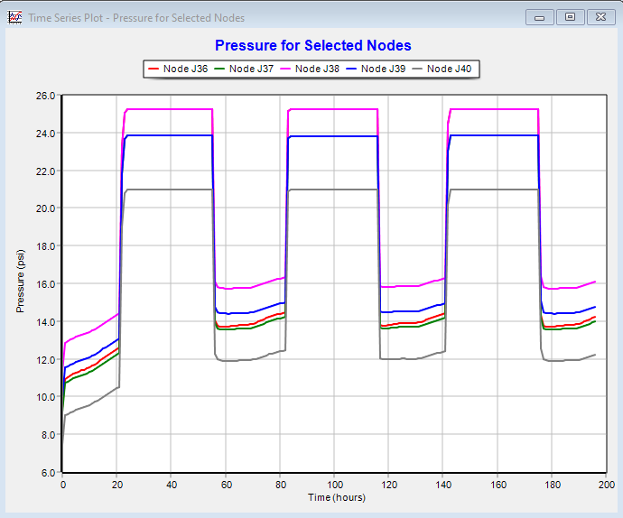
Figure 26. Node group J36-J40
This node group contains the smallest pressure in the system at 2100 gpm, which coincides with the pumps being started in response to emptying tanks, is roughly 6 psi (about 13.5 feet of head) at the pipeline crossing of FM 2007, in the EPANET model it is at the node immediately south of the road shown below on the left panel of Figure 19.

Perform simulations using ordinary time variation. Save all the files for transfer to Chad. Save copy on FreeSWMM to use as a future example.

Water Hammer Analysis

Case 1. 0-second shutoff, frictionless pipe

This case assumes a sudden shutdown, the valve pressure ranges from -45 psi to 70 psi using the material properties for DR-17 HDPE. The pressure wave travel time is on the order of 250 seconds to traverse the 21 mile pipeline, roughly 5 miles per minute. Numerical instability appears as the oscillation at the leading edge of the pressure wave.

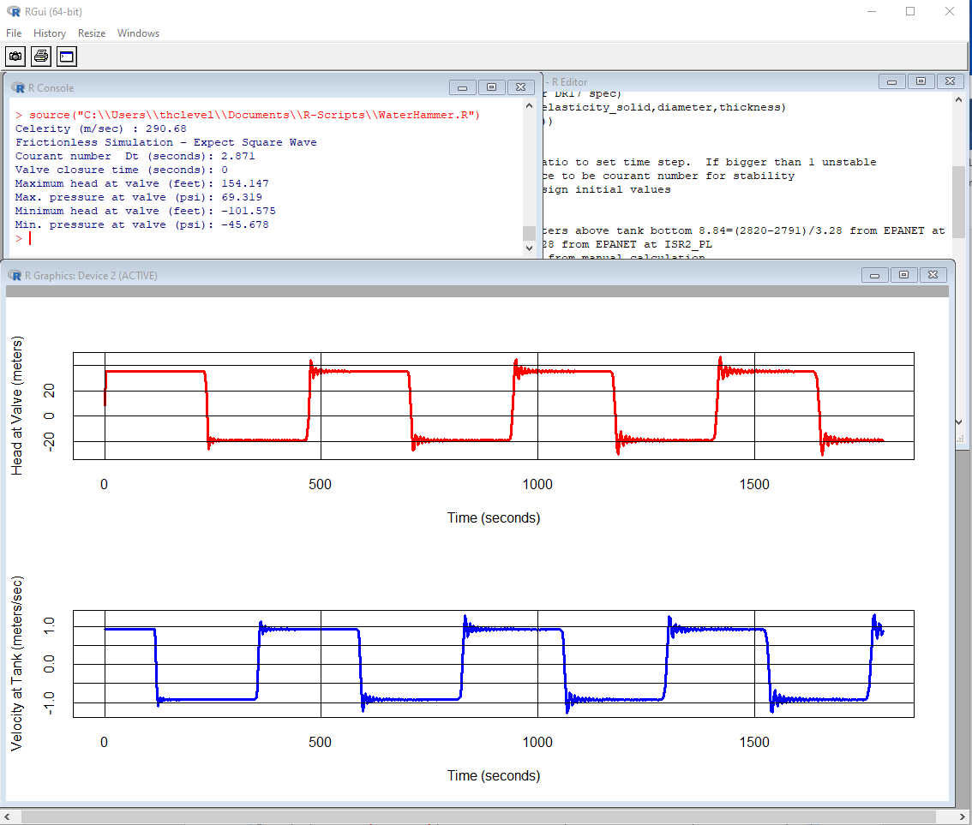
Figure 27. Water Hammer; 0-second shutdown; no damping

Case 1. 3-second shutoff, smooth pipe friction factor

This case assumes a sudden shutdown, the valve pressure ranges from -2 psi to 50 psi using the material properties for DR-17 HDPE. The pressure wave travel time is on the order of 250 seconds to traverse the 21 mile pipeline, roughly 5 miles per minute. The friction factor used is for smooth pipes at Re of about 50,000. As velocity is slowed the friction factor about doubles.

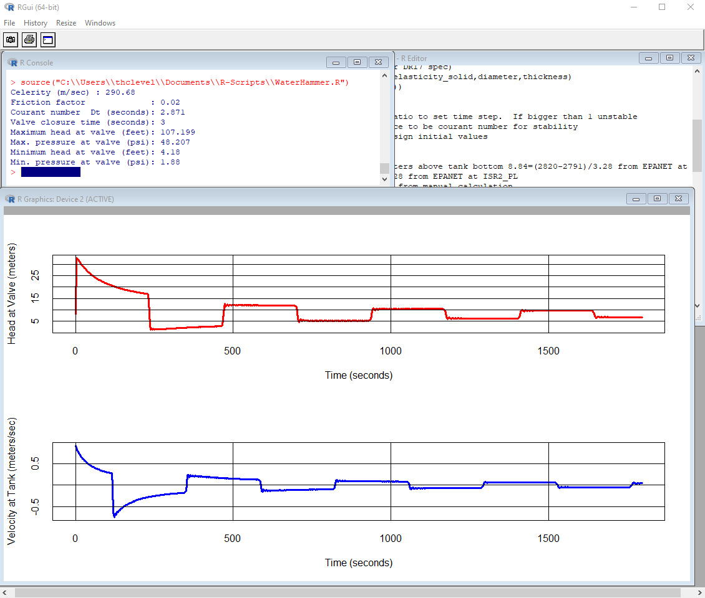
Figure 28. Water Hammer; 3-second shutdown; frictional damping

Case 2. 6 -second shutoff, smooth pipe friction factor

This case assumes a linear shutdown over 30 seconds, the valve pressure ranges from -30 psi to 54 psi using the material properties for DR-17 HDPE. The pressure wave travel time is on the order of 250 seconds to traverse the 21 mile pipeline, roughly 5 miles per minute.

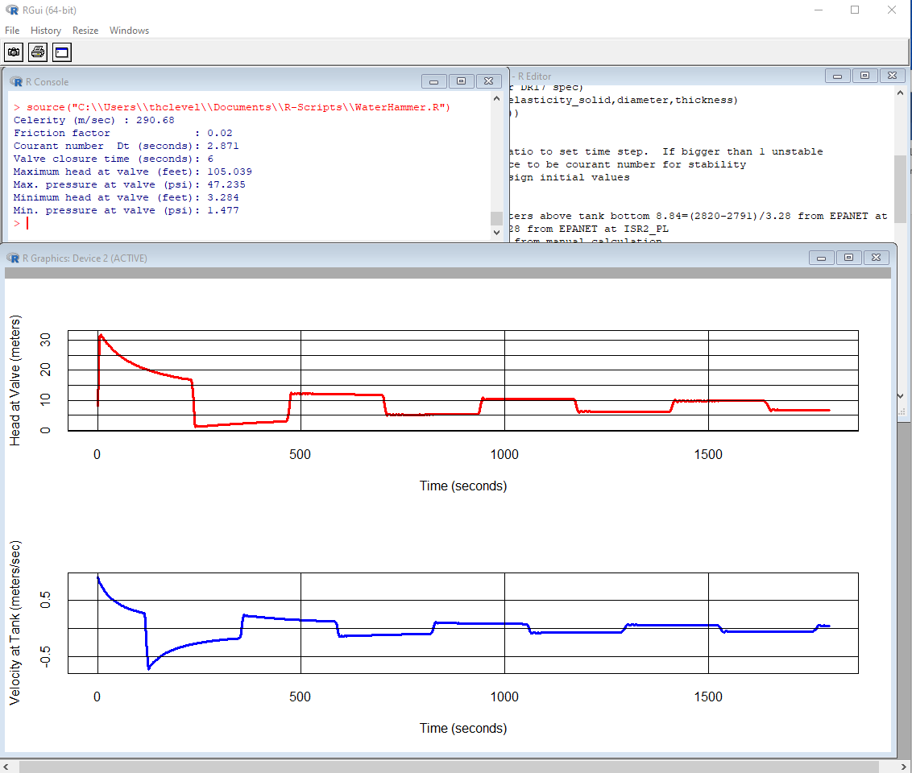
Figure 29. Water Hammer; 6-second shutdown; frictional damping

Case 3. 30-second shutoff, smooth pipe friction factor

This case assumes an instant shutdown, the valve pressure ranges from -2 psi to 49 psi using the material properties for DR-17 HDPE. The pressure wave travel time is on the order of 250 seconds to traverse the 21 mile pipeline, roughly 5 miles per minute but is damped by friction (as expected)

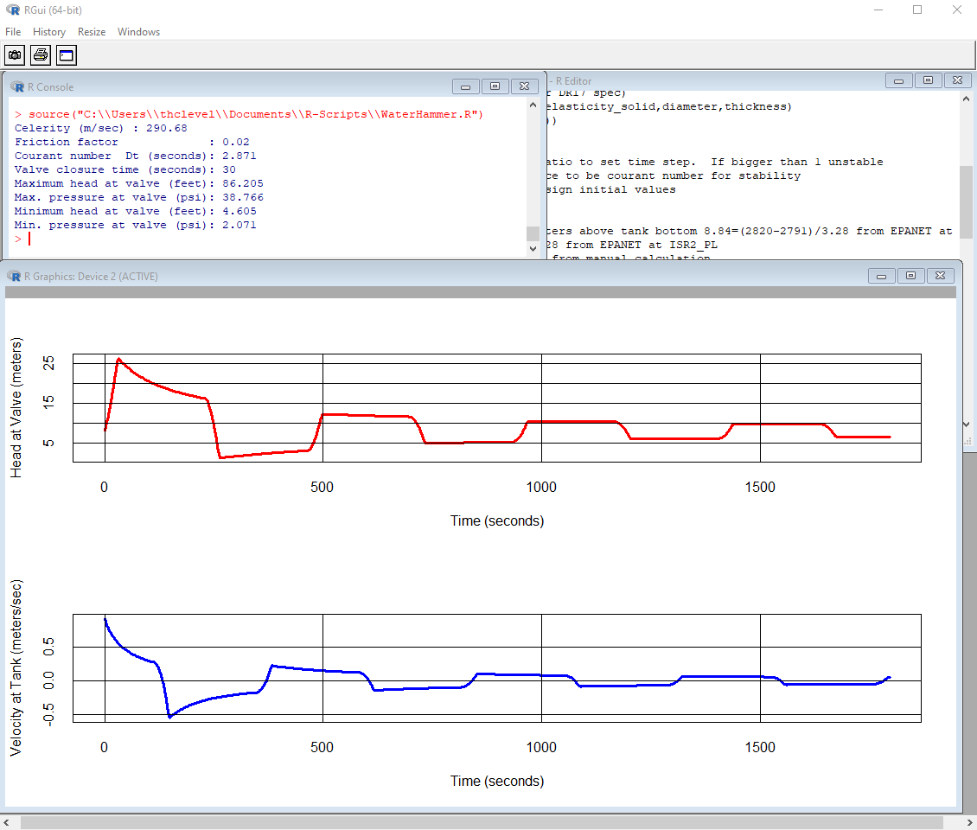
Figure 30. Water Hammer; 30-second shutdown; frictional damping

Case 4. 60 -second shutoff, smooth pipe friction factor

This case assumes a linear shutdown over 30 seconds, the valve pressure ranges from -1 psi to 41 psi using the material properties for DR-17 HDPE. The pressure wave travel time is on the order of 250 seconds to traverse the 21 mile pipeline, roughly 5 miles per minute but is damped by friction (as expected)

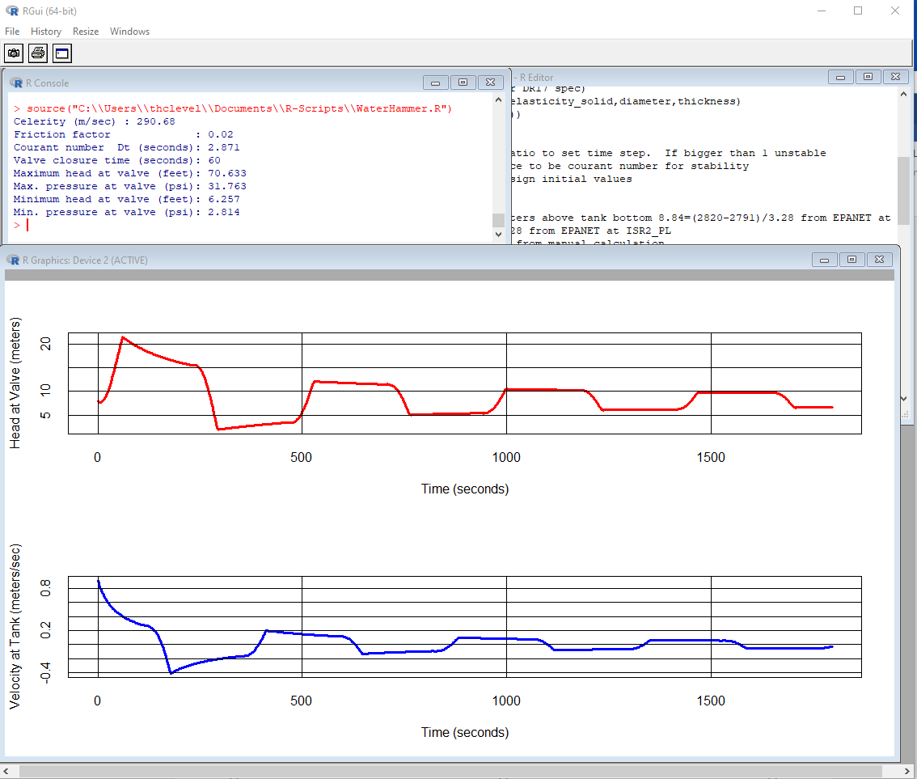
Figure 31 Water Hammer; 60-second shutdown; frictional damping

Conclusions

References

Cleveland, T. G. (2018) “Pipeline Transients — Water Hammer” pp. 141-148 in Fluid Mechanics Computations in R: A Toolkit to Accompany CE 3305 at TTU. Department of Civil, Environmental, and Construction Engineering. http://54.243.252.9/ce-3372-webroot/3-Readings/CFMinR/CFMinR.pdf

Appendix – I Loss Coefficients for Different Materials

Various references were consulted to determine a useful value for HDPE roughness parameter in EPANET including Figure 30, Figure 31, and Figure 32.

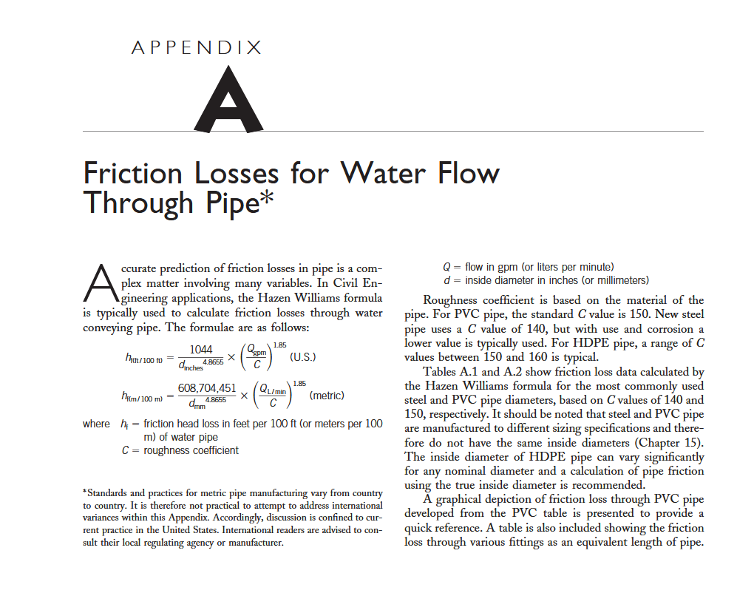
Figure 32. Hazen-Williams Friction Factor for HDPE
(from https://onlinelibrary.wiley.com/doi/pdf/10.1002/9780470168103.app1)

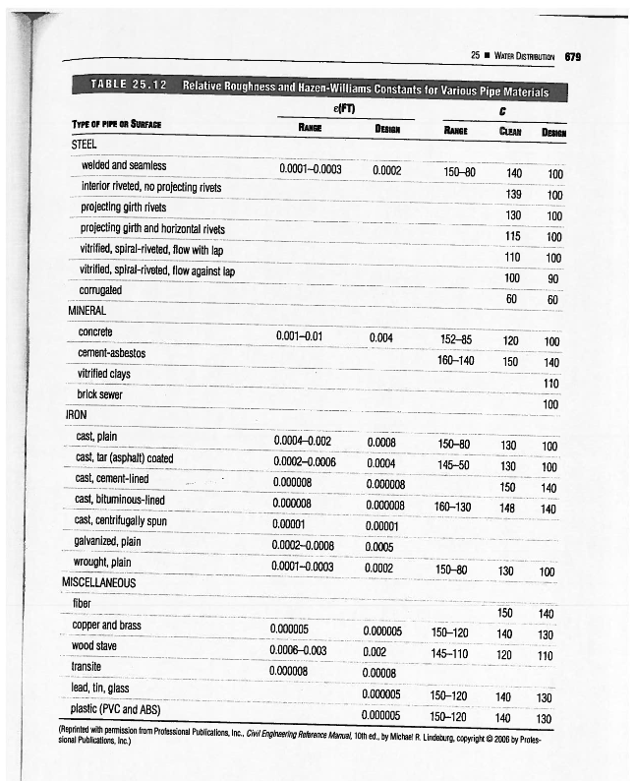
Figure 33. C Values for various materials from: "Water Distribution Systems" in Land Development Handbook, Ed. S.O. Dewberry, Dewberry Inc., McGraw-Hill

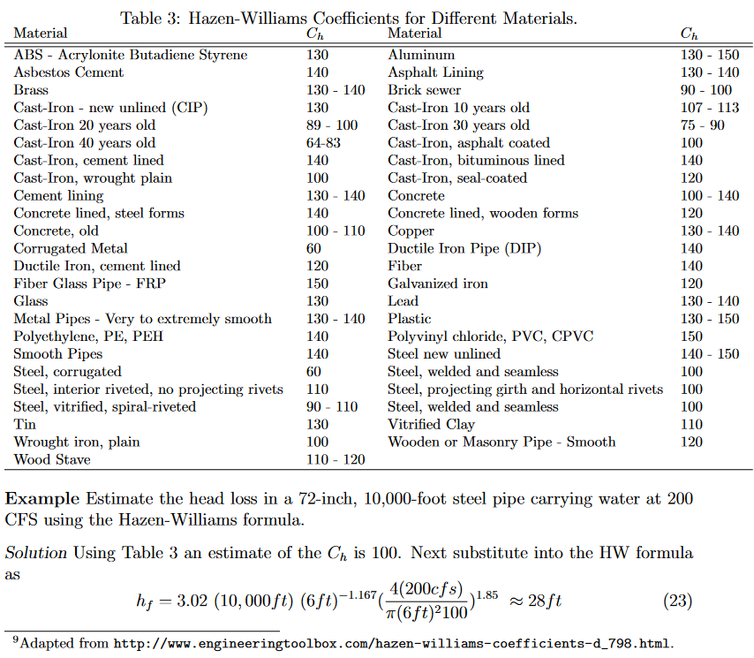
Figure 34. Values of C for various materials from:
(http://54.243.252.9/ce-3372-webroot/3-Readings/HydraulicsNotes/hydraulics-notes-tgc.pdf)

Appendix II - Burst Pressure Guidance for HDPE

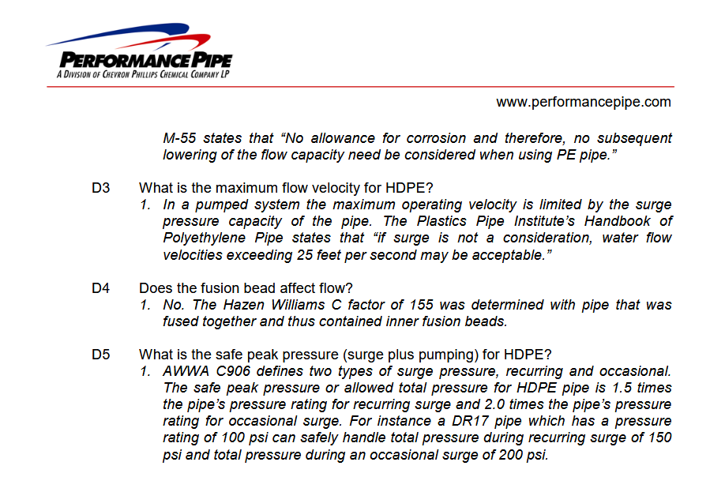
Figure 35. Burst-Pressure Guidance (and another C value) from
https://hdpe.ca/assets/data/technical-data/performance-pipe/FAQ-Municipal-water.pdf

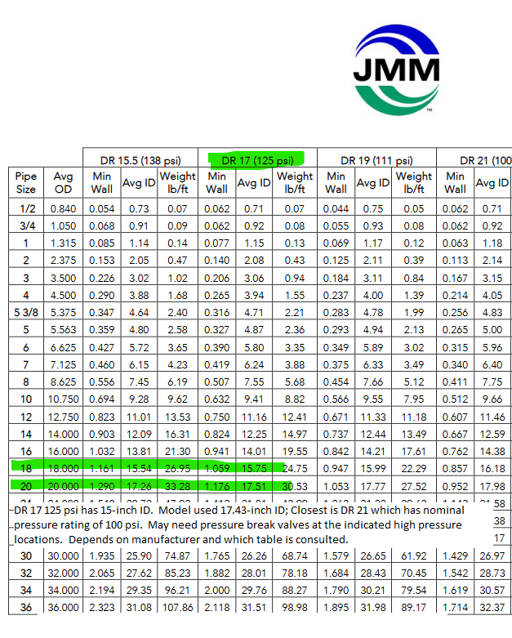
Figure 36. Tabulated HDPE Pressure ratings from https://www.jmeagle.com/sites/default/files/HDPESpecSheet4710%20.pdf

Appendix III – EPANET Input File

[TITLE]

[JUNCTIONS]
;ID Elev Demand Pattern
J1 2604.32 0.00000 ;
J2 2604.32 0.00000 ;
J3 2620.72 0.00000 ;
J4 2607.60 0.00000 ;
J5 2604.32 0.00000 ;
J6 2587.92 0.00000 ;
J7 2591.20 0.00000 ;
J8 2587.92 0.00000 ;
J9 2578.08 0.00000 ;
J10 2581.36 0.00000 ;
J11 2574.80 0.00000 ;
J12 2578.08 0.00000 ;
J13 2578.08 0.00000 ;
J14 2568.24 0.00000 ;
J15 2568.24 0.00000 ;
J16 2574.80 0.00000 ;
J17 2561.68 0.00000 ;
J18 2610.88 0.00000 ;
J19 2614.16 0.00000 ;
J20 2624.00 0.00000 ;
J21 2630.56 0.00000 ;
J22 2656.80 0.00000 ;
J23 2656.80 0.00000 ;
J24 2653.52 0.00000 ;
J25 2666.64 0.00000 ;
J26 2666.64 0.00000 ;
J27 2656.80 0.00000 ;
J28 2660.08 0.00000 ;
J29 2683.04 0.00000 ;
J30 2679.76 0.00000 ;
J31 2699.44 0.00000 ;
J32 2696.16 0.00000 ;
J33 2735.52 0.00000 ;
J34 2732.24 0.00000 ;
J35 2758.48 0.00000 ;
J36 2761.76 0.00000 ;
J37 2765.04 0.00000 ;
J38 2761.76 0.00000 ;
J39 2765.04 0.00000 ;
J40 2771.60 0.00000 ;
J41 2784.72 0.00000 ;
J42 2788.00 0.00000 ;
J43 2781.44 0.00000 ;
J44 2781.44 0.00000 ;
J45 2781.44 0.00000 ;
J46 2781.44 0 ;
J47 2781.44 0 ;
J48 2778.16 0 ;
J49 2774.88 0 ;
J50 2774.88 0 ;
J51 2781.44 0 ;
J52 2791.28 0 ;
J53 2791.28 0 ;
J54 2774.88 0 ;
J55 2784.72 0 ;
J56 2784.72 0 ;
J57 2788 0 ;
J58 2784.72 0 ;
J59 2784.72 0 ;
J60 2781.44 0 ;
J61 2781.44 0 ;
J62 2791.28 0 ;
J63 2774.88 0 ;
J64 2791.28 0 ;
J65 2784.72 0 ;
J66 2797.84 0 ;
J67 2784.72 0 ;
J68 2791.28 0 ;
J69 2791.28 0 ;
J70 2788 0 ;
J71 2797.84 0 ;
J72 2797.84 0 ;
J73 2804.4 0 ;
J74 2801.12 0 ;
J75 2804.4 0 ;
J76 2814.24 0 ;
J77 2797.84 0 ;
J78 2810.96 0 ;
J79 2814.24 0 ;
J80 2810.96 0 ;
J81 2814.24 0 ;
J82 2824.08 0 ;
J83 2781.44 0 ;
WDS-IN 2601.00 2100 2 ;
BOOST_IN 2601 0 ;
1 2604.32 0 ;
TCVTSR1 2601 0 ;

[RESERVOIRS]
;ID Head Pattern
R25W3 2330 ;
R25W5 2330 ;
R25W2 2330 ;
R24W2 2330 ;
R24W3 2330 ;
R24W1 2330 ;
R25W1 2330 ;
R30W1 2330 ;
R30W4 2330 ;
R30W5 2330 ;
R30W6 2330 ;
R30W3 2330 ;
R30W2 2330 ;
R25W4 2330 ;

[TANKS]
;ID Elevation InitLevel MinLevel MaxLevel Diameter MinVol VolCurve Overflow
TSR-1 2601 15 0.0000 30 92 0.0000 ;Terminal Storage (Z=2601.04)
TSR-2 2601 15 0.0000 30 92 0.0000 ;Terminal Storage 2 (Z=2607.6)
ISR-1 2791.00 22.5 15 30 52.0 0.0000 ;Grade 2791
ISR-2 2791.00 15 0 30 52 0.0000 ;

[PIPES]
;ID Node1 Node2 Length Diameter Roughness MinorLoss Status
1 J45 J44 103.75 17.43 150 0.00 OPEN ;
2 J44 J43 63.44 17.43 150 0.00 OPEN ;
3 J43 J42 543.04 17.43 150 0.00 OPEN ;
4 J42 J41 141.37 17.43 150 0.00 OPEN ;
5 J41 J40 12253.62 17.43 150 0.00 OPEN ;
6 J40 J39 555.50 17.43 150 0.00 OPEN ;
7 J39 J38 158.26 17.43 150 0.00 OPEN ;
8 J38 J37 1255.29 17.43 150 0.00 OPEN ;
9 J37 J36 2098.64 17.43 150 0.00 OPEN ;
10 J36 J35 180.96 17.43 150 0.00 OPEN ;
11 J35 J34 5143.43 17.43 130 0.00 OPEN ;
12 J34 J33 154.09 17.43 130 0.00 OPEN ;
13 J33 J32 5444.28 17.43 130 0.00 OPEN ;
14 J32 J31 86.43 17.43 130 0.00 OPEN ;
15 J31 J30 5079.74 17.43 130 0.00 OPEN ;
16 J30 J29 95.38 17.43 130 0.00 OPEN ;
17 J29 J28 3006.91 17.43 130 0.00 OPEN ;
18 J28 J27 235.90 17.43 130 0.00 OPEN ;
19 J27 J26 2175.36 17.43 130 0.00 OPEN ;
20 J26 J25 172.13 17.43 130 0.00 OPEN ;
21 J25 J24 4964.61 17.43 130 0.00 OPEN ;
22 J24 J23 154.06 17.43 130 0.00 OPEN ;
23 J23 J22 204.70 17.43 130 0.00 OPEN ;
24 J22 J21 3800.44 17.43 130 0.00 OPEN ;
25 J21 J20 3851.41 17.43 130 0.00 OPEN ;
26 J20 J19 3178.39 17.43 130 0.00 OPEN ;
27 J19 J18 190.21 17.43 130 0.00 OPEN ;
28 J18 J17 15888.45 17.43 130 0.00 OPEN ;
29 J17 J16 1243.64 17.43 130 0.00 OPEN ;
30 J16 J15 984.75 17.43 130 0.00 OPEN ;
31 J15 J14 11142.98 17.43 130 0.00 OPEN ;
32 J14 J13 1028.97 17.43 130 0.00 OPEN ;
33 J13 J12 1006.01 17.43 130 0.00 OPEN ;
34 J12 J11 12584.41 17.43 130 0.00 OPEN ;
35 J11 J10 110.04 17.43 130 0.00 OPEN ;
36 J10 J9 822.89 17.43 130 0.00 OPEN ;
37 J9 J8 1643.15 17.43 130 0.00 OPEN ;
38 J8 J7 2617.41 17.43 130 0.00 OPEN ;
39 J7 J6 96.86 17.43 130 0.00 OPEN ;
40 J6 J5 2621.34 17.43 130 0.00 OPEN ;
41 J5 J4 933.52 17.43 130 0.00 OPEN ;
42 J4 J3 4425.24 17.43 130 0.00 OPEN ;
43 J3 J2 245.25 17.43 130 0.00 OPEN ;
44 J2 J1 2258.84 18.00 135.0000 0.00 OPEN ;
82 J67 J65 1938.8408 6 150 0 CV ;
83 J65 J64 624.5776 12 150 0 CV ;
84 J64 J62 1602.3456 6 150 0 CV ;
85 J62 J61 359.9144 8 150 0 CV ;
86 J61 J60 34.5056 12 150 0 Open ;
87 J60 J59 6.8552 12 150 0 Open ;
88 J59 J58 9.4136 12 150 0 Open ;
89 J58 J56 2110.2208 12 150 0 CV ;
90 J56 J55 10.2664 12 150 0 Open ;
91 J55 J53 1402.036 12 150 0 CV ;
92 J53 J52 348.992 12 150 0 Open ;
93 J52 J51 795.8264 12 150 0 CV ;
94 J51 J50 949.7568 14 150 0 Open ;
95 J82 J81 2047.1136 6 150 0 CV ;
96 J81 J80 14.7272 12 150 0 Open ;
97 J80 J78 19.2864 12 150 0 Open ;
98 J79 J78 28.8312 6 150 0 Open ;
99 J78 J76 936.9976 6 150 0 CV ;
100 J76 J74 770.7672 6 150 0 CV ;
101 J74 J72 1367.7928 8 150 0 CV ;
102 J72 J71 696.18 8 150 0 CV ;
103 J71 J69 2981.2576 8 150 0 CV ;
104 J69 J61 716.1552 12 150 0 CV ;
105 J77 J76 2322.8632 12 150 0 CV ;
106 J73 J72 2085.5552 6 150 0 CV ;
107 J66 J65 1302.1928 6 150 0 CV ;
108 J68 J64 1108.4432 6 150 0 CV ;
109 J63 J62 1094.4048 6 150 0 CV ;
110 J83 J52 951.9872 12 150 0 CV ;
111 J54 J53 1159.2832 12 150 0 CV ;
112 J57 J56 92.824 12 150 0 Open ;
113 J70 J71 27.6504 12 150 0 Open ;
45 J75 J74 25.68 12 150 0 Open ;
52 J50 J49 13.67 14 150 0 Open ;
53 J49 J48 16.695 14 150 0 Open ;
54 J48 J47 114.70 14 150 0 Open ;
V2ISR1 J47 ISR-1 27.24 14 150 0 CV ;
ISR2_PL ISR-2 J46 20.172 17.43 150 0 CV ;
56 J46 J45 22.96 17.43 150 0 Open ;
ISR_1_2 ISR-1 ISR-2 87.32 17.43 150 0 CV ;
TSR_OUT TSR-2 BOOST_IN 77.61 17.43 130 0 Open ;Connector to Existing System
TSR_INPUT 1 TSR-1 20.00 17.43 130 0 Open ;
TSR_TRAN TCVTSR1 TSR-2 60.37 17.43 130 0 Open ;
FCV_TSR J1 1 1000 18 100 0 Open ;
48 TSR-1 TCVTSR1 10 18 100 0 CV ;

[PUMPS]
;ID Node1 Node2 Parameters
P-24W2 R24W2 J54 HEAD 8FAHC ;
P-25W2 R25W2 J63 HEAD 8FAHC ;
P-25W5 R25W5 J66 HEAD 8FAHC ;
P-25W3 R25W3 J67 HEAD 8FAHC ;
P-25W4 R25W4 J68 HEAD 8FAHC ;
P-30W2 R30W2 J73 HEAD 8FAHC ;
P-30W3 R30W3 J75 HEAD 8FAHC ;
P-30W6 R30W6 J82 HEAD 8FAHC ;
P-30W5 R30W5 J78 HEAD 8FAHC ;
P-30W4 R30W4 J77 HEAD 8FAHC ;
P-30W1 R30W1 J70 HEAD 8FAHC ;
P-25W1 R25W1 J69 HEAD 8FAHC ;
P-24W1 R24W1 J57 HEAD 8FAHC ;
P-24W3 R24W3 J83 HEAD 8FAHC ;
49 BOOST_IN WDS-IN HEAD BOOST_TSR SPEED 1.0 ;

[VALVES]
;ID Node1 Node2 Diameter Type Setting MinorLoss

[TAGS]

[DEMANDS]
;Junction Demand Pattern Category

[STATUS]
;ID Status/Setting
P-24W2 Closed
P-25W2 Closed
P-25W5 Closed
P-25W3 Closed
P-25W4 Closed
P-30W2 Closed
P-30W3 Closed
P-30W6 Closed
P-30W5 Closed
P-30W4 Closed
P-30W1 Closed
P-25W1 Closed
P-24W1 Closed
P-24W3 Closed

[PATTERNS]
;ID Multipliers
;12-hour step demand changes
2 0.1 0.1 0.1 0.1 0.1 0.1
2 1.0 1.0 1.0 1.0 1.0 1.0
2 1.0 1.0 1.0 1.0 1.0 1.0
2 1.0 0.1 0.1 0.1 0.1 0.1
;Constant Pattern (Same as Steady Flow Model)
1 1 1 1 1 1 1
1 1 1 1 1 1 1
1 1 1 1 1 1 1
1 1 1 1 1 1 1
;Generic Pattern Max Well Flow at Hour 0800 - Use 300 gpm as base
4 1 1 2 2.5 3.5 4.5
4 6 7 6 4.5 3.5 2.5
4 1.5 1 1.5 2.5 3.5 4
4 5 4 3.5 2.5 1.5 0.9

[CURVES]
;ID X-Value Y-Value
;PUMP: PUMP: 8FAHC 17-stage turbine lift pump (at wellhead)
8FAHC 0 652
8FAHC 60 648
8FAHC 90 632
8FAHC 120 606
8FAHC 150 557
8FAHC 180 484
8FAHC 220 404
;PUMP: PUMP: Booster Station TSR into WDS
BOOST_TSR 0 100
BOOST_TSR 2100 70
BOOST_TSR 4000 6
;PUMP: PUMP: Wellhead Booster
WB 0 812
WB 112 717
WB 168 485
;PUMP: PUMP: BoosterStationISRExit
BOOST_ISR 0 120
BOOST_ISR 2100 114
BOOST_ISR 4200 99
;PUMP: PUMP: BoosterStation-Intermediate
BOOST_JP16 0 55
BOOST_JP16 2100 52
BOOST_JP16 4200 42

[CONTROLS]

[RULES]
RULE KEEPISR1FULL
IF TANK ISR-1 LEVEL < 27
THEN PUMP P-24W2 STATUS IS OPEN
AND PUMP P-24W3 STATUS IS OPEN
AND PUMP P-24W1 STATUS IS OPEN
AND PUMP P-25W2 STATUS IS OPEN
AND PUMP P-25W5 STATUS IS OPEN
AND PUMP P-30W3 STATUS IS OPEN
AND PUMP P-30W4 STATUS IS OPEN
AND PUMP P-30W5 STATUS IS OPEN
AND PUMP P-25W1 STATUS IS OPEN
AND PUMP P-30W6 STATUS IS OPEN
AND PUMP P-30W2 STATUS IS OPEN
AND PUMP P-25W4 STATUS IS OPEN
AND PUMP P-25W3 STATUS IS OPEN
AND PUMP P-30W1 STATUS IS OPEN

RULE STOPISR1FILL
IF TANK ISR-1 LEVEL > 29
THEN PUMP P-24W2 STATUS IS CLOSED
AND PUMP P-24W3 STATUS IS CLOSED
AND PUMP P-24W1 STATUS IS CLOSED
AND PUMP P-25W2 STATUS IS CLOSED
AND PUMP P-25W5 STATUS IS CLOSED
AND PUMP P-30W3 STATUS IS CLOSED
AND PUMP P-30W4 STATUS IS CLOSED
AND PUMP P-30W5 STATUS IS CLOSED
AND PUMP P-25W1 STATUS IS CLOSED
AND PUMP P-30W6 STATUS IS CLOSED
AND PUMP P-30W2 STATUS IS CLOSED
AND PUMP P-25W4 STATUS IS CLOSED
AND PUMP P-25W3 STATUS IS CLOSED
AND PUMP P-30W1 STATUS IS CLOSED

RULE STOPTSR2OVERFILL
IF TANK TSR-2 LEVEL > 29.5
THEN CV TSR_TRAN STATUS IS CLOSED

RULE KEEPTSR2FILLED
IF TANK TSR-2 LEVEL < 10.0
THEN CV TSR_TRAN STATUS IS OPEN

RULE STOPTSR1OVERFILL
IF TANK TSR-1 LEVEL > 29.5
THEN PIPE TSR_INPUT STATUS IS CLOSED

RULE KEEPTSR1FILLED
IF TANK TSR-1 LEVEL < 10.5
THEN PIPE TSR_INPUT STATUS IS OPEN

[ENERGY]
Global Efficiency 75
Global Price 0
Demand Charge 0

[EMITTERS]
;Junction Coefficient
J1 0.00
J2 0.00
J3 0.00
J4 0.00
J5 0.00
J6 0.00
J7 0.00
J8 0.00
J9 0.00
J10 0.00
J11 0.00
J12 0.00
J13 0.00
J14 0.00
J15 0.00
J16 0.00
J17 0.00
J18 0.00
J19 0.00
J20 0.00
J21 0.00
J22 0.00
J23 0.00
J24 0.00
J25 0.00
J26 0.00
J27 0.00
J28 0.00
J29 0.00
J30 0.00
J31 0.00
J32 0.00
J33 0.00
J34 0.00
J35 0.00
J36 0.00
J37 0.00
J38 0.00
J39 0.00
J40 0.00
J41 0.00
J42 0.00
J43 0.00
J44 0.00
J45 0.00
J46 0.00
J47 0.00
J48 0.00
J49 0.00
J50 0.00
J51 0.00
J52 0.00
J53 0.00
J54 0.00
J55 0.00
J56 0.00
J57 0.00
J58 0.00
J59 0.00
J60 0.00
J61 0.00
J62 0.00
J63 0.00
J64 0.00
J65 0.00
J66 0.00
J67 0.00
J68 0.00
J69 0.00
J70 0.00
J71 0.00
J72 0.00
J73 0.00
J74 0.00
J75 0.00
J76 0.00
J77 0.00
J78 0.00
J79 0.00
J80 0.00
J81 0.00
J82 0.00
J83 0.00

[QUALITY]
;Node InitQual

[SOURCES]
;Node Type Quality Pattern
R30W5 CONCEN 1000 1

[REACTIONS]
;Type Pipe/Tank Coefficient

[REACTIONS]
Order Bulk 1
Order Tank 1
Order Wall 1
Global Bulk 0
Global Wall 0
Limiting Potential 0
Roughness Correlation 0
[MIXING]
;Tank Model

[TIMES]
Duration 196:00
Hydraulic Timestep 0:01
Quality Timestep 0:05
Pattern Timestep 1:00
Pattern Start 0:00
Report Timestep 1:00
Report Start 0:00
Start ClockTime 00:00
Statistic NONE

[REPORT]
Status Full
Summary No
Page 0

[OPTIONS]
Units GPM
Headloss H-W
Specific Gravity 1.0
Viscosity 1.0
Trials 40
Accuracy 0.001
CHECKFREQ 2
MAXCHECK 10
DAMPLIMIT 0
Unbalanced Continue 10
Pattern 1
Demand Multiplier 1.0
Emitter Exponent 0.5
Quality None mg/L
Diffusivity 1.0
Tolerance 0.01

[COORDINATES]
;Node X-Coord Y-Coord
J1 641814.170 3474046.260
J2 642174.170 3473459.180
J3 642174.170 3473384.410
J4 643500.630 3473137.950
J5 643553.250 3473417.650
J6 644341.480 3473285.740
J7 644342.700 3473256.240
J8 645140.640 3473265.010
J9 645633.590 3473175.790
J10 645803.270 3472990.990
J11 645830.570 3472971.490
J12 648271.440 3470011.340
J13 648441.120 3469755.840
J14 648563.990 3469467.190
J15 649669.840 3466254.960
J16 649794.670 3465981.910
J17 650020.910 3465677.650
J18 653391.120 3462198.220
J19 653410.620 3462143.610
J20 654065.940 3461429.780
J21 654081.540 3460255.670
J22 654916.300 3459452.120
J23 654916.300 3459389.710
J24 654951.400 3459358.500
J25 654970.910 3457845.030
J26 654931.900 3457809.920
J27 654943.600 3457146.800
J28 654959.200 3457076.590
J29 654970.910 3456159.920
J30 654993.330 3456141.400
J31 655012.840 3454592.820
J32 654996.260 3454572.340
J33 655013.810 3452912.590
J34 655048.920 3452881.380
J35 655060.620 3451313.300
J36 655021.610 3451274.290
J37 655033.320 3450634.570
J38 654842.180 3450303.010
J39 654853.880 3450256.200
J40 655002.110 3450174.290
J41 655061.050 3446438.890
J42 655033.460 3446405.780
J43 654867.920 3446403.020
J44 654854.390 3446389.200
J45 654856.490 3446357.640
J46 654856.060 3446350.650
J47 654834.150 3446326.550
J48 654799.220 3446324.930
J49 654794.740 3446322.510
J50 654792.930 3446318.750
J51 654800.190 3446033.000
J52 654748.750 3445795.890
J53 654726.120 3445691.920
J54 654380.690 3445766.720
J55 654635.590 3445274.170
J56 654635.150 3445271.070
J57 654663.140 3445266.870
J58 654539.420 3444634.870
J59 654538.650 3444632.110
J60 654537.540 3444630.340
J61 654530.680 3444622.370
J62 654459.410 3444538.930
J63 654205.780 3444755.720
J64 654142.030 3444167.550
J65 654018.310 3444022.800
J66 653716.430 3444280.640
J67 653634.310 3443573.400
J68 654399.140 3443948.240
J69 654697.400 3444481.380
J70 655604.610 3444406.810
J71 655602.550 3444398.640
J72 655804.400 3444333.010
J73 655608.480 3443728.110
J74 656201.180 3444204.710
J75 656204.150 3444211.960
J76 656416.550 3444110.710
J77 656700.530 3444759.470
J78 656678.430 3443996.590
J79 656685.690 3444001.540
J80 656683.050 3443992.960
J81 656684.370 3443988.670
J82 656637.860 3443366.290
J83 655032.550 3445735.080
WDS-IN 641822.894 3474128.901
BOOST_IN 641833.841 3474121.635
1 641812.268 3474061.294
TCVTSR1 641842.722 3474060.143
R25W3 653629.234 3442168.042
R25W5 652658.601 3445169.196
R25W2 653116.026 3445738.188
R24W2 653673.861 3446385.277
R24W3 655793.635 3446061.733
R24W1 655403.151 3445381.173
R25W1 655235.800 3444968.375
R30W1 655603.971 3444934.905
R30W4 657054.343 3445570.837
R30W5 657902.253 3444008.898
R30W6 656630.388 3442123.415
R30W3 656920.463 3445916.695
R30W2 655559.345 3442112.258
R25W4 654443.674 3442156.885
TSR-1 641832.240 3474054.830
TSR-2 641885.570 3474083.130
ISR-1 654842.390 3446327.570
ISR-2 654857.987 3446348.849

[VERTICES]
;Link X-Coord Y-Coord
ISR_1_2 654850.419 3446328.391
ISR_1_2 654856.065 3446333.768

[LABELS]
;X-Coord Y-Coord Label & Anchor Node
654988.295 3446320.946 "Empty Tank Elev = 2791"
643070.753 3474498.797 "Empty Tank Elev = 2601"

[BACKDROP]
DIMENSIONS 641069.852 3441832.292 657444.848 3475580.259
UNITS None
FILE
OFFSET 0.00 0.00

[END]

Appendix IV - Water Hammer R Script
The script below is adapted from:

Cleveland, T. G. (2018) “Pipeline Transients — Water Hammer” pp. 141-148 in Fluid Mechanics Computations in R: A Toolkit to Accompany CE 3305 at TTU. Department of Civil, Environmental, and Construction Engineering. http://54.243.252.9/ce-3372-webroot/3-Readings/CFMinR/CFMinR.pdf

It is intended to be run in an ordinary R environment. It was developed for pedagogical purposes, and at best is an approximation of general characteristics of system behavior.

###################################################################################
#Pipeline Transients using Explicit Finite Differences (linearized formulation) #
###################################################################################
rm(list=ls()) # deallocate memory
######## prototype functions ###############
celerity <- function(density,elasticity_fluid,elasticity_solid,diameter,thickness){
temp1<- 1.0/elasticity_fluid
temp2<- diameter/(elasticity_solid*thickness)
temp3<- temp1 + temp2
temp4<- density*temp3
celerity <- sqrt(1.0/temp4)
return(celerity)
}
### Simulator Code ##############################
# Simulation Conditions (this section could be replaced with an input file)
# fluid properties
density <- 1000 #kg/m^3
elasticity_fluid <- 2.0e09 #Pa (2.0 GPa)
elasticity_solid <- 1.5e09 #Pa (1.5 GPa)
diameter <- 0.4572 #m (18 inches nominal for DR17 spec)
thickness <- 0.02689 #m (1.059 inhces for DR17 spec)
cc <- celerity(density,elasticity_fluid,elasticity_solid,diameter,thickness)
message("Celerity (m/sec) : ",round(cc,3))
# simulation properties
deltax <- 845.125 #meters (60 elements)
courantRatio <- 0.9876 #select courant ratio to set time step. If bigger than 1 unstable
deltat <- courantRatio*(deltax/cc) # force to be courant number for stability
# allocate head and velocity vectors, assign initial values
elevValve = 793 #meters
elevTank = 850.9 #meters
startHead <- 859-elevTank #total head meters above tank bottom 8.84=(2820-2791)/3.28 from EPANET at ISR_2
startVelo <- 0.92 #meters/second 3.02/3.28 from EPANET at ISR2_PL
pipeLength <- 33805 #meters 21*5280/3.28 from manual calculation
closeTime <- 0 #seconds
simulationDuration <- 1800 #seconds
frictionFactor <- 0.02 #Moody Chart smooth pipe should be OK for HDPE; Re = 50,000
cellCount <- as.integer((pipeLength/deltax)+1)
head <- numeric(0)
velocity <- numeric(0)
for(i in 1:cellCount){
head[i]<-startHead
velocity[i]<-startVelo
}
###################################################################################
# useful constants
dtdx <- deltat/deltax
cc2g <- cc^2/9.81
do2 <- 1.0/(diameter*2) #used when friction included
#### force full-open velocity to agree with startVelo #######
c_factor = sqrt(2*9.8*(head[1]))/startVelo # used to simulate valve closure over finite time.
#c_factor = 1.0
##############################################
# allocate some output vectors
etime<-numeric(0)
headvalve<-numeric(0)
velocitytank<-numeric(0)
# simulation values
etime[1] <- 0
headvalve[1] <- head[cellCount]
velocitytank[1] <-velocity[1]
######################
# Time Stepping Loop #
######################
maxiter <- 1+simulationDuration/deltat
for(itime in 2:maxiter){
etime[itime]<-etime[itime-1]+deltat
###### valve closure model ##############
closeRatio <- 1-(etime[itime]/closeTime)
if(closeRatio >= 0.0){
velocity[cellCount] <- closeRatio*sqrt(2*9.8*(head[1]))/c_factor
}
else{
velocity[cellCount] <- 0
}
####### update velocity #########
for(i in 1:(cellCount-1)){
friction <- frictionFactor*velocity[i]*abs(velocity[i])*do2
velocity[i]=velocity[i]-9.81*dtdx*(head[i+1]-head[i])-deltat*friction
}
####### update head #########
for(i in 2:(cellCount)){
head[i]=head[i]-cc2g*dtdx*(velocity[i]-velocity[i-1])
}
headvalve[itime]<-head[cellCount]
velocitytank[itime] <-velocity[1]
}
# report results
if(frictionFactor <= 0.0001){
message("Frictionless Simulation - Expect Square Wave")
} else{
message("Friction factor : ",round(frictionFactor,3))
}
########################
message("Courant number Dt (seconds): ",round(deltat,3))
message("Valve closure time (seconds): ",round(closeTime,3))
message("Maximum head at valve (feet): ",round(3.28*(max(headvalve)),3))
message("Max. pressure at valve (psi): ",round(14.75*(max(headvalve))/10,3))
message("Minimum head at valve (feet): ",round(3.28*(min(headvalve)),3))
message("Min. pressure at valve (psi): ",round(14.75*(min(headvalve))/10,3))
# plot results
par(mfrow=c(2,1))
plot(etime,headvalve,type="l",pch=19,lwd=3,tck=1,xlab="Time (seconds)",ylab="Head at Valve (meters)",col="red")
plot(etime,velocitytank,type="l",pch=19,lwd=3,tck=1,xlab="Time (seconds)",ylab="Velocity at Tank (meters/sec)",col="blue")
#
###########

The Shuttle Radar Topography Mission (SRTM) was flown aboard the space shuttle Endeavour February 11-22, 2000. The National Aeronautics and Space Administration (NASA) and the National Geospatial-Intelligence Agency (NGA) participated in an international project to acquire radar data which were used to create the first near-global set of land elevations. Endeavour orbited Earth 16 times each day during the 11-day mission, completing 176 orbits. SRTM successfully collected single-pass interferometry radar data over 80% of the Earth's land surface between 60° north and 56° south latitude with data points posted every 1 arc-second (approximately 30 meters).
QEPANET does not entirely work with recent QGIS; however it does work well enough to extract spatial coordinates and elevations for “node-type” objects, so it was used herein to obtain coordinates and elevations for use in the EPANET model.
A reasonable value for new pipe of various materials, HDPE probably has a higher value of around 150, so the 130 is conservative to some extent. A couple of references for loss coefficients are attached in Appendix I
These two tanks are located in the north portion of the maps above; on the QGIS map the northern tank icon is apparent. The tank icon at the southern part of the model are the two ISR tanks.
Errors stop program execution and need immediate attention. Warnings are notifications to the modeler that an unusual condition exists.
Nearly all the pipelines connecting pumps to the collection tanks have check valves – hence stopping a pump usually causes the program to close the immediate downstream check valve. This conceptualization was employed to prevent computed backward flows.
Recall that all wells are on/off in these initial simulations.

