PE-1

Exhibits for project 1.
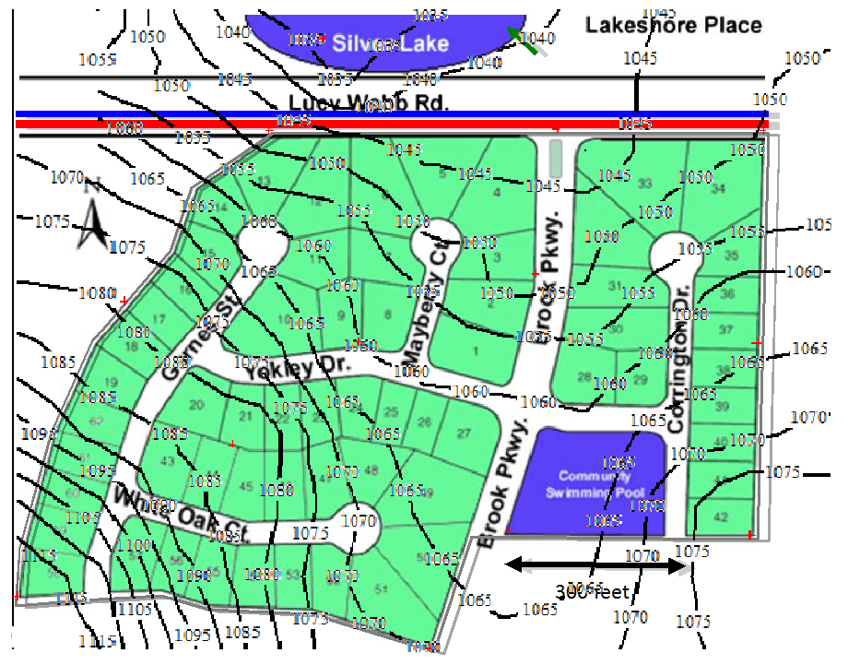Figure 1: Basemap with land-surface elevation contour map overlay.

Figure 1 is a basemap with the land-surface elevation contour map overlain on the basemap. The red markers are the locations of the elevations provided in the project data in Table 1.

Figure 2: Basemap with elevations equal to land surface minus 3 feet.
Figure 2 is a basemap with the elevation contour map of land surface elevation minus 3 feet overlain on the basemap. The red markers are the locations of the elevations provided in the project data in Table 1. This map represents the upper elevations for laterals as per design guidance …....

