CIVE 7332 Spring 1999 Project#3

A 300-ft thick aquifer is used for water supply. The aquifer is also under consideration as a disposal field for treated waste water (aquifer-storage-recovery), where the filtration and dilution capacity of the aquifer will be used to receive the waste water for intentional re-use. (In the current global regulatory environment intentional re-use is not allowed, but as population increases, society must consider this option to supply water demands).

Figure 1 is a plan-view representation of a conceptual model of the aquifer.

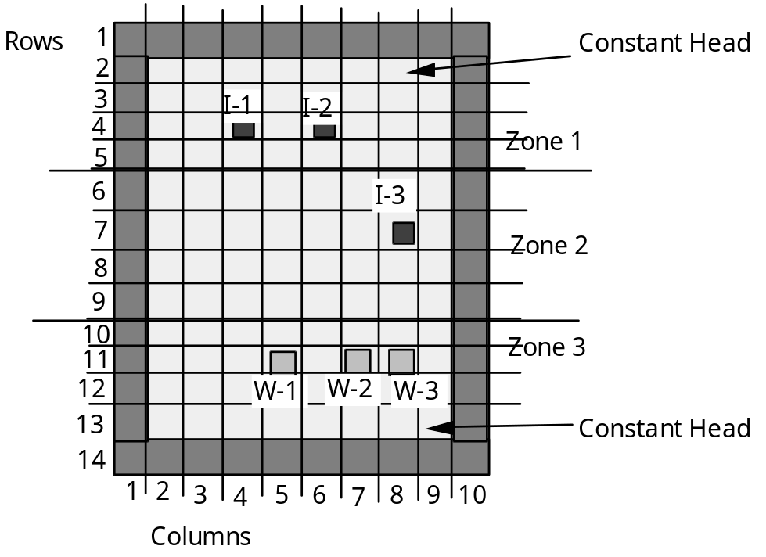

Figure 1. Plan-view of aquifer conceptual model.
Each cell is 1500 ft x 1500 ft

The northern constant head boundary is set at h=600 ft. The southern edge constant boundary varies from 540 ft to 520 ft as one traverses from east to west. Three water supply wells, W-1, W-2, and W-3 are already in service. Hydrologic data suggests that the aquifer system has three distinct zones with different hydraulic characteristics. These characteristics are listed in Table 1.

Table 1. Hydraulic Characteristics of Aquifer

Zone | K (cm/sec) | porosity
1 | 0.472 | 0.21
2 | 0.157 | 0.20
3 | 0.047 | 0.20

The longitudinal dispersivity has been estimated as α_{L}=50 m and the transverse dispersivity has been estimated at α_{T}=20 m. The drinking water wells supply water at the rates shown in Table 2.

Table 2. Drinking Water Supply

Well | Pumping Rate (cfs)
W-1 | 30.0
W-2 | 9.0
W-3 | 9.0

The proposed re-use scheme will inject tracer-labeled waste-water into the aquifer into any of the three injection sites, I-1, I-2, or I-3. The goal is for the concentration of a non-toxic tracer to never exceede 250 mg/L at the water production wells. The tracer is added just before injection as a dilution indicator so that the water utility can shut down a well if the water in that well is not sufficiently diluted (much like the tracer added to natural gas to detect leaks). The tracer concentration at the injection point is 1000 mg/L (the operation goal is the dilute the waste water four time before it reaches the drinking water wells).

Construct a computer model to answer the following questions.

(1) Can 39 cfs of waste water be injected at I-3 and meet the water quality goal (4:1 dilution at drinking water wells)?

(2) Is it possible to inject more waste water (higher flow or different location)?

(3) Find the maximum volume that can be injected (at any or all of the three sites) and meet the water quality goal - this is the "regulatory assimilative capacity of the system." Does this volume exceed the drinking water demand currently satisfied by the three wells?

(4) Assume that instead of a non-toxic tracer, the injection water concentration represents some particular water quality parameter. Assuming that the injection rate never exceedes the demand rate, what is the maximum waste load (mg/sec) that can be put into the aquifer and meet the raw water quality goal?

A sample input file can be downloaded from the server: cleveland4.cive.uh.edu
Use ftp to connect as: user = anonymous; password = your_e_mail_address.
file is in directory: ftp7332
file name is: moc08.inp
this server is usually operating during daytime hours, sometimes overnight.

