Transportation of Water: Mississippi River Basin to Llano Estacado

Amanda Frazier

Dr. Cleveland

CE 3372-002

30 November 2016

*Introduction*

The Llano Estacado Regional Water Plan Water Importation Evaluation previously analyzed the viability of transporting water in an open channel system from the Mississippi River Basin to the Llano Estacado region in the 1980s (2). The purpose of this evaluation was to replace the use of the High Plains Ogallala Aquifer in irrigation to allow the aquifer to have time to recharge the water levels. At the time the idea of long distance water transport was only recently successfully built and used in the Central Valley Water Project in California, where many of the design plans and assumptions were adopted. Two plans were created, one that analyzed a path between the Red River in Arkansas and the Llano Estacado region and a longer system that analyzed a path between the White River in Arkansas and the Llano Estacado region with an additional extension to the Sabine River in Texas. Figure 1 shows the water path of the system. This report analyzes the viability of using a pressurized pipe system instead of an open channel system to meet similar water demands for the longer system.

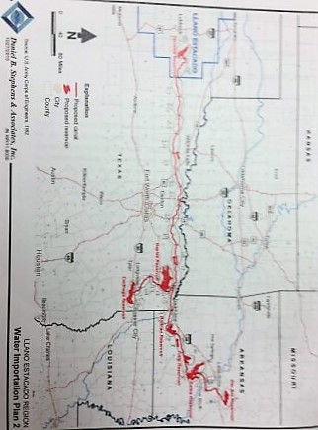

Figure 1: Plan 2 of the Water Importation Evaluation

*Design Considerations for Pressurized Water Transportation*

The path of the water transportation system was taken from the Water Importation Evaluation to create a pressurized water transportation model. The system is almost entirely uphill, requiring many lift stations to overcome about 2,830 feet. Using pressurized pipes eliminates many of the drawbacks that arise from open channel systems, notably the infiltration of water into the ground and the evaporation of water into the air, which means less water is needed to meet the same demands at the end of the system. However, pressurized pipes have some design considerations that are not considered in the design of open channel systems, such as analyzing the high and low pressure locations inside of the pipes.

*Low and High Pressure Points.* Pressures within a pipe must stay within the available pressure limits of the pipe material. For low pressure, -5 psi was chosen as the minimum limit before crushing occurs (7). A pipe that had pressures that exceeded the material allowance is shown in Figure 2 (3). If this occurs along a pipe the entire system has failed and must be shut off.

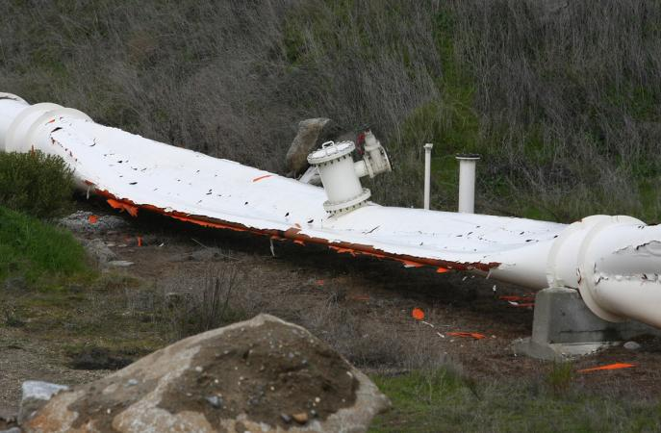

Figure 2: Crushed Pipe along Folsom Line

High pressure points can be equally as important, causing problems from leaking to busts in the pipe. Usually these failures occur at the junction fittings, and while it does not always cause an immediate system failure it does cause very high maintenance costs. For this design, a pressure of 100 psi was chosen as the maximum pressure limit. One solution for high pressure locations is to add a pressure release valve, which allows pressure out of the system once it reaches a certain pressure limit without allowing pressure into the system if the pressure decreases. Ironically, a pressure release valve is also shown in Figure 2. Another solution for high pressure locations is the use of a surge tank, which uses pressurized air over the water to regulate the pressures, especially in cases with rapidly changing pressures.

*Lift Stations.* Small pipes along the sides of the system are used to fill the larger pipes to create a pressurized system allowing the pumps to work correctly. The design pumps were modeled from the South Bay pumping plant, which has nine pumps in parallel pumping water from the Bethany Reservoir along the California Aqueduct. Each lift station in the model is equivalent to three South Bay lift stations, and has a normal static head of 566 feet, a total design flow of 960 cfs, and a total static head of about 900 feet. The details of the South Bay pumping plant were provided by the South Bay Aqueduct article (4). This data can be used to create a pump curve as shown in Figure 3. To reach the flow requirements at the Terminal reservoir 35 lift stations were required.

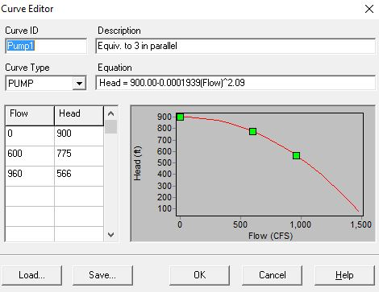

Figure 3: Generated Pump Curve for Lift Stations

*Design Model for Pressurized Water Transportation*

To create a model to show the pressurized water distribution system, the topographic information and distances must first be found. The topographic map can be added to the program and the elevations at each junction interpolated. Each junction is placed 10 miles apart, with four pipes running parallel along the path. The diameter of all pipes is 12 feet, and due to such large pressurized pipe sizes the construction of the pipes should be steel-lined concrete (5). The seven reservoirs are located as specified in the Water Importation Evaluation, and lift stations added where necessary. The total power required from each lift stations is 63,000 kW-hrs (4).

*Model Preparation.* Most of the topographic information was gathered using Google earth and the pathways provided by the Water Importation Plan. The path tool in Google earth collected many points along the pipe system that showed the longitude, latitude, and altitude values, and this information was converted into the necessary format to use in QuikGrid using a TCX converter program. QuikGrid uses the data to create a topographic map that clearly shows the elevations along the entire path of the pipe system, which can be added as a background in the EPANET program. The EPANET program is able to model complex pressurized pipe systems for water transportation and distribution. The topographic map is shown in Figure 4. The Google earth program measures the elevations in meters rather than in feet, which is what the EPANET model is set up to use, so after interpolating the junction and reservoir elevations the values must be converted to feet. The distances between the locations were also found using the Google earth path tool.

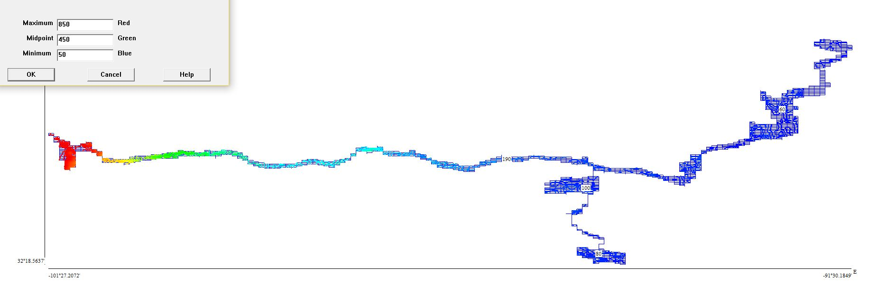

Figure 4: Topographic Map of Flow Path

*Testing the Model.* With a finished model the testing can begin. The first correction to the system was the number of lift stations needed to lift the water from the start to the end of the path. It was found that a minimum of seven lift stations were needed to overcome the elevation difference. This produced a final flow of 26.76 cfs, which is far below the minimum target flow of 2,140 cfs. More pumps were added to raise the flow rate, but the pumps were not able to raise the flow over 240 cfs. Therefore, more pipes were added in parallel. This multiplies the flow rates into ranges closer to the discharge goals, and then pumps were added to the system to adjust the values further. The last step was to check the pressures at every junction to make sure it stays within the design parameters of -5 psi and 350 psi. Often the junction immediately preceding a lift station was too low, and the junction immediately following a lift station was too high. This was fixed by spacing the stations closer together.

*Final Design*. The final design produced a total flow of 3,526.48 cfs, which was well above the target amount. 35 lift stations were necessary to mostly overcome the pressure limitations, however low pressure points were present before many of the pumps in the Terminal-Naples reach. This is shown in Figure 5. The dark blue locations represent the low pressure locations, and there are no locations that exceed the red high pressure limits. To eliminate the high pressure points in the system a

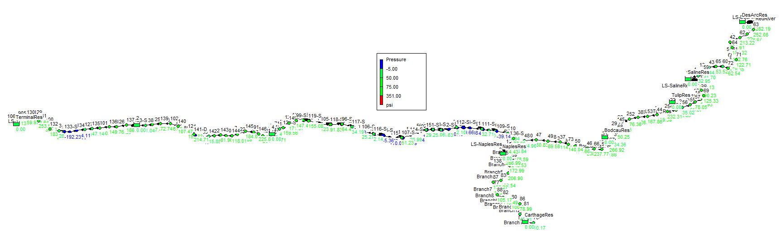

Figure 5: Pressure Design

In two locations, the pressure was far above the accepted limits. This problem was fixed using air gapping, with the high pressure water discharging into a tank that is open to the atmosphere and a pump that pushes water into the following pipe. Figure 6 shows the details of this method (1). This process allows very large controlled pressure drops.

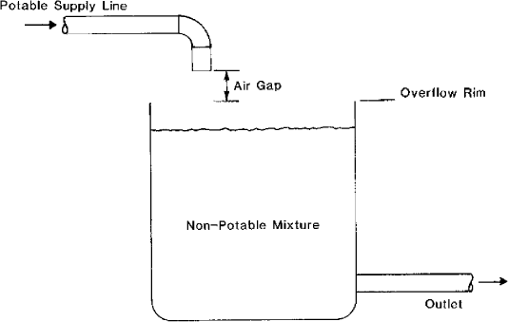

Figure 6: Air Gapping

*Effectiveness of the Water Transportation*

While the model can move large quantities of water across the long distance, the pressures are particularly difficult to regulate between the Terminal reservoir and the Naples reservoir due to the very large elevation difference over a relatively short distance. This means that there is a higher cost for maintenance to monitor the low and high pressure locations. The pressurized pipe system is effective at meeting the design criteria for the minimum flow, but would not be feasible to meet the maximum open channel flow value of over 13,000 cfs.

*Costs of the Water Transportation*

Energy needed compared to production worldwide. The total length of the system is 1200 miles. A reasonable approximation for construction cost is about $2 million per mile, not including acquiring the land, which gives a total construction cost of $2.4 billion. A reasonable cost for the construction of each of the lift stations is approximately $1 million. With 35 design lift stations, each with 3 representative lift stations, the cost is $105 million. The total construction cost comes out to be about $2.51 billion. The total electricity used for all lift stations is 2,205 MW, and with the assumption that the pumps have consistent energy consumption over time this converts to 2,205 MW-hr. In Texas, the average cost of electricity is $0.1094 per KW-hr which means the electricity cost of the lift stations is $241.2 million (8). The total energy produced by wind in Texas for 2014 was about 39 million MW-hrs, which means nearly 16 percent of the total electricity required could be provided by wind power (6). During the 50 year lifetime of the system, the maintenance costs can be assumed to be equivalent to rebuilding the system three times. Together, this amounts to a total cost of $10.3 billion.

*Conclusions*

With the current technology and need for a water transportation system that transports water from the Mississippi River Basin to the Llano Estacado region, this is still not a viable solution. The limitations, such as high construction and maintenance costs and difficulties meeting the pressure requirements, outweigh the benefits of such a system. If pipe materials that are better able to withstand low or high pressures are created to make the system easier to run and maintain, or if there is a greater need for water in the Llano Estacado region than there is currently, the process should be reevaluated. While it is an expensive solution now it is effective in transporting the water in large quantities to more than meet the demands caused by irrigation.

References

1. "Air Gap." *The Free Dictionary*. Farlex, n.d. Web. 02 Dec. 2016.
2. "Appendix 5G." *Llano Estacado Regional Water Plan*. N.p.: Daniel B. Stephens & Associates, 2015. N. pag. Print.
3. Chaddock, Don. "Water Supply to Folsom Restored." *Folsom Telegraph*. Gold Country Media, 12 Feb. 2009. Web. 28 Nov. 2016.
4. Davis, Gray, Mary D. Nichols, and Thomas M. Hannigan. "South Bay Aqueduct." *Department of Water Resources*. State of California, n.d. Web. 1 Nov. 2016.
5. "Hazen-Williams Coefficients." *Engineering ToolBox*. N.p., n.d. Web. 25 Oct. 2016.
6. "Profile Overview." *Texas - State Energy Profile Overview*. U.S. Energy Information Administration, 21 Jan. 2016. Web. 15 Nov. 2016.
7. Roberson, John A., John J. Cassidy, and M. Hanif. Chaudhry. *Hydraulic Engineering*. Boston: Houghton Mifflin, 1988. Print.
8. "U.S. Energy Information Administration." *Texas - Rankings*. U.S. Department of Energy, Aug. 2016. Web. 02 Dec. 2016.