CE 5362 Branched System Training Exercise

Figure 1 is a sketch of a channel and tributary system with a road (bridge) crossing the main channel. The cross sections are surveyed and the sections are included in Figures 2-15.

Cross section 1 is the most downstream section; sections 10 and 14 are upstream sections. Roughness coefficients for the left-overbank, channel, and right overbank are estimated as 0.10, 0.05, and 0.08 for the main channel portion of the system and 0.08, 0.05, and 0.08 for the tributary portion of the system.

Table 1 is a data table that contains the location of the cross sections relative to the diagram (Section 1 is located at distance 0 from the outlet, Section 10 is located 1760 feet upstream of the outlet, etc.). Section 11 “connects” to the main channel between Section 6 and 7. The angle that the tributary forms with the main channel is about 60-degrees.

X-LB and Z-LB are distance and elevation relative to the left bank of each section – Figure 2 is a plot of Section 3 for reference.

The road is “cut” into the surrounding grade so that the low chord of the bridge at the main channel is at elevation 290, and the roadway surface is at elevation 295 feet.

Using the supplied hydrographs (three are steady flow, one is transient), and appropriate analysis tools, determine if the current bridge low chord can accommodate the different flows.

If flow cannot clear the low chord, treat the bridge as a large culvert and determine if the roadway surface is still passable (not flooded).

Repeat the analysis assuming the bridge abutments extend 100 feet into the left and right overbank.

Document in a brief report:

- How you chose to analyze the hydraulics (i.e. tool choices, assumptions, boundary conditions, etc.) – and why you made your choices.
- Data preparation (i.e. how the hydrographs were digitized for analysis, etc.)
- Results of the three steady flow cases.
- Results of the transient (dynamic) flow case.
- Serviceability of the bridge with and without abutments.
- Speculation on the effect of the bridge on the channel system with and without abutments.

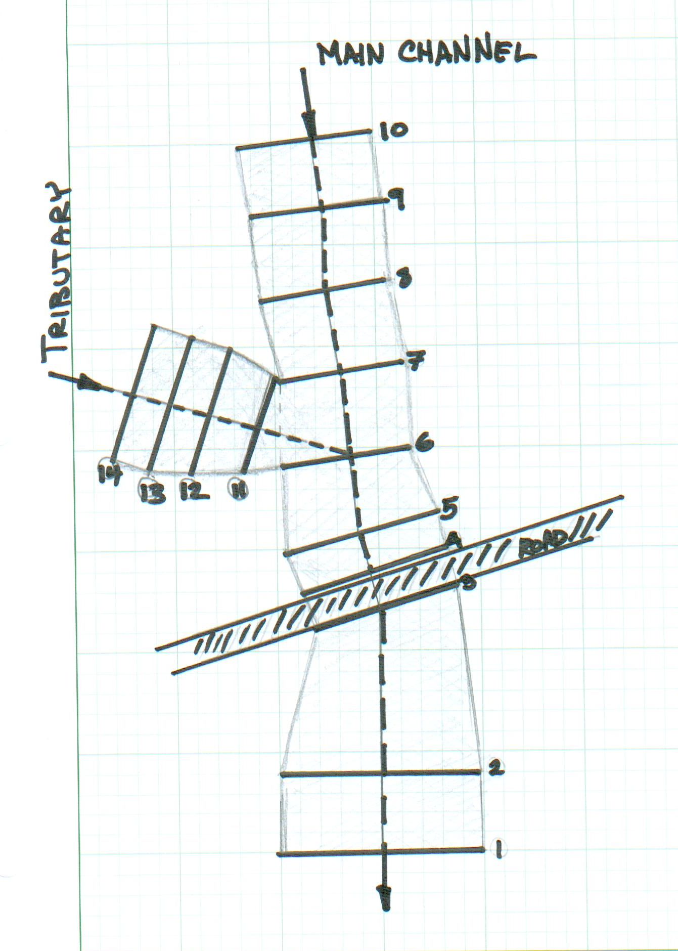
Figure 1. Sketch of Channel-Tribuitary System

Table 1. Cross Section Location and Elevation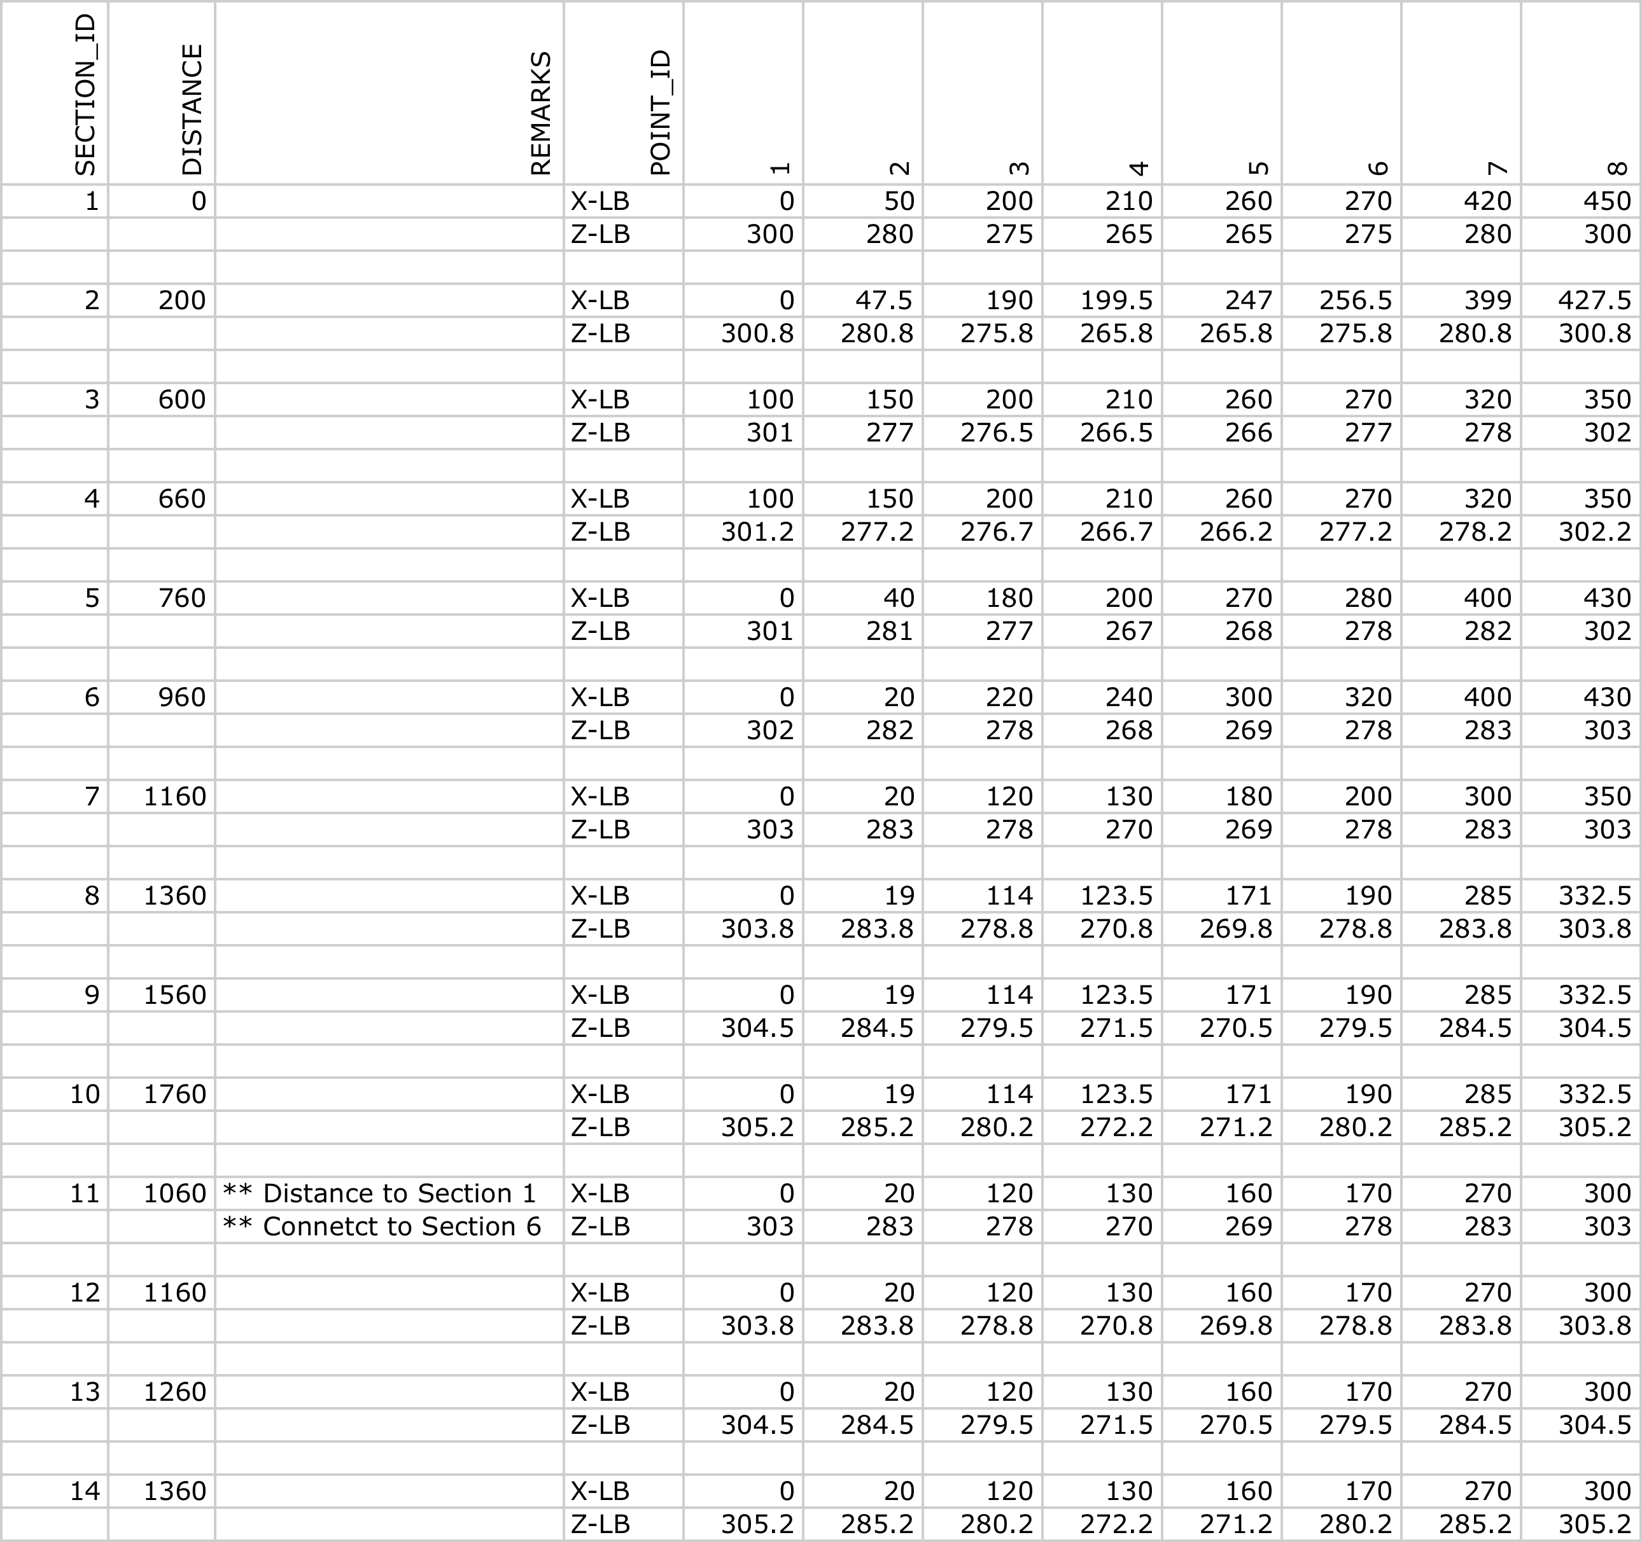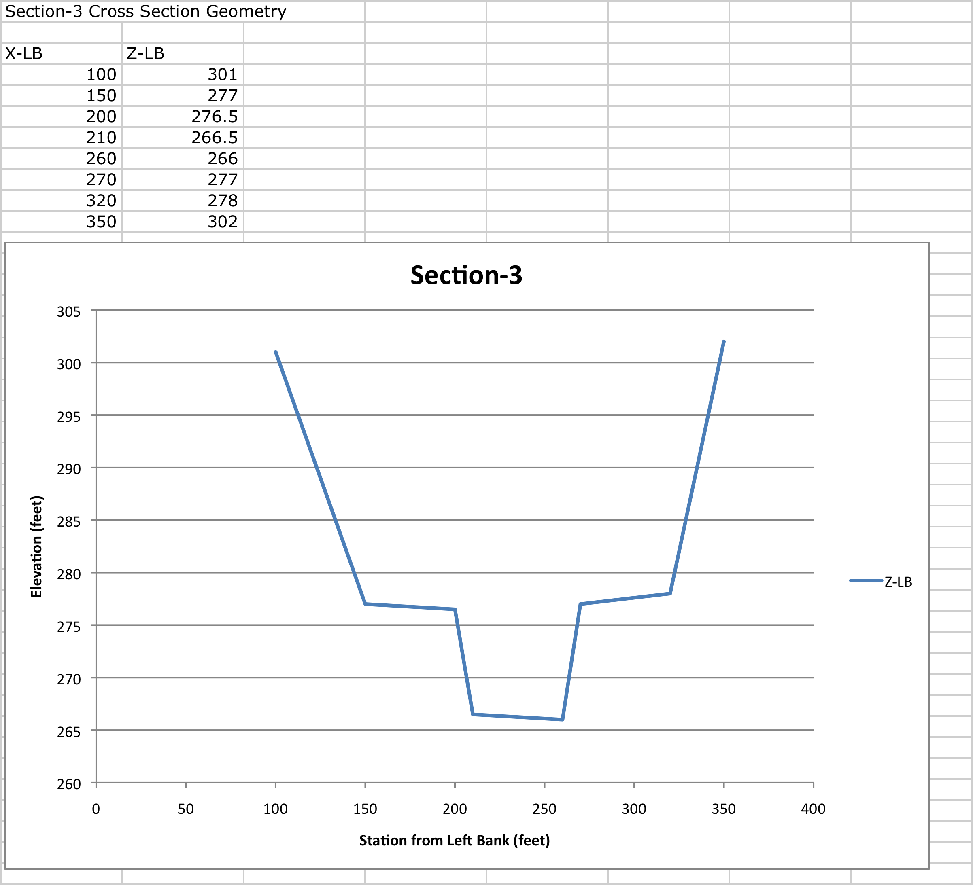
Figure 2. Example Cross Section Sketch

Table 2. Steady Flow Conditions
Cross Section 1
Normal Depth |  | Slope =0.004
Q_1 | 2000 | cfs
 | 20000 | cfs
 | 50000 | cfs
Q_10 | 1500 | cfs
 | 15000 | cfs
 | 35000 | cfs
Q_14 | 500 | cfs
 | 5000 | cfs
 | 15000 | cfs

Table 3. Unsteady Flow Conditions
Unsteady Flow
 | Time | Discharge
Q_10 | 0 | 2000
 | 1 | 5410.7
 | 2 | 16552.8
 | 3 | 30365.7
 | 4 | 39411.6
 | 5 | 40111.9
 | 6 | 36978.2
 | 7 | 33453.6
 | 8 | 33790.3
 | 9 | 39048.2
 | 10 | 42683.4
 | 11 | 44943.9
 | 12 | 47230.8
 | 13 | 47748.5
 | 14 | 40036.3
 | 15 | 27756.3
 | 16 | 17005.6
 | 17 | 10659.7
 | 18 | 7067.8
 | 19 | 4918.7
 | 20 | 3680.7
 | 21 | 2965.3
 | 22 | 2525.9
 | 23 | 2291.2
 | 24 | 2144.8
 | Time | Discharge
Q_14 | 0 | 500
 | 1 | 9303.5
 | 2 | 11182.8
 | 3 | 10831.9
 | 4 | 6944.2
 | 5 | 6359.3
 | 6 | 5829.2
 | 7 | 5291.8
 | 8 | 13092.6
 | 9 | 7916.8
 | 10 | 9450.9
 | 11 | 10746.9
 | 12 | 11668.4
 | 13 | 3398.6
 | 14 | 1055.4
 | 15 | 593.7
 | 16 | 500
 | 17 | 500
 | 18 | 500
 | 19 | 500
 | 20 | 500
 | 21 | 500
 | 22 | 500
 | 23 | 500
 | 24 | 500

