- (20 points) A reactor is used to treat a waste constituent according that follows a first-order rate model. The decay constant is K. The reactor volume is V = 500 cubic meters. The steady flow rate of liquid through the reactor is Q_{in} = Q_{out} = 50 cubic meters per day. The concentration in the feed is C_{in}; a function of time. Concentration in the outlet is C_{out}; also a function of time.

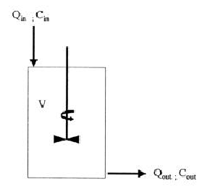
Figure 1. Reactor Sketch for Problem #1

  - Using the variables in the sketch, write the mass flow rate into the reactor.

mass_flow_in = C_{in} * Q_{in}

  - Using the variables in the sketch, write the mass flow rate out of the reactor.

Mass_flow_out=C_{out}Q_{out}

  - Assuming complete mixing, what is the concentration (using the variables above) inside the reactor?

C = C_{out}

  - Using the variables in the sketch, write the amount of mass accumulated within the reactor. (Calculus)
mass_acccumulated_per_time =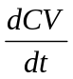

  - Does the liquid volume in the reactor stay constant?

Yes (because we are not told Q is a function of time, we assume it is constant with respect to time). => Q_{in} = Q_{out} =Q

  - Write the first-order decay equation for the constituent within the reactor.

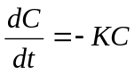 or 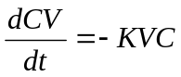

  - Using (a)-(f) write the mass balance for the constituent within the reactor.

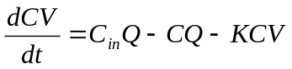

  - Solve the equation in (g) for steady state conditions.

the time derivative vanishes at steady state

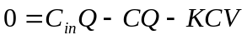 rearrange and isolate “C”

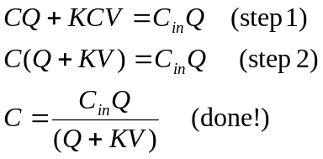

- (20 points) The reactor in problem 1 was operated under the conditions above, and the following data were collected at the outlet.

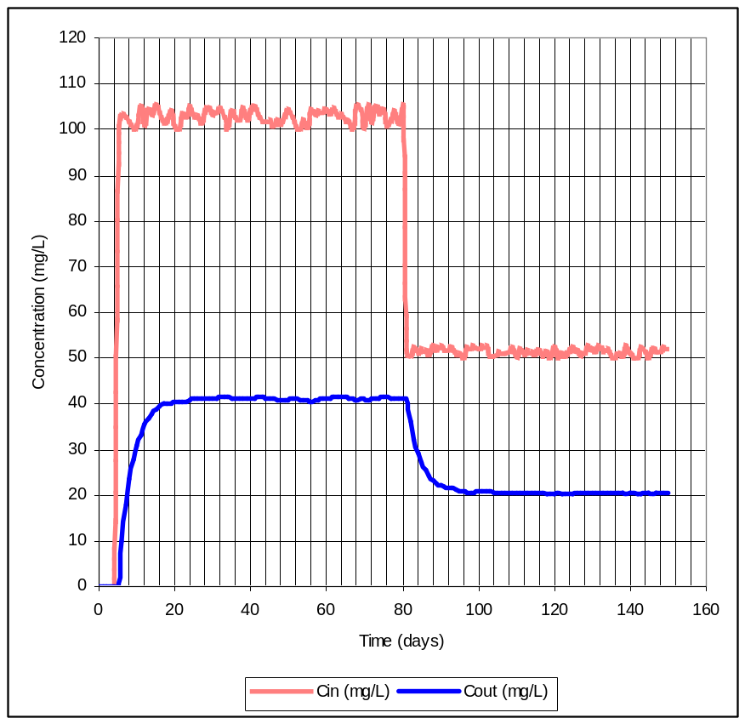
C_{in}
Equilibrium periods
use ΔC to infer K
Transient periods
Figure 2. Data from Reactor Operation

- Use the results of your analysis (Problem 1) and the figure above to determine the value of the decay constant in reciprocal days (day⁻¹).

Use chart to estimate Cin and C during a non-transient period of time.
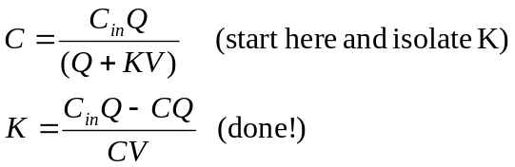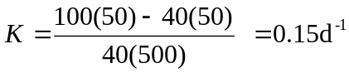

- Use the results of your analysis and the figure above to estimate the time for the reactor reach a new equilibrium after a change in the input concentration.

Pick a transient period, duration is about 20 days.
- (10 points) Hydrochloric acid, HCl, completely ionizes when dissolved in water. Calculate the pH of a solution containing 25 mg/L of HCl.

HCl <> H₊ + CL⁻

Complete inoization means that one mole of HCL produces one mole H⁺ and one mole Cl⁻

Thus need to find how many moles in 25 mg

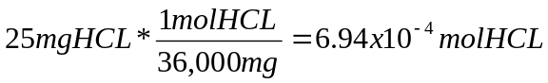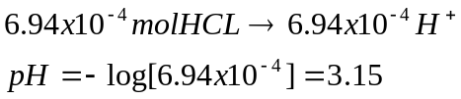
4) (15 points) Consider the reaction representing combustion of propane in an oxygen atmosphere.

C₃H₈ + O₂ => CO₂ + H₂O

  - Balance the equation
  - How many moles of oxygen are required to burn one mole of propane?
  - How many grams of oxygen are required to burn 100 grams of propane?
  - At STP (1 atm, 25 ºC) what volume of oxygen is required to burn 100g of propane?
  - At STP, air is 21% oxygen. What volume of air is required to burn 100 grams of propane?
  - At STP what volume of CO₂ is produced when 100 grams of propane are burned?

    - C₃H₈ + 5 O₂ => 3 CO₂ + 4 H₂O

    - 5 mol O₂ per 1 molC₃H₈

    - 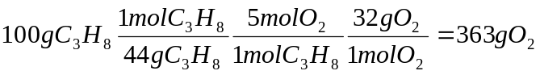

    - 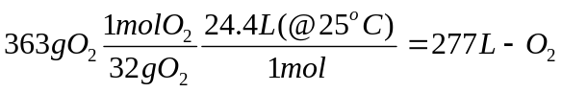

    - 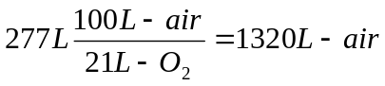

    - 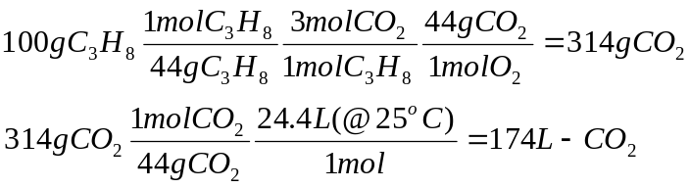
(15 points) One individual pours one gallon containing 10,000 mg/L of a hazardous chemical into 1,000 gallons of water. A second person pours 20 gallons containing 5,000 mg/L of the same chemical in the water. You learn that the chemical formula of this highly biodegradable chemical is C₁₀H₂₀. You collect a 5-mL sample for your laboratory to analyze. What laboratory results do you expect for:
  - Concentration of the chemical after the second individual has added their 20 gallons (express results in ppm)?
  - The COD in the 5-mL sample in mg/L?

Sketch:
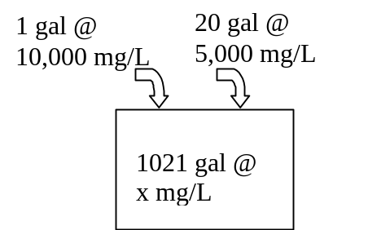

  - Find total mass, divide by total volume, convert to ppm.

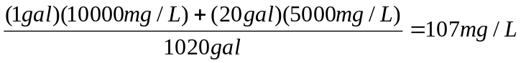

This is a relatively dilute solution so C = ~ 107 ppm. (If you convert the 1L to a mass, you will arrive at nearly the same result)

  - C₁₀H₂₀ + 15 O₂ => 10CO₂ + 10 H₂O

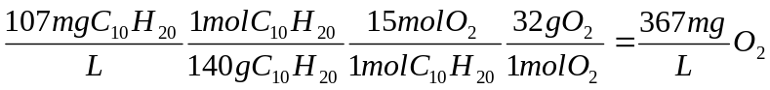

- (20 points) Given the pH of a water-carbonate system that is closed to the atmosphere, with residual carbonate solid present, and the concentration of H₂CO_{3,} determine the concentration of the other species in solution.

a) First look up the relevant equilibrium constants for the equilibria below:

      - H₂O <> H⁺ + OH⁻ K_{w} =1 x 10 ^{–14} M

      - CaCO₃ <> Ca²⁺ + CO₃²⁻ K_{sp}= 4.57 x 10 ^{–9} M

      - H₂CO₃ <> H⁺ + HCO₃⁻ K_{a1}=4.47 x 10 ^{–7} M

      - HCO₃⁻ <> H⁺ + CO₃²⁻ K_{a2}=4.68 x 10 ^{–11} M

b) Write the law of mass action for the equilibria:

(1) 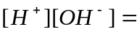 K_{w} =1 x 10 ^{–14} M

(2) 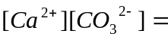 K_{sp}= 4.57 x 10 ^{–9} M

(3) 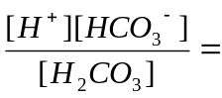 K_{a1}=4.47 x 10 ^{–7} M

(4) 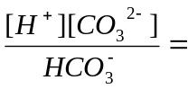 K_{a2}=4.68 x 10 ^{–11} M

c) Write the charge Balance:

[H⁺] + 2[Ca²⁺] = [OH⁻ ] + [HCO₃⁻ ] + 2[CO₃²⁻]

Finally, In a system closed to the atmosphere the following holds:

[Ca²⁺] = [H₂CO₃ ] + [HCO₃⁻ ] + [CO₃²⁻]

For this problem you are given:

pH = 9.95 ; [H⁺]=10 ^{–9.95}

[H₂CO₃ ] = 2.5 x 10⁻⁸

Find:

d) [Ca²⁺ ] =[ 4.57 x 10 ^{–9} ] /[ 4.15 x 10 ^{–5} ] = 1.1 x 10 ^{–4} M

e) [CO₃²⁻ ] = [4.68 x 10 ^{–11}][ 9.96 x 10 ^{–5} ] / [10 ^{–9.95} ] = 4.15 x 10 ^{–5} M

f) [HCO₃⁻ ] =[4.47 x 10 ^{–7}][ 2.5 x 10⁻⁸]/[ 10 ^{–9.95} ] = 9.96 x 10 ^{–5} M

g) [OH⁻ ] =[10 ^{–14}]/[10 ^{–9.95} ] = 8.9 x 10 ^{–5} M

Verify that your results satisfy the charge balance.

[H⁺] + 2[Ca²⁺] = 2.2 x 10 ⁻⁴

[OH⁻ ] + [HCO₃⁻ ] + 2[CO₃²⁻] = 2.27 x 10 ⁻⁴

Close, difference is ~ 10 ^{–5}. Cause is rounding error propagation and our book uses different acid-base dissociation constants than problem source.

