CIVE 3331 – Exercises 018

Exercise_018_1
(Problem 4.1)

Consider a carcinogenic VOC with the dose-response curve shown in Figure P4.2. If 70-kg people breath 20 m^3/day of air containing 10^-3 mg/m^3 of this VOC throughout their entire 70-year lifetime, find the cancer risk (you first need to find the potency).

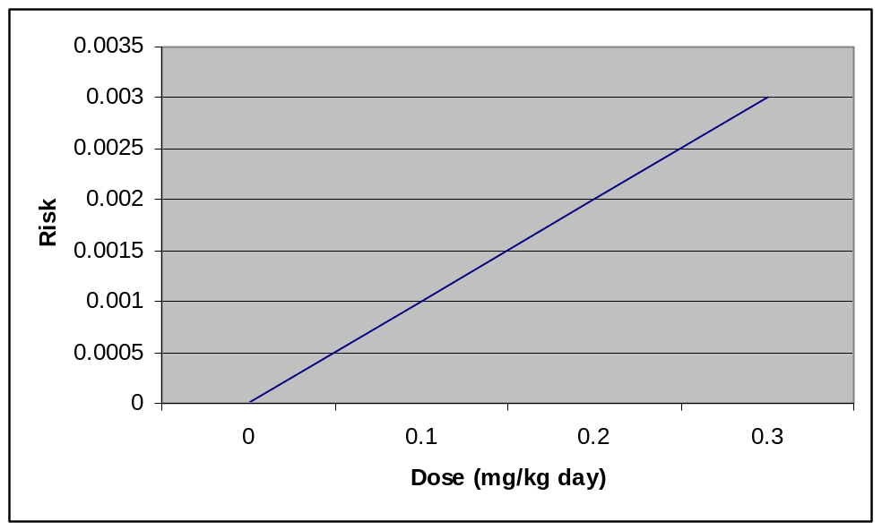
Exercise_018_2
(Problem 4.3)

Suppose 30 out of 500 rats exposed to a potential carcinogen develop tumors. A control group of 300 rats not exposed to the carcinogen develops only 10 tumors. Based on these data, compute (a) the relative risk, (b) the attributable risk, and (c) the odds ratio. Do these indicators suggest that there might be a relationship between exposure and tumor risk?
Exercise_018_3
(Problem 4.8)

The drinking water standard for 2, 3, 7, 8-TCDD (dioxin) is 3 x 10^-8 mg/L. Using EPA exposure factors for residential consumption, what lifetime risk would this pose?
Exercise_018_4
(Problem 4.15)

One way to estimate maximum acceptable concentrations of toxicants in drinking water or air is to pick an acceptable lifetime risk and calculate the concentration that would give that risk assuming agreed-on exposures such as the residential factors given in Table 4.10. Find the acceptable concentrations of the following substances:

- Benzene in drinking water (mg/L), at a lifetime acceptable risk of 1 x 10^-5
- Trichloroethylene in air (mg/m^3), at a lifetime acceptable risk of 1 x 10^-6
- Benzene in air (mg/m^3), at a lifetime acceptable risk of 1 x 10^-5
- Vinyl chloride in drinking water (mg/L), at a lifetime acceptable risk of 1 x 10^-4
Exercise_018_5
(Problem 4.30)

Suppose 10 million people are exposed to a carcinogen that poses an individual lifetime (70-yr) cancer risk of 10^-4.

- How many cancers per year might be caused by this carcinogen?
- If spending $1 per year per person (for an indefinitely long time) to reduce exposure to that carcinogen reduces that risk to 10^-5, what would be the cost of each cancer avoided?

