ENGR-1330-2021-3 Computational Thinking and Data Science

Assignment 1

Name: _________________________________________

R Number: ______________________________________

Purpose: Demonstrate familiarity with the JupyterLab computing environment; Python; and practice critical thinking regarding persuasive speech.

1. Jupyter notebooks are used in this class as a computing and documenting environment. Jupyter notebooks are an ordered collection of cells. What kind of cells are represented in a notebook?   
     
   Code; markdown; raw (there is a 4th type but it is being deprecated)
2. The two building blocks of Python code are **expressions** and **statements**. Define in a few sentences each component (e. g. An **expressio**n is a piece of code that .... . A **statement** is …. )  
     
   An **expressio**n is a piece of code that is self-contained (it would make sense to write it on a line by itself and it usually evaluates to some value  
     
   A **statement** is a whole line of code. Some statements are just expressions. Other statements *make something happen* rather than *having a value*. For example, an *assignment statement* assigns a value to a name.
3. Have some fun; create a notebook and insert the code below and run it. Describe what happens: (Obviously it’s supposed to run a video, what is the video about? If you get an error, screen capture the error message and postulate how to solve the error)

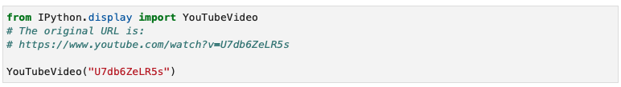  
The video is the dropping of an eagle feather and a hammer (roughly a few billion dollars to get two objects to the moon) on the Moon. It runs within the Notebook (Tested on my machines just fine)

If students get errors it will likely be at the import statement, something to the effect Module ... not found.

1. Is the line in the script above **YouTubeVideo("U7db6ZeLR5s")** best described as an expression or at statement?  
   Statement
2. An ad for ADT Security Systems says,

*"When you go on vacation, burglars go to work [...] According to FBI statistics, over 25% of home burglaries occur between Memorial Day and Labor Day."*

Do the data in the ad support the claim that burglars are more likely to go to work during the time between Memorial Day and Labor Day? Please explain your answer.

**Note:** You can assume that "over 25%" means only slightly over. Had it been much over, say closer to 30%, then the marketers would have said so.  
  
The time between Memorial Day and Labrador Day is about 3 months, ¼ of a year. So the implication that those three months are unusual is bunk – it’s the same fraction of a year we would expect if burglering was just a job. Fortunately, the question itself is deceptive, because the ad copy only implies the 3 months are unusual, but does not explicitly state such.

Upon completion of the exercise save your responses as a PDF file and upload to Blackboard.