ENGR-1330-2021-3 Computational Thinking and Data Science

Assignment 1

Name: _________________________________________

R Number: ______________________________________

Purpose: Demonstrate familiarity with the JupyterLab computing environment; Python; and practice critical thinking regarding persuasive speech.

1. Jupyter notebooks are used in this class as a computing and documenting environment. Jupyter notebooks are an ordered collection of cells. What kind of cells are represented in a notebook?
2. The two building blocks of Python code are **expressions** and **statements**. Define in a few sentences each component (e. g. An **expressio**n is a piece of code that .... . A **statement** is …. )
3. Have some fun; create a notebook and insert the code below and run it. Describe what happens: (Obviously it’s supposed to run a video, what is the video about? If you get an error, screen capture the error message and postulate how to solve the error)

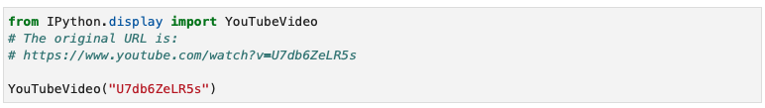

1. Is the line in the script above **YouTubeVideo("U7db6ZeLR5s")** best described as an expression or at statement?
2. An ad for ADT Security Systems says,

*"When you go on vacation, burglars go to work [...] According to FBI statistics, over 25% of home burglaries occur between Memorial Day and Labor Day."*

Do the data in the ad support the claim that burglars are more likely to go to work during the time between Memorial Day and Labor Day? Please explain your answer.

**Note:** You can assume that "over 25%" means only slightly over. Had it been much over, say closer to 30%, then the marketers would have said so.

Upon completion of the exercise save your responses as a PDF file and upload to Blackboard.