Cyclistic Bike-Share
Case Study Analysis
Google Data Analytics Certificate
May 2026

1. Business Task
How do annual members and casual riders use Cyclistic bikes differently?

The goal of this analysis is to identify behavioral differences between casual riders and annual members, and to use those insights to develop recommendations for converting casual riders into long-term members.

2. Data Source
12 months of Cyclistic trip data was used for this analysis, covering the period May 2025 – April 2026.

- Source: Divvy Trip Data (https://divvy-tripdata.s3.amazonaws.com/index.html)
- Tool used for processing and analysis: Google BigQuery
- Tool used for visualization: Tableau Public
- Total records before cleaning: ~4,500,000+ rows across 12 monthly CSV files

The data is provided by Motivate International Inc. under a public license. Personally identifiable information has been removed.

3. Process — Data Cleaning

Tools Used
All data was uploaded to Google BigQuery. The 12 monthly CSV files were combined into a single table using UNION ALL, and two new columns were added:
- ride_length - calculated using TIMESTAMP_DIFF(ended_at, started_at, SECOND)
- day_of_week - extracted using EXTRACT(DAYOFWEEK FROM started_at), where 1 = Sunday and 7 = Saturday

Cleaning Log
The following checks were performed on the raw data. Rows with issues were removed before analysis.

Issue | Rows Affected | Action Taken | Query Used
Null start/end times | 0 | No action | WHERE started_at IS NULL OR ended_at IS NULL
End time before start time | 29 | Removed | WHERE ended_at < started_at
Rides under 60 seconds | 157,212 | Removed | WHERE TIMESTAMP_DIFF(..., SECOND) < 61
Rides over 24 hours | 5,833 | Removed | WHERE TIMESTAMP_DIFF(..., SECOND) > 86400

Total rows removed: 163,074

Final Cleaning Query
CREATE OR REPLACE TABLE `cyclistic_data.all_trips_cleaned` AS
SELECT
*,
TIMESTAMP_DIFF(ended_at, started_at, SECOND) AS ride_length,
EXTRACT(DAYOFWEEK FROM started_at) AS day_of_week
FROM `cyclistic_data.all_trips`
WHERE
started_at IS NOT NULL
AND ended_at IS NOT NULL
AND ended_at > started_at
AND TIMESTAMP_DIFF(ended_at, started_at, SECOND) > 60
AND TIMESTAMP_DIFF(ended_at, started_at, SECOND) < 86400

4. Analysis

Summary Statistics

Metric | Casual Riders | Members
Total Rides | 1,563,607 | 2,850,308
Avg Ride Length | 1,275.6 seconds (~21 min) | 747.8 seconds (~12 min)
Peak Day | Saturday & Sunday | Tuesday–Thursday
Peak Hour | Steady throughout day | 8am and 5pm spikes
E-bike preference | 1.37x more than classic | 1.23x more than classic

Rides by Day of Week
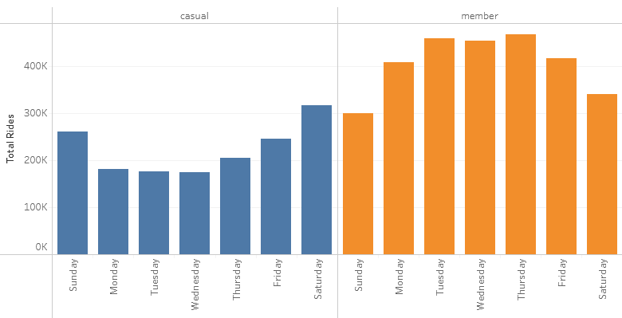

Casual riders peak strongly on weekends (Saturday and Sunday), while members ride most consistently on weekdays (Tuesday through Thursday). This suggests members use Cyclistic primarily for commuting, while casual riders use it for leisure.

Rides by Hour of Day

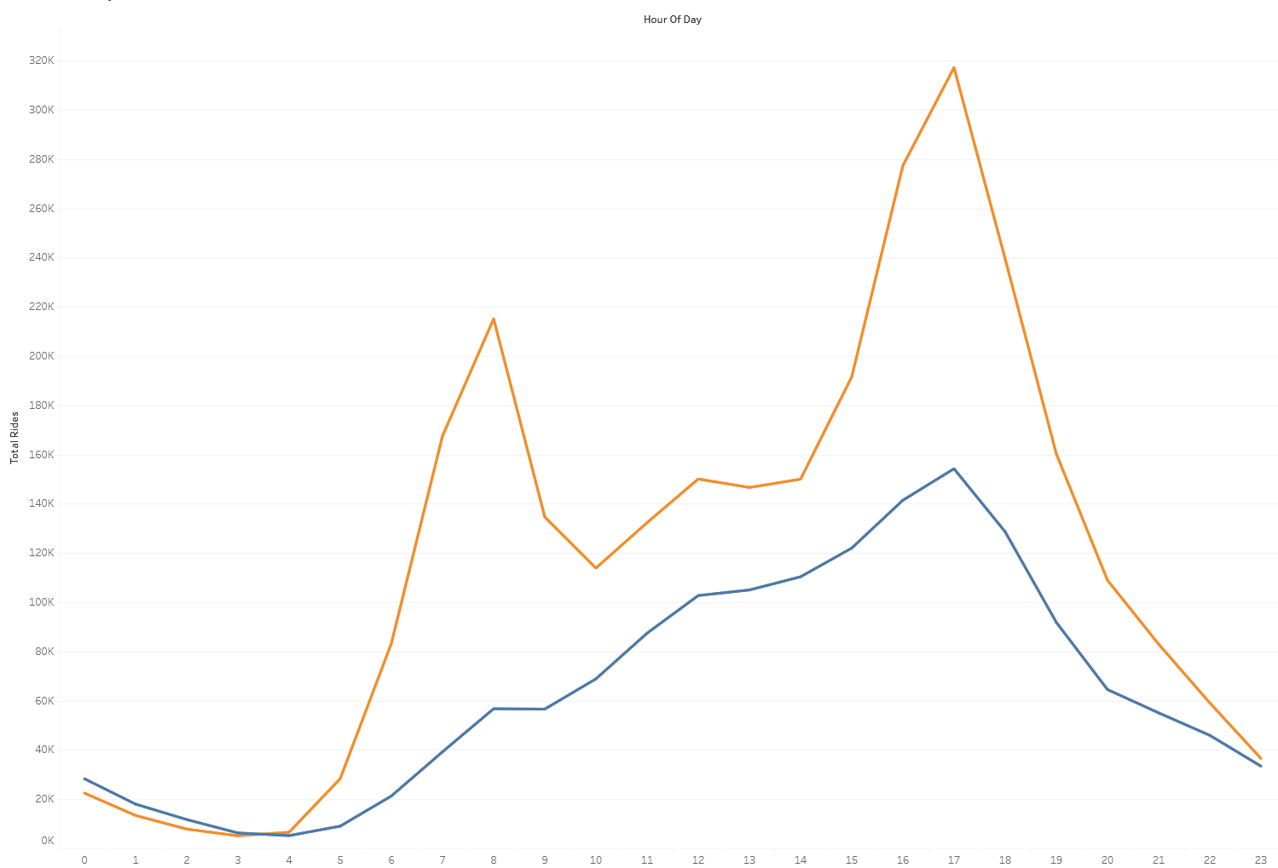

Members show two distinct spikes at 8am and 5pm, consistent with commute patterns. Casual riders show a gradual increase through the day peaking around 5pm, with no morning rush hour spike; further supporting the leisure use hypothesis.

Average Ride Length

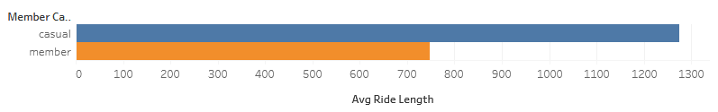

Casual riders take rides that are on average 70% longer than members. This pattern is consistent across all days of the week.
This difference likely reflects the nature of each group’s usage. Members use bikes for short, efficient commutes between fixed points. Casual riders are less focused on reaching a destination quickly, and are more likely to take scenic or extended routes.

5. Recommendations

Recommendation 1: Introduce a Weekend Membership Tier
Casual riders are significantly more active on Saturdays and Sundays compared to members, suggesting they ride primarily for leisure. A weekend-only membership at a lower price point reduces the commitment barrier and directly targets their existing riding habits, making it an easier sell than a standard annual membership.

Recommendation 2: Introduce an Off-Peak Membership Tier
The data shows casual riders are more evenly spread throughout the day, rather than concentrated at commute hours. An off-peak membership (e.g. 10am - 4pm) could appeal to casual riders who do not use the service during rush hours. This would also help Cyclistic manage bike availability during peak commute periods.

Recommendation 3: Create Incentives for Longer Rides
On average, casual riders take significantly longer rides than members (21 minutes vs 12 minutes). By introducing a loyalty program that rewards longer rides with points or discounts toward a membership upgrade, Cyclistic can give casual riders a tangible financial reason to convert.

6. Conclusion
Analysis of 12 months of Cyclistic trip data reveals a clear behavioral divide between casual riders and annual members.

- Members use Cyclistic as a utility: riding consistently on weekdays, peaking at commute hours, with shorter and more purposeful trips.
- Casual riders use Cyclistic for leisure: riding longer distances on weekends with no clear commute pattern.

These differences suggest that casual riders are not simply infrequent users, but a distinct group with different motivations. Converting them requires meeting them where they are; offering flexible membership tiers that match their weekend and off-peak riding habits, and creating incentives that reward the longer rides they already take.

With the right pricing strategy and targeted marketing, Cyclistic has a strong opportunity to convert its large casual rider base into long-term members.

