WEEK 4: INTERNSHIP TASK DATA VISUALIZATION AND REPORTING FOR AGRIBUSINESS INSIGHTS

Submitted By

Name: Anik Kumar Dutta
Stream: B.sc (Data Science)
College: Guru Nanak Institute of Technology
Task: Data Visualization and Reporting for Agribusiness Insights
Tools & Technologies
Microsoft Excel | Microsoft Word
Project Focus
Data Visualization • Business Analysis • Agribusiness Insights • Reporting
Submitted As Part of
Internship Training Program
Academic Year: 2026

WEEK 4 — DATA VISUALIZATION AND REPORTING
1. Introduction
Agribusiness plays an important role in the economy by connecting agricultural production, distribution, marketing, and sales. With the increasing availability of business data, data visualization has become an important tool for understanding business performance and making better decisions. Raw data in tables can contain a large amount of useful information, but it is often difficult to identify trends and patterns by looking at numbers alone. Visualization helps transform these numbers into meaningful and easy-to-understand information.
This report presents an analysis of agribusiness sales data using different data visualization techniques. The main purpose of this report is to identify important patterns in product performance, regional revenue, monthly sales trends, and the relationship between sales quantity and revenue. Five different visualizations have been created using Microsoft Excel to present the findings clearly.
The visualizations used in this report are Revenue by Product, Revenue by Region, Monthly Revenue Trend, Revenue vs Quantity using a Scatter Plot, and Revenue Share by Product. Each visualization has been selected according to the type of information that needs to be presented. Together, these visualizations provide a clear overview of business performance and help identify areas where management can take strategic action.
The analysis focuses on converting the available business data into useful insights that can support decisions related to product management, regional sales, marketing, inventory planning, and overall agribusiness strategy.

2. Dataset Overview
The dataset used for this analysis contains sales-related information relevant to an agribusiness environment. The major variables include product information, geographical region, sales quantity, revenue, and time-based sales information.
The product information helps identify which products contribute most to total revenue. Regional information allows the comparison of business performance across different locations. Monthly revenue data helps identify changes in sales performance over time. Quantity and revenue data are used to understand whether higher sales volume is associated with higher revenue.
Microsoft Excel was used to organize the data and create the required visualizations. Appropriate chart types were selected based on the nature of each variable and the business question being investigated.

3. Visualization 1: Revenue by Product

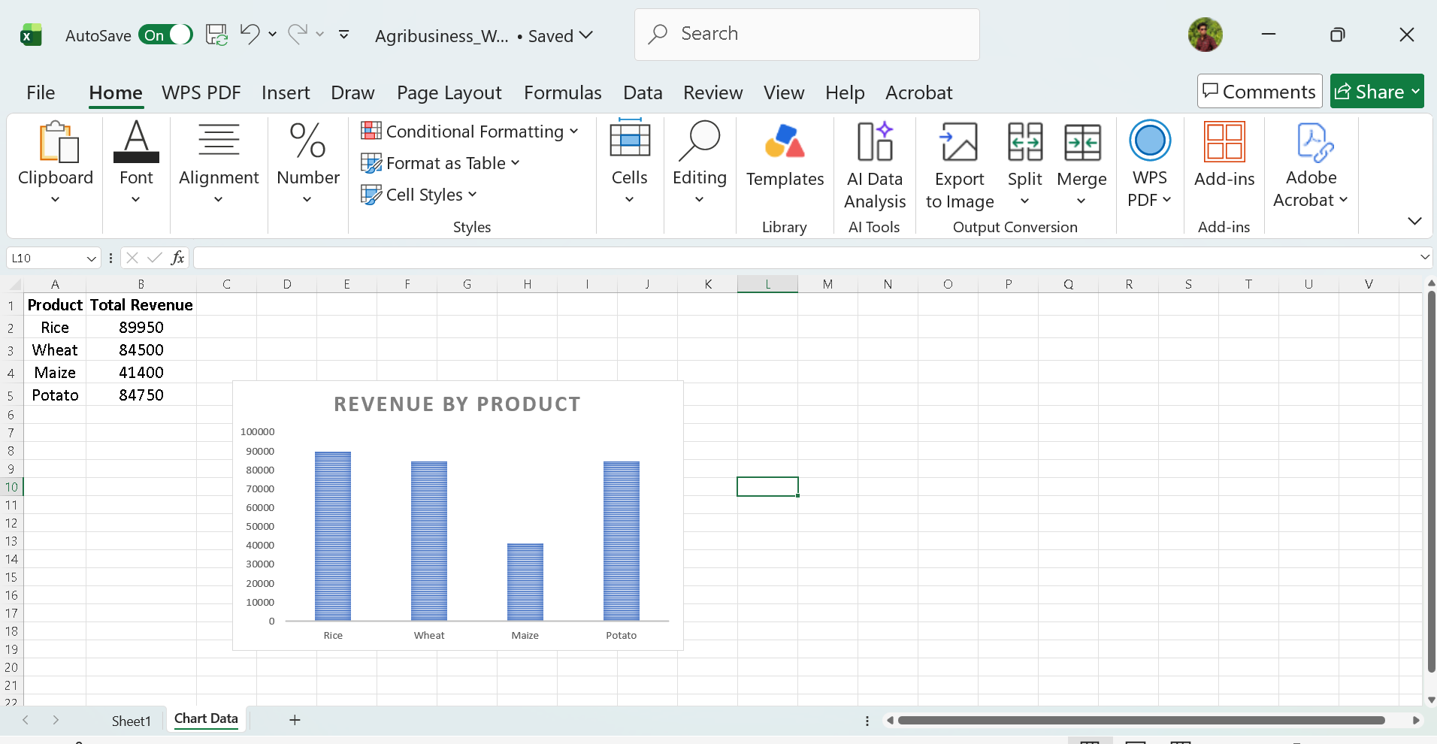

Selection Criteria
A bar or column chart was selected to represent revenue by product because it provides a simple and effective way to compare the performance of multiple products. The length or height of each bar makes it easy to identify products with higher and lower revenue.
Business Insight
The Revenue by Product visualization shows how total revenue is distributed among the different products in the dataset. It helps identify the products that are contributing significantly to overall business revenue.
Products with higher revenue can be considered important contributors to business performance. These products may deserve greater attention in terms of inventory availability, marketing activities, distribution, and customer engagement. On the other hand, products with relatively lower revenue may require further investigation to understand whether the reason is low demand, limited availability, pricing issues, or weaker marketing.
This visualization therefore helps management compare product performance quickly and make product-level decisions based on actual sales data.

4. Visualization 2: Revenue by Region

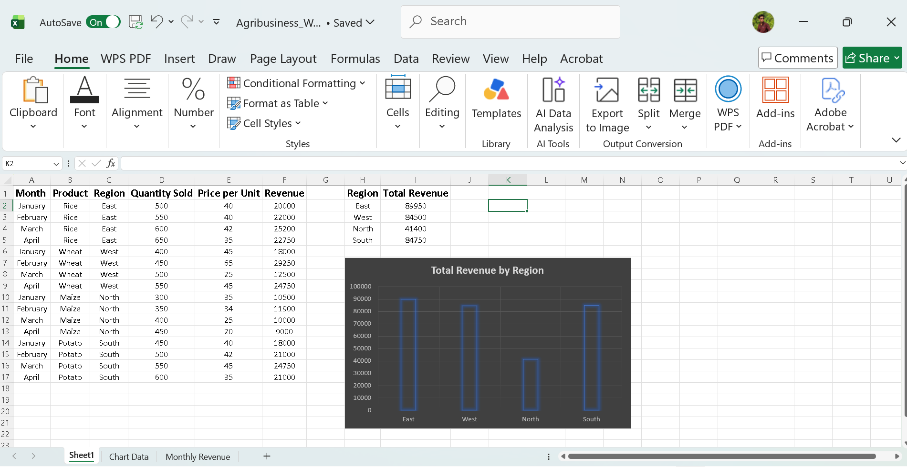

Selection Criteria
A bar or column chart was selected to compare revenue across different geographical regions. A comparison chart is suitable because the main purpose is to identify which regions generate higher or lower revenue.
Business Insight
The Revenue by Region visualization provides an overview of geographical business performance. It helps identify the regions that contribute most to total revenue and the regions where sales performance is relatively lower.
High-performing regions can be considered strong markets. The business may continue investing in these regions through better distribution, product availability, promotional campaigns, and customer relationships. Lower-performing regions may require additional analysis to understand the causes of weak performance.
Possible reasons for regional differences may include customer demand, market size, distribution facilities, competition, transportation costs, or differences in product preferences.
Therefore, this visualization can support regional planning and help management allocate resources more effectively.

5. Visualization 3: Monthly Revenue Trend

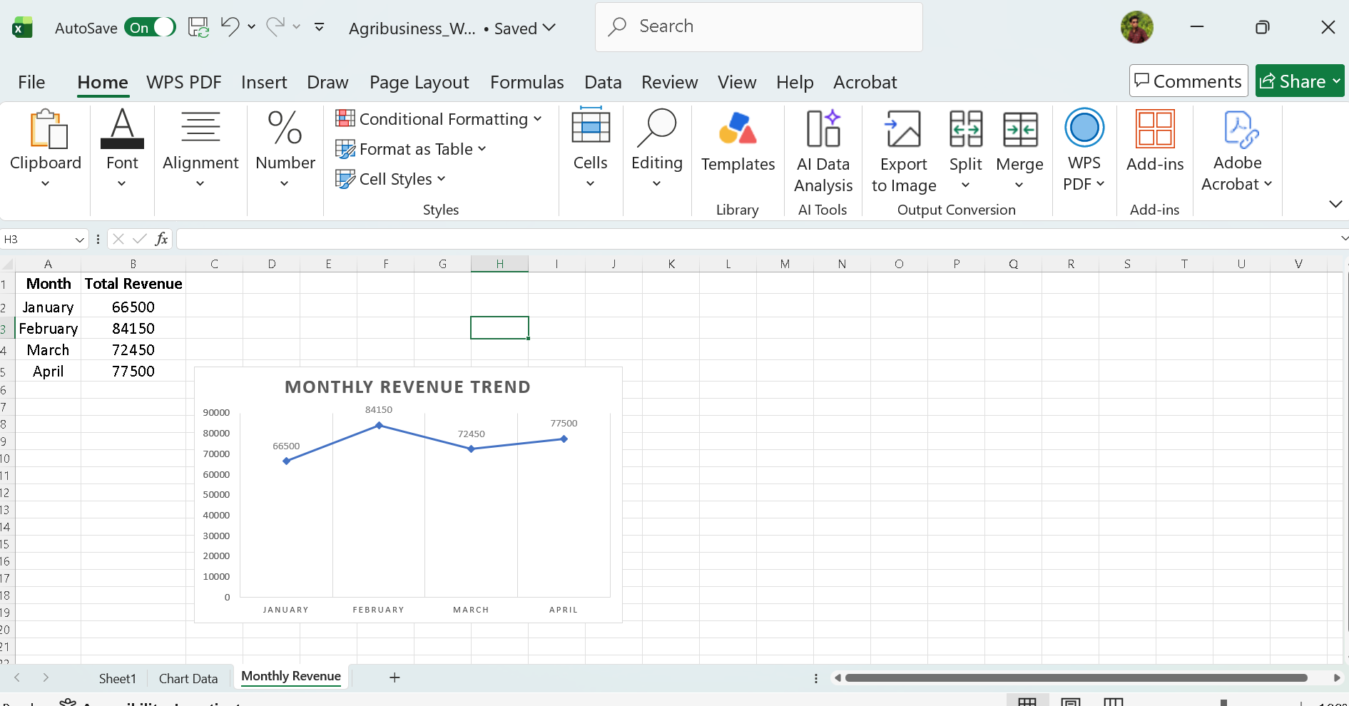

Selection Criteria
A line chart was selected to represent monthly revenue because line charts are particularly effective for showing changes and trends over time. The movement of the line makes it easy to identify increases, decreases, peaks, and periods of lower performance.
Business Insight
The Monthly Revenue Trend visualization shows how revenue changes over different months. This helps identify periods of strong and weak business performance.
An increasing trend may indicate growing customer demand, successful marketing activities, improved distribution, or seasonal demand. Similarly, a decline in revenue during particular months may indicate lower demand, supply problems, seasonal effects, or other market conditions.
Understanding monthly revenue trends is useful for planning inventory and resources. For example, if the business regularly experiences higher revenue during certain months, management can prepare sufficient stock and marketing activities before those periods.
The monthly trend can also help management compare business performance over time and identify whether the overall business is moving in a positive or negative direction.

6. Visualization 4: Revenue vs Quantity

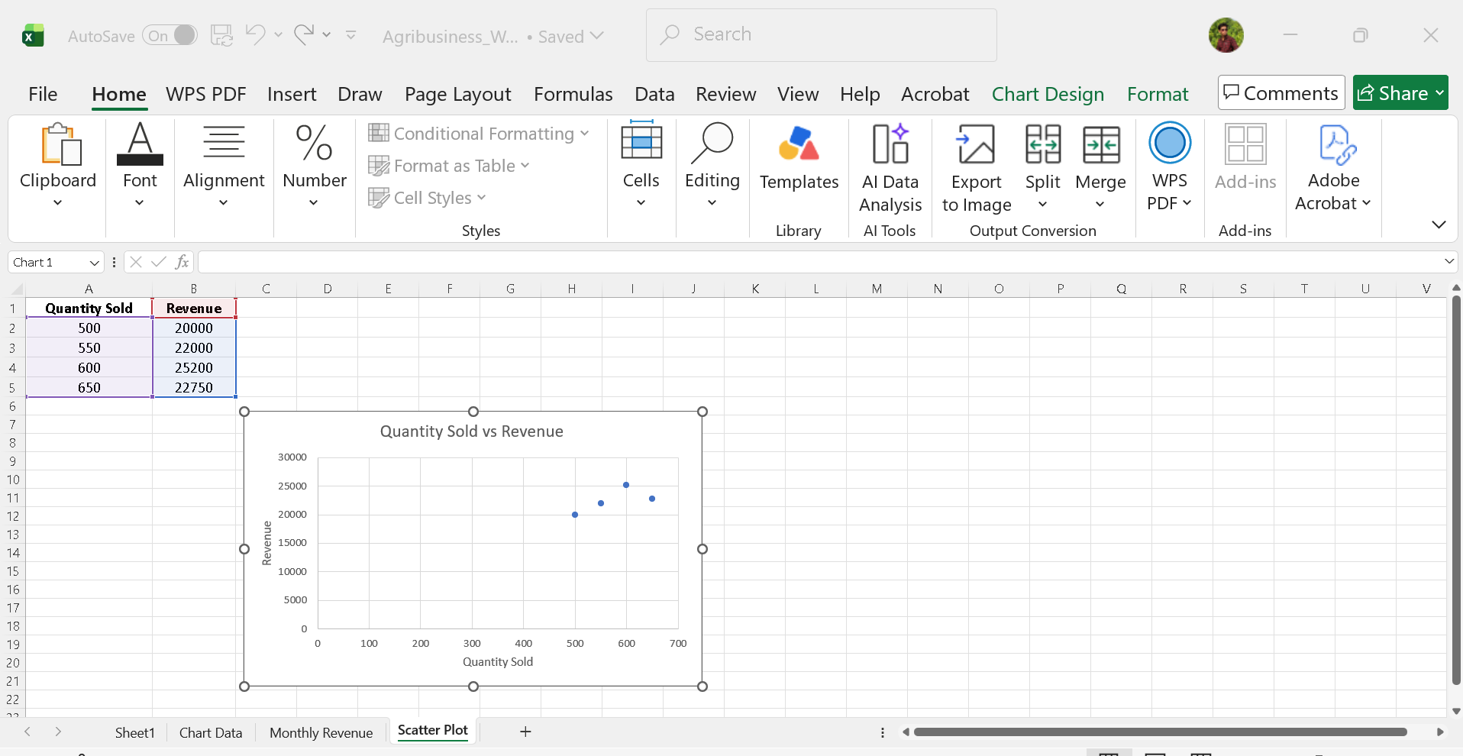

Selection Criteria
A scatter plot was selected to examine the relationship between sales quantity and revenue. Unlike a bar or line chart, a scatter plot is useful for examining whether two numerical variables are related to each other.
Business Insight
The Revenue vs Quantity scatter plot helps determine whether selling a larger quantity is associated with higher revenue. If the points generally move upward as quantity increases, it suggests a positive relationship between sales quantity and revenue.
However, the relationship may not always be perfectly linear. Some products may generate high revenue even with relatively lower quantities because of higher selling prices. Similarly, products sold in large quantities may not always generate the highest revenue if their prices are relatively low.
This visualization is therefore useful for understanding sales efficiency and product characteristics. Management can use this information when reviewing product pricing, sales volume, and revenue generation.
The scatter plot can also help identify unusual observations or outliers that may require further investigation.

7. Visualization 5: Revenue Share by Product

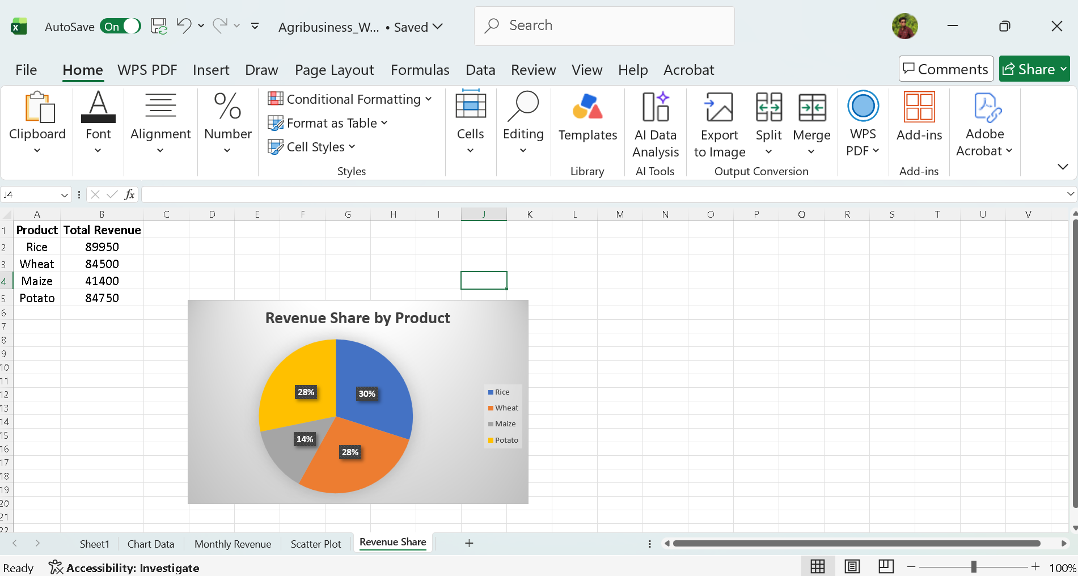

Selection Criteria
A pie chart or donut chart was selected to show the percentage contribution of each product to total revenue. This visualization is suitable when the objective is to understand how the total revenue is divided among different product categories or products.
Business Insight
The Revenue Share by Product visualization provides a clear picture of each product's contribution to total revenue. Products with larger portions of the chart contribute a greater percentage of total revenue, while smaller portions represent products with lower revenue contributions.
This information can help management identify the products that have the greatest impact on overall business performance. High-contribution products may need continuous inventory availability and focused marketing support.
At the same time, products with smaller revenue shares should not automatically be discontinued. Management should investigate whether these products have growth potential, seasonal demand, or opportunities for improved marketing and distribution.
The visualization therefore supports product portfolio management and helps the business understand its revenue dependency on individual products.

8. Key Insights from the Visualizations
The five visualizations together provide several important insights into the agribusiness dataset.
First, the Revenue by Product chart helps identify the strongest and weakest products based on revenue generation. This allows the business to focus resources on products that have significant market demand while also investigating the reasons behind weaker product performance.
Second, the Revenue by Region chart highlights differences in business performance across geographical markets. Some regions may generate substantially more revenue than others. This indicates that regional market conditions and customer demand should be considered when planning sales and distribution strategies.
Third, the Monthly Revenue Trend provides information about changes in business performance over time. Identifying high-revenue and low-revenue periods can improve inventory planning and help the business prepare for periods of increased demand.
Fourth, the Revenue vs Quantity scatter plot helps understand the relationship between sales volume and revenue. It demonstrates whether higher quantities generally result in higher revenue and helps identify unusual observations that may need additional investigation.
Finally, the Revenue Share by Product visualization shows the contribution of individual products to total revenue. This helps management understand which products have the greatest influence on overall business performance.
Overall, the visualizations demonstrate that data can provide useful information for product planning, regional strategy, sales forecasting, and resource allocation.

9. Agribusiness Recommendations
Based on the findings from the visualizations, several recommendations can be considered.
9.1 Focus on High-Performing Products
Products generating higher revenue should receive appropriate attention in inventory planning, marketing, and distribution. Maintaining sufficient stock of these products can help avoid lost sales opportunities.
9.2 Improve Low-Performing Products
Products with relatively low revenue should be investigated before making decisions about reducing or discontinuing them. The business should examine factors such as pricing, customer demand, product availability, and promotional activities.
9.3 Strengthen High-Performing Regions
Regions generating higher revenue can be considered important markets. The business can strengthen these markets through improved distribution networks, promotional campaigns, and better customer service.
9.4 Develop Strategies for Low-Performing Regions
Low-performing regions should be analyzed to identify barriers to growth. Targeted marketing campaigns, competitive pricing, improved distribution, and region-specific product strategies may help increase sales.
9.5 Improve Inventory Planning
Monthly revenue trends can be used to identify periods of high and low demand. The business should prepare inventory according to expected demand so that excess stock and stock shortages can both be minimized.
9.6 Use Data for Pricing Decisions
The relationship between quantity and revenue can support pricing and sales decisions. Products generating strong revenue at lower quantities may have higher prices or higher value per unit, while high-volume products may require different pricing strategies.
9.7 Monitor Revenue Concentration
If a small number of products contribute a large percentage of total revenue, the business should monitor its dependency on those products. Diversifying the product portfolio can reduce business risk and create additional growth opportunities.

10. Conclusion
Data visualization provides an effective method for converting complex business data into meaningful information. In this report, five different visualizations were used to analyze agribusiness performance from multiple perspectives.
The Revenue by Product chart provided a comparison of product performance, while the Revenue by Region chart highlighted geographical differences in revenue generation. The Monthly Revenue Trend showed changes in revenue over time and provided useful information for planning. The Revenue vs Quantity scatter plot helped examine the relationship between sales volume and revenue. Finally, the Revenue Share by Product chart showed the contribution of individual products to total revenue.
Together, these visualizations demonstrate how data analysis can support practical business decisions. The insights can help management improve product planning, regional strategies, inventory management, marketing activities, and pricing decisions.
The main value of data visualization is that it makes important patterns easier to understand and communicate. By regularly monitoring these business metrics through clear visualizations, an agribusiness organization can make more informed, data-driven decisions and respond more effectively to changes in customer demand and market conditions.

11. Final Statement
This project demonstrates the practical use of Microsoft Excel for data visualization and business reporting. The analysis combines quantitative data with visual storytelling to communicate agribusiness insights clearly and support strategic decision-making.

12. Supporting Excel Workbook
The original Excel workbook containing the dataset, worksheets, calculations, chart data, and visualizations has been embedded below for reference and verification.

