Technical Design Document

**PROJECT NAME: Online Vegetable Sales**

**TEAM MEMBERS: MENTOR:**

Ramya Palamani Rajesh Mishra

Arjun Dutta

Priyanka Sheel

Siddhant Shekhar

Santosh Varma Thamishetty

**Introduction:**

Online Vegetable sales is created to meet the needs of selling online vegetable. Its main focus is on people who don’t have time to go to the market and buy vegetables online. It is to attract the people of all ages and genders to buy the best quality vegetables online. The architecture implemented is Spring Boot Micro services.

**Functional Requirements:**

The functional requirements of the project are:

**For the Admin:**

* Login
* Adding vegetables
* Deleting vegetables
* View the orders
* View the customers
* Respond to queries

**For the User:**

* Register
* Login
* Adding items to cart
* Deleting items from cart
* Placing order
* Giving feedback
* Asking queries

**Micro-Services**

The different micro-services in which this project is divided into are:

* **Admin Service:** For admin login to its portal.
* **Customer Service:** For Registering and login.
* **Cart Service:** For adding and deleting items from cart.(Customer)
* **Address Service:** For adding the address on which the item needs to be delivered.(Customer)
* **Payment Service**: Make a payment for the ordered items.(Customer)
* **Feedback Service:** For giving feedback (Customer)
* **Query Service**: For asking queries and their answers.(Admin, Customer)

**Overall Architecture Diagram:**

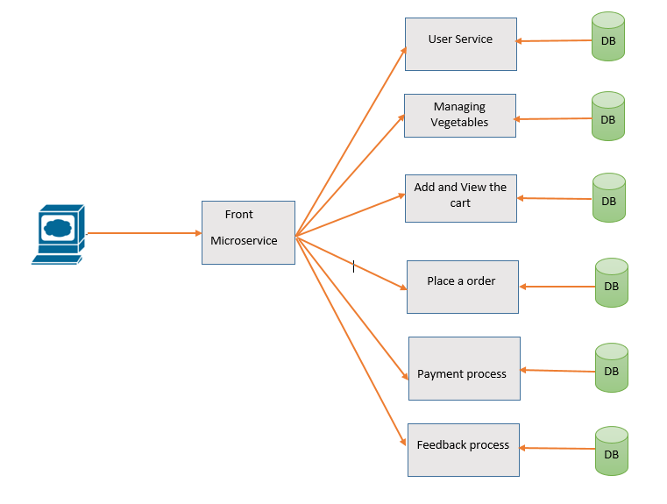

**Activity Diagrams**

User/Admin Service:

1. Login

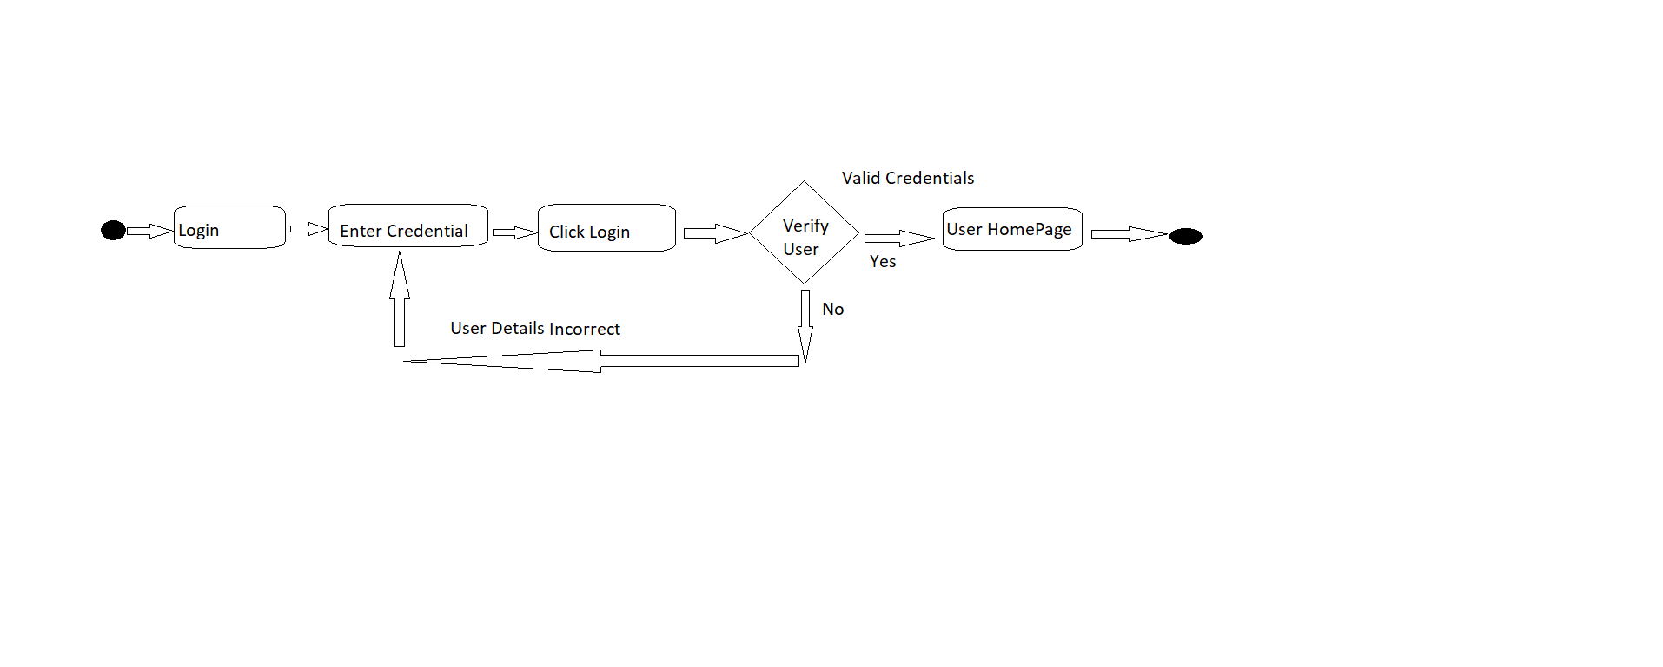

1. Register

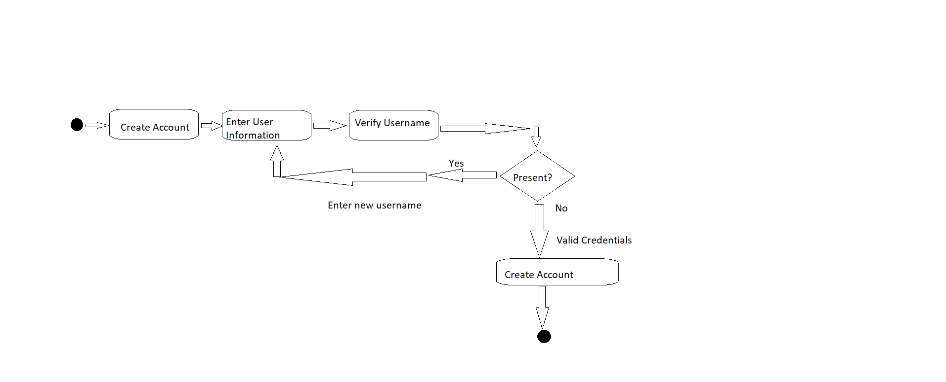

Order Service:

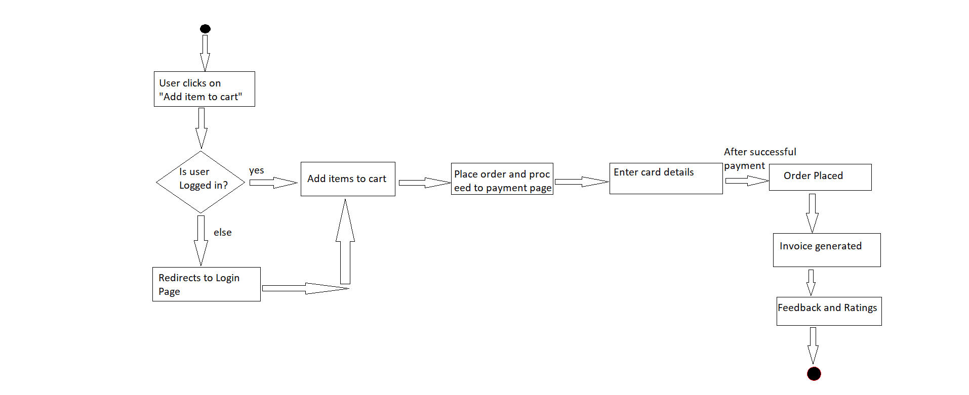

Search and View Service:

View Product

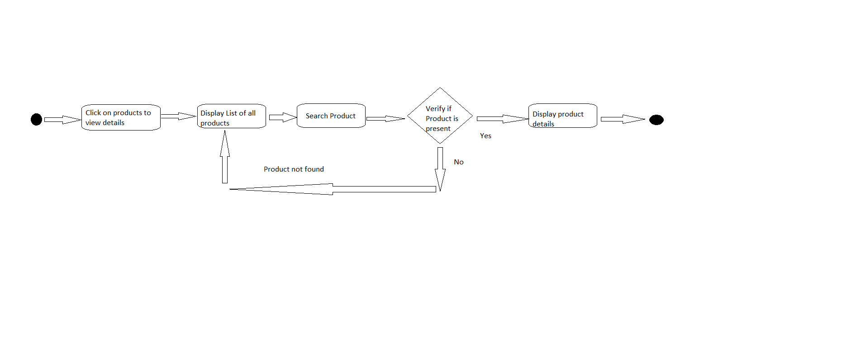

**Wireframes**

**Customer Login:**

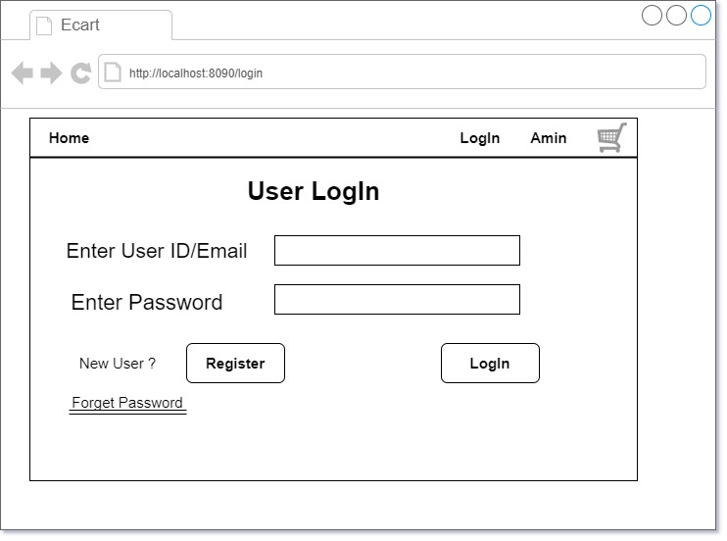

**Admin Login:**

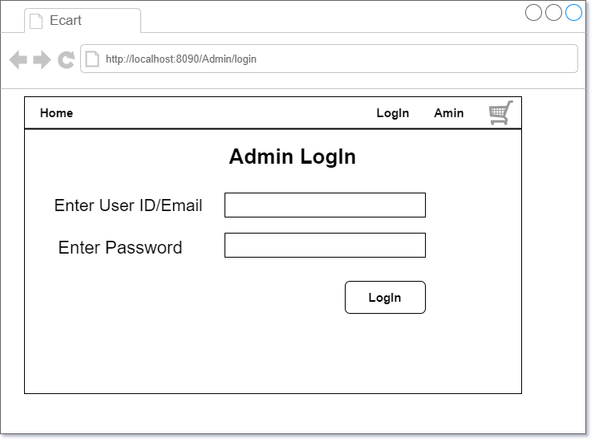

**Customer Registration:** 