*Abstract*—Greenhouse is an important aspect of agriculture where crops are grown in a controlled microenvironment. But the environmental condition inside the greenhouse needs to be continuously monitored for maintaining the optimal condition best suited for a crop’s growth. Controlling all the environmental condition has always been challenging. This is where the role of IOT comes to play. We can easily automate a system which will not only monitor the environmental conditions within a greenhouse but also control it. All of these are achievable through sensors and actuators. Sensors continuously read the environment parameters and any change from the optimal (threshold) can be counteracted by suitable actuators. An algorithm is developed which considers optimal threshold value of temperature, humidity level, soil acidity, soil moisture, carbon dioxide content for a particular crop and aims in maintaining the optimal value throughout the crop cycle. This entire system is automated which enables the greenhouse to sustain without any human intervention. Moreover, the farmer in a remote region also gets a notification regarding the automation happening in the greenhouse which he can easily access using a mobile application.

*Index Terms*—Internet of Things, IOT Ecosystem, Sensors, Automation, Greenhouse Monitoring, and Control.

INTRODUCTION

In the present world where every person is always in transit, they need to have access to all of their devices all the time. The solution comes with the devices having an internet connection so that it can be accessed from everywhere around the globe. This is what resulted in we call “internet of things”. In the year 1999, the term “internet of things” was coined by Kevin Austin, the executive director of the Auto-ID[1]. From then IOT is in its ever-growing stage.

In general, IOT consist of anything and everything that uses some embedded technology to communicate with each other. IOT is an ecosystem of interrelated processing devices, mechanical and digital machines, physical objects, animals or people that have particular unique identifiers (UIDs) associated with it and is able to transfer information over the network without requiring person-to-person or person-to-devices communication[2].

IOT has impacted every sphere of day to day life. According to the Gartner 2011 Hype Cycle of Emerging Technologies, IOT is current at ‘Technology Trigger’ phase. [3] It is predicted that by the year 2020 there will be more than 26 billion IoT devices. As said the rule of IOT is that, "Anything that can be connected, will be connected."[4].

Agriculture plays a major role in a country like India. One of the modern sectors of agriculture is a greenhouse, where crops are grown in a controlled artificial environment. It is said a greenhouse optimal condition can increase a crop’s yield by 10 to 12 times. It also enables to grow off-season fruit and vegetable crop which are not only diseases-free also requires less water, chemical fertilizer, and pesticides than an open field crop. More than 50 countries worldwide had undertaken cultivation of crops on a commercial scale, which means they need high-quality reliable product all through the year. This is plausible by using greenhouse agriculture. In every country, there are thousands of hectors of greenhouse area available. Monitoring and control of the greenhouse environment are of utmost importance which needs to be done all 24 hours. Here comes the role of IOT which can monitor and control a greenhouse environment in real time[5]. It can also minimize crop disaster and increase production.[6], [7]

In this paper, we are going to present a model for implementation of a smart greenhouse ecosystem with the help of IoT devices that can monitor and control every aspect of a greenhouse, such as temperature (DHT11 sensor), humidity, soil moisture, ambient light (LDR sensor), etc. The main aim is to reduce the cost as per power and resources and get a better yield but using those resources optimally. The greenhouse will also module itself for the type of crop it will be going to for using the specific requirement of the crop.

The rest of the paper constitutes of the related works in the same topic in section 2, IOT components used in Section 3, the proposed work in section 4, hardware components used in section 5, section 6 contains the system architecture, section 7 has the pseudo-algorithm, section 8 with information processing and extraction, section 9 constitute the decision making, finally concluding this paper in section 10 with the discussion and section 11 with the list of references.

Related Works

**Joaquín Gutiérrez** et.al [8] have developed an automated irrigation system to optimize water use for agricultural crops. Distributed WNS has been used that monitors the soil moisture and temperature in the root region of the vegetation. Using the threshold values of temperature humidity of soil an algorithm was developed and coded into a microcontroller-based gateway to regulate water supply. 90% saving of water compared to traditional irrigation practice was achieved when this system was tested on sage crops for 136 days. Since the system uses photovoltaic cells, it can be implemented in geographically isolated areas with limited water supply.

Another work done by **R. Nageswara Rao** et.al [9] developed a system whose goal is using a low quantity of water for crop development. The suggested model estimates the water required using the calibrated information sent from the sensors that have been used to monitor the soil humidity condition and temperature as well as the duration of sunshine per day. This system has implemented Precision Agriculture (PA) with cloud computing, that optimizes the usage of water fertilizers all the while maximizing the yield of the crops as well as helping in analyzing the weather conditions of the field.

A project done by **N.Suma** et.al [10] includes various features like GPS based remote controlled monitoring, leaf wetness, temperature and moisture sensing, proper irrigation facilities, intruders scaring, security etc. WSNs have been used for noting the soil properties and environmental factors continuously. The parameters that are being observed are controlled through remote devices or internet services and the operations are performed by interfacing sensors, Wi-Fi, a camera with a microcontroller. This project has been developed for farmer welfare.

In another work done by **Shaik Jhani Bhasha** et.al [11], the system monitors the water feeding activity in fields. This mechanism has been successfully implemented using PIC16F877A microcontroller, GSM module, water level sensors and a mobile phone with other necessary electronic devices and using these technology water motor can be turned on or off by farmers remotely.

**Mohanraj I** et.al [12] proposed an e-Agriculture Application based on the framework consisting of KM-Knowledge base and Monitoring modules. They focus on monitoring the data in the farming cycle so that it can advise the farmers to make profitable decisions. The paper demonstrates the advantages of ICT in the Indian agricultural sector.

Using WSNs with remotely controlled IP cameras **Hui Chang** et al [13] suggested an agriculture monitoring system. Temperature and humidity are mainly observed by conventional WSNs, while the design presented here integrates video of the foliage as well as information about the various environmental condition.

Nowadays precision agriculture is being used to improve efficiency and productivity in the usage of resources, thus helping to deal with the problems faced in agriculture due to climate change conditions, land quality, availability of space and labor force etc. **Sangeetha A** et al [14] developed a decision support system based on the combination of the wireless sensor and actuation network technology to support the irrigation management in agriculture for farmers in developing countries using Li-Fi technology, topology and routing protocols.

Network-embedded greenhouse monitoring and control system is a small-size tightly coupled network of information system components like sensors, actuators etc with limited accuracy.

**Stipanièev** et al [15] used the 1-wire protocol and embedded web servers to develop network embedded greenhouse monitoring and control. The experimental system has been developed using Tiny Internet Interface (TINI) which collects data from local sensor networks and route them to the global network using the web servers and in order to activate the actuators, it uses 1-wire local network. The major advantages of Network Embedded System Technology like changing physical topology, low cost and space requirement wrt to PC based systems while maintaining the complete functionality has been achieved by the system.

**Yunseop Kim** et al [16] designed a system for variable rate irrigation, WSN and real-time in-field sensing software and control of a site-specific precision linear-move irrigation system. Six in-field sensors were used to monitor field conditions site specifically depending on the soil property map. Programming logic used to control the irrigation machine also sends periodic georeferenced information of sprinklers to base stations. A user interface has also been developed for real-time monitoring of the variable irrigation rate.

**Shen Jin** et al [17] developed a remote measurement and control system for a greenhouse using GSM-SMS. The architecture comprises of central station and base stations. The central station manages the GSM module and database system while the base stations microcontroller, sensors, the operation administer, and GSM module. The design also uses embedded operating systems which make it easy to extend the system, maintenance etc.

IOT ECOSYSTEM COMPONENTS

1. Smart devices and sensors: These constitute the Things in the IoT ecosystem. These things can be anything starting from a cell phone to sensors like temperature, humidity etc. which are interconnected with each other. [18]  
Here we have used sensors like the CO2 sensor, LDR sensor, DHT11 temperature, and humidity sensor, a soil moisture sensor, and the ph. sensor. Reading from these sensors will be the deciding factor to use the other components like the motor pump, water pump, exhaust fan, exhaust fan, and artificial light.

2. Gateway: It is the layer between the cloud and the sensors module which also ensures security. Its main aim is to smoothen the bi-directional data flow between the sensors, protocols, and networks.

We use Arduino Mega connected with ESP8266 as the gateway platform from where the data from the sensor is directed to the cloud.

3. Cloud: The large bulk of data created is managed and handled by the cloud. It is an optimized network of servers for high-performance data processing.

We have used HPE UIOT Platform for the purpose of data management and processing. [19]

4. Analytics: It provides real time data collection and validation. It and comparing the data with other sources explains the meaning and trend in data, exposing some useful insights.

Here the HPE UIOT Cloud Platform takes care of data analytics where it create rule centric analytics to analyze the sensor data and decide. We create rule and action for the respective rules in if-then format. [20]

5. User Interface: It is the topmost layer of an IOT Ecosystem visible and used by the user. It can be anything from an Android Application to a Web-Based Platform.

Proposed Work

The model is a miniature model of a working greenhouse environment monitored and controlled in real time. An agricultural environment parameter consists of temperature, humidity, soil acidity, soil moisture, and ambient light present; all of these components can be monitored and artificially altered using IoT sensors and actuators, hence maintain a constant most optimal condition for a crop’s best yield. Moreover, these conditions will adapt itself no matter how harsh the outside condition is. Also, we can tune the system such that the parameters can automatically be altered during each stage of crop cycle and notify the user(farmer) about the current stage. The greenhouse environment can be made optimal for a specific crop with an easy-to-use mobile application.

Hardware Components

For this IOT ecosystem different hardware and software components are used for the various components of IOT.

**Components which sense the environment**:

1. **Arduino Mega**: It is an open source processing device having the ATmega2560 programmable microcontroller with a clock speed of 16 MHz with auto-reset. It takes a power input of 12V. It has a USB plug to upload or burn the program to the microcontroller.[21] It has a set of analog and digital pins where respective inputs/outputs are fed into. It is connected with an ESP8266 Wi-Fi Module that enables the Arduino to have internet access.[22] The microcontroller sends data to the cloud for processing with the help of this Wi-Fi module.[23] Fig. 1 shows Arduino Mega. Fig. 2. shows the ESP8266 Wi-Fi module. It forms the gateway for the IoT ecosystem.

Fig. 1 Fig. 2

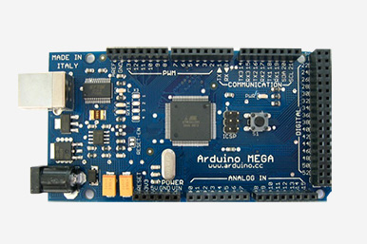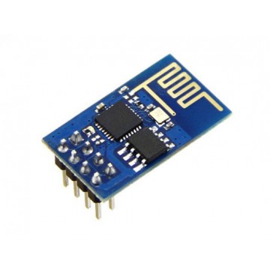

**Sensors**

**Components which monitors the environment-**

1. **DHT11**: It is a low-cost humidity and temperature sensor requiring a 5V power supply. It has a range of 20-90RH for measuring humidity with ±5% accuracy and has a range of 0-50º C for measuring temperature with an accuracy of ±2º C. It uses two-way single wire serial interface. It has a three-stage communication consisting of the request, response, and data reading. It contains a thermistor whose resistance changes with the change in temperature. Humidity is measured with the help of two electrodes separated by a moisture holding substrate between them. So as the humidity of atmosphere changes the resistances also changes and we can get the value using this formula.  
   Fig. 3 is a DHT11 sensor. [24],[25]

* For temperature sensing:   
   Temperature = (Vout * 100) / 5º C
* For humidity sensing:  
   RH = ((Vout / Vsupply) - 0.16) /0.0062 %

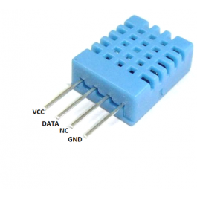Fig. 3

1. **MG811**: It is a reliable and stable CO2 sensor and has a low dependency on humidity and temperature. The module has both digital and analog output.[26]

When the sensor exposed to CO2，the electrodes reaction occurs and gives us the CO2 concentration in the atmosphere. Having a potentiometer gives us the freedom to tune the correct sensitivity required for the system.

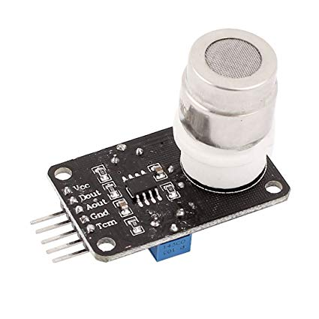Fig. 4

1. 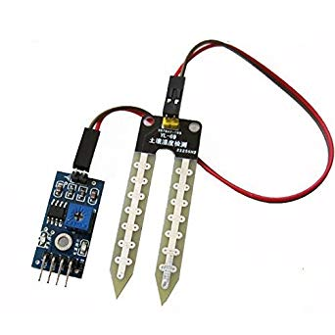**Soil-Moisture LM-393**: It is a cost effect and reliable soil moisture content detection module that work on 5V supply. It consists of two metal rods (Fig. 5) held apart through which current passes. The resultant resistance is high when soil moisture is low and vice-versa. The module is fitted with a potentiometer that can vary the sensitivity of the sensor. [27]

Fig. 5

1. 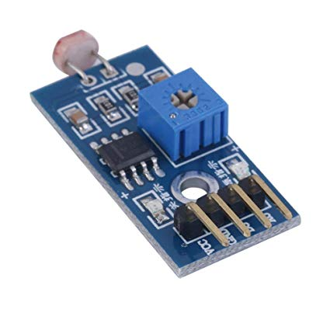**LDR LM-393:** It is an LDR module to detect the presence of ambient light intensity in the environment. It uses Cadmium Sulphide for the register material. The resistance of the LDR (light dependent resistor) changes with the change in intensity of light. The LM-393 module has both analog and digital output pin.

Fig. 6

1. **pH-Sensor:** It is low power (5V) soil pH sensor to measure the acidity of soil (Fig. 7). It has two components.
   * 1. pH probe: It has one glass and one reference electrode. Both of these are a hollow tube containing Silver-Chloride wire in Potassium-chloride solution. It compares the liquid inside the glass electrode which is known and compares it with the unknown liquid outside.
     2. pH sensor; it has a potentiometer that can vary the sensitivity of the sensor.

All these components sense the environment and provide the information to the Arduino Mega which in turn processes the data and convert into a percentage. This value is then forwarded to the cloud for further processing in JSON format.

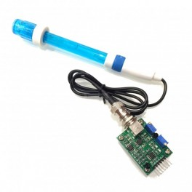

Fig. 7

**Actuators**

**Components which control the environment-**

1. **Peltier Module**- This is a cooling and heating unit which will control and balance the temperature to achieve optimum temperature in the greenhouse.
2. **Exhaust Fan**- To control the CO2 percentage and air quality as per standard level
3. **Air Humidifier**- To maintain a humidity level of the air.
4. **Water Sprinkler**- To maintain the moisture level in the soil.
5. **Acid Sprinkler**- To maintain an acid level of the soil.
6. **Alkaline Sprinkler**- To maintain alkalinity level of the soil.
7. **Artificial Light**- To provide artificial optimum lighting.

These components take the processed information from the cloud and set the environment inside the greenhouse best suited for optimum crop growth.

System Architecture

**Arduino Mega   
+ ATmega2560 µC**

**RELAY**

**ESP-8266**

Fig. 8

Fig. 8 show all the hardware contents of this ecosystem consisting of sensors and components to control the artificial environment. All the input sensors provide the environment information in the form of analog voltage ranging from 1-1024 (10bit) and one-wire data (DHT11). These data are then processed and converted to a readable percentage or rounded figures which can easily be calculated or used as a reference for easier decision making. These are directly connected to the Arduino Mega via its analog pin. It has a programable microcontroller that is programed to get the analog date from particular analog pin and convert it to digital data. It then appends all the sensor data in digital format and send it to cloud (in JSON format) per second. The cloud contains data set containing the optimal values for each environment parameter for the specific crop. The necessary decision is made on the cloud side depending upon the (optimal) threshold and necessary steps for control are sent through the Arduino for modifying the parameters. The respective environment conditions are sent to Android UI as notifications. The App also consist of control that which we can switch the actuators on or off manually. Arduino Mega (IoT Gateway) also communicates with the actuators through a relay (except the artificial lighting module). The relay is used because we cannot we a direct connection between the control circuit operating at 5V and the output device operating at 12V. The black and the red arrows represent the supply of 5V and 12V power respectively. The control circuit sends a switching signal to the relay which then provides 12V power supply to turn on the specific actuator. It is shown in Fig. 9 the two-way data transfer from hardware components to cloud and the UI, the data is encoded in JSON format as that’s the default input/output type of the HPE UIOT Platform.

**HPE UIOT PLATFORM**

Hardware

components

UI

JSON FORMAT

Fig. 9

Pseudo-Algorithm



Sensors Arduino Mega Cloud/UI Actuators  
Fig. 10

Fig. 10 shows the figurative overview as for how the system is going to function. Algorithm overview of the system is given below.

**Start**

1. Arduino Mega acquires sensor data continuously connected through its input pins.
2. Analog to Digital conversion of the sensor data on the Arduino Board.
3. Transmission of the data to the cloud (HPE UIOT Platform) through the IOT Gateway (Arduino Mega + ESP8266) using JSON encoding
4. If the data is above the threshold
   1. Server (i.e. cloud) automatically Turns ON the control measure by sending a signal to the Arduino.
   2. Sends a notification to the Intelligent Greenhouse Application
5. If the data is within a threshold
   1. Server (i.e. cloud) automatically Turns OFF the control measure by sending a signal to the Arduino.
   2. Sends a notification to the Intelligent Greenhouse Application
6. Else
7. Continue checking for the threshold condition for each sensor, GOTO Step 4
8. Endif

**End**

Information processing and Extraction

The entire system resides on the fact we have the correct environment parameters values is available for every crop that is to be cultivated. It can be downloaded from any government agricultural site. The information is loaded in the cloud as dataset which forms the optimal threshold for every crop. The various sensor data are then compared to the optimal value to make the decision.

The system architecture consists of an Arduino Mega microcontroller board, sensors like DHT11 temperature & humidity sensor, a moisture sensor, LDR Sensor, pH Sensor, CO2 Sensor, a Wi-Fi module i.e. ESP8266. The UI software consists of an android application which includes setting up of the profile for predefined irrigation based on the seasons or on daily and weekly mode. The software has also been programmed to send a notification to the farmer whenever the physical parameters sensed are below the threshold value and based on the farmers input a control signal will be sent to the Arduino Mega to either switch ON/OFF the irrigation. The Arduino Mega board controls all the activities taking place on board and acts as the IoT gateway. The sensor senses all the physical parameters and converts the analog value to digital value. Temperature and humidity sensors are used to measure the temperature and humidity respectively on the field. Soil Moisture Sensor is of a capacitive type and is used to measure the moisture of the soil.

This data is then transmitted to the IOT gateway. The IOT gateway then transmits the data to the cloud using the Wi-Fi module. The cloud in our system will include a Web Server, a database and a decision logic. The database will maintain the data received from the IOT gateway. The decision logic then decides whether the farmer action is needed to water the plants. For example, in the developed system a threshold for temperature is kept at 25 ◦C. Whenever the temperature goes above the threshold temperature, the database will trigger action to the decision logic which then sends a notification to Smart Greenhouse Android application. The cloud turns on the Peltier module to heating effect.

Decision making

|  |  |
| --- | --- |
| If | Then |
| Soil moisture level low | Turn on water sprinkler |
| Soil moisture level ok | Turn off water- sprinkler |
| CO2 conc. high | Turn on exhaust |
| CO2 conc. ok | Turn off exhaust |
| Humidity level low | Tun on nozzle |
| Humidity ok | Turn off nozzle |
| Ph low | Turn on the alkaline sprinkler |
| Ph high | Turn on the acidic sprinkler |
| Ph balanced | Turn off acidic and alkaline sprinklers |
| Temperature high | Turn on Peltier module and turn on the servo to cool down mode |
| Temperature low | Turn on Peltier module and turn on the servo to heat up mode |
| Temperature Ok | Turn off Peltier module |
| Ambient light low | Turn on Artificial light to a certain light level using PWM. |
| Ambient light OK | Turn off Artificial light. |

Conclusion And Discussion

This paper provides a model for an intelligent greenhouse its architecture and functionality. It depicts the benefit of using IoT in agricultural sector mainly in the greenhouse. Contrary to the other models where traditional monitoring analog systems are used, we not only monitor the parameters of the environment but also regulate them using actuators. In our proposed system we have been using 6 parameters but in fact the count is endless. We can include fertilization and pest removal module in this same model. We can also improve the model by using IP cameras that can be used for monitoring purpose also using image processing we can detect any kind of diseases in plants, yield rate of a plant and much more. Also, a module to check the quality and type of soil and recommend the crop best suited for this soil can be integrated that will benefit farmer. Using the cloud for data processing and analysis we can monitor and analyze the sensor data, and access historical data easily. All of these are low cost, low power sensors which can enable a to maintain, monitor and control any number of greenhouses siting in any corner of the globe as long as he has an active internet connectivity within them.

References

[1] Ashton K., “That ‘Internet of Things’ Thing,” *RFID J.*, p. 4986, 2009.

[2] “What is internet of things (IoT)? - Definition.” [Online]. Available: https://internetofthingsagenda.techtarget.com/definition/Internet-of-Things-IoT. [Accessed: 10-Dec-2018].

[3] J. Gubbi, R. Buyya, and S. Marusic, “Internet of Things (IoT): A Vision, Architectural Elements, and Future Directions,” *Atmos. Environ.*, no. 1, pp. 1–19, 2013.

[4] Jacob Morgan, “A Simple Explanation Of ‘The Internet Of Things.’” [Online]. Available: https://www.forbes.com/sites/jacobmorgan/2014/05/13/simple-explanation-internet-things-that-anyone-can-understand/#557bed561d09. [Accessed: 10-Dec-2018].

[5] D. Liu, X. Cao, C. Huang, and L. Ji, “Intelligent agriculture greenhouse environment monitoring system based on IOT technology,” *Proc. - 2015 Int. Conf. Intell. Transp. Big Data Smart City, ICITBS 2015*, pp. 487–490, 2016.

[6] K. A. Patil and N. R. Kale, “A model for smart agriculture using IoT,” *Proc. - Int. Conf. Glob. Trends Signal Process. Inf. Comput. Commun. ICGTSPICC 2016*, pp. 543–545, 2017.

[7] G. Sushanth and S. Sujatha, “IOT Based Smart Agriculture System,” *Int. J. Recent Innov. Trends Comput. Commun.*, vol. 2, no. February, pp. 177–181, 2017.

[8] J. Gutiérrez, J. F. Villa-Medina, A. Nieto-Garibay, and M. Á. Porta-Gándara, “Automated Irrigation System Using a Wireless Sensor Network and GPRS Module,” *IEEE Trans. Instrum. Meas.*, 2013.

[9] R. Nageswara Rao and B. Sridhar, “IoT based smart crop-field monitoring and automation irrigation system,” *Proc. 2nd Int. Conf. Inven. Syst. Control. ICISC 2018*, no. Icisc, pp. 478–483, 2018.

[10] N. Suma, S. R. Samson, S. Saranya, G. Shanmugapriya, and R. Subhashri, “IOT Based Smart Agriculture Monitoring System,” *Int. J. Recent Innov. Trends Comput. Commun.*, vol. 2, no. February, pp. 177–181, 2017.

[11] S. J. Bhasha and S. M. Hussain, “Agricultural field monitoring and automation using PIC16F877A microcontroller and GSM.,” vol. 3, no. 6, pp. 2155–2157, 2014.

[12] I. Mohanraj, K. Ashokumar, and J. Naren, “Field Monitoring and Automation Using IOT in Agriculture Domain,” *Procedia Comput. Sci.*, vol. 93, no. December 2016, pp. 931–939, 2016.

[13] H. Chang, N. Zhou, X. Zhao, Q. Cao, M. Tan, and Y. Zhang, “A new agriculture monitoring system based on WSNs,” *Int. Conf. Signal Process. Proceedings, ICSP*, vol. 2015–Janua, no. October, pp. 1755–1760, 2014.

[14] A. Sangeetha, P. Sarah, and G. Poovarasi, “IOT BASED HYBRID SYSTEM FOR PRECISION AGRICULTURE MONITORING USING WSN INTO MODERN INFORMATION AND COMMUNICATION TECHNOLOGY ( ICT ),” no. 2, pp. 3116–3124, 2018.

[15] D. Stipanicev and J. Marasovic, “Networked embedded greenhouse monitoring and control,” *Control Appl. 2003. CCA …*, pp. 1350–1355, 2003.

[16] Yunseop (James) Kim, R. G. Evans, and W. M. Iversen, “Remote Sensing and Control of an Irrigation System Using a Distributed Wireless Sensor Network,” vol. 57, no. 7, pp. 1379–1387, 2008.

[17] J. Shen, J. Song, Q. Han, S. Wang, and Y. Yang, “A remote measurement and control system for greenhouse based on GSM-SMS,” *2007 8th Int. Conf. Electron. Meas. Instruments, ICEMI*, pp. 282–285, 2007.

[18] “What are the major components of Internet of Things - RF Page.” [Online]. Available: https://www.rfpage.com/what-are-the-major-components-of-internet-of-things/. [Accessed: 12-Dec-2018].

[19] “Universal Internet of Things (IoT) Platform | HPE India.” [Online]. Available: https://www.hpe.com/in/en/solutions/iot-platform.html. [Accessed: 14-Dec-2018].

[20] “IoT Ecosystem Components: The Complete Connectivity Layer.” [Online]. Available: https://www.newgenapps.com/blog/iot-ecosystem-components-the-complete-connectivity-layer. [Accessed: 10-Dec-2018].

[21] “Arduino Reference.” [Online]. Available: https://www.arduino.cc/reference/en/. [Accessed: 16-Dec-2018].

[22] M. Mehta, “ESP8266 : A Breakthrough in Wireless Sensor Networks and Internet of Things,” *Int. J. Electron. Commun. Eng. Technol.*, vol. 6, no. 8, pp. 7–11, 2015.

[23] L. Louis, “Working Principle of Arduino and Using It As a Tool for Study and Research,” *Int. J. Control. Autom. Commun. Syst. (IJCACS), Vol.1, No.2, April 2016*, vol. 1, no. 2, pp. 21–29, 2016.

[24] Mouser Electronics, “DHT11 - Humidity and Temperature Sensor,” *Datasheet*, pp. 1–7, 2011.

[25] J. He, J. Qu, Y. Wang, and H. Pan, “The designing and porting of temperature &humidity sensor node driver based on ARM-Linux,” *Proc. - 2014 IEEE Work. Electron. Comput. Appl. IWECA 2014*, pp. 127–130, 2014.

[26] Telaire, “7001i CO2 Sensor,” vol. 2013, no. 2/5/2013, pp. 2–3.

[27] Datasheet, “LMx93-N , LM2903-N Low-Power , Low-Offset Voltage , Dual Comparators,” no. 1, 2018.