Gitops 1 app deployment
2 manages infra delivery
No records to track changes to k8s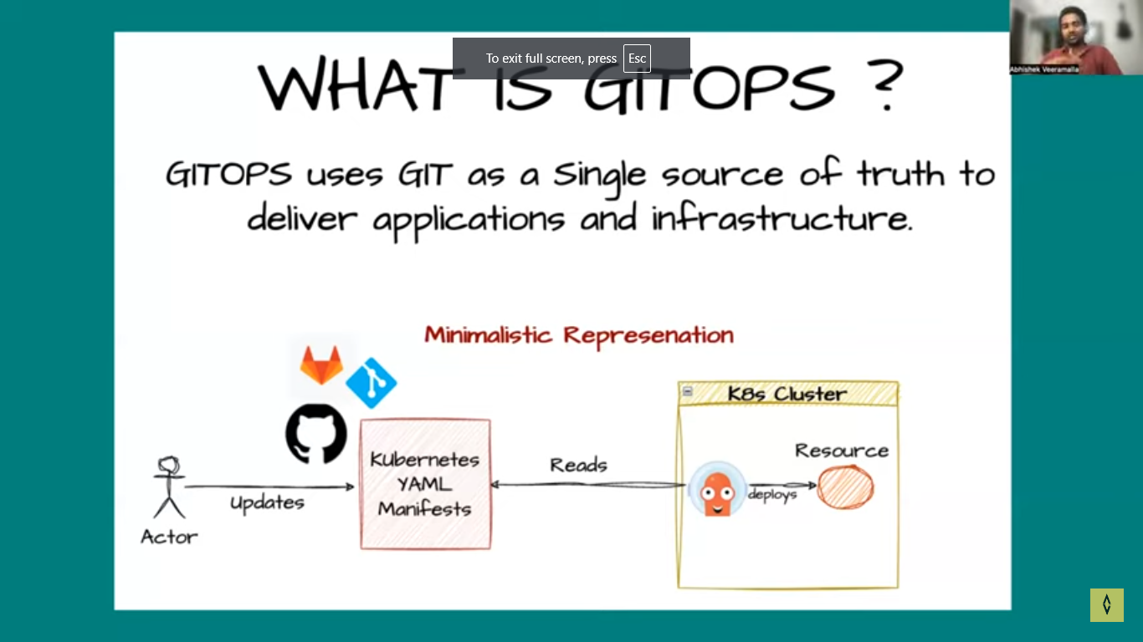
Deployment has mechanism of tracking
Either infra/app dep using yml
It solving problem were tracking of app/infra delivery and muc more
Wen ave 100 k8s cluster infra management is diff
As like as ci, cd also ave tracing

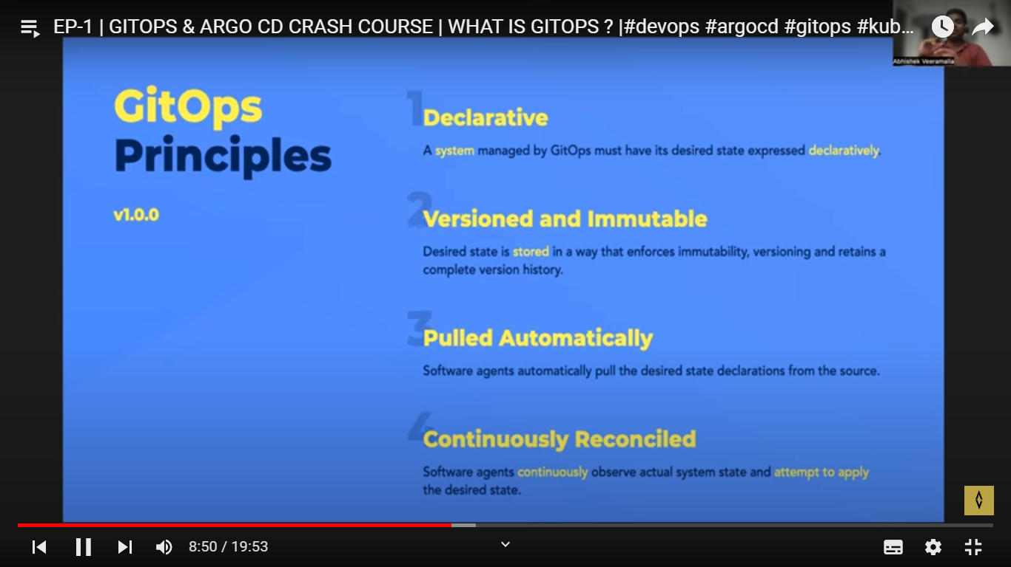

It can be s3,git
Canges pulled automatically
Can be Pull/push mechanis but cabges auto updated
Changes should be made in git for deploy
Security : except git nobody will make changes, it will be conti reconcile process
If unwanted canges done, gitops will override. Gitops watc and reads all res

Git ops stored everything about k8s, git in cache an any diff will override in k8s
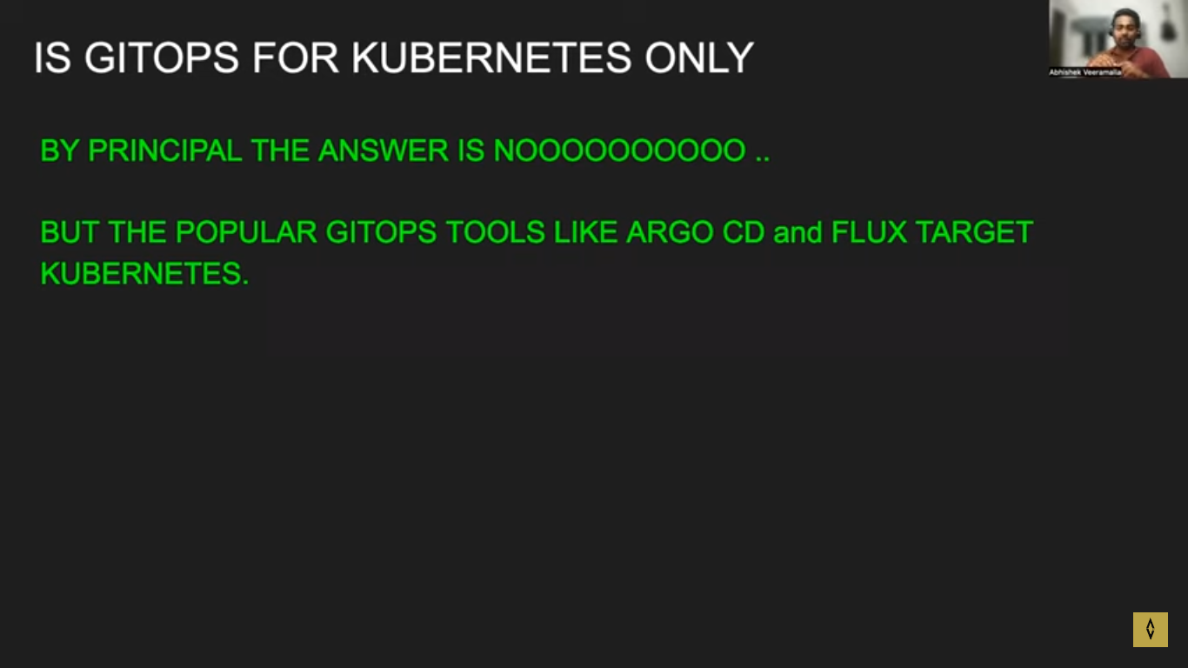

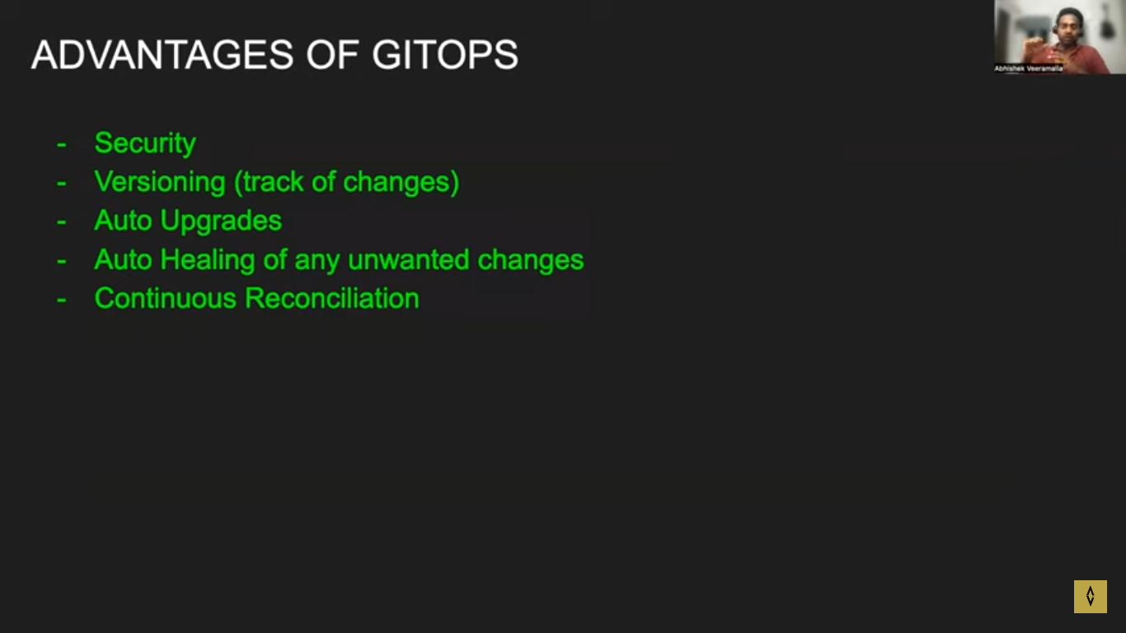

Sexurity : any changes will override
Versioning : use can use s3 also
