### Introduction

The PmodLib Pmod driver library is a collection of library functions designed to operate various Pmod modules attached to Digilent boards utilizing the PIC32 processor. This document describes the general use of the PmodLib Public API, source code location, and processor specific archive creation. Detailed documentation for each Pmod is located in a separate programmer's reference manual specific to that module.

**Overview**

The PmodLib driver library is written entirely in C utilizing MPLAB 8.80 and is based on the Microchip C32 bit C libraries. Each module has its own public API header. General use helper functions and functions common to specific communication protocols are shared between modules. The following modules and libraries are available in this release:

|  |  |
| --- | --- |
| PmodACL | The PmodACL is a 3-axis digital accelerometer module powered by the Analog Devices ADXL345. This library supports 4-wire SPI only. |
| PmodDA2 | The Pmod DA2 Digital to Analog peripheral module converts signals from digital values to analog voltages on two channels simultaneously with 12-bit resolution. Communication protocol supported is SPI. |
| PmodHB5 | The PmodHB5 2A H-bridge module is an ideal solution for robotics and other applications where logic signals are used to drive small to medium-sized DC motors such as the Digilent motor/gearbox. |
| PmodJSTK | The Digilent PmodJSTK joystick module is designed to be a versatile user interface that can be used in a wide variety of projects. The PmodJSTK has an Atmel ATtiny24 Microcontroller with 2K Flash, 128b EEProm, 128b of internal SRAM and a CTS252 Two Axis Resistive Joystick. The joystick also incorporates a center button. This center button, along with the two push buttons, are read by the microcontroller. Communication protocol supported is SPI. |
| PmodMIC | The PmodMIC is ideal for providing audio input for use with Digilent system boards. It has a microphone preamp with a dynamic range compressor and 12bit A/D converter. The PmodMIC is ideal for use with a Digilent system board and the PmodAMP1 to create a complete audio prototyping environment. Communication protocol supported is SPI. |
| PmodSF(16/128) | The Digilent PmodSF provides easily accessible non-volatile memory storage for Digilent FPGA and Microcontroller system boards. This module comes in 16Mbit and 128Mbit versions. Communication protocol supported is SPI. |
| BufferLib | N-Way buffer library, useful when recording audio from PmodMIC and storing to PmodSF. |

**Source and Archive Folders:**

Source code and binaries for PmodLib are included in PmodLib.zip and extract into the folder PmodLibArchive. Header files and source code for each module are located in PmodLibSrc, code for specific modules is located in a directory specific to that module. Code that is shared between modules is located in PmodCommon.

Precompiled binary archives are available for the Cerebot32MX4 and Cerebot32MX7, these files are located in PmodLib/lib. Precompiled archives are identified as follows: pmodlib_<PROC_MODEL>.a, for example the Cerebot32MX4 has a PIC32MX460F512L processor, projects utilizing this archive should include pmodlib_460.a. Include files are located in PmodLib/include, headers for a specific module are located in a directory specific to that module. A header file that includes all modules is provided as PmodLib/pmodlib.h.

**Archive Use:**

The following section provides instructions for configuring an existing project to utilize the pmodlib_460.a archive, this process is generic and can be used for all PIC32 processor models. If you are using a processor that does not have a precompiled archive, see the section in this document on "Archive Creation".

Directory Configuration:

Ensure that the directory PmodLib and its contents are accessible to your project, this folder does not have to be located in your project directory. In MPLAB, go to **Project->Build Options->Project**, select the **Directories** tab, on the directories tab select **Include Search Path** in the **Show directories for:**  combo box. Click **New**, then navigate to or type in the path for <PARENT_DIR>/PmodLibArchive/PmodLib/include. Repeat for **Library Search Path,** using <PARENT_DIR>/PmodLibArchive/PmodLib/lib. See examples below.

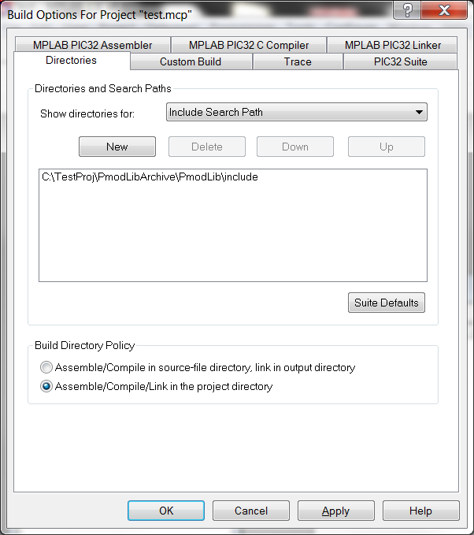 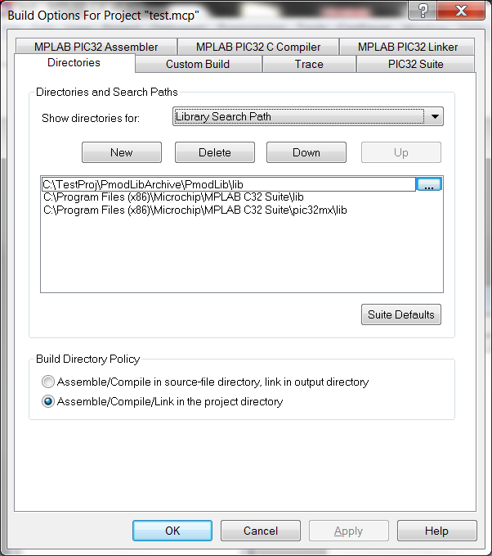

Project Configuration:

To use the archive in your project, you will need to explicitly add it to your project. If the project window is not currently open, open it by navigating to **View->Project**, project must be checked to view the project tree. If not already expanded, expand <PROJECT_NAME>.mcp, right click on **Library Files**, select **Add Files**, navigate to <PARENT_DIR>/PmodLibArchive/PmodLib/lib and select pmodlib_460.a. Your project tree should look similar to the example below:

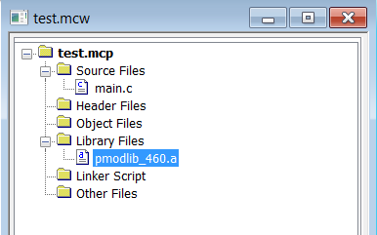

The final step is to include the PmodLib header in your project, since we included this path in the project include search path, adding the following line to your code will include pmodlib: #include <pmodlib.h>

See example below:

#include <pmodlib.h>

int main(void)

{

return 0;

}

All functions provided in PmodLib are now available for use in your project. Only those functions which are actually used will be linked with your project, greatly reducing the amount of space PmodLib will require in the final build.

**Archive Creation**:

To build an archive for boards other than the Cerebot32MX4 or Cerebot32MX7 an MPLAB v8.80 project has been included in PmodLibBuild.   
  
Procedure:

In MPLAB open <PARENT_DIR>/PmodLibArchive/PmodLibBuild/PmodLibBuild.mcp. Navigate to **Configure->Select Device**. In the **Device** combo box, select the processor model for your board, then clock **OK.**

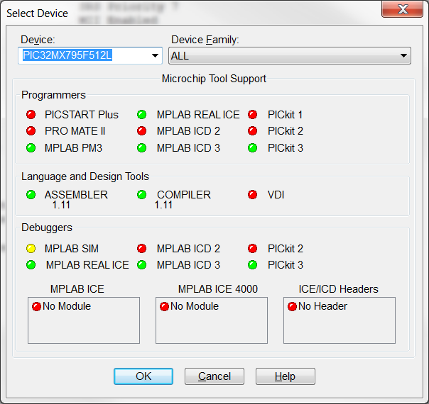

Next select the appropriate Programmer/Debugger for your board, under **Debugger** or **Programmer**. To build the archive navigate to **Project->Build All**. The archive will be built in <PARENT_DIR>/PmodLibArchive/PmodLib/lib as PmodLibBuild.a.