11.05.2026
https://www.facebook.com/share/v/14MbqjEhZmj/
Jkupdate news portal posted the media interaction of Hon’ble CM Omar Abdullah on Facebook. He stated that there was nothing in the proposal that went against the Reorganization Act or the Business Rules. He explained that decisions such as tapping telephones, suspending mobile services, or shutting down the internet had traditionally been issued through the Home Department. Since law and order and security were under the responsibility of the Hon’ble Lieutenant Governor, it was natural that such powers remained with the Hon’ble LG. He argued that if any situation had deteriorated and required internet or mobile shutdowns, the orders would have had to come from the Home Department under the Hon’ble Lieutenant Governor’s authority. Therefore, he believed it was better for these powers to remain with the Hon’ble LG rather than the elected government, as it would prevent unnecessary political complications for others who had no direct role in security matters. He further remarked that as long as responsibility for security and law and order remained with the Hon’ble Lieutenant Governor, these powers should also have remained under his control rather than being transferred to the elected government.
https://www.facebook.com/reel/2155879481928724
Asif Iqbal Naik Journalist posted the media interaction of Hon’ble Cabinet Minister Satish Sharma on Facebook. He told Hon’ble MLA Sunil Sharma that the people had already rejected him for sixty months while he remained in the opposition, and advised him not to behave in an aggressive or hot-headed manner as it would only invite public criticism and ridicule. He said that any disrespect toward the mandate of the people of Jammu and Kashmir or attempts at political manipulation and horse-trading were unacceptable. He emphasized that people supported leaders who promoted unity and inclusiveness, citing former Hon’ble Prime Ministers Atal Bihari Vajpayee and Dr. Manmohan Singh as examples of dignified and inclusive leadership. He further highlighted ongoing governance and development measures, including the distribution of appointment letters to selected candidates in Ganderbal through the Hon’ble Chief Minister and planned improvements in sports initiatives, Rehbar-e-Khel regularization, NYC enhancements, and financial support through Khelo India centers. He also noted the establishment of new sports infrastructure. While acknowledging administrative shortcomings over the past eleven years and suggesting that an inquiry would reveal several issues, he stressed a balanced and positive approach. He reiterated that the demand for statehood remained central and expressed hope that the Hon’ble Prime Minister of India, Hon’ble PM Narendra Modi, would fulfill the long-standing promise.
https://www.facebook.com/share/v/17VzJvDk7D/
APBH news portal posted the protest of All J&K Daily Wagers Sangharsh Samiti against government at Dogra Chowk, Jammu on Facebook, Where Sunny Kant Chib President of AJKDWSS addressed the media. He said that when the Jammu and Kashmir government was formed, it had made several promises to the poor and common people, but those promises had not been fulfilled. As a result, people were forced to come out on the streets in protest, as they felt betrayed and deprived of justice. He argued that if the government had delivered on its commitments, these citizens would have been in their homes instead of agitating. He further stated that repeated assurances of six months or one year given in cabinet meetings had proven meaningless. He described the protestors as ordinary, poor people with limited means, not from Tata-Birla or Ambani families and emphasized their hardship and struggle. He warned that if their demands were not addressed, they would intensify their protest by staging sit-ins outside ministers’ residences and offices. He concluded that continued neglect of the poor could lead to widespread unrest in Jammu and Kashmir, as people would no longer remain silent if justice was denied.
https://www.facebook.com/reel/1136306605336354
Milan news portal posted the interview of Taranjeet Singh Tony Congress on Facebook. He expressed deep concern over the deteriorating state of democracy and judiciary in India. He stated that courts had begun taking dictation from BJP and RSS affiliates even before drafting orders. He warned that if people’s faith in the constitutional system and rule of law breaks due to denial of justice, it would breed massive discontent and lead the country towards jungle raj. He criticized the Election Commission and BJP for manipulating elections, citing how 27 lakh votes were allegedly spoiled and the judge casually told voters to “try next time.” He accused the BJP-RSS of betraying the nation, claiming they had compromised institutions and were suppressing voices, including within the Hindu community. He highlighted growing public anger over delayed justice in cases like Ankit Bhandari and others, warning that continued injustice would turn ordinary people into rebels. He cautioned the government against repeating such tactics in Punjab, saying the state’s history and people’s resilience would not tolerate it. Finally, he urged that if democratic means fail, people might be forced to take to the streets for change.
https://www.facebook.com/share/v/16oFSY3bqu/
JK Channel news portal posted the interview of Representatives of the goldsmith association Jammu on Facebook. They said they had always supported government decisions, even during difficult times like COVID-19, but argued that such decisions should also begin with government departments that use large convoys and resources. Traders expressed concern that stopping gold purchases would severely affect their livelihoods, loan repayments and family responsibilities. They questioned how small artisans and shopkeepers would survive under such conditions, noting that market activity had already declined. While they supported national interest, they urged that the burden should not fall only on common traders. They also suggested that if austerity measures were needed, government officials should first adopt changes like reducing fuel-heavy convoys and using electric vehicles.
https://x.com/travellingdogra/status/2053686581614309846?s=20
Vikramjeet Singh Manhas President of AIURF posted on X, “Ten years ago, an initiative was taken to build a para gliding hub in Pancheri, but it was abandoned after just filling the plinth because no further funds were allocated. Jammu Tourism. Is there an order from above that nothing like this should be built in Jammu?”
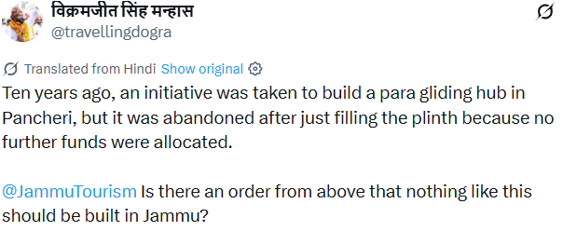

https://x.com/drgaganbhagat/status/2053692240015606099?s=20
Dr. Gagan Bhagat Deputy Chief Spokesperson of JKNC posted on X, “Enough with the twisted narratives and cheap politics! HCM Omar Abdullah Sb has made it crystal clear: 'I will NEVER encourage alcohol consumption.' CM J&K remarks were deliberately distorted by opponents to create unnecessary controversy and for their personal political gains. They stand exposed NOW. The Truth:
1. No new liquor shops have been opened or allotted under his government.
2. Not a single step taken to advertise, promote, or increase alcohol availability.
3. Shops exist only for those whose faith permits it – NOT to influence our youth or local community.
This is responsible, mature leadership – respecting cultural and religious values while focusing on real issues of Jammu Kashmir No fear-mongering, no lies, just facts and commitment to the people. Stop spreading misinformation and let us deliver what we promised.”
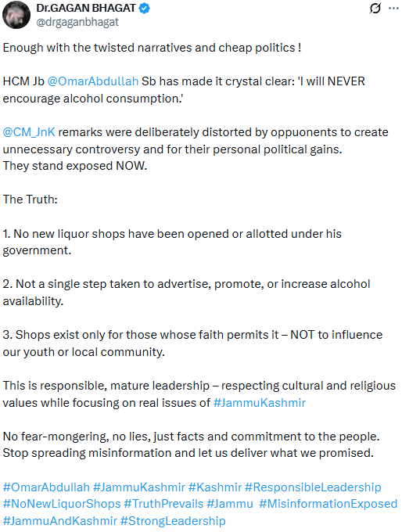

https://www.facebook.com/share/v/1FPs1c22ok/
JK Channel news portal posted the Protest of Rapido Bike, Scooty riders in favour of Rapido on Facebook. The riders said that Rapido had provided employment opportunities to many unemployed youths, allowing them to earn around ₹20,000 to ₹30,000 per month depending on their work. They explained that customers preferred Rapido because of its fixed fare system and reliable service, where riders followed proper GPS-based pickup and drop locations. They further stated that every rider had completed proper documentation, including Aadhaar, PAN card, driving license and bank details and had been officially registered on the platform. They argued that Rapido had helped them earn a livelihood when they had no other job opportunities. they had been instructed or forced to stop operations, which severely affected their income and daily survival, as many of them depended entirely on this work for loan repayments and household expenses. They urged the authorities and government to reconsider the decision, stating that the platform had provided safe, affordable and efficient transport services to the public. They also requested that proper dialogue be held with the company instead of suddenly shutting down their work.
https://www.facebook.com/share/v/1CeX6FkpKd/
Sunrise Mail News portal posted the interview of Sunil Dimple Mission Statehood on Facebook. He claims that the meeting could have addressed key issues such as statehood restoration, unemployment, wages for daily workers, land rights and pending regularisation of various workers. He alleges that many elections promise remain unfulfilled, including free electricity, LPG subsidies and employment opportunities. The discussion highlights concern of daily wage workers, contractual employees and landowners still waiting for government action. He also criticises rising prices of essential goods like fuel, gas and electricity, arguing that they are increasing pressure on common citizens. Allegations are made about political interference, delays in policy implementation and lack of transparency in decision-making. It is further claimed that government actions are affecting middle-class households and small businesses. The report also touches on broader political disputes between ruling and opposition parties over governance and accountability. Overall, it presents a critical viewpoint on unmet promises, economic burden, and political tensions surrounding Jammu and Kashmir’s administration.
https://www.facebook.com/share/v/1Gy5zWBAer/
JK 24 news portal posted the interview of Neeraj Kundan Congress Leader on Facebook. He stated that a senior opposition leader strongly criticized Hon’ble Prime Minister Narendra Modi and the BJP government, calling the recent statement on kidneys “unfortunate” and reflective of policy failures. He said the day is not far when Hon’ble Prime Minister Narendra Modi would ask citizens to donate one kidney for the nation and label those who refuse as anti-national. He accused the government of having no real concern for people, citing demonetization and the refusal to grant rights to daily wage workers despite quickly slapping PSA on elected MLAs. After 12 years in power, the Hon’ble Prime Minister had failed to deliver, making the 2047 vision unrealistic. He said, has always stood as a secular force for the poor and backward classes. He highlighted the suffering of daily wagers in Kashmir whose voices remain unheard. He also condemned the deletion of Rahul Gandhi’s video from Instagram as a new tactic to control social media, proving there is no level playing field in the country. He urged the BJP to focus on reversing failed policies instead of slogans.
https://www.facebook.com/share/v/1Cn4SA6FGL/
Take One Digital Network news portal posted the protest of Non-gazetted employees at Government Medical College Doda, demanding immediate finalisation of Recruitment and Service Rules for staff appointed after 2019 on Facebook. They are regular/permanent government employees appointed in 2019 in the Health and Medical Education Department, Jammu & Kashmir, through the Jammu & Kashmir Services Selection Board (JKSSB). Since our appointment, they have been consistently demanding the framing of Service Rules for the past six to seven years. Without notified Service Rules, our career progression and future growth have become completely stagnant. We have raised this demand multiple times through proper channel — from the Principal of our institution to the Administrative Secretary, Health and Medical Education Department. We have also met Hon’ble Minister Sakina Itoo after the formation of the current government. However, our demand is yet to be resolved. This is not limited to non-gazetted employees of GMC Doda alone. The same demand exists in all newly established Government Medical Colleges in the UT of Jammu & Kashmir — GMC Doda, Kathua, Rajouri, Anantnag, Baramulla, Handwara, and Udhampur (total 7 colleges). They urgently request that Service Rules for non-gazetted employees be framed, finalized and notified at the earliest and placed in the public domain.
https://x.com/IltijaMufti_/status/2053701087157539033?s=20
Iltija Mufti PDP posted on X, “JK CMs expected U-Turn on the refusal to prohibit liquor shops lacks logic. He claims it’s wrong to impose a ban on Hindus consuming alcohol since their religion doesn’t forbid it. If this is the case how have Hindu majority states like Gujarat & Bihar banned alcohol successfully without a whimper?
We are proud of J&K’s secular credentials but deeply unfortunate & insensitive for its Chief Minister to dismiss the religious sensibilities of the majority with such indifference.”
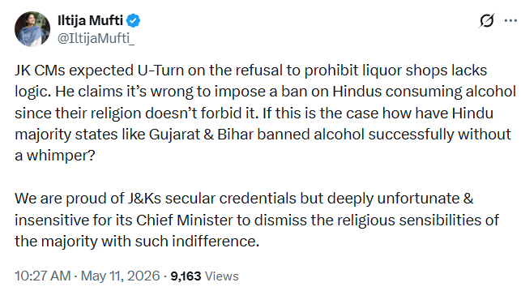

https://www.facebook.com/share/v/1BcxmGmpFC/
The State Sentinel news portal posted the interview of RTO Jammu & Kashmir officer Mr. Jasmeet Singh on Facebook. He stated that under the Motor Vehicle Act and Rules, every aggregator is required to obtain a valid license, and specific conditions must be fulfilled to secure it. He explained that while services like Nova Cabs and other aggregators are operating in the region, Rapido has not applied for an aggregator license in Jammu & Kashmir and is therefore operating without authorization from the Transport Commissioner’s office. He clarified that the action being taken is not intended to shut down any service but is focused on ensuring public safety and security, especially for women, children and elderly passengers. The officer emphasized that it is necessary for aggregators to have a proper office, maintain transparent operational data and ensure accountability regarding who is operating the services and from where. He added that vehicle fitness, helmet usage, rider verification and proper registration are essential safety requirements. According to him, in case of any untoward incident, authorities must be able to trace the service provider, which makes licensing and documentation mandatory. He further stated that enforcement action is currently underway and vehicles operating without valid licenses will be seized as per rules. However, he clarified that the department is not against Rapido or any other aggregator specifically, but is acting against all violations uniformly. If any aggregator applies for a license and fulfills all legal requirements, the department is prepared to issue permission within a week. He also explained that the action was initiated after violations came to the department’s notice and were verified and that operating without a license cannot be permitted. He reiterated that the government is open to allowing aggregators to operate in Jammu & Kashmir, provided they comply with regulations. He stated that Rapido and similar services must apply for a license, establish a local office and share required operational data, after which they can legally resume services in the region.
https://www.facebook.com/reel/1455054135949506
Karandeep Singh, State General Secretary of JKPYC, posted on Facebook that people have suffered a lot due to rising inflation and said it is now time for a change in government. He claimed that Prime Minister Narendra Modi had referred to wartime conditions as a reason for the situation, but questioned the government’s policies and accused it of failing to control inflation while using patriotism to divert attention. He said that people are patriotic and ready to sacrifice for the country, but patriotism should not be used to hide government failures. He also criticised statements asking people to reduce buying gold, use less petrol and diesel, and cut down on cooking oil consumption, asking why common citizens should bear the burden. He further said that ordinary people, jewellers, and gold buyers are suffering because of government policies, while real issues are being ignored in the name of patriotism and war. He added that people were once told to continue supporting the government even if fuel and gas prices rose sharply, but now public opinion is changing and people are responding.

https://www.facebook.com/reel/1177059741153039
Bharat Monitor news portal posted the video of Mandeep Singh Chib President of Yuva Rajput Sabha on Facebook where he announced that the Yuva Rajput Sabha organisation will celebrate its Foundation Day on May 12 and extended advance greetings to the Rajput community. He said the Sabha has decided to continue supporting the Hon’ble Lieutenant Governor’s anti-drug campaign by organising an anti-drug awareness rally. The rally will begin from Hari Niwas Gate at around 9 AM and pass through Bawa, Amphalla, Rihadi, BC Road, and Bus Stand before concluding at Maharaja Hari Singh’s statue. He stated that a langar and prasad distribution would also be organised to spread the message of unity and brotherhood. Emphasising the need to keep youth away from drugs, he praised the administration for taking action against drug-related activities, including arrests and demolition of properties linked to the drug trade. He added that drugs are weakening the country’s youth and future, making public awareness campaigns essential. He also invited the media fraternity to cover the event, highlighting the important role of media in spreading awareness and connecting society with the administration.

