**Create a Spring Web Project using Maven**

**Steps:**

1. Creating a Spring Boot Project Using Spring Initializr

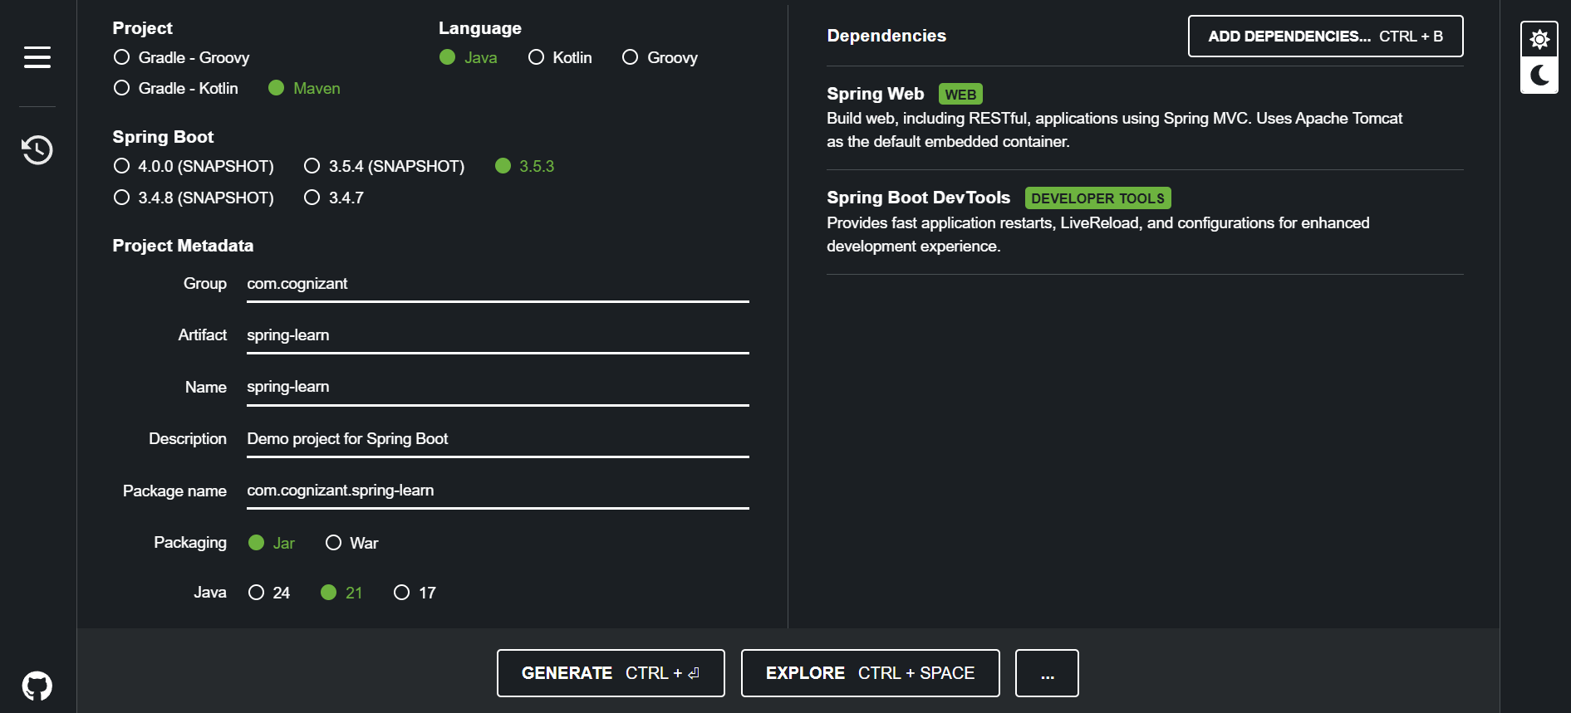

Click generate a zip with name spring-learn will be downloaded.

1. Extract the zip in a proper work location.
2. Open any editor

I am using intellij select open option to open the project.



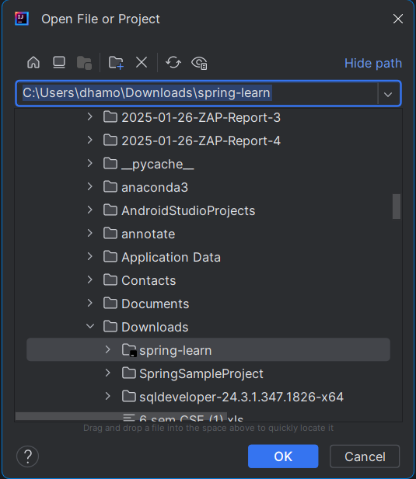

Select the project and open. Rebuild the maven and build the project with proper JDK. Here I am using java 21.

1. Run the SpringLearnApplication.java from the following path

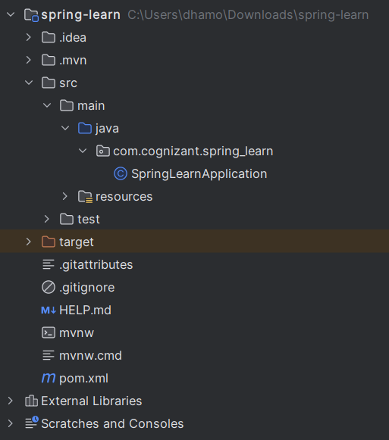

1. The application run at the port number 8080 at localhost in tomcat server.

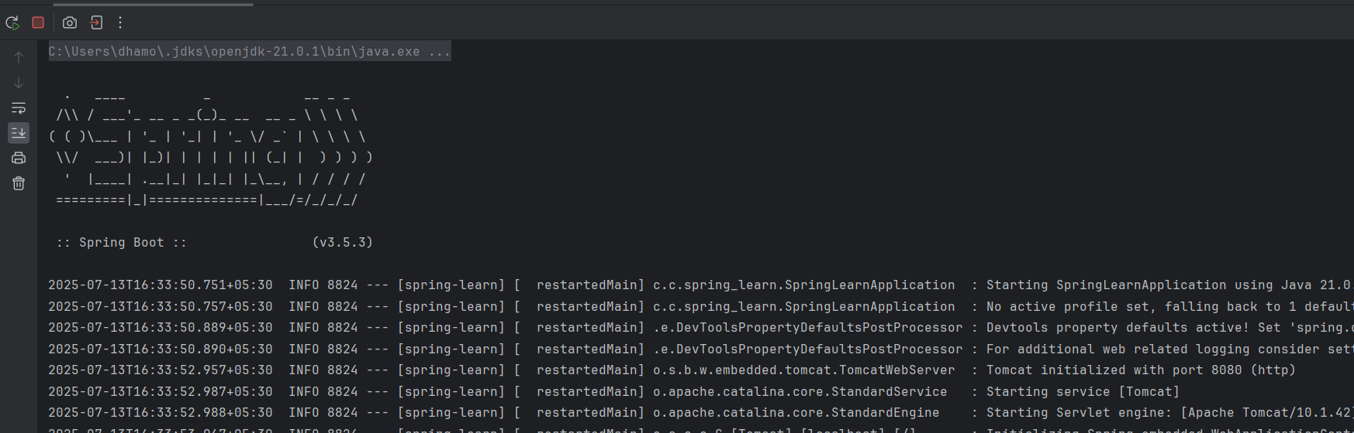  
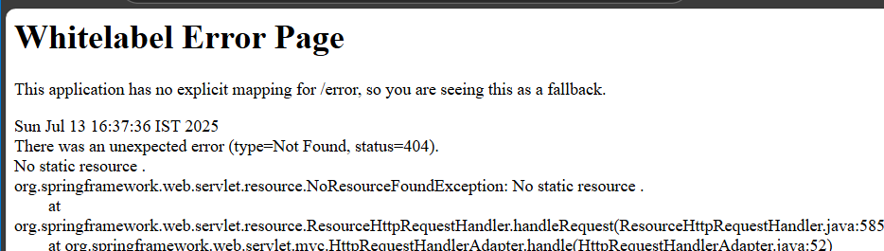

The above is a custom error shown by SpringBoot at port 8080.

SME to walk through the following aspects related to the project created:

1. src/main/java - Folder with application code.
2. src/main/resources - Folder for application configuration.
3. src/test/java - Folder with code for testing the application.

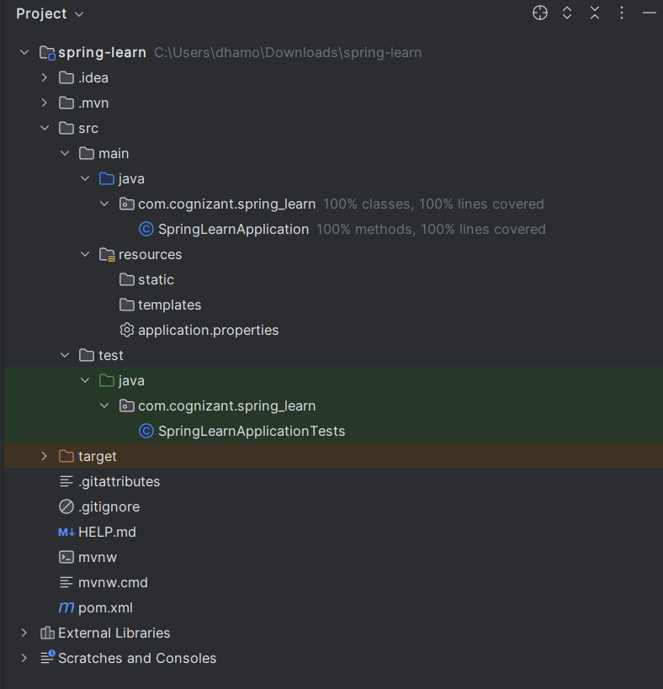

Project structure.

1. SpringLearnApplication.java - Walkthrough the main() method.

package com.cognizant.spring_learn;  
  
import org.springframework.boot.SpringApplication;  
import org.springframework.boot.autoconfigure.SpringBootApplication;  
  
@SpringBootApplication  
public class SpringLearnApplication {  
  
 public static void main(String[] args) {  
 SpringApplication.*run*(SpringLearnApplication.class, args);  
 }  
  
}

1. Purpose of @SpringBootApplication annotation

The @SpringBootApplication annotation is a **convenience annotation** that is used to mark the **main class** of a Spring Boot application. It enables several key Spring Boot features through meta-annotations.

1. pom.xml
   1. Walkthrough all the configuration defined in XML file
   2. Open 'Dependency Hierarchy' and show the dependency tree.

pom.xml

<?xml version="1.0" encoding="UTF-8"?>  
<project xmlns="http://maven.apache.org/POM/4.0.0" xmlns:xsi="http://www.w3.org/2001/XMLSchema-instance"  
 xsi:schemaLocation="http://maven.apache.org/POM/4.0.0 https://maven.apache.org/xsd/maven-4.0.0.xsd">  
 <modelVersion>4.0.0</modelVersion>  
 <parent>  
 <groupId>org.springframework.boot</groupId>  
 <artifactId>spring-boot-starter-parent</artifactId>  
 <version>3.5.3</version>  
 <relativePath/> <!-- lookup parent from repository -->  
 </parent>  
 <groupId>com.cognizant</groupId>  
 <artifactId>spring-learn</artifactId>  
 <version>0.0.1-SNAPSHOT</version>  
 <name>spring-learn</name>  
 <description>Demo project for Spring Boot</description>  
 <url/>  
 <licenses>  
 <license/>  
 </licenses>  
 <developers>  
 <developer/>  
 </developers>  
 <scm>  
 <connection/>  
 <developerConnection/>  
 <tag/>  
 <url/>  
 </scm>  
 <properties>  
 <java.version>21</java.version>  
 </properties>  
 <dependencies>  
 <dependency>  
 <groupId>org.springframework.boot</groupId>  
 <artifactId>spring-boot-starter-web</artifactId>  
 </dependency>  
  
 <dependency>  
 <groupId>org.springframework.boot</groupId>  
 <artifactId>spring-boot-devtools</artifactId>  
 <scope>runtime</scope>  
 <optional>true</optional>  
 </dependency>  
 <dependency>  
 <groupId>org.springframework.boot</groupId>  
 <artifactId>spring-boot-starter-test</artifactId>  
 <scope>test</scope>  
 </dependency>  
 </dependencies>  
  
 <build>  
 <plugins>  
 <plugin>  
 <groupId>org.springframework.boot</groupId>  
 <artifactId>spring-boot-maven-plugin</artifactId>  
 </plugin>  
 </plugins>  
 </build>  
  
</project>