**MahaShakthiYogam**

**Development Plan**

**Vijay Radhakrishnan**

**January 29, 2013Table of Contents**

1. Terminologies - 3 -

2. Introduction - 3 -

2.1. Agreed Organization - 3 -

2.2. Objective - 3 -

3. Approaching the Problem - 3 -

3.1. Methodologies used - 3 -

3.2. Task Processing - 3 -

3.3. Resource Allocation - 4 -

3.4. Clustering - 4 -

4. MahaShakthiYogam Requirements - 4 -

5. Problem Statement and scope of the solution - 4 -

6. - 4 -

6.1. Identification of the Core Business - 4 -

6.2. Identification of the Program Leader - 4 -

6.3. Identification of the “List of Project Leaders” - 4 -

7. Roles and Responsibilities - 5 -

7.1. Program Leader - 5 -

7.2. Process- Quality Assurance Manager - 5 -

7.3. Project Leader - 5 -

8. Quality - 5 -

9. Risk / Recommendations - 6 -

10. Sample Workpackage assessment Symphony BMW - Engen Celik - 6 -

11. Annex 1 – MSY Data 7

12. Annex 2 – Yoga Market Trends 7

# Terminologies

Technical Manager or Program Leader – **Program Leader - <Branch>** where Branch is Embedded, Design Calculations, Transportation etc.

Project Leader – **Project Leader**

Project Manager **- Project Manager**

Bid Manager – **Bid Manager**

**Business Manager – Business Manager**

These are inserted as Document Properties. Check “Einfügen -> Feld->Docproperty->”

Alt+F , EigenSchaften -> Anpassen

# Introduction

## Agreed Organization

## Objective

To propose a detailed internal structure of the Delivery Model 3-5 through the Program Departmentby capturing

# Approaching the Problem

The Author presents an Object oriented approach to the current problem and applying the system engineering methodologies of treating the Business Organization as a Highly Interactive System

## Methodologies used

* UML Business Use case Diagram
* UML Activity diagram

## Task Processing

* 1. What should be done?
  2. Who should do what?
  3. When should that be done?

## Resource Allocation

* 1. Who should own which Resource?
  2. Who should own which resource to what and when?

## Clustering

* 1. Group similar functions interdependent as one department and different functions as other department.

# MahaShakthiYogam Requirements

Re1#13 – Recruiting needs to be given a minimum of 4 weeks time plus SoWs to find a right candidate

# Problem Statement and scope of the solution

Statement - Efficient use of resources and structure for the Tech Org structure

|  |  |
| --- | --- |
| Parameter | Value |
| Number of Companies | 3 to 5 in 2013 |
| Total Number of Practioners | 100 |
| Total Number of teachers | 3 |

# MahaShakthiYogam

## Identification of the Core Business

1. Stress Management & Reduction Courses
   1. Personal
   2. Corporate
2. MahaShakthiYogam / PranaShakthi
3. MahaShakthiYogam / GnanaShakthi
4. MahaShakthiYogam / AtmaShakthi

## Identification of the Program Leader

The selection of the Program Leader with right vision and leadership qualities are critical to overall success of the Business. Profiling of the pool helps identify the possible Program Leader as per qualities suggested in chapter Roles and responsibilities

Naming this Position Program Leader as manager is not good enough. Leadership skills are must.

## Identification of the “List of Project Leaders”

The list of potential Project Leaders is crucial to the execution success of the Workpackage.

For each business manager, the possible list of such WP leaders should be identified. For example, with Michael Dahms BU, there were 2 such Engineers out of 25. This task has to be performed for each Business manager and if necessary a structured training given to short listed candidates

Business Mangers provide the list of potential Workpackage possibilities (ex. BMW, Audi, Cassidian)

The engineers who could be future potential WP leaders already present or who could be placed at these customers shall be identified

Please note that the Core team (50%-60%) shall be Customer and domain centric.

**Project Leader** is 100% customer centric.

# Roles and Responsibilities

## Program Leader

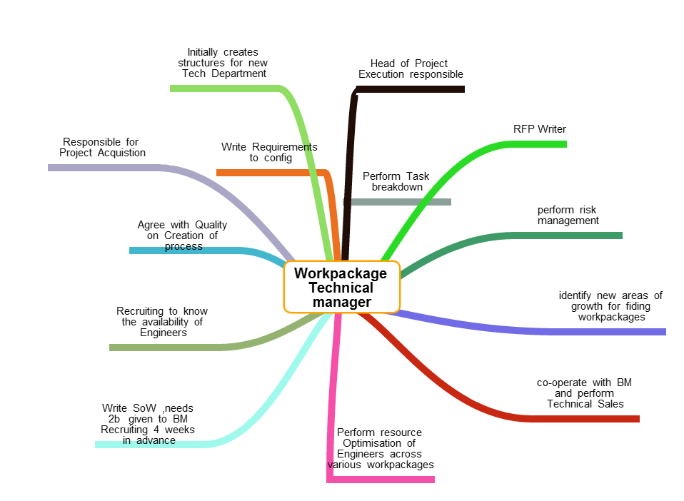

## Process- Quality Assurance Manager

## Project Leader

# Quality

* Quality has to be an Integral function to the lifecycle of the Workpackage
* Since MATIS has different customers each Workpackage differing in complexity, one size fits all shall not work
* MATIS Quality Department shall define 5 levels of QAL (Quality Assurance Level A-E)

# Risk / Recommendations

# Sample Workpackage assessment Symphony BMW - Engen Celik

1. Sample work package with BMW
   1. 18 small work packages listed in Big Work package
   2. Grouped based on System / Software / Validation & Verification(test)
   3. Automobile projects have more end to end life cycles
2. System Engineering Expert – Maximum one Guy is same as Functional Safety requirements classified under the SW department
3. Classification of Software requires
   1. Functional Safety (Automobile domain specific) – High Level Software requirements
   2. Middle level (Modelling- Communication interfaces) – Embedded Systems engineer with experience of 5 years can fit here
   3. Low level Driver developer – Core low level Sw-Hw expert In designing memory , chips, low level bus specifications , optimisations etc. (Generic requirement)
4. Validation and test
   1. System Integration
   2. SW-HW integration
   3. SW-SW Integration
   4. Unit testing
5. Technical Leadership (Project , Risk , Resource management)
6. Quality & Process Management (For example – review policy)
7. Average estimation from the Author is about 6.5 people for 8-9 months which is about 8000 Hours + Risk including the Ramp up and peak development phase

# Annex 1 – MSY Data

The ones in Green are considered embedded generic Projects based on Annex 2 Trends and priority should be given to them over the Design Calculations Workpackage because of the risk in matching the existing Matis pool resources to the Work package needs

|  |  |  |  |  |  |  |  |
| --- | --- | --- | --- | --- | --- | --- | --- |
| **Title of the Workpackage** | **Branch** | **Customer** | **Type** | **Volume of Workpackage in Manhours** | **Duration** | **Other comments (Optional)** | **Onsite/Offsite** |
| Design ETVS & ETVD | Aerospace / Defense | Eurocopter | Design Calculations | 10000 | 3 months | WP Proposal together with partner ELAN AUsy & Altair | MATIS Interface @Customer, Engineers at MATIS office |

# Annex 2 – Yoga Market Trends

Embedded systems are a combination of electronics and software sitting in machines or devices. This covers a wide range of applications ranging from consumer/fashion based technologies such as those found in mobile phones, to safety-critical applications such as avionics or railway signalling.

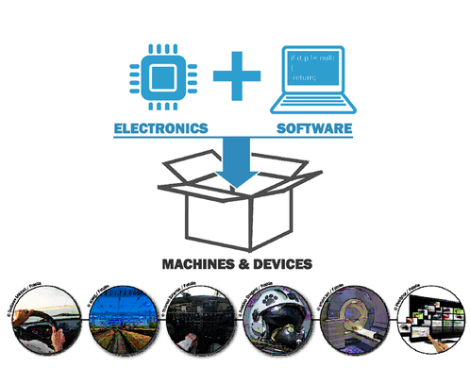

The necessity to perform more intelligent tasks implies an increase in complexity of embedded systems. Stronger needs in terms of connectivity as well as intensification in criticality  handling – both in terms of safety and security – are also key trends: it is expected complex embedded systems will generate a $2 trillion market by 2015 (source: IDC – September 2011).

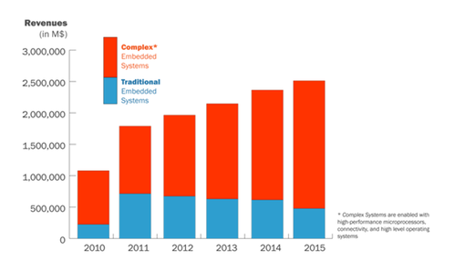

Connectivity, Complexity and Criticality are concrete challenges for Embedded Systems, no matter the industry: everybody is concerned. When adding cost and time constraints to the overall picture, the market’s needs for dedicated expertise and support becomes quite obvious.