

IT3060 – HCI Lab Sheet 05
IT23609426 – M.A.D.Y.Dharmasena

Activity 1: Mobile & Cross-Platform Frontend Comparison
Criteria | Flutter | React Native | Kotlin Multiplatform | Swift / SwiftUI
Development Speed | High (Hot Reload, rich UI widgets) | High (Fast Refresh, vast npm library) | Moderate (UI built per platform or via Compose) | Moderate (Platform-specific for iOS)
Code Reusability | ~90% (Single codebase for iOS/Android/Web) | ~85–90% (Shared logic & core UI) | ~60–80% (Shared business logic, native UI) | 0% (iOS/macOS only)
Performance | High (Compiled to native ARM code via Dart) | Near-Native (Hermes engine, JSI bridge) | Native (Compiles to native binaries) | Highest (Native Apple hardware optimization)
Ecosystem Support | Large & rapidly growing (pub.dev) | Massive (npm, huge community & libraries) | Growing (Strong Kotlin/Android backing) | Massive within Apple ecosystem
Learning Curve | Moderate (Requires Dart knowledge) | Low-Moderate (JavaScript/TypeScript, React) | High (Requires Kotlin & native platform knowledge) | Moderate (Swift & SwiftUI concepts)
Web Compatibility | Good (Canvas/HTML renderer) | Moderate (React Native for Web) | Experimental (Compose for Web/Wasm) | None (Apple platforms only)
AI/ML Integration | Good (tflite_flutter, Google ML Kit) | Excellent (TensorFlow Lite, On-Device Bridge) | Native access to CoreML/TensorFlow | Excellent native CoreML integration
Real-time Features | High (WebSockets, Firebase SDKs) | High (Socket.io, Firebase, WebSockets) | High (Kotlin Coroutines & Flow) | High (Network framework, WebSockets)
Maintenance Cost | Low (Single codebase for all platforms) | Low-Moderate (Single team, dependency updates) | Moderate (Platform-specific UI maintenance) | High (Requires separate Android team)
Security | High (Obfuscation, secure storage plugins) | High (Hermes bytecode compilation, Keychain/Keystore) | High (Native security APIs) | Highest (Native iOS Secure Enclave access)

Recommendation for FitFlow
Selected Stack: React Native (TypeScript).
Justification: FitFlow needs to be delivered quickly and efficiently, as it is a mid-sized start-up with budget constraints. With ~90% code reusability between iOS and Android, React Native integrates effortlessly with TensorFlow Lite to adjust workouts on-device, with direct camera access for computer vision nutrition logging and live WebSocket/Firebase support for community features.

Activity 2: Backend, Database, and Authentication Comparison
Metric / Feature | Node.js (Express / NestJS) | Python (FastAPI) | Go (Golang)
Performance & Concurrency | High (Event-driven asynchronous I/O) | Moderate (ASGI / AsyncIO) | Extremely High (Goroutines & channels)
Development Speed | Fast (Vast npm ecosystem, JS/TS end-to-end) | Fast (Auto OpenAPI docs, clean syntax) | Moderate (Verbose error handling)
AI/ML Native Ecosystem | Moderate (JS wrappers around C/C++ models) | Native (PyTorch, TensorFlow, OpenCV) | Moderate (Gorgonia, CGO bindings)
Real-time Capabilities | Excellent (Socket.io, WebSockets) | Good (WebSockets via Starlette) | Excellent (Native WebSocket, low latency)
Maintainability & Scaling | High with NestJS architecture | High with pydantic type safety | High (Strict typing, simple structure)

2. Database Options Comparison
Database | Type | Scalability | Health Data & Query Suitability | Real-time Native Support
PostgreSQL | Relation(SQL) | High (Read replicas, partitioning) | Excellent (ACID compliant, JSONB for unstructured data) | No (Requires Listen/Notify or Redis)
MongoDB | Document (NoSQL) | Horizontal (Auto-sharding) | High (Flexible schemas for workout logs & food items) | Change Streams supported
Firebase Firestore | Document (NoSQL) | High (Managed serverless) | Moderate (Query limits, higher cost at scale) | Native out-of-the-box realtime listeners
AWS DynamoDB | Key-Value (NoSQL) | Unlimited (Low latency at scale) | High (Requires careful single-table design) | DynamoDB Streams

Authentication Solutions
Solution | Security & Compliance | Real-time / OAuth Integration | Cost Structure | Maintenance Effort
Firebase Auth | GDPR / CCPA compliant | Native Google/Apple OAuth, seamless Firebase sync | Generous free tier, pay-as-you-go | Very Low (Fully managed)
AWS Cognito | HIPAA / GDPR compliant | Standards-based SAML / OAuth 2.0 | Tiered based on Monthly Active Users (MAUs) | Moderate (AWS IAM configuration)
Auth0 | HIPAA / GDPR / ISO27001 | Turnkey social logins & MFA | Expensive for scaling startup user bases | Low
Supabase Auth | GDPR / Row Level Security | PostgreSQL RLS + OAuth 2.0 | Predictable open-source pricing | Low-Moderate

Recommendation for FitFlow
Backend Engine: Node.js with Express / NestJS while the heavy computer vision and AI model processing will be accomplished with a lightweight Python FastAPI microservice
Database Layer: processing will be accomplished with a lightweight Python FastAPI microservice. Database Layer: MongoDB for user profile, past workouts and nutrition history and Firebase Firestore for live messaging, activity feeds and real-time sync.
Authentication: Firebase Auth with OAuth (Google, Apple) and JSON Web Tokens (JWT) for secure request validation, without any state.

Activity 3: Technology Comparison Matrix
Evaluation Criteria | Weight | Stack 1: React Native + Node.js + Firebase/Mongo + Firebase Auth | Stack 2: Flutter + FastAPI + PostgreSQL + Supabase | Stack 3: Native (Swift/Kotlin) + Go + DynamoDB + Cognito | Stack 4: KMP + NestJS + PostgreSQL + Auth0
Development Speed | 0.15 | 8 / 10 | 8 / 10 | 5 / 10 | 6 / 10
Performance & UX | 0.15 | 8 / 10 | 8 / 10 | 10 / 10 | 8 / 10
AI/ML Integration | 0.15 | 8 / 10 | 9 / 10 | 8 / 10 | 7 / 10
Real-time Support | 0.10 | 9 / 10 | 8 / 10 | 8 / 10 | 7 / 10
Security & Privacy | 0.15 | 9 / 10 | 8 / 10 | 9 / 10 | 9 / 10
Cross-Platform Reusability | 0.10 | 9 / 10 | 9 / 10 | 5 / 10 | 7 / 10
Cost & Maintainability | 0.10 | 9/ 10 | 8 / 10 | 5 / 10 | 6 / 10
Ecosystem Support | 0.10 | 9/10 | 8 / 10 | 8 / 10 | 7 / 10
Weighted Total Score | 0.10 | 8.55/10 | 8.25 / 10 | 7.4 / 10 | 7.20 / 10

Activity 4: High-Level System Architecture & ADR
System Layering & Data Flows
Frontend Layer: React Native mobile application executing TensorFlow Lite models on device for real-time motion/workout guidance without latency.
API Gateway & Core Backend: Node.js/Express server routing RESTful HTTP requests, handling JWT authorization, and managing user profiles.
AI & Computer Vision Microservice: Python (FastAPI) service running model inference for image-based food recognition during camera nutrition logging. Real-time Layer.
Real-time Layer: Firebase Firestore & WebSockets providing instant community push notifications, activity feed updates, and social challenges.
Data Storage & Cache: MongoDB Atlas for user/nutrition documents, Redis for session caching and rate limiting, and AWS S3 for secure encrypted photo storage.

Data Flow
- Personalized Workout Plans
- The user provides fitness goals, fitness levels, and preferences via the React Native application.
- It is forwarded to the API Gateway in Node.js / Express. Using Node.js, you can get the user's historical metrics and profile information from MongoDB Atlas.
- Data is sent to the Python / FastAPI AI microservice (or locally run with on-device TensorFlow Lite).
- The AI engine creates an adaptive, customized daily exercise routine. The plan generated is stored in MongoDB Atlas, and plans that are used daily are stored in Redis for quick retrieval. The customized workout plan is delivered back to the React Native interface.
Flow: User $→$ React Native $→$ Node.js Gateway $→$ Python AI Microservice $→$ MongoDB Atlas / Redis $→$ React Native

- Social Sharing

- The user sets a workout target in the React Native app. The request goes to the Node.js API Gateway, and media assets are stored in AWS S3.
- Post metadata and social links are directly stored in Firebase Firestore. Activity notifications and feeds are pushed in real-time to private social circles using WebSockets / Firebase Cloud Messaging.
- Other community members receive the post and interact with them in real-time.
Flow: User $→$ React Native $→$ Node.js Gateway $→$ Firebase Firestore / AWS S3 $→$ WebSockets $→$ Private Social Circles
- Nutrition Tracking
- The user takes a picture of his meal or enters food information through the React Native level camera interface.
- The request payload is passed through the Node.js Gateway to the Python FastAPI (Computer Vision ML) service.
- Using the computer vision / Google ML Kit, the AI service is used to process the image and determine what food is in the frame and the macronutrients. Nutrition logs verified by users are kept in the MongoDB Atlas database.
- Automated feedback and diet recommendations are returned and shown in the React Native App.
- This flow begins with one user using the User app, then calls the User app React Native camera (which is included with the starter kit), then calls the User app's Node.js Gateway, which calls the Python AI Service (Vision ML), which calls the User app's MongoDB Atlas, which is called by the User app.
Flow: User $→$ React Native Camera $→$ Node.js Gateway $→$ Python AI Service (Vision ML) $→$ MongoDB Atlas $→$ React Native

3. Security Considerations
- A redesigned FitFlow architecture guarantees the highest level of health and personal data security and adherence to GDPR and CCPA requirements.
- Data Transmission: All network communication is encrypted with HTTPS / TLS 1.3.
- Data stored in MongoDB Atlas for user data and media stored in AWS S3 is encrypted at rest with AES-256. Managed Firebase Auth, which provides secure multi-factor authentication on top of Google/Apple OAuth and stateless JSON Web Tokens (JWT). Isolation of regular end-user data from administrative resources using role-based access control (RBAC) authorization.
- Mobile Client Security: Hermes bytecode compilation, key pinning, secure token storage using iOS Keychain and Android Keystore.
- API Protection: Input sanitization, parameter validation, rate limiting with Redis, OWASP Top 10 vulnerabilities protection.
- Granular privacy toggles for private social circles, audit logging and automated tools to help with user data access and deletion requests under GDPR.
4. Scalability Considerations
- The system architecture provides for accelerated scalability on all layers of application: Microservice Containerization: Running node.js and python backend services in Docker containers and orchestrating them with Kubernetes.
- Load Balancing: Distribute dynamically in stateless instances of Node.js API.
- In-Memory Caching: High-performance Redis layer to cache frequent queries and reduce database workloads.
- A combination of horizontal auto-sharding in MongoDB Atlas and automatic scaling in Firebase Firestore.
- Decoupled AI Architecture: Independent Python FastAPI microservice for scaling compute resources independently from intensive ML image processing. Edge / Local Processing: Do adaptive workout calculations on device using TensorFlow Lite models to reduce server usage.
- Content Delivery Network (CDN): Media transfer with high speed across the world for user uploaded progress media.
5. Integration Considerations
- FitFlow seamlessly integrates with external health ecosystems, cloud services, and platform utilities:
- Supported background sync for continuous biometric and step tracking: Apple HealthKit & Google Health Connect / Google Fit.
- For real-time data sync, remote configuration and push notification use, Firebase Ecosystem.
- Computer Vision / ML Frameworks: Support for integration with TensorFlow Lite and Google ML Kit for on-device food logging.
- Payment Gateways: Stripe and Apple / Google In-App Purchases for premium subscription tiers management.
- Third Party Messaging: SendGrid / Twilio for transactional emails and multi-factor security alerts.
- OpenAPI (Swagger) API Documentation: API versioning and partner integration are made clear with OpenAPI (Swagger) API Documentation.

6. Architecture Decision Record (ADR)
Field | Details
Status | Accepted
Context | FitFlow requires a scalable, secure, and cross-platform architecture supporting real-time social interactions, adaptive AI workouts, instant camera nutrition tracking, and GDPR/CCPA data privacy compliance.
Decision | Use the same code base for both platforms (frontend mobile delivery) using the same language (React Native / TypeScript); use Node.js / Express for main API gateway services, Python FastAPI for computer vision ML microservices, MongoDB Atlas / Firebase Firestore for storage, Firebase Auth for identity management, and Redis for in-memory caching.
Rationale | Isolates ML tasks to dedicated microservices, supports having ~90% code reusability on iOS/Android, speeds up time to market for a mid-sized team, and provides turnkey real-time functionality.
Consequences | Multi-runtime maintenance (Node.js, Python) and dual-database operating management are required, and the system will be most flexible and independent from scaling.

Final Architecture
The new tech stack creates a solid base for the application redesign of FitFlow. React Native gives a quick user involvement throughout iOS and Android. This combination of Node.js, MongoDB Atlas, Firebase Auth, and Firestore provides secure authentication, low-latency social interaction, and central business operations, as well as primary data persistence. Python FastAPI microservices and TensorFlow Lite power core machine learning capabilities. This system, along with Redis caching and GDPR-compliant security measures, guarantees high performance, robust privacy assurances, and future scalability for startups.
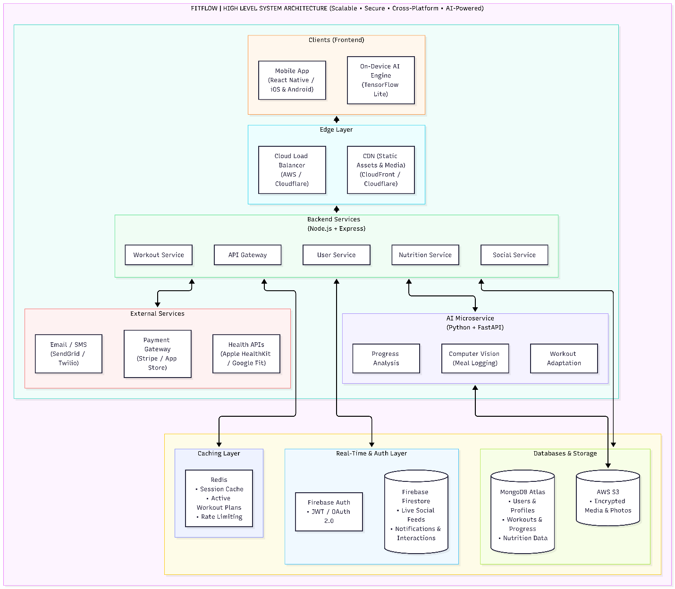

Activity 5 – GitHub repository link

