用两种方法求圆周率
#include <math.h>
#include <stdlib.h>
#include <iostream>
using namespace std;

double Gregory() {
double pi = 0.0;
int s = 1, n = 1;
while (true) {
double t = double(s) / n;
if (fabs(t) < 1e-6) break;
pi += t;
s = -s; n += 2;
}
return pi * 4;
}
double MonteCarlo() {
int count = 0, N = 1000000;
for (int i = 0; i < N; ++i) {
double x = double(rand()) / RAND_MAX;
double y = double(rand()) / RAND_MAX;
if (x * x + y * y <= 1.0) ++count;
}
return double(count) / N * 4;
}
int main() {
cout << "Gregory : " << Gregory() << endl;
cout << "Monte Carlo 0: " << MonteCarlo() << endl;
cout << "Monte Carlo 1: " << MonteCarlo() << endl;
}

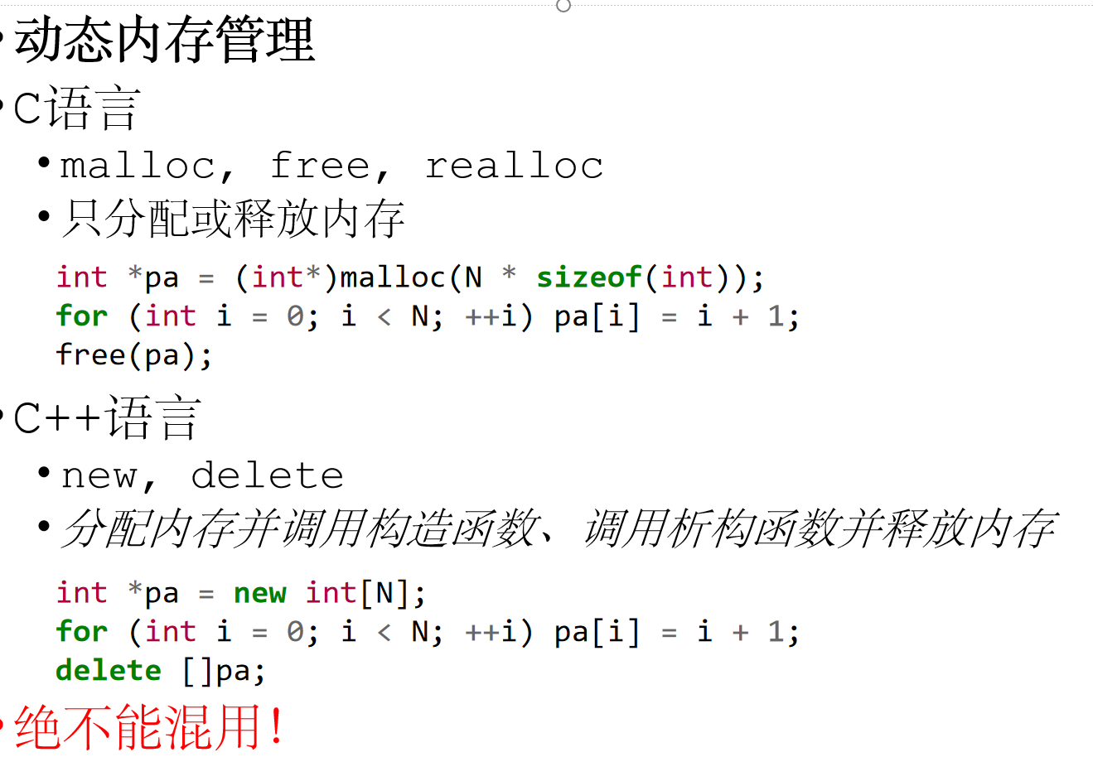
标准输入输出
C语言
scanf, printf
scanf("%d %d", &a, &b);
printf("%d %d", a, b);
C++语言
cin, cout
cin >> a >> b;
cout << a << ' ' << b;
慎用scanf！
必须提供正确的指针，且保证存储空间
慎用字符串输入！
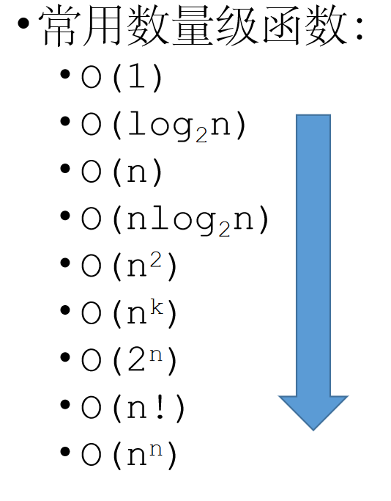

判断逆序
#include <iostream>
using namespace std;

// 定义栈的最大容量
#define MAX_SIZE 100

// 栈结构体
struct Sqstack {
char data[MAX_SIZE]; // 存储栈元素的数组
int top; // 栈顶指针
};

// 初始化栈
void initStack(Sqstack &s) {
s.top = -1;
}

// 判断栈是否为空
bool Stackempty(Sqstack &s) {
return s.top == -1;
}

// 压栈操作
bool push(Sqstack &s, char e) {
if (s.top == MAX_SIZE - 1) { // 栈满了
return false;
}
s.data[++(s.top)] = e;
return true;
}

// 弹栈操作
bool pop(Sqstack &s, char &e) {
if (Stackempty(s)) { // 栈空了
return false;
}
e = s.data[(s.top)--]; // 返回栈顶元素并减少栈顶指针
return true;
}

// 判断字符是否符合栈的匹配规则
bool judgechar(Sqstack &s, char *p) {
char e;

// 向栈中压入字符，直到遇到 '@' 或 '#'
while (*p != '@' && *p != '#') {
if (!push(s, *p)) { // 压栈失败
return false;
}
p++;
}

// 如果遇到 '#'，直接返回 false
if (*p == '#') return false;

p++; // 跳过 '@' 或 '#'

// 比较栈中元素和剩余的字符
while (*p != '#') {
if (pop(s, e) && e == *p) {
p++;
} else {
return false;
}
}

// 检查栈是否为空
return Stackempty(s);
}

int main() {
Sqstack s;
initStack(s); // 初始化栈

char input[] = "abc@cba#"; // 这里的输入可以根据需要修改

if (judgechar(s, input)) {
cout << "匹配成功!" << endl;
} else {
cout << "匹配失败!" << endl;
}

return 0;
}
宗罪变后缀表达式
#include <iostream>
#include <cstring>
#include <cctype> // for isdigit and isalpha

using namespace std;

#define MAX_SIZE 100 // 最大栈大小

// 定义栈结构
struct SqStack {
char data[MAX_SIZE]; // 栈内数据
int top; // 栈顶指针
};

// 初始化栈
void InitStack_sq(SqStack &s, int size) {
s.top = -1;
}

// 判断栈是否为空
bool StackEmpty(const SqStack &s) {
return s.top == -1;
}

// 压栈操作
void Push_sq(SqStack &s, char ch) {
if (s.top < MAX_SIZE - 1) {
s.data[++s.top] = ch;
}
}

// 弹栈操作
bool Pop_sq(SqStack &s, char &ch) {
if (!StackEmpty(s)) {
ch = s.data[s.top--];
return true;
}
return false;
}

// 获取栈顶元素
bool GetTop_sq(const SqStack &s, char &ch) {
if (!StackEmpty(s)) {
ch = s.data[s.top];
return true;
}
return false;
}

// 判断操作符的优先级
int precedence(char op) {
if (op == '+' || op == '-') return 1;
if (op == '*' || op == '/') return 2;
if (op == '^') return 3;
return 0; // '(' 和 ')' 没有优先级
}

// 判断字符是否为操作符
bool isOperator(char ch) {
return ch == '+' || ch == '-' || ch == '*' || ch == '/' || ch == '^' || ch == '(' || ch == ')';
}

// 判断运算符的优先级，返回 true 如果栈顶运算符优先级大于或等于当前运算符
bool preop(char stackOp, char currentOp) {
return precedence(stackOp) >= precedence(currentOp);
}

// 栈销毁
void DestroyStack_sq(SqStack &s) {
s.top = -1;
}

// 主函数，执行中缀转后缀
void getsuffix(char exp[], char suffix[]) {
SqStack S;
InitStack_sq(S, 10); // 初始化栈，最大栈大小为10
Push_sq(S, '#'); // 压入栈底符号

char *p = exp;
char ch;
int k = 0;

while (*p != '\0') {
ch = *p++; // 获取当前字符

if (!isOperator(ch)) {
suffix[k++] = ch; // 如果是操作数，直接加入后缀表达式
continue;
}

switch (ch) {
case '(':
Push_sq(S, ch); // 左括号压栈
break;

case ')':
while (Pop_sq(S, ch) && ch != '(') {
suffix[k++] = ch; // 右括号时，弹栈直到遇到左括号
}
break;

default: // 处理运算符
while (GetTop_sq(S, ch) && preop(ch, ch)) {
suffix[k++] = ch; // 弹出栈顶的运算符
Pop_sq(S, ch);
}
Push_sq(S, ch); // 将当前运算符压栈
break;
}
}

suffix[k] = '\0'; // 添加字符串结束符
DestroyStack_sq(S); // 销毁栈
}

int main() {
const char expression[] = "a+b*(c^d-e)^(f+g*h)-i";
char suffix[MAX_SIZE];

getsuffix(expression, suffix);
cout << "后缀表达式为: " << suffix << endl;
return 0;
}
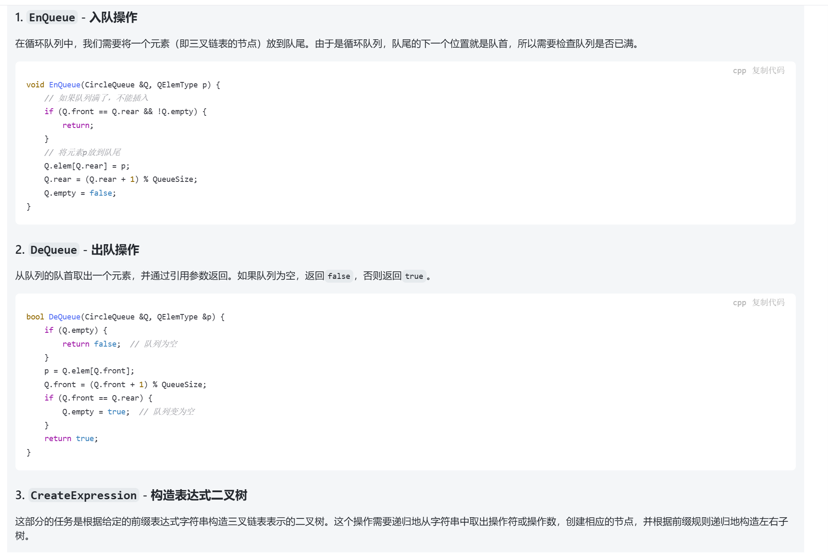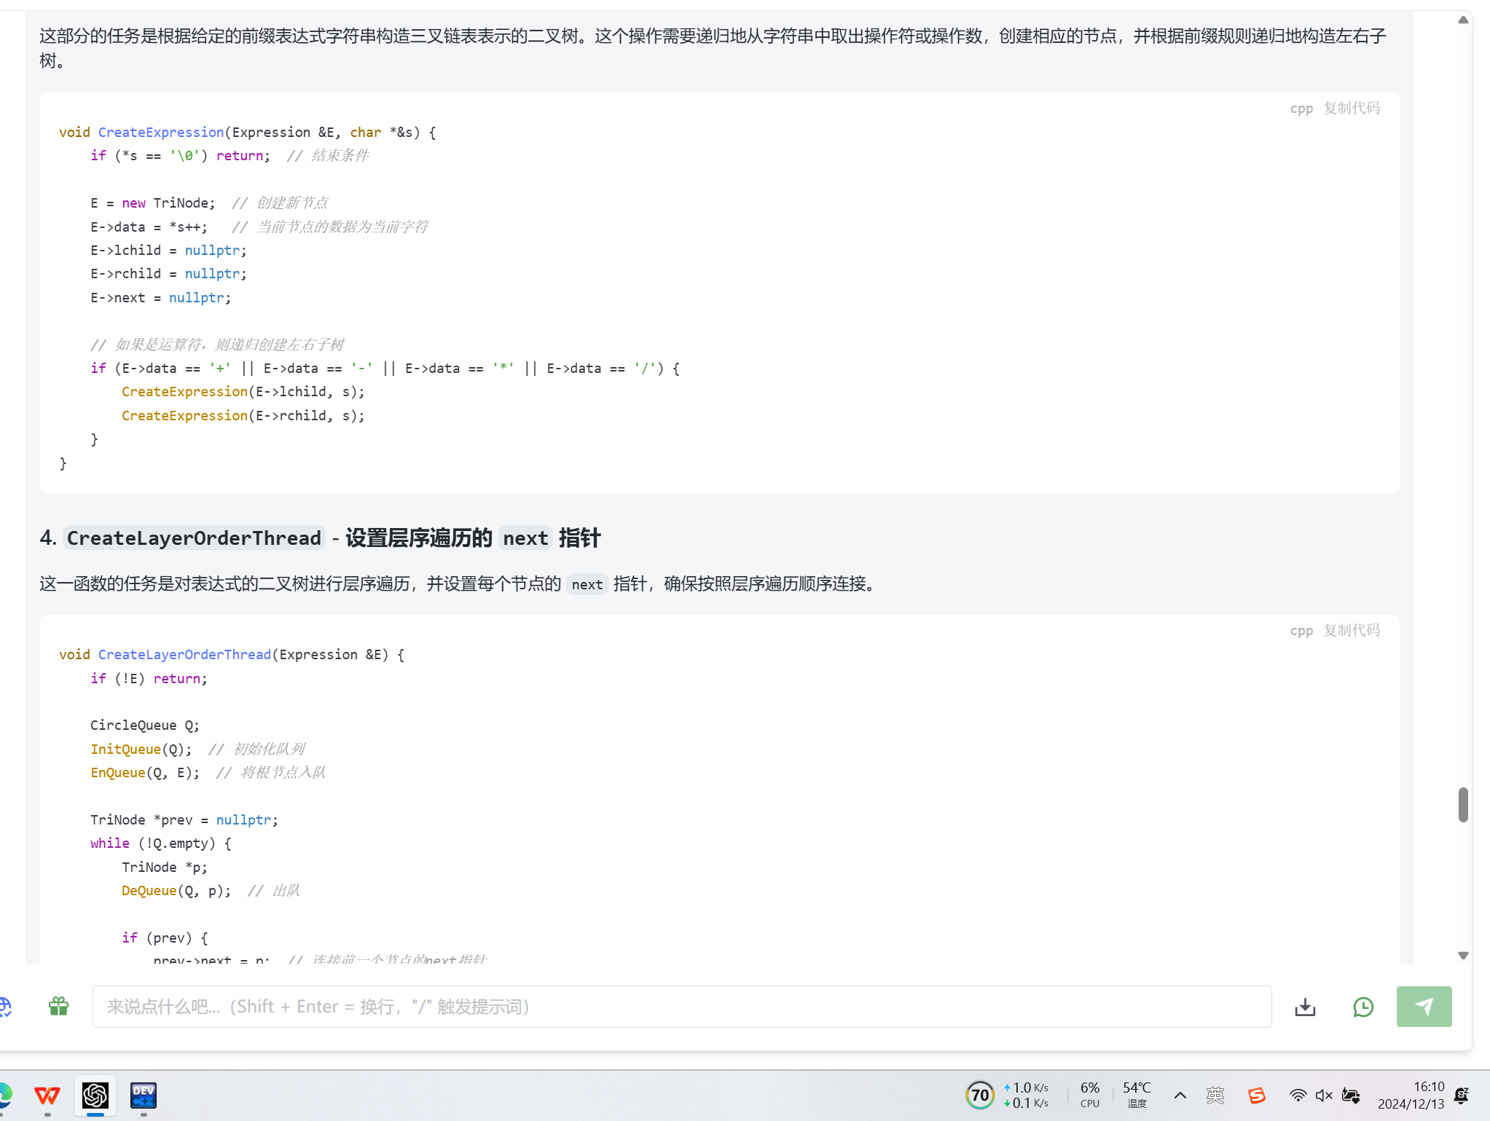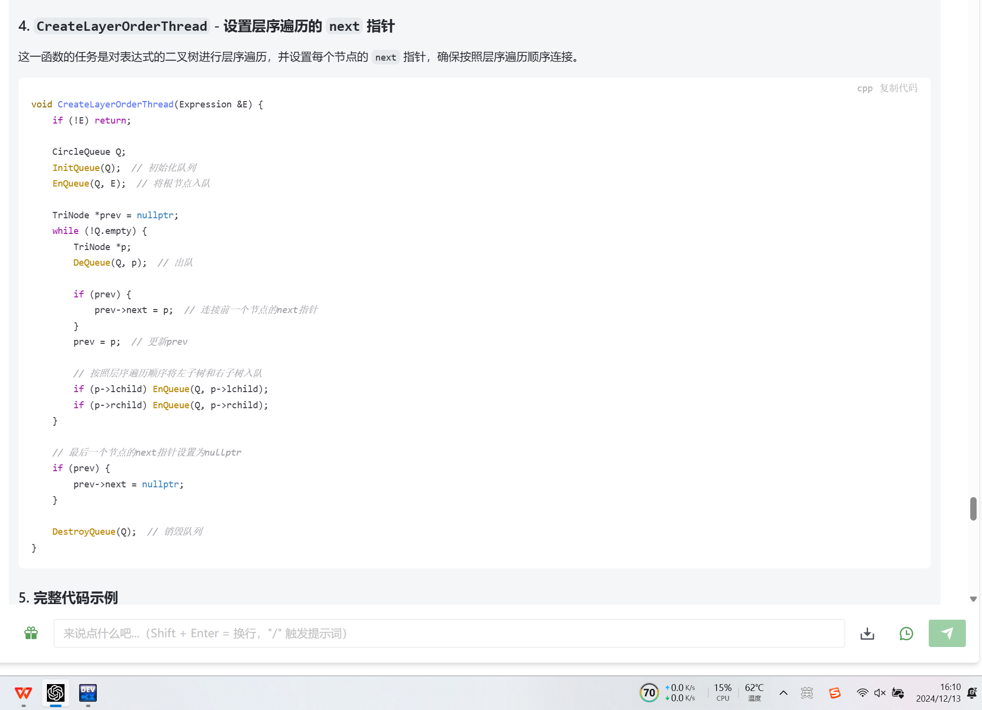#include <cstdio>
#include <cstring>
using namespace std;

typedef char TElemType;
typedef struct TriNode {
TElemType data;
TriNode *lchild;
TriNode *rchild;
TriNode *next;
} *Expression;

const int QueueSize = 8;
typedef TriNode *QElemType;
typedef struct {
QElemType *elem;
int front;
int rear;
bool empty;
} CircleQueue;

void InitQueue(CircleQueue &Q) {
Q.elem = new QElemType[QueueSize];
Q.front = 0;
Q.rear = 0;
Q.empty = true;
}

void DestroyQueue(CircleQueue &Q) {
delete []Q.elem;
}

void EnQueue(CircleQueue &Q, QElemType p) {
if (Q.front == Q.rear && !Q.empty) return; // 队列已满
Q.elem[Q.rear] = p;
Q.rear = (Q.rear + 1) % QueueSize;
Q.empty = false;
}

bool DeQueue(CircleQueue &Q, QElemType &p) {
if (Q.empty) return false; // 队列为空
p = Q.elem[Q.front];
Q.front = (Q.front + 1) % QueueSize;
if (Q.front == Q.rear) Q.empty = true;
return true;
}

void CreateExpression(Expression &E, char *&s) {
if (*s == '\0') return;
E = new TriNode;
E->data = *s++;
E->lchild = nullptr;
E->rchild = nullptr;
E->next = nullptr;

if (E->data == '+' || E->data == '-' || E->data == '*' || E->data == '/') {
CreateExpression(E->lchild, s);
CreateExpression(E->rchild, s);
}
}

void CreateLayerOrderThread(Expression &E) {
if (!E) return;
CircleQueue Q;
InitQueue(Q);
EnQueue(Q, E);

TriNode *prev = nullptr;
while (!Q.empty) {
TriNode *p;
DeQueue(Q, p);
if (prev) prev->next = p;
prev = p;

if (p->lchild) EnQueue(Q, p->lchild);
if (p->rchild) EnQueue(Q, p->rchild);
}

if (prev) prev->next = nullptr;
DestroyQueue(Q);
}

void LayerOrderTraverse(Expression E) {
TriNode *p = E;
while (p) {
printf("%c", p->data);
p = p->next;
}
printf("\n");
}

int main() {
char *str = new char[12];
strcpy(str, "-+a*b-cd/ef");
char *s = str;
Expression exp;
CreateExpression(exp, str);
delete []s;
CreateLayerOrderThread(exp);
LayerOrderTraverse(exp);
return 0;
}
