# IT0021 Family

## OP Structure for country fields

IT0021, country fields

BR: 0397

SG: 0412

US: 0106

### ABAP report (by AI)

ABAP report to download structure information

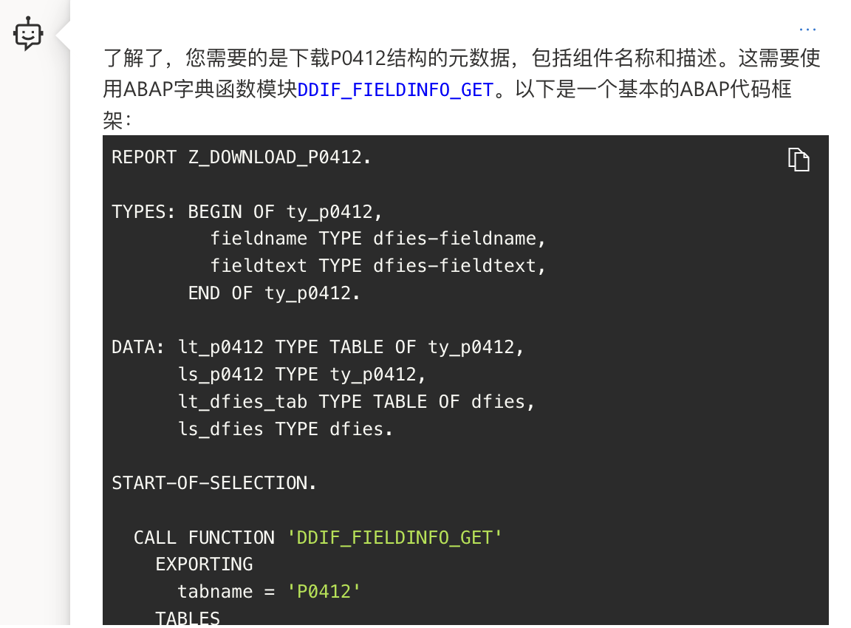

REPORT Z_DOWNLOAD_P0412.

TYPES: BEGIN OF ty_p0412,

fieldname TYPE dfies-fieldname,

fieldtext TYPE dfies-fieldtext,

END OF ty_p0412.

DATA: lt_p0412 TYPE TABLE OF ty_p0412,

ls_p0412 TYPE ty_p0412,

lt_dfies_tab TYPE TABLE OF dfies,

ls_dfies TYPE dfies.

START-OF-SELECTION.

CALL FUNCTION 'DDIF_FIELDINFO_GET'

EXPORTING

tabname = 'P0412'

TABLES

dfies_tab = lt_dfies_tab.

LOOP AT lt_dfies_tab INTO ls_dfies.

ls_p0412-fieldname = ls_dfies-fieldname.

ls_p0412-fieldtext = ls_dfies-fieldtext.

APPEND ls_p0412 TO lt_p0412.

ENDLOOP.

CALL FUNCTION 'SAP_CONVERT_TO_XLS_FORMAT'

EXPORTING

i_filename = 'C:\temp\P0412.xls'

TABLES

i_tab_sap_data = lt_p0412.

#### Result

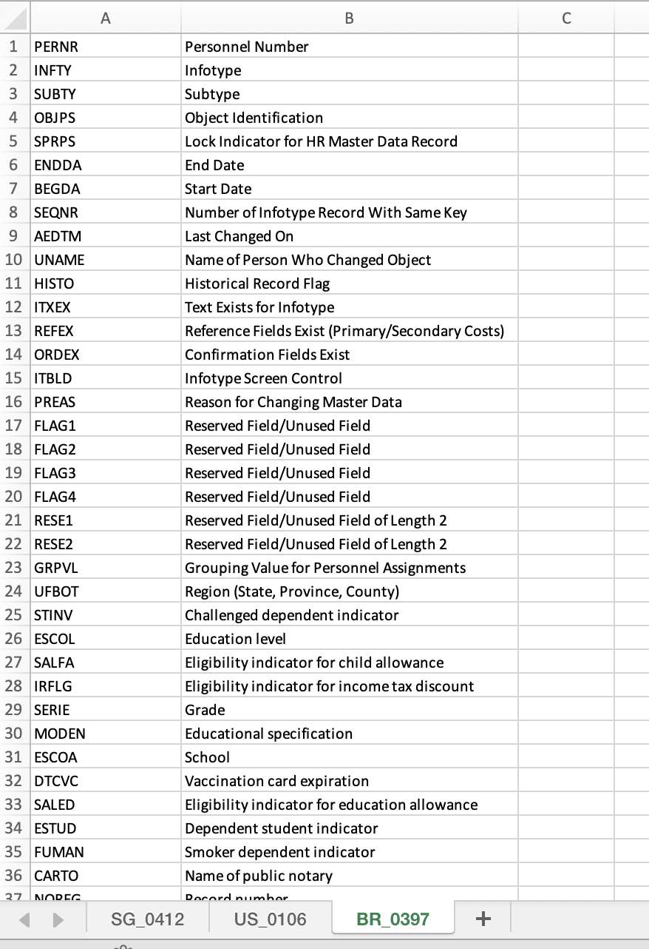

## ESS XML ready

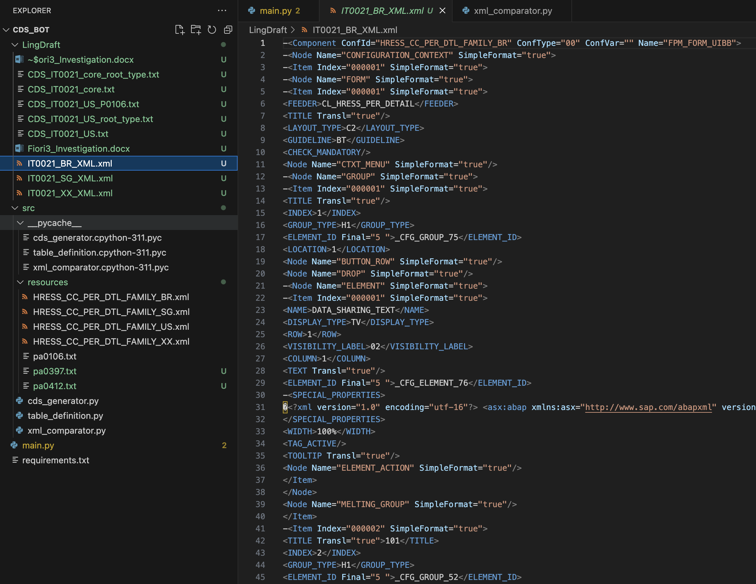

### Comparison XML (no AI)

between country and core

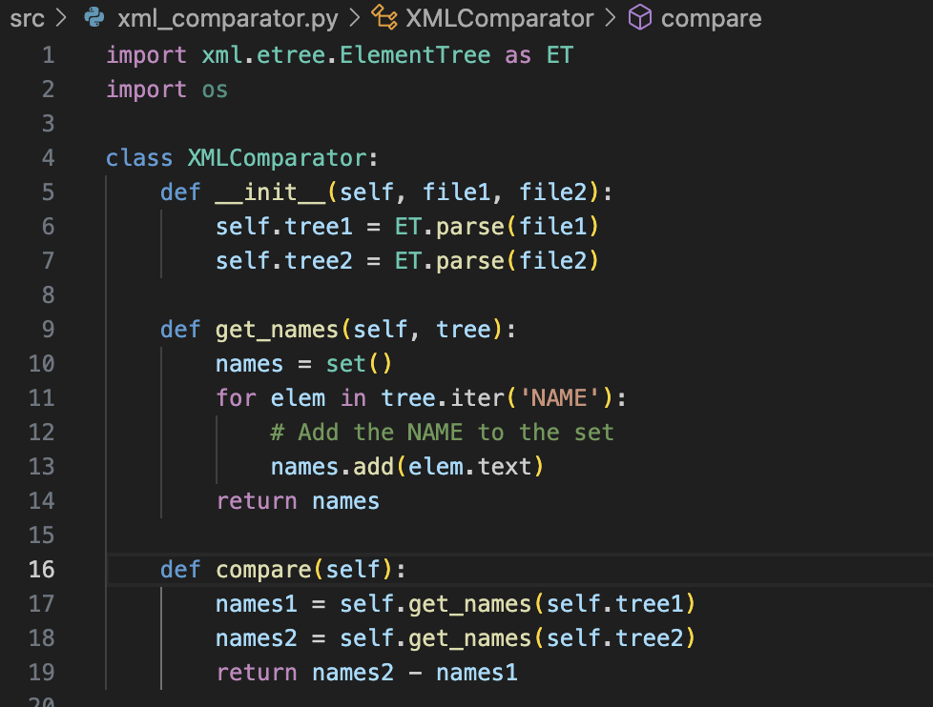

### Mapping Country structure and XML (by AI)

Output difference, naming for country specific fields from XML.

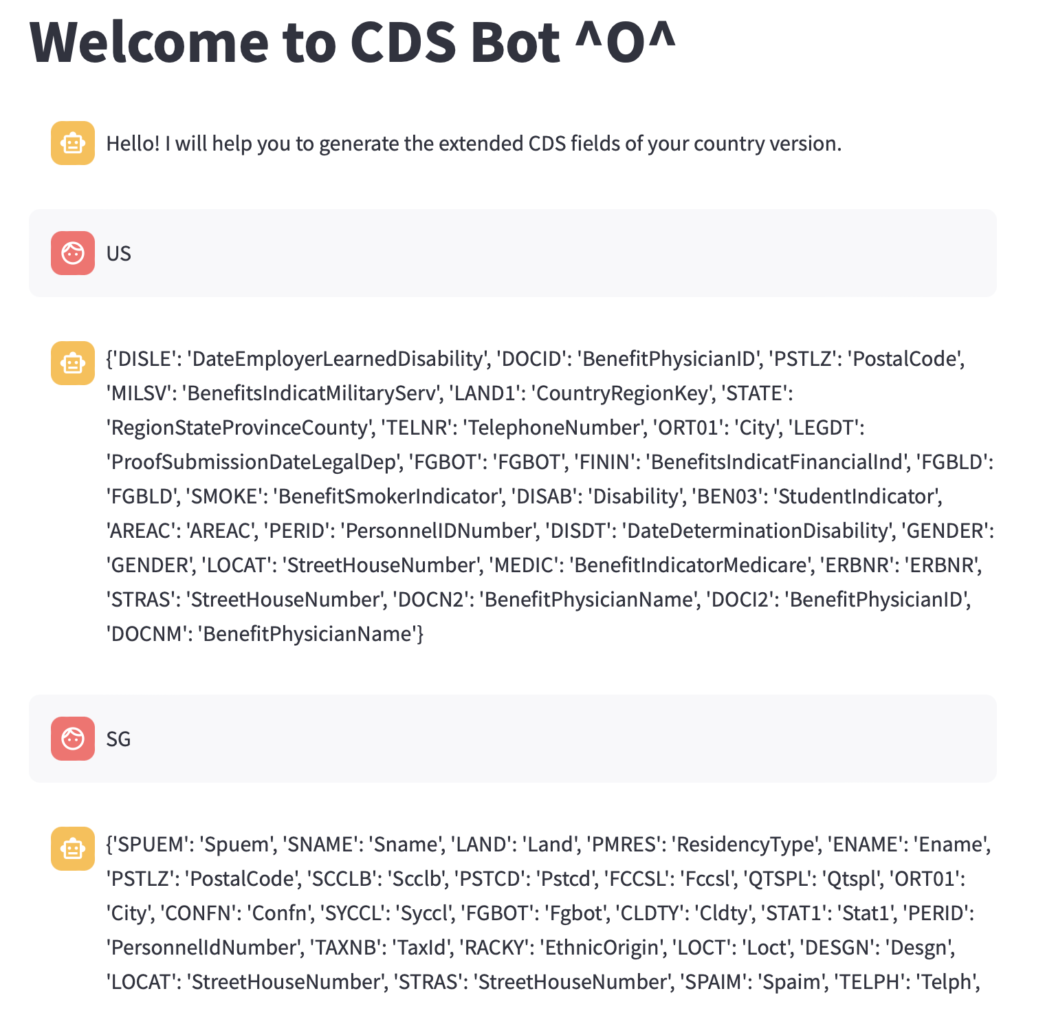

***Need additional check from existing fields.***

***Need automate the register process.***

## CDS View Generator

### Using Mapping result to generate CDS view (by AI)

#### input:

US:

{'DISLE': 'DateEmployerLearnedDisability', 'DOCID': 'BenefitPhysicianID', 'PSTLZ': 'PostalCode', 'MILSV': 'BenefitsIndicatMilitaryServ', 'LAND1': 'CountryRegionKey', 'STATE': 'RegionStateProvinceCounty', 'TELNR': 'TelephoneNumber', 'ORT01': 'City', 'LEGDT': 'ProofSubmissionDateLegalDep', 'FGBOT': 'FGBOT', 'FININ': 'BenefitsIndicatFinancialInd', 'FGBLD': 'FGBLD', 'SMOKE': 'BenefitSmokerIndicator', 'DISAB': 'Disability', 'BEN03': 'StudentIndicator', 'AREAC': 'AREAC', 'PERID': 'PersonnelIDNumber', 'DISDT': 'DateDeterminationDisability', 'GENDER': 'GENDER', 'LOCAT': 'StreetHouseNumber', 'MEDIC': 'BenefitIndicatorMedicare', 'ERBNR': 'ERBNR', 'STRAS': 'StreetHouseNumber', 'DOCN2': 'BenefitPhysicianName', 'DOCI2': 'BenefitPhysicianID', 'DOCNM': 'BenefitPhysicianName'}

SG:

{'SPUEM': 'Spuem', 'SNAME': 'Sname', 'LAND': 'Land', 'PMRES': 'ResidencyType', 'ENAME': 'Ename', 'PSTLZ': 'PostalCode', 'SCCLB': 'Scclb', 'PSTCD': 'Pstcd', 'FCCSL': 'Fccsl', 'QTSPL': 'Qtspl', 'ORT01': 'City', 'CONFN': 'Confn', 'SYCCL': 'Syccl', 'FGBOT': 'Fgbot', 'CLDTY': 'Cldty', 'STAT1': 'Stat1', 'PERID': 'PersonnelIdNumber', 'TAXNB': 'TaxId', 'RACKY': 'EthnicOrigin', 'LOCT': 'Loct', 'DESGN': 'Desgn', 'LOCAT': 'StreetHouseNumber', 'STRAS': 'StreetHouseNumber', 'SPAIM': 'Spaim', 'TELPH': 'Telph', 'EMRGN': 'Emrgn', 'CITY': 'City', 'SPEMS': 'SpouseEmploymentStatus', 'CLCNO': 'Clcno', 'STRT': 'Strt'}

### Move ESS logic to generate Behavior Class (by AI)

### Binding ABAP fields and Fiori3 fields (No AI)

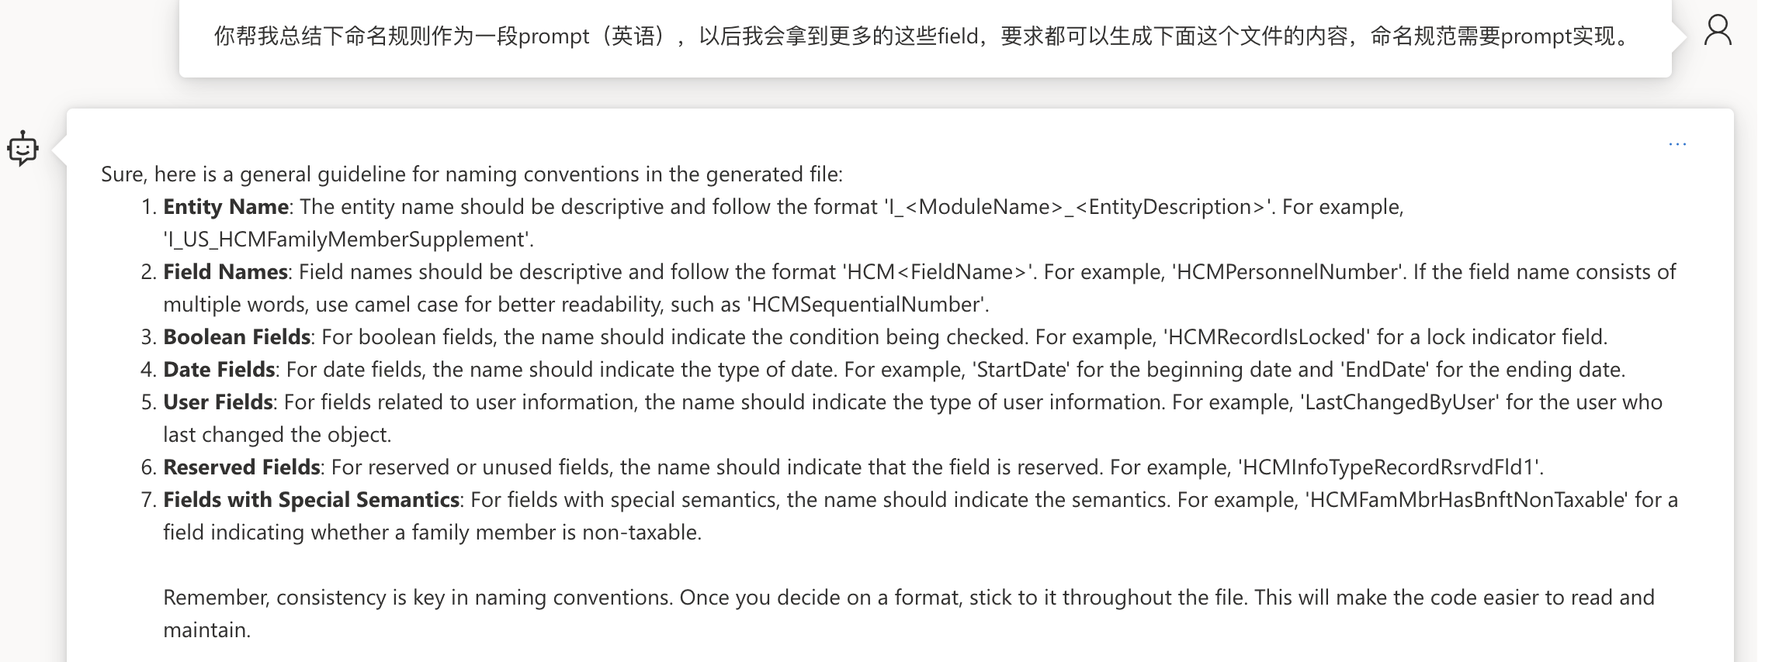

Sure, here is a general guideline for naming conventions in the generated file:

1. **Entity Name**: The entity name should be descriptive and follow the format 'I_<ModuleName>_<EntityDescription>'. For example, 'I_US_HCMFamilyMemberSupplement'.
2. **Field Names**: Field names should be descriptive and follow the format 'HCM<FieldName>'. For example, 'HCMPersonnelNumber'. If the field name consists of multiple words, use camel case for better readability, such as 'HCMSequentialNumber'.
3. **Boolean Fields**: For boolean fields, the name should indicate the condition being checked. For example, 'HCMRecordIsLocked' for a lock indicator field.
4. **Date Fields**: For date fields, the name should indicate the type of date. For example, 'StartDate' for the beginning date and 'EndDate' for the ending date.
5. **User Fields**: For fields related to user information, the name should indicate the type of user information. For example, 'LastChangedByUser' for the user who last changed the object.
6. **Reserved Fields**: For reserved or unused fields, the name should indicate that the field is reserved. For example, 'HCMInfoTypeRecordRsrvdFld1'.
7. **Fields with Special Semantics**: For fields with special semantics, the name should indicate the semantics. For example, 'HCMFamMbrHasBnftNonTaxable' for a field indicating whether a family member is non-taxable.  
     
   Remember, consistency is key in naming conventions. Once you decide on a format, stick to it throughout the file. This will make the code easier to read and maintain.

NWBC

Role: SAP_EMPLOYEE_ESS_WDA_3

