**Test 1**

**Part I. Choose the correct answer to complete each sentence. (20 *marks*)**

1.You ________ up once or twice a night.

A. wake B. wakes C. woke D. woken

2. __________ he sleep well?

A. Do B. Is C. Does D. Has

3. He is currently_________ to places and regions.

A. travel B. travels C. travelling D. travelled

4. They_________ fishing and eat what they catch.

A. drive B. play C. do D. go

5. Young people are_______to the city.

A. move B. moves C. moved D. moving

6. I’m nearly eighty, but I don’t __________ any exercise!

A. practice B. do C. go D. play

7. I________got a sore throat.

A. has B. have C. had D. having

8. If you still feel ill in a few days, see a_________.

A. engineer B. teacher C. consultant D. doctor

9. You need to do more exercise _______eat healthy food.

A. any B. but C. so D. yet

10. One day I would __________ to become a professional player.

A. love B. prefer C. like D. rather

11. You __________ play cricket with a bat and a ball.

A. has to B. can’t C.should D. have to

12. My favourite football team__________another goal!

A. scored B. beat C. ran D. left

13. Wear these __________over your eyes when you ski.

A. gloves B. googles C. tie D. belt

14. The __________is 100 meters long. The fastest runner can complete it in less than ten seconds.

A. ring B. trophy C. pitch D. track

15. The people go on foot in a town or city are _________.

A. walk B. tourists C. pedestrians D. commuters

16. The __________form of public transport is the bus.

A. the most popular B. most popular C. popularer D. more popular

17. Do you want me to pick _________the children from school?

A. by B. up C. in D. off

18. They _________all over the world to study volcanoes.

A.bought B. met C. travelled D. flew

19. Rachel_________a party tonight.

A. will have B. is having C. has D. has had

20. A: I need someone to carry these books for me. B: I__________you!

A. am going to help B. am helping C. will help D. help

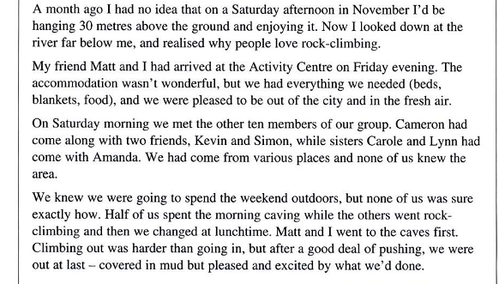

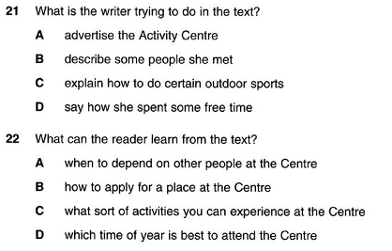

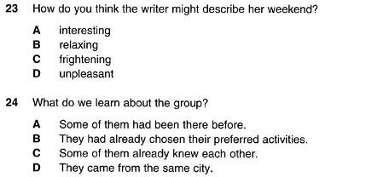

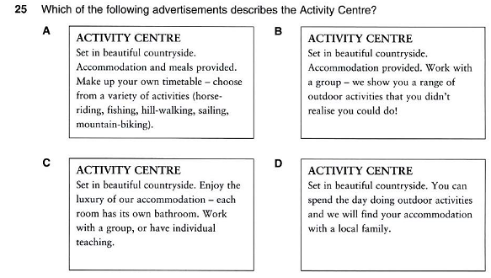

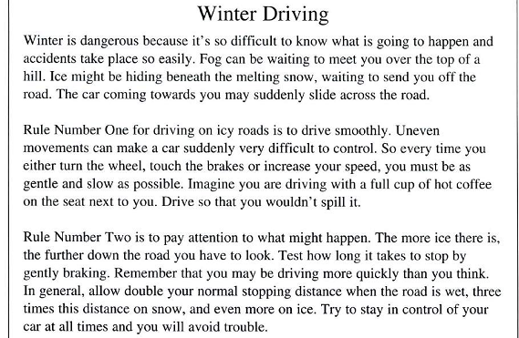

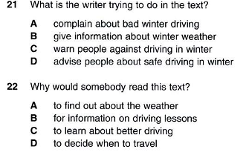 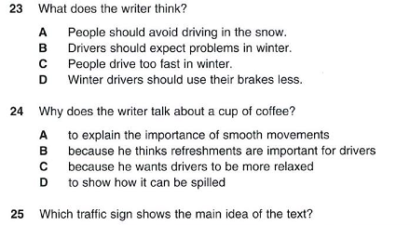 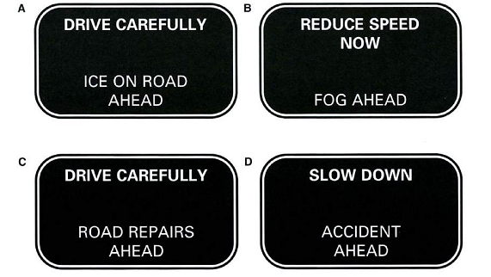

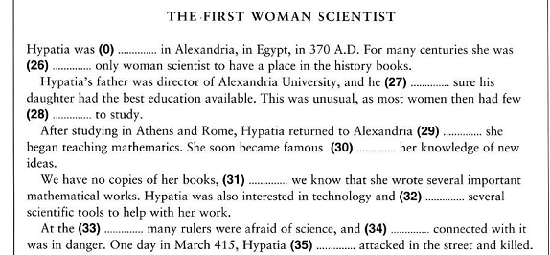

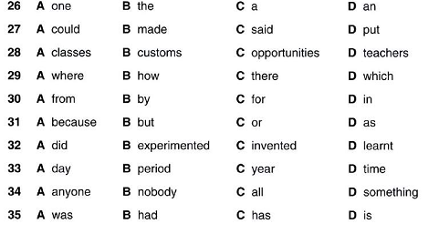

Writing

**Part 1:**

1. He/ currently/ travelling/ places and regions/.
2. I/ really/ enjoy/ see/ cyclists/ mountains.
3. You/ to/ play cricket/ bat/ ball/.
4. President/ give/ winning team/ silver trophy/.
5. Cars/ dangerous/ bikes/.
6. Our car/ clean/ as/ electric car/.
7. Amazon river/ amazingly/ long/.
8. As/ they/ walking/ mountains/ weather/ get/ worse/.
9. How much/ computer/ cost/?
10. You/ want/ join us/ drink/?

Part 2:

Đề thi:

Write a 100-word paragraph to describe a sport which you are playing or which you like/know, or describe a competition which you joined in.