**1.Ma Trận**

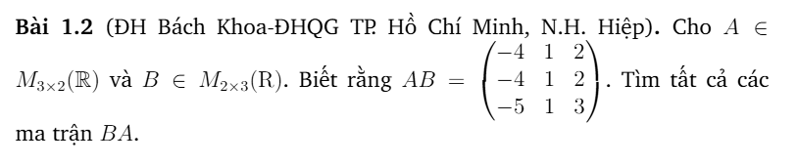

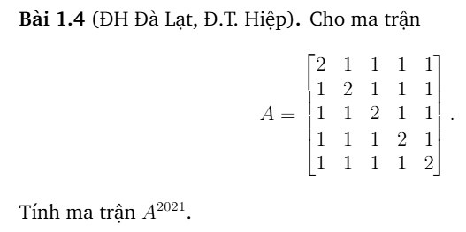

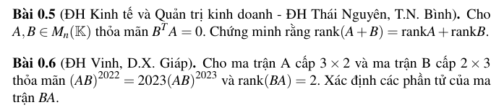



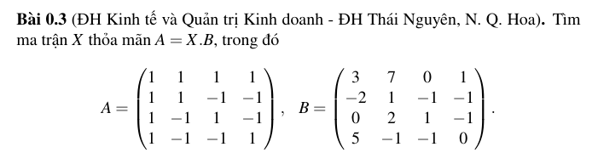

Đề 2022

**2.Định Thức**

Đề 2023

**3.Hệ phương trình tuyến tính**

**4. Đa thức**

**5.Giá trị riêng**

