

**ELLENA**

**ONLINE WOMEN FASHION SHOP**

**Software Requirement Specification**

– Ho Chi Minh, May 2022 –

# Table of Contents

**Table of Contents** **2**

I. Overview **4**

1. Introduction 4

2. System Functions 5

a. Screen Flow 5

Figure 2.1: Screen flow - Administrator 5

Figure 2.1: Screen flow - Manager 5

Figure 2.1: Screen flow - Customer 6

Figure 2.1: Screen flow - Employee 6

b. Screen Details 7

c. User Authorization 7

d. Non-Screen Functions 8

3. Common Requirements 9

II. Functional Requirements **10**

1. Account Management 10

View all accounts 10

Add an account 10

Edit an account’s information 11

Function trigger: this function is triggered when user: 11

2. Product Management 12

List products 12

Add category 13

Manage category 14

Edit product information 15

3. Login 16

Login 16

4. Register 16

Register 16

5. Logout 17

Logout 17

6. Order management 18

View list order 18

Edit order 19

7. Update user’s profile 20

Display user’s information 20

Edit user’s information 21

8. Shopping 22

Search 22

View product detail 23

Add to cart 24

Remove product from cart 25

Edit cart 26

Check out 27

Send feedback 28

# I. Overview

## 1. Introduction

The Online Shopping System for electronics item store web application is designed to give full solutions for both the brand and buyers over the internet in a single site. It will allow the clothes company to build up an online store where customers can explore and purchase items, without having to physically visit the store. [This proposed system is suitable for the average user and does not require any educational level, experience, or technical skill.]

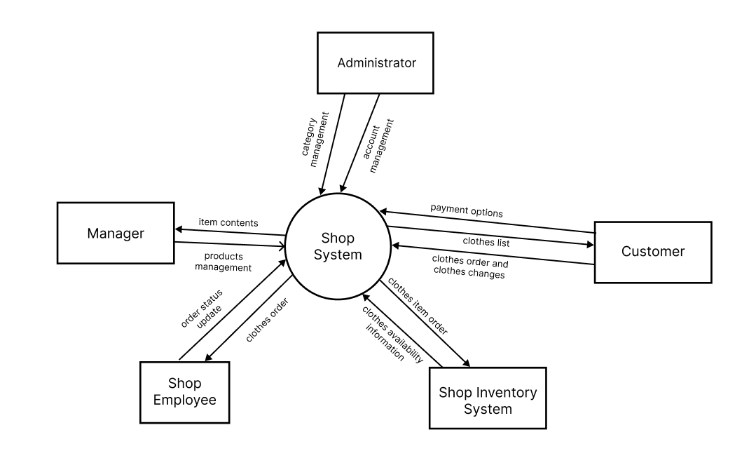

## 2. System Functions

#### a. Screen Flow

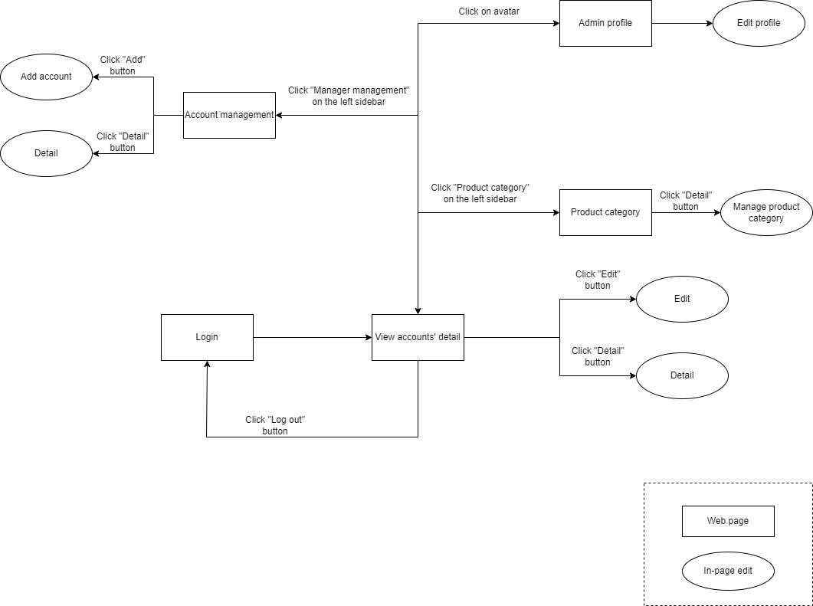

#### Figure 2.1: Screen flow - Administrator

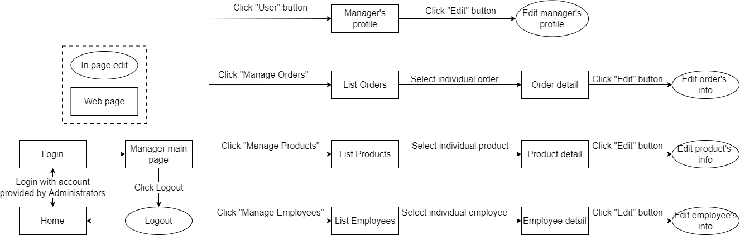

#### Figure 2.1: Screen flow - Manager

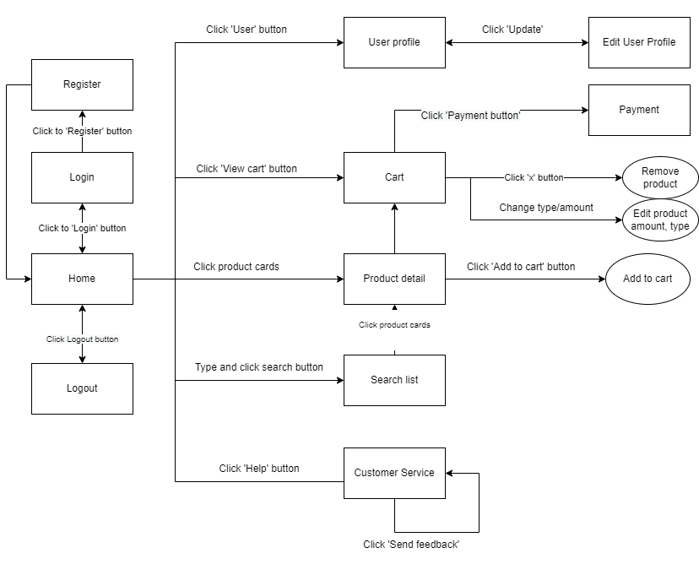

#### Figure 2.1: Screen flow - Customer

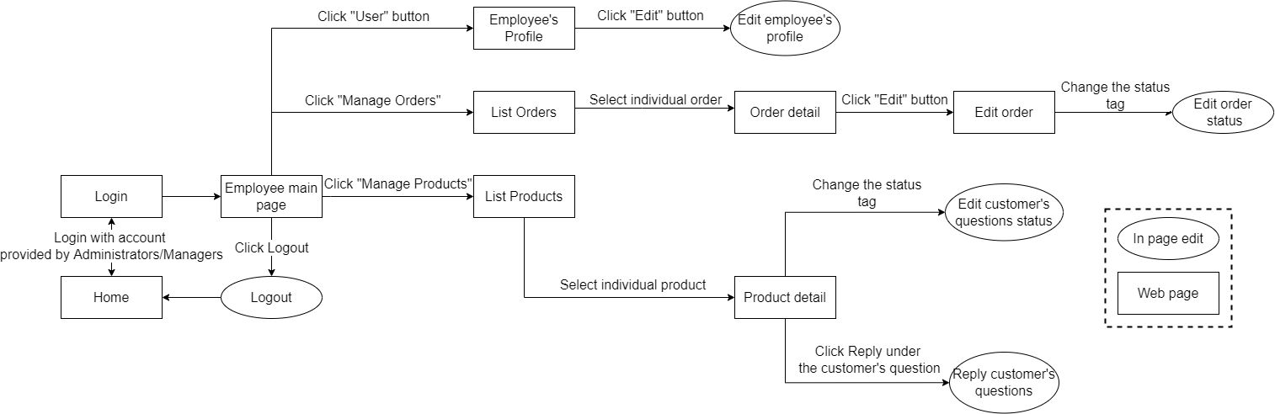

#### Figure 2.1: Screen flow - Employee

#### b. Screen Details

| **#** | **Feature** | **Screen** | **Description** |
| --- | --- | --- | --- |
| 1 | Login | Login | Login |
| 2 | Logout | User main page | Log out |
| 3 | Logout | Employee main page | Log out |
| 4 | Logout | View account’s detail | Logout |
| 5 | Logout | Manager main page | Log out |
| 6 | Account management | Admin profile | Change account’s information |
| 7 | Account management | Account management | +Change account’s information |
| 8 | Account management | Add a new account | Add a new manager/employee account |
| 9 | Account management | View accounts’ detail | + Edit account  + View account’s information |
| 10 | Order management | List Orders | List orders |
| 11 | Order management | Order detail | Edit order’s information |
| 12 | Product management | Product management | Add/delete(inactive) category |
| 13 | Product management | List Products | List products |
| 14 | Product management | Product detail | Edit product’s information |
| 15 | Register | Register | User registers an account |
| 16 | Update user’s profile | User profile | Display user’s information |
| 17 | Update user’s profile | Edit user profile | Edit user’s information |
| 18 | Shopping | Cart | View cart, remove product, edit cart (quantity, type) |
| 19 | Shopping | Search list | Search for products |
| 20 | Shopping | Product detail | View product’s detail, add product to cart |
| 21 | Shopping | Payment | Pay and check out |
| 22 | Shopping | Customer service | Send feedback |

#### c. User Authorization

| **Screen** | **Administrator** | **Manager** | **Employee** | **Customer** |
| --- | --- | --- | --- | --- |
| Login | X | X | X | X |
| Log into account | X | X | X | X |
| Account Management | X |  |  |  |
| Change account’s information | X |  |  |  |
| Add manager/employee account | X |  |  |  |
| View accounts’ detail | X |  |  |  |
| Edit account | X |  |  |  |
| View account’s information | X |  |  |  |
| Manager management | X |  |  |  |
| Change account’s information, status | X |  |  |  |
| Customer management | X |  |  |  |
| Change account’s information, status | X |  |  |  |
| Category management | X |  |  |  |
| Add/delete(inactive) category | X |  |  |  |
| List Orders |  | X | X |  |
| List orders |  | X | X |  |
| Order detail |  | X | X |  |
| Edit order’s information |  | X | X |  |
| List Products |  | X |  |  |
| List products |  | X |  |  |
| Register |  |  |  | X |
| User registers an account |  |  |  | X |
| Update profile |  |  |  | X |
| Display user’s information |  |  |  | X |
| Edit user profile |  |  |  | X |
| Edit user’s information |  |  |  | X |
| Cart |  |  |  | X |
| View cart |  |  |  | X |
| Remove product |  |  |  | X |
| Edit cart |  |  |  | X |
| Search list |  |  |  | X |
| Search for products |  |  |  | X |
| Product detail |  |  |  | X |
| View product’s detail |  |  |  | X |
| Add product to cart |  |  |  | X |
| Payment |  |  |  | X |
| Select payment option |  |  |  | X |
| Pay online |  |  |  | X |
| Customer service |  |  |  | X |
| Send feedback |  |  |  | X |

In which:

* Administrator: is the role that has the highest privilege in the system. They can manage all the accounts in the shop.
* Manager: is the one who manages the shop’s service and employess.
* Employee: is the person who works for the shop. They help confirm the order from customers.
* User: is the one who seeks for and/or buys the shop’s clothes.

#### d. Non-Screen Functions

| **#** | **Feature** | **System Function** | **Description** |
| --- | --- | --- | --- |
| 1 | Contact | Chat with employees | Contact with employees via Tawk.to inbox solution. |
| 2 | Online payment | Momo | Purchase with Momo digital wallet. |
| 3 | Online payment | VNPay | Purchase with VNPay electronic payment solution. |
| 4 | Sign in | Google Sign-in | Call Google API to allow customers to log in with their Gmail accounts. |

## 3. Common Requirements

* The online women fashion shop system helps users browse various selections of women's clothes, placing multiple orders at ease without having to go to the shop in person.
* The users will be able to sign up, login, and search for women's clothes with their item details.
* The users can add their wanted clothes to a cart. After that, they can modify or delete them. Lastly, if they want to make a purchase, they can check out the cart.
* The administrator manages accounts that have different roles (manager, employee, customer). They can view, add, and modify the accounts.
* The manager can view and update products in the inventory.
* The manager and the employee manage orders. They can view orders and change their status.
* The employee will be able to view and change the order's status.

# II. Functional Requirements

## 1. Account Management

### View all accounts

* *Function trigger: This function is triggered when user:*
  + *Login as administrator*
* *Function description:*
  + *Role: Administrator*
  + *Purpose: All user accounts can be viewed and managed.*
* *Screen layout: 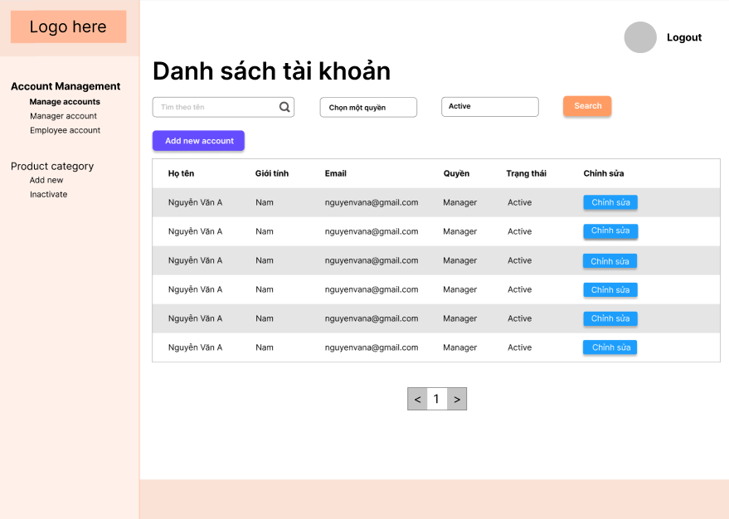*
* *Function Details: An account's email, name, gender, role, and status can all be viewed by the user. They can also use this page to access profile details and edit features by clicking on buttons on the left of the account. Furthermore, the built-in search feature allows users to easily filter accounts by name, role, and status.*

### Add an account

* *Function trigger: This function is triggered when user:*
  + *Login as administrator*
  + *Navigate to ‘Manage account’ page*
  + *Click on ‘Add account’ feature*
* *Function description:*
  + *Role: Administrator*
  + *Purpose: Add a new user account to the database*
* *Screen layout: 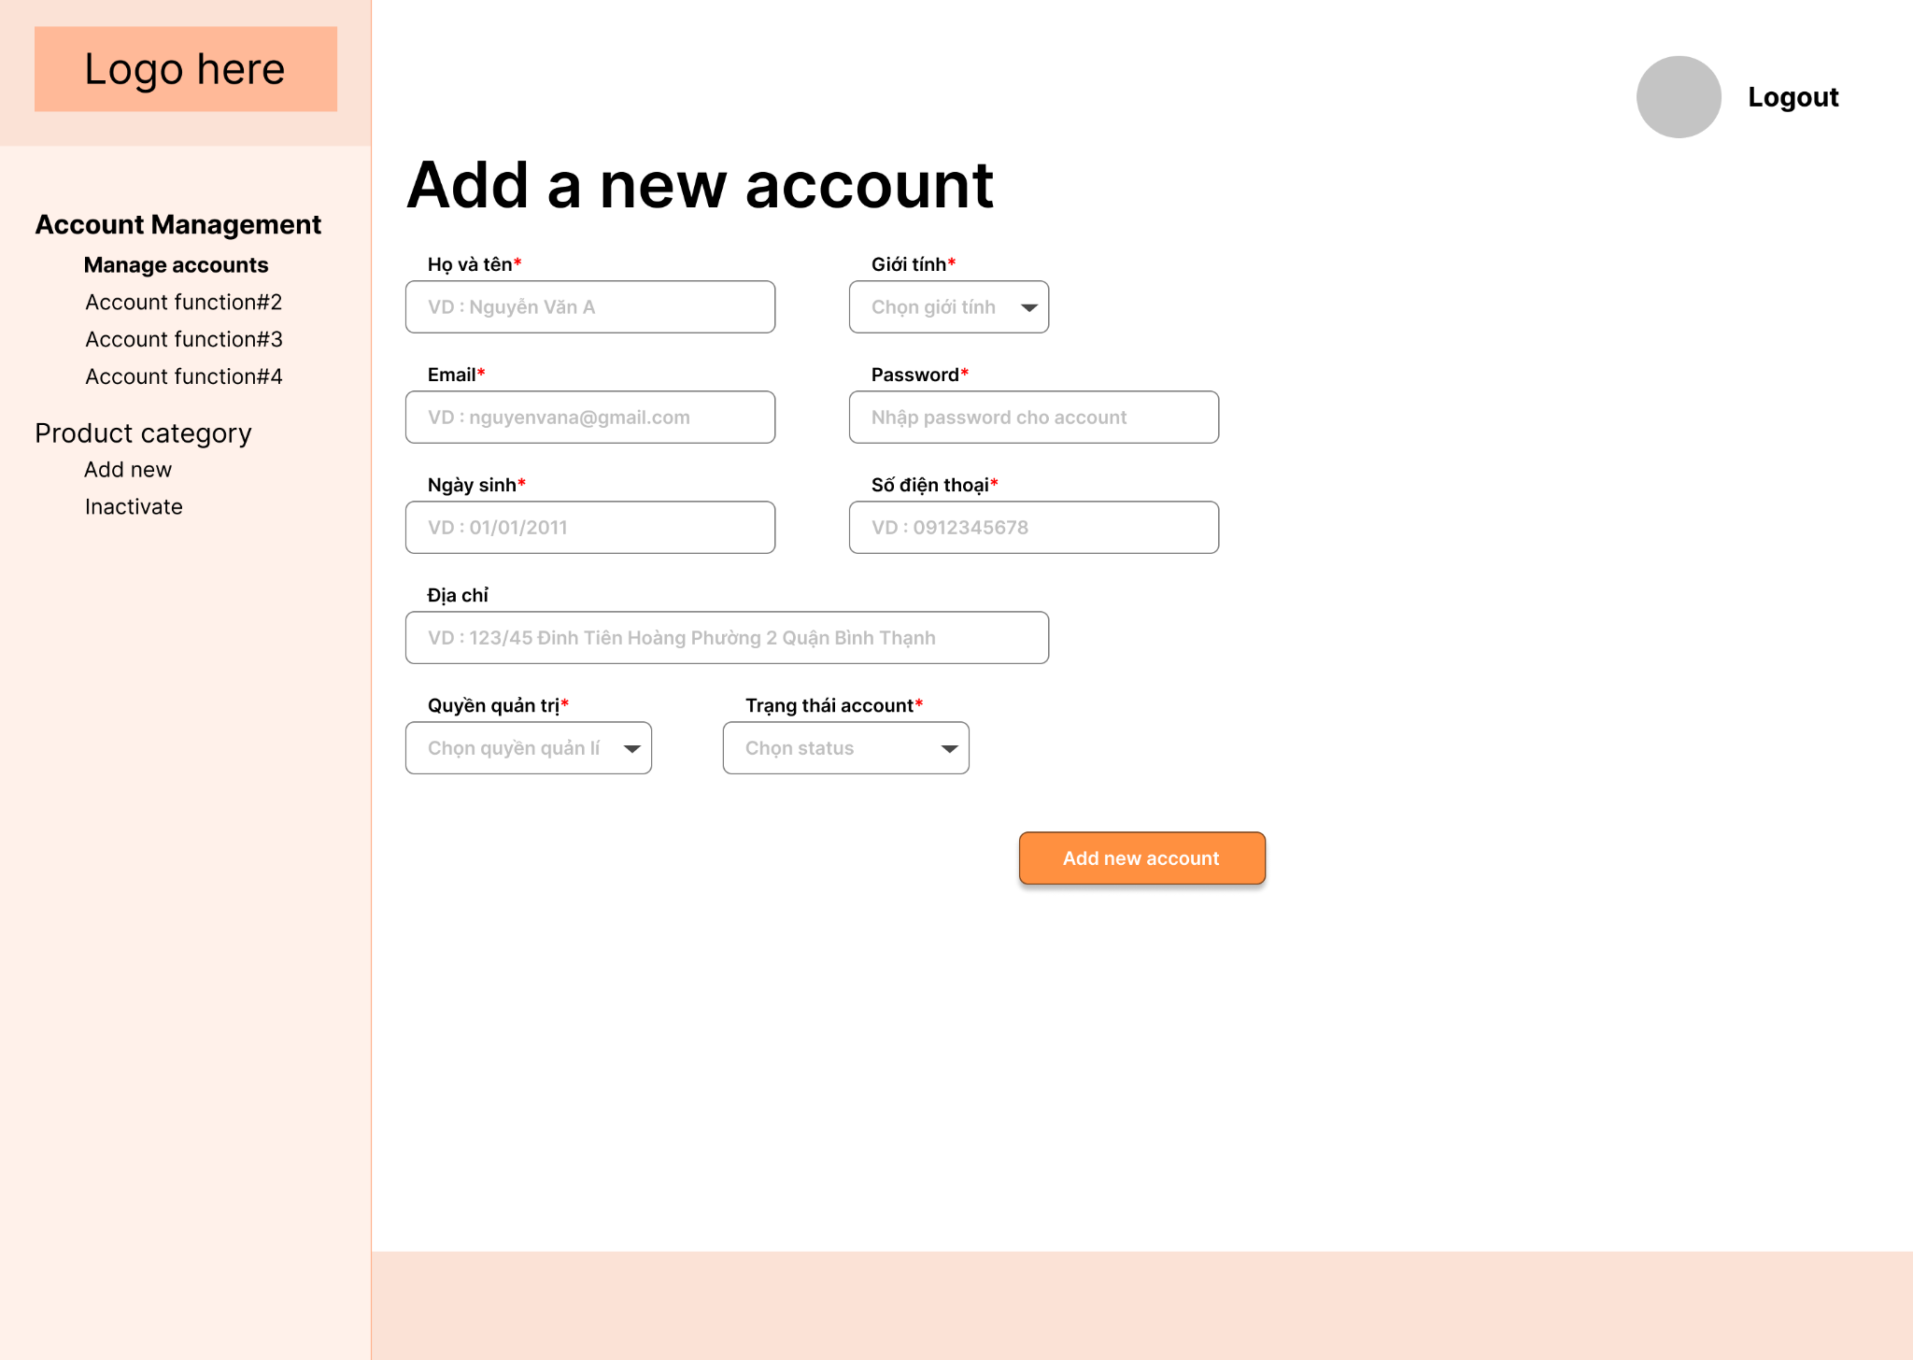*
* *Function Details: Basic required information of a user includes email, password, name, gender, birthdate, phone number, status, and optional information such as image, address. A warning message will appear on the input field if the user submits an incomplete form or enters the improper type of data. If all information is correct, they will get a success message and be navigated to the ‘Manage Account’ page.*

### Edit an account’s information

### *Function trigger: this function is triggered when user:*

* + *User logged in as administrator*
  + *Navigate to ‘Manage accounts’ page*
  + *Click ‘Edit’ button*
* Function description: Edit account’s information (manager account, employee account), status (manager account, employee account, customer account)
* Screen layout: 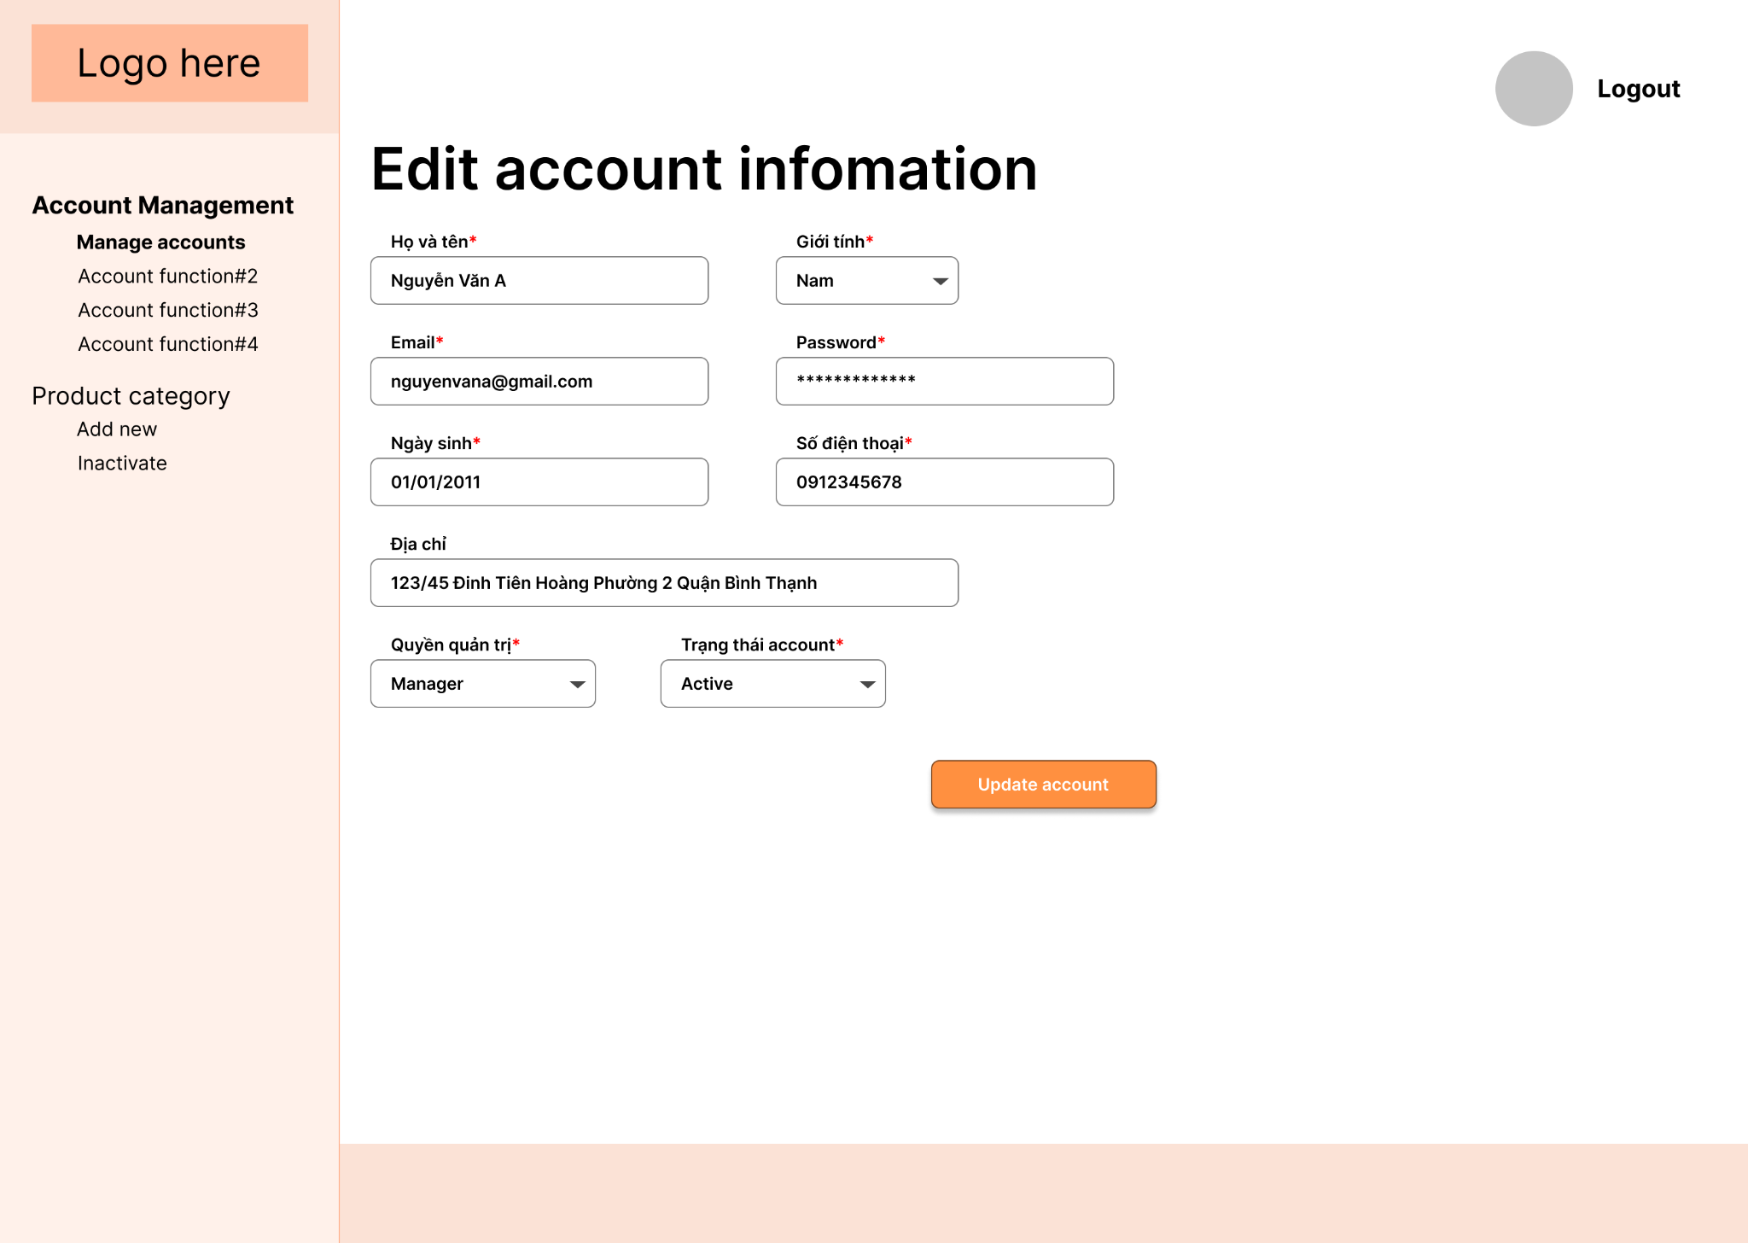
* Function Details: Modify account email, password, name, gender, role, phone number, address, status and submit those information as a form by ‘Update’ button. If the user submits an incomplete form or inputs the wrong type of data, a warning message will appear on the input field. They will receive a success message and the page will be refreshed with new information if all of the information is right.

## 2. Product Management

### List products

* Function trigger: this function is triggered when:
  + Login as manager
  + Click ‘Product Management’
* Function description: list out all products in the database.
* Screen layout: mockup prototype of the screen, sample below is for Manage Products screen

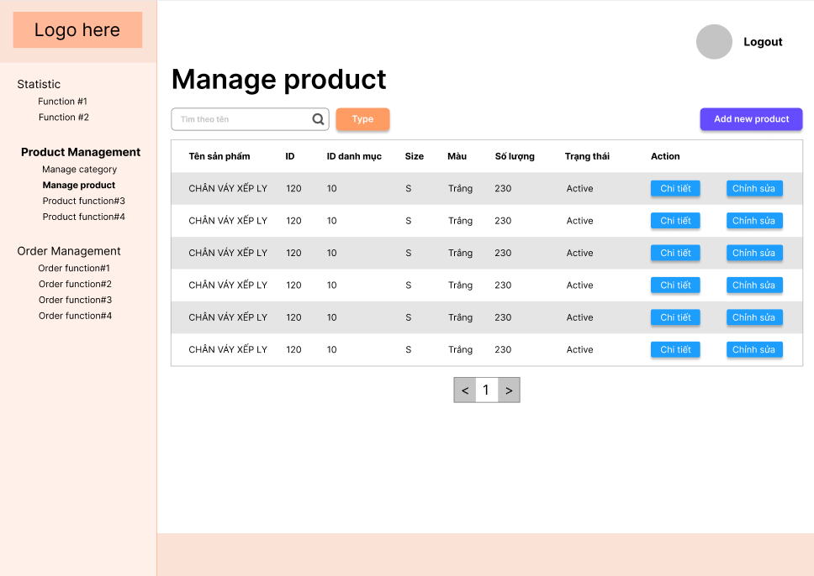

* Function Details: provide product information: ID, name, image, price, category, size, quantity, colour, import date as the login or click on ‘All products’. There is also an ‘Edit’ button so that the manager can easily modify the product’s information. Managers can also filter products by name using the built-in search feature.

### Add category

* Function trigger: this function is triggered when:
  + Login as administrator
  + Navigate to ‘Product Management/ Manage Category’
  + Click ‘Add new category’ button
* Function description:
  + *Purpose*: Add new product category into the database
* Screen layout:

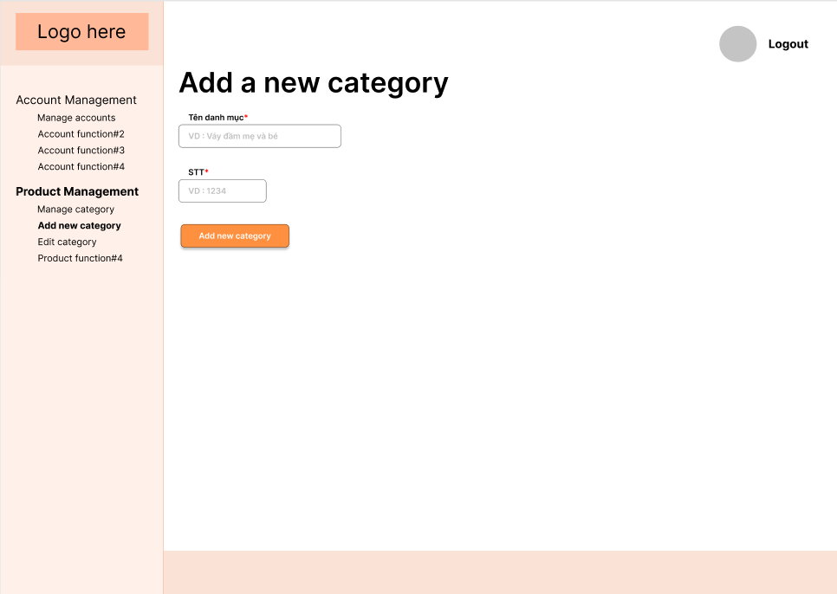

* Function Details: The manager creates a new category ID, name, and priority order. The constraint will be checked by the system. A warning message will show on the input field if the ID is duplicated. If all of the information is correct, they will receive a success message and the page will be updated.

### Manage category

* Function trigger: this function is triggered when:
  + Login as administrator
  + Navigate to ‘Product Management/ Manage Category’
* Function description: change category status, priority order or category name.
* Screen layout:

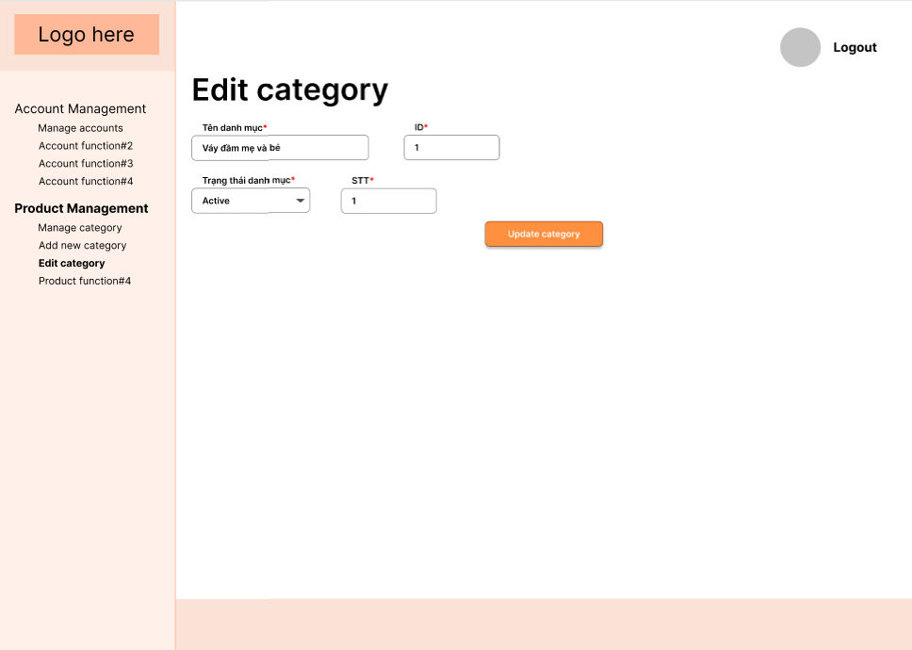

* Function Details: Modify category: name, priority order, status.

### Edit product information

* Function trigger: this function is triggered when:
  + Login as manager
  + Follow ‘’ navigation path
* Function description: list out all products in the database
* Screen layout:

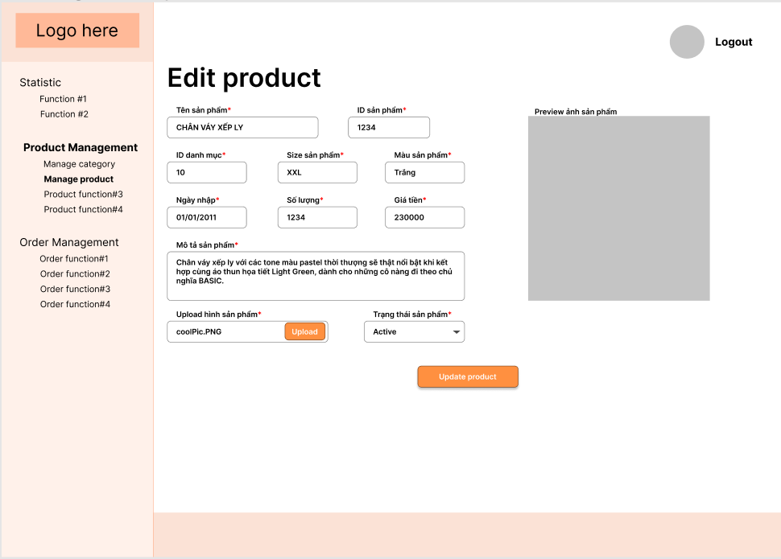

* Function Details: Modify account product information: ID, name, image, price, category, size, quantity, colour, import date and submit those information as a form by ‘Update’ button. If the manager submits an incomplete form or inputs the wrong type of data, a warning message will appear on the input field. They will receive a success message and the page will be refreshed with new information if all of the information is right.

## 3. Login

### Login

* Function trigger: this function is triggered when:
  + Click on ‘Login’ button
* Function description: login as different roles to use the system.
* Screen layout:

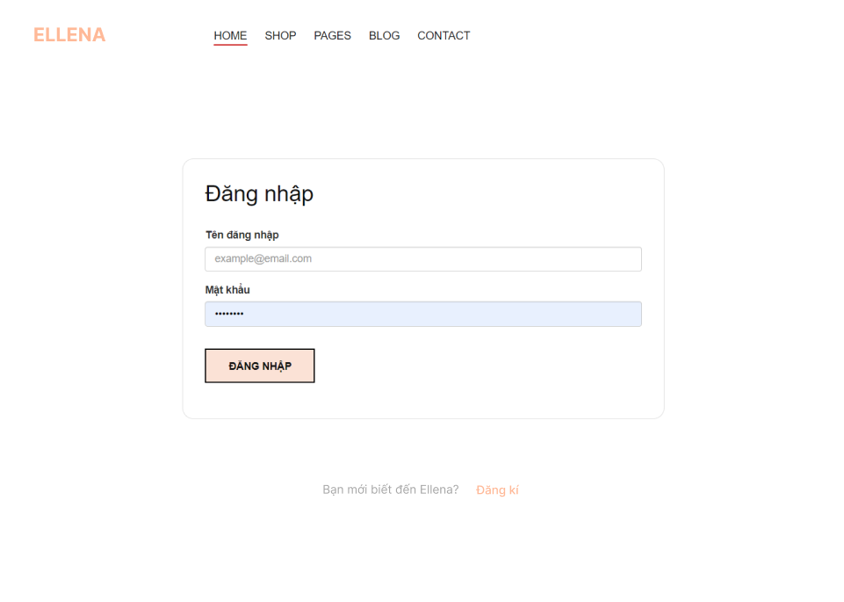

* Function Details: If you log in as an administrator, you'll be taken to the admin page. If you login with the management role, you'll be taken to the manager page. If you log in as an employee, you'll be taken to the employee page. If you login as a customer, you'll be taken to the customer page.

## 4. Register

### Register

* Function trigger: this function is triggered when:
  + Click on ‘Login’ button in Home page
  + Click on ‘Register’ button
* Function description: register an account as Customer role
* Screen layout:

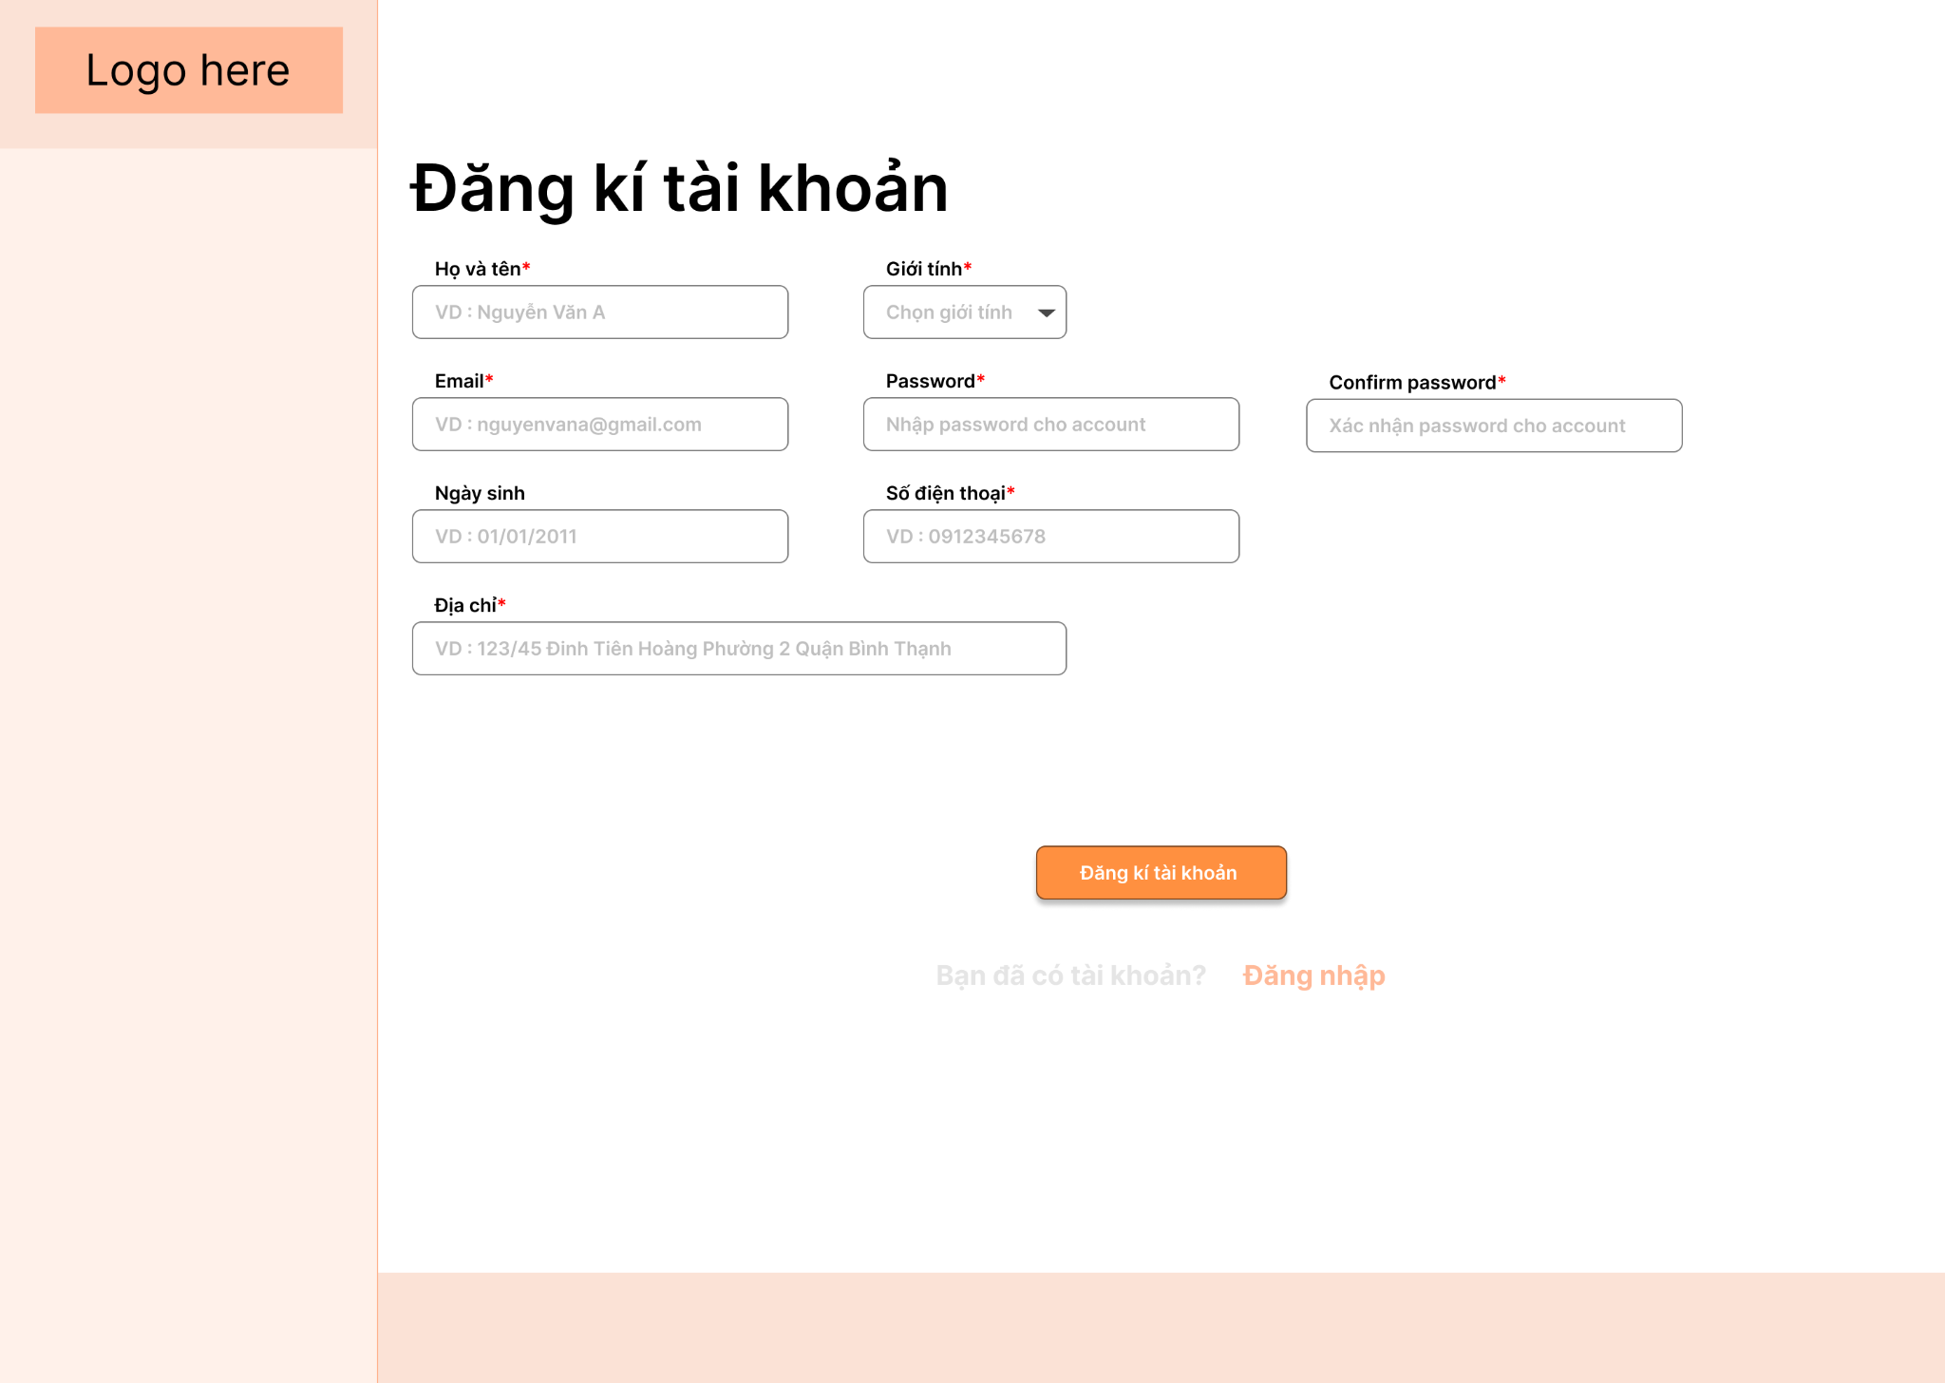

* Function Details: Customers have to complete the register form. If the customer submits an incomplete form or inputs the wrong type of data, a warning message will appear on the input field. They will receive a success message and the page will be redirected to the shopping page as logged in.

## 5. Logout

### Logout

* Function trigger: this function is triggered when:
  + Log in by any role
  + Click on ‘Logout’ button
* Function description: logout
* Screen layout: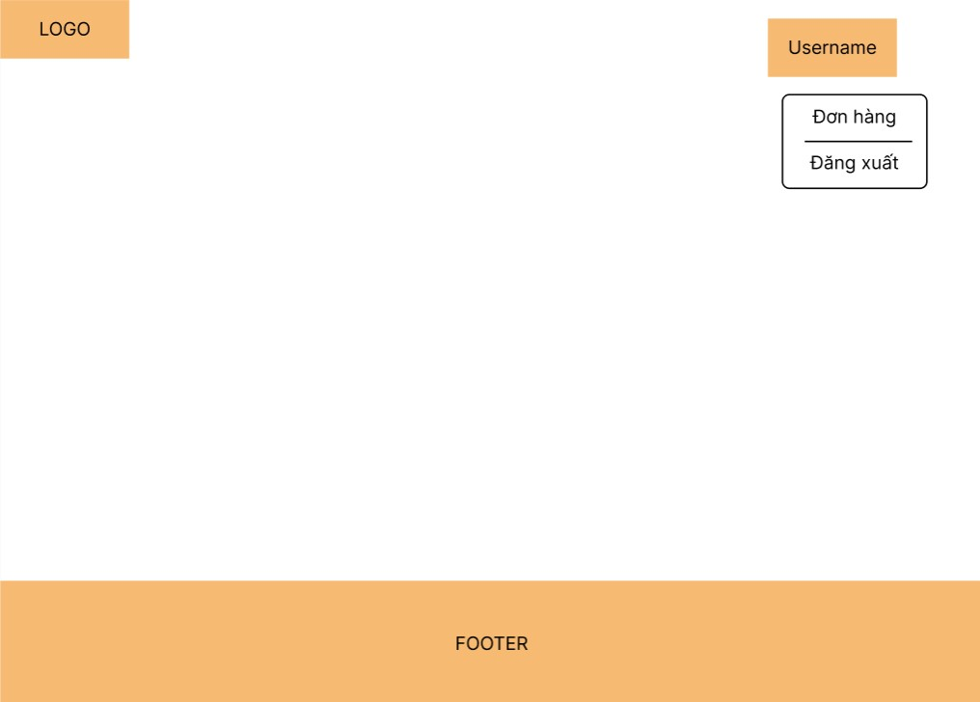
* Function Details: The user login session is ended when you log out. Logging out keeps other users from gaining access to the system without verifying their credentials.

## 6. Order management

### View list order

* Function trigger: this function is triggered when:
  + Login as manager or employee
  + Navigate to Order Management
* Function description: list out all of the orders.
* Screen layout: 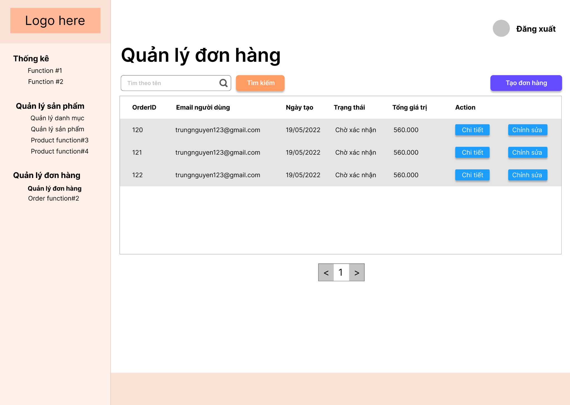
* Function Details: the orders’ information are displayed on the screen: order ID, order date, user ID, status, total price. User can easily filter orders by status using the built-in search feature.

### Edit order

* Function trigger: this function is triggered when:
  + Login as manager or employee
  + Navigate to the ‘Order Management’ Page
  + Click on ‘Chỉnh sửa’ button
* Function description: change order’s status.
* Screen layout:

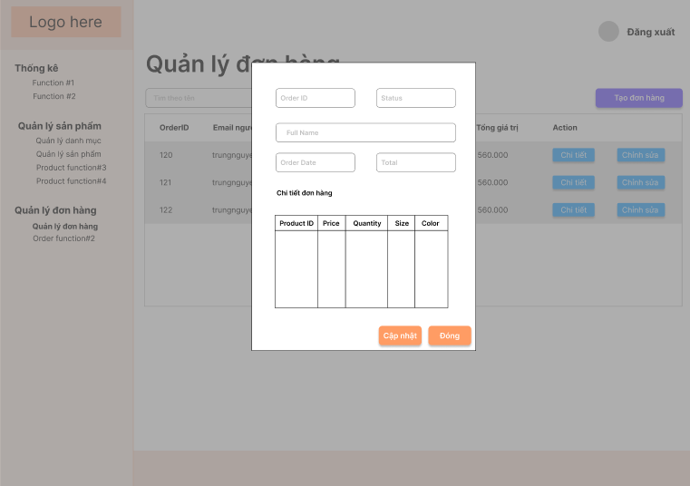

* Function Details: when the manager click on ‘Chỉnh sửa’ button, there will be a pop-up shows order’s detail: order ID, status, customer’s full name, order date, total, and all products that the customer bought. Change order’s status by choosing one of the options of the drop-down list: ‘Chưa xác nhận’, ‘Đã xác nhận’, ‘Đang giao’, ‘Đã giao’, ‘Đã hủy’. Then the manager clicks on the ‘Cập nhật’ button to confirm change or clicks ‘Đóng’ to cancel.

## 7. Update user’s profile

### Display user’s information

* Function trigger: this function is triggered when:
  + Login as customer
  + Click on ‘’
* Function description: user views their personal information.
* Screen layout: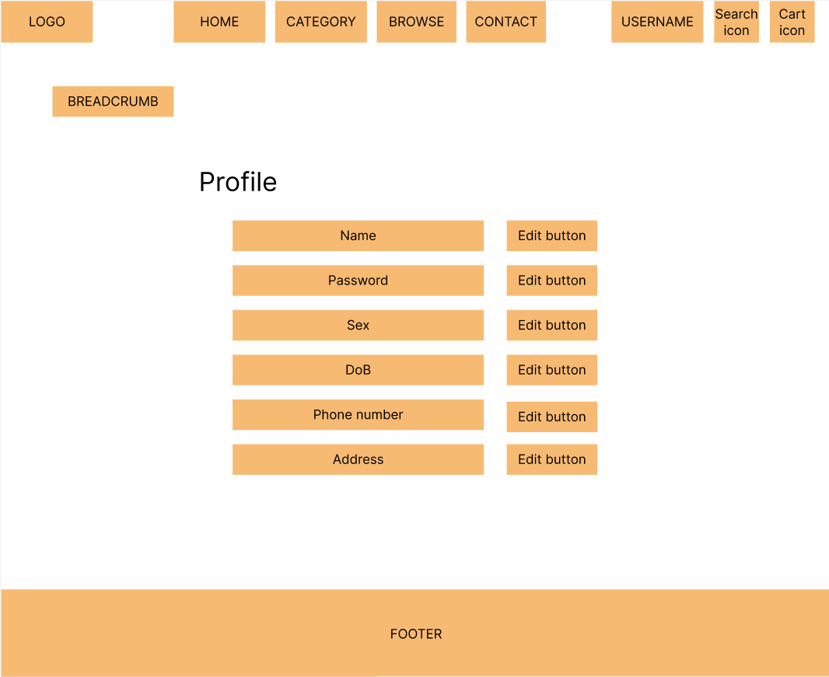
* Function Details: All of the customer’s information is displayed on the screen.

### Edit user’s information

* Function trigger: this function is triggered when:
  + Login as customer
* Function description: logout
* Screen layout
* Function Details: Modify account email, password, name, gender, role, phone number, address, status and submit those information as a form by ‘Update’ button. If the user submits an incomplete form or inputs the wrong type of data, a warning message will appear on the input field. They will receive a success message and the page will be refreshed with new information if all of the information is right.

## 8. Shopping

### Search

* Function trigger: this function is triggered when:
  + Click on ‘Logout’ button
* Function description: search for products by name.
* Screen layout:

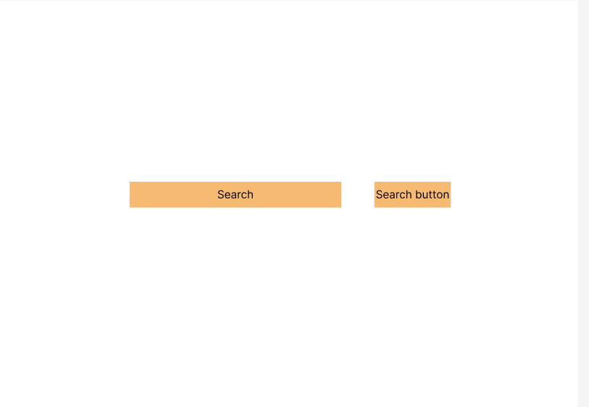

* Function Details:

### View product detail

* Function trigger: this function is triggered when:
  + Click on product card
* Function description: view product’s information.
* Screen layout:

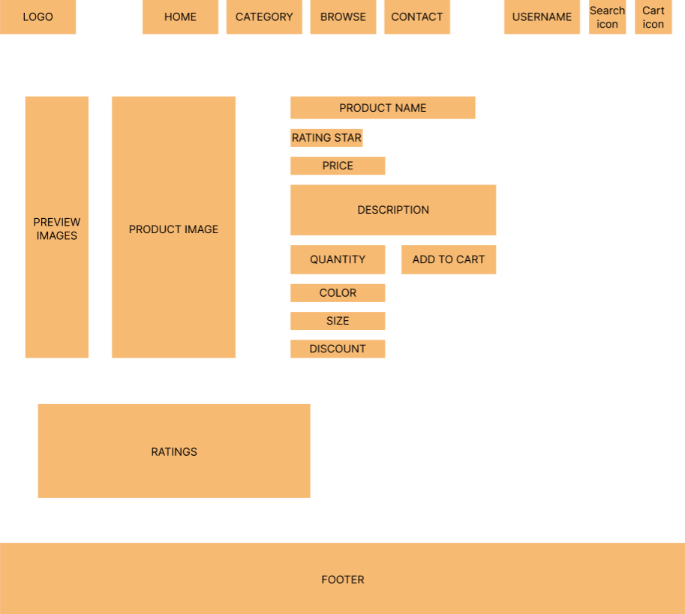

* Function Details: display the product’s information: name, price, number of feedback, rated, size, colour, image, quantity.

### Add to cart

* Function trigger: this function is triggered when:
  + Login as customer
  + Click on product card
  + Click on ‘Add to cart’ button
* Function description: add product(s) to cart
* Screen layout:



* Function Details: Enables shoppers to select products for purchase without making a payment.

### Remove product from cart

* Function trigger: this function is triggered when:
  + Login as customer
  + Click on ‘Cart’ button
  + Click ‘remove’ button on the product card
* Function description: remove a product from cart
* Screen layout:

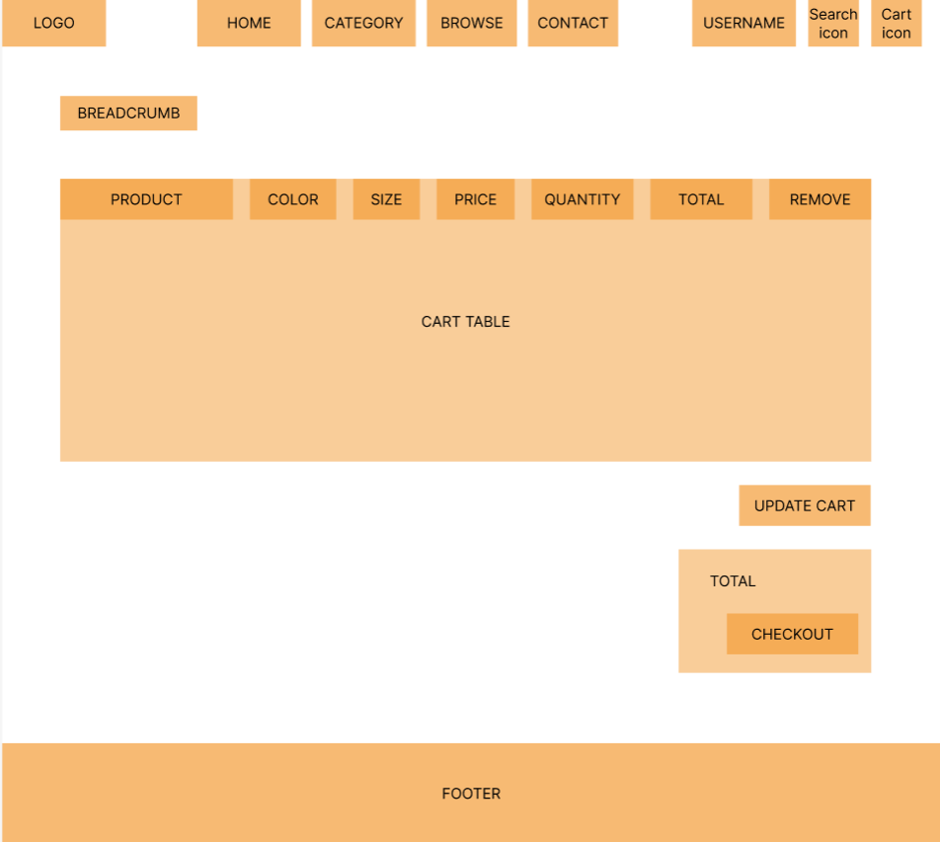

* Function Details: This action will delete the product from the customer's cart permanently.

### Edit cart

* Function trigger: this function is triggered when:
  + Login as customer
  + Click on
* Function description: edit quantity, size, colour
* Screen layout:



* Function Details: drop down list from the field customers want to change

### Check out

* Function trigger: this function is triggered when:
  + Login as customer
  + Click on ‘Check out’ button
* Function description:
* Screen layout:



* Function Details: Customer

### Send feedback

* Function trigger: this function is triggered when:
  + Login as customer
  + Click on ‘Help’ button
* Function description: Help customer review the product they have purchased
* Screen layout:

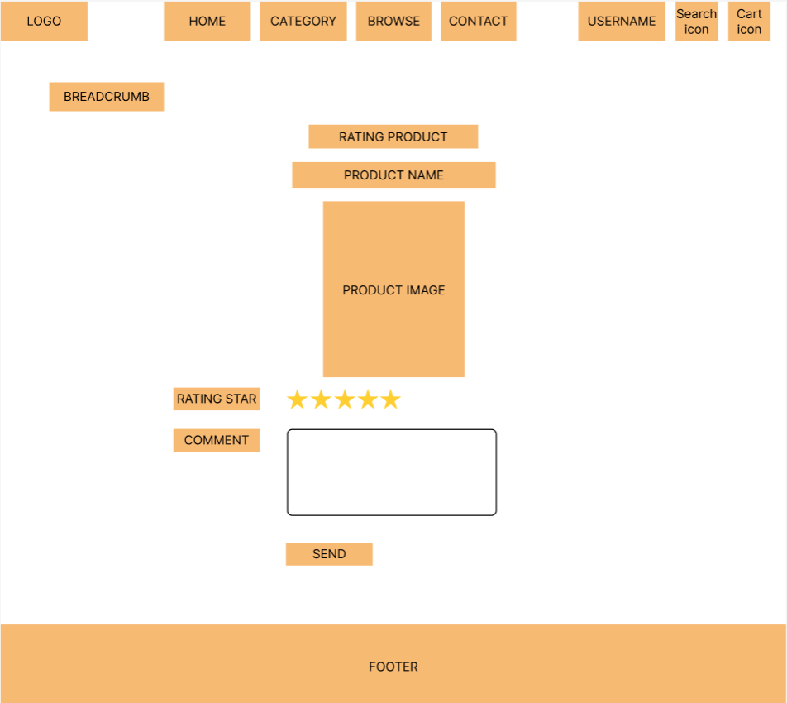

* Function Details: Customer sends feedback and rates product’s quality.