

**Vaccination Management**

**Software Requirement Specification**

Version: 1.2

**Hanoi, Jan 2020**

Approval Page

|  |  |  |  |
| --- | --- | --- | --- |
| **Prepared by :** | Business Analyst | Signature: | ____________________ |
|  |  | Date: | ____ /____ / ____ |
|  |  |  |  |
|  |  |  |  |
| **Reviewed by :** | Business Analyst | Signature: | ____________________ |
|  |  | Date: | ____ /____ / ____ |
|  |  |  |  |
| **Supported by:** |  | Signature: | ____________________ |
|  |  | Date: | ____ /____ / ____ |
|  |  |  |  |
|  |  |  |  |
| **Approved by :** |  | Signature: | ____________________ |
|  |  | Date: | ____ /____ / ____ |

Revision History

|  |  |  |  |
| --- | --- | --- | --- |
| **Date** | **Version** | **Author** | **Change Description** |
| 21/06/2018 | 1.0 |  | Create new |
| 21/06/2020 | 1.2 |  | Update |
|  |  |  |  |
|  |  |  |  |
|  |  |  |  |
|  |  |  |  |

**Table of Contents**

1. Introduction 5

1.1 Purpose 5

1.2 Scope of Project 5

2. Overall Description 5

2.1 Actor 5

2.2 Usecase diagram of the system 6

3. Requirements Specifications 6

3.1 Functional Requirements 6

3.1.1 Log in 6

3.1.2 Dashboard 7

3.1.3 UC01: Employee management 8

3.1.4 UC02: Vaccine type management 12

3.1.5 UC03: Vaccine management 16

3.1.6 UC04: Vaccination schedule 22

3.1.7 UC05: Customer management 26

3.1.8 UC06: Vaccination result management 31

3.1.9 UC07: News 35

3.1.10 UC08: Reports 38

3.2 Detailed Non-Functional Requirements 43

3.2.1 Logical Structure of the Data 43

3.2.2 Security 43

3.2.3 Performance 43

4. Other Requirements 43

5. Integration 43

6. Data Migration 0

6.1 Migration Scope 0

6.2 Data Mapping 0

7. Appendices 0

7.1 Messages List Refs 0

7.2 Email Templates 3

7.2.1 ET 1: Sending email to Class Admin for assignment 3

7.2.2 ET 2: Sending email to Class Admin for change 3

7.2.3 ET 3: Sending email to Master Trainer and Trainer for class assignment 4

7.2.4 ET 4: Sending email to Class Admin, Master Trainer, Trainer for cancelled Class 4

7.2.5 ET 5: Sending email to Delivery Manager for approval 4

7.2.6 ET 6: Sending email to FA Manager after a Class is approved by Delivery Manager 5

7.2.7 ET 7: Sending email to Class Admin, Master Trainer, Trainer after a class is rejected by Delivery Manager 5

7.2.8 ET 8: Sending email to Delivery Manager, Class Admin, Master Trainer, Trainer after a class is accepted by FA Manager 5

7.2.9 ET 9: Sending email to Delivery Manager, Class Admin, Master Trainer, Trainer after a class is declined by FA Manager 6

7.2.10 ET 10: Sending email to Delivery Manager, Master Trainer, Trainer, Trainee after a class is started by Class Admin 6

7.2.11 ET 11: Sending email to Delivery Manager after a Class is finished. 6

7.2.12 ET 12: Sending email to FA Manager after a Class is closed. 7

7.2.13 ET 13: Sending email to Class Admin after a class is requested by Delivery Manager 7

7.2.14 ET 14: Sending email to Candidate and Campus to inform after Candidate is transferred to Campus 7

7.2.15 ET 15: Sending email to Candidate and FA to inform after Candidate is transferred to FA 8

7.2.16 ET 16: Sending email to Candidate and Internship to inform after Candidate is transferred to Internship 8

# Introduction

## Purpose

The purpose of this document is to describe in detail the functions of the "Vaccination Administration System of the Community Health Center". It illustrates the functionality and builds a complete system. It clearly explains the constraints of the system, presents an overview of screens and interactions with other outside systems or applications. This document uses the description to make presentation to customers for improvement and adjustment.

## Scope of Project

This software system will be a Web application that manages vaccination for a preventive medicine center. The application is based on the urgent need of vaccination management for a large number of users. This application helps the manual work optimize by simple, time-saving and efficient operation.

# Overall Description

## Actor

The table below will describe all the actors involved in the Vaccination Management System of the Preventive Medicine Center. Each actor will have a different role in the system; We now have actors: **Admin** and **Normal User Account:**

* **Admins** have the right to add information, update or delete data of all information that the system manages or access to all modules in the system, while.
* **Normal User** will be limited some functions, service users can view information about the vaccine types, information, vaccination schedule, vaccination registration when eligible…

|  |  |
| --- | --- |
| **Actor** | **Description** |
| **Administrator** | Have right to access, add, update, and delete information in all modules. |
| **Normal User Account** | Have right to access, modify personal information, view information on services, vaccination schedule, inform, vaccine information, counseling, contact. |

## Usecase diagram of the system

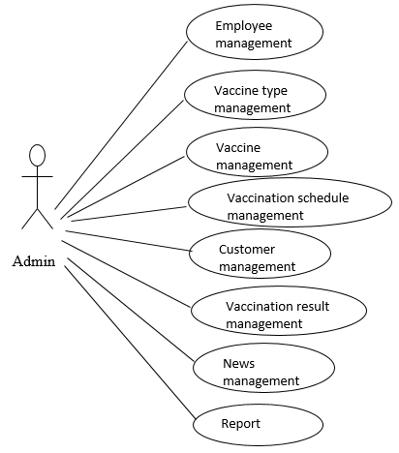

Figure 1: Use case Diagram

# Requirements Specifications

## Functional Requirements

### Log in

This screen is for user to log in to System.

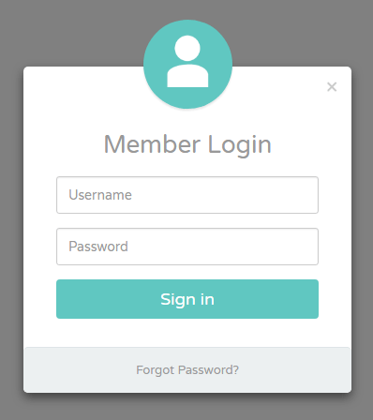

Screen 1: Login screen

|  |  |  |  |  |  |  |
| --- | --- | --- | --- | --- | --- | --- |
| **#** | **Component** | **Comp. Type** | **Editable** | **Mandatory** | **Default Value** | **Description** |
| 1 | Screen Name | Label | No | N/A. | N/A. | This field display text: “Login”. |
| 2 | Username | Text Box | Yes | Yes | N/A. | * This field allows user to input username to log in to the system. * This field gets all values of [Account] field in “User information” entity. |
| 3 | Password | Text Box | Yes | Yes | N/A. | * This field allows user to input password to log in to the system. * This field gets all values of [Password] field in “User information” entity. * The inputted password is displayed as *****. |
| 4 | Log in | Button | N/A. | N/A. | N/A. | * This button allows user to log in to the system. * Refer to ­­UC1: Log in for more details. |

### Dashboard

This is Landing Page.

In order to access this screen, user has to be logged in to the system successfully.

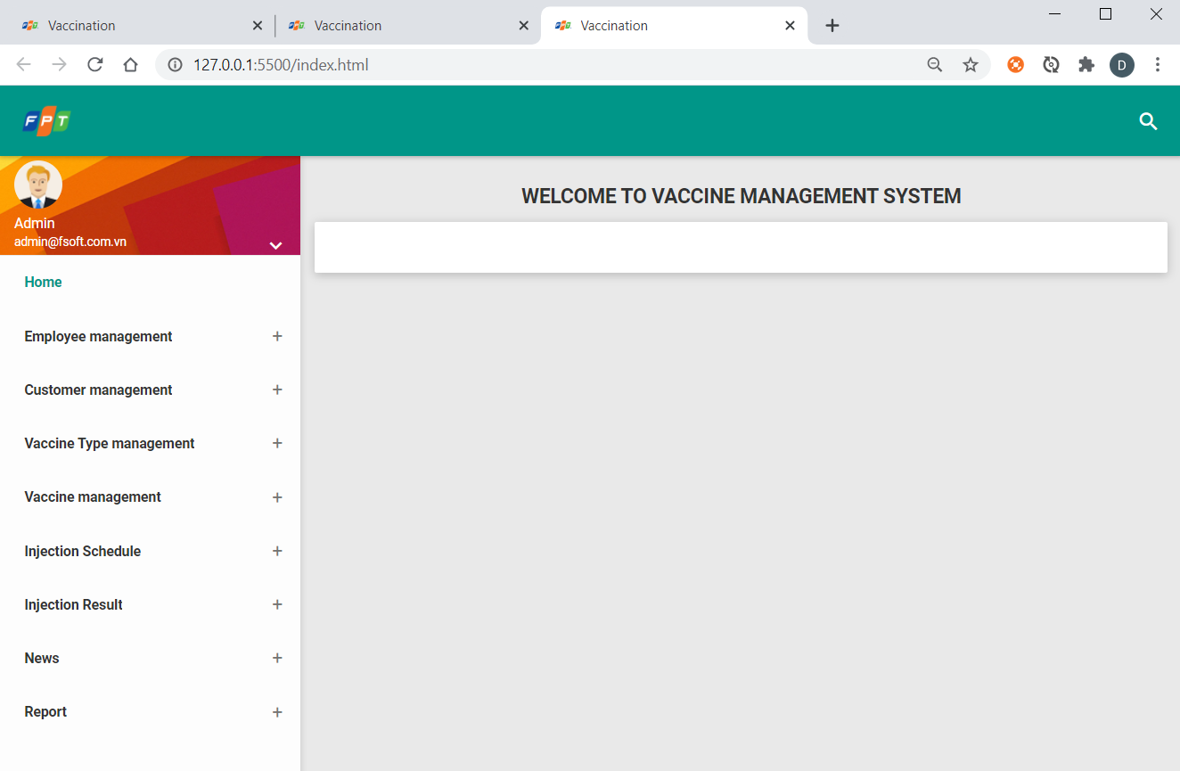

Screen 2: Landing Page

|  |  |  |  |  |  |  |
| --- | --- | --- | --- | --- | --- | --- |
| **#** | **Component** | **Comp. Type** | **Editable** | **Mandatory** | **Default Value** | **Description** |
| 1 | Screen Name | Label | No | N/A. | N/A. | This field displays text: “Dashboard”. |

### ­­UC01: Employee management

|  |  |
| --- | --- |
| **Use Case Name** | Employee management |
| **Use Case ID** | UC01 |
| **High Level Requirement Ref** | Allow admin to manage information of medical employees at Preventive Medicine Center |
| **Actor** | Admin |
| **Description** | All of employee information is accessed from database and displayed on screen. All admins can view, add, edit, delete information of medical employees. |
| **Trigger** | NA, |
| **Pre-condition** | Admin logs in system, click link “**Employee management**” |
| **Post-processing** |  |

#### Search for employee information

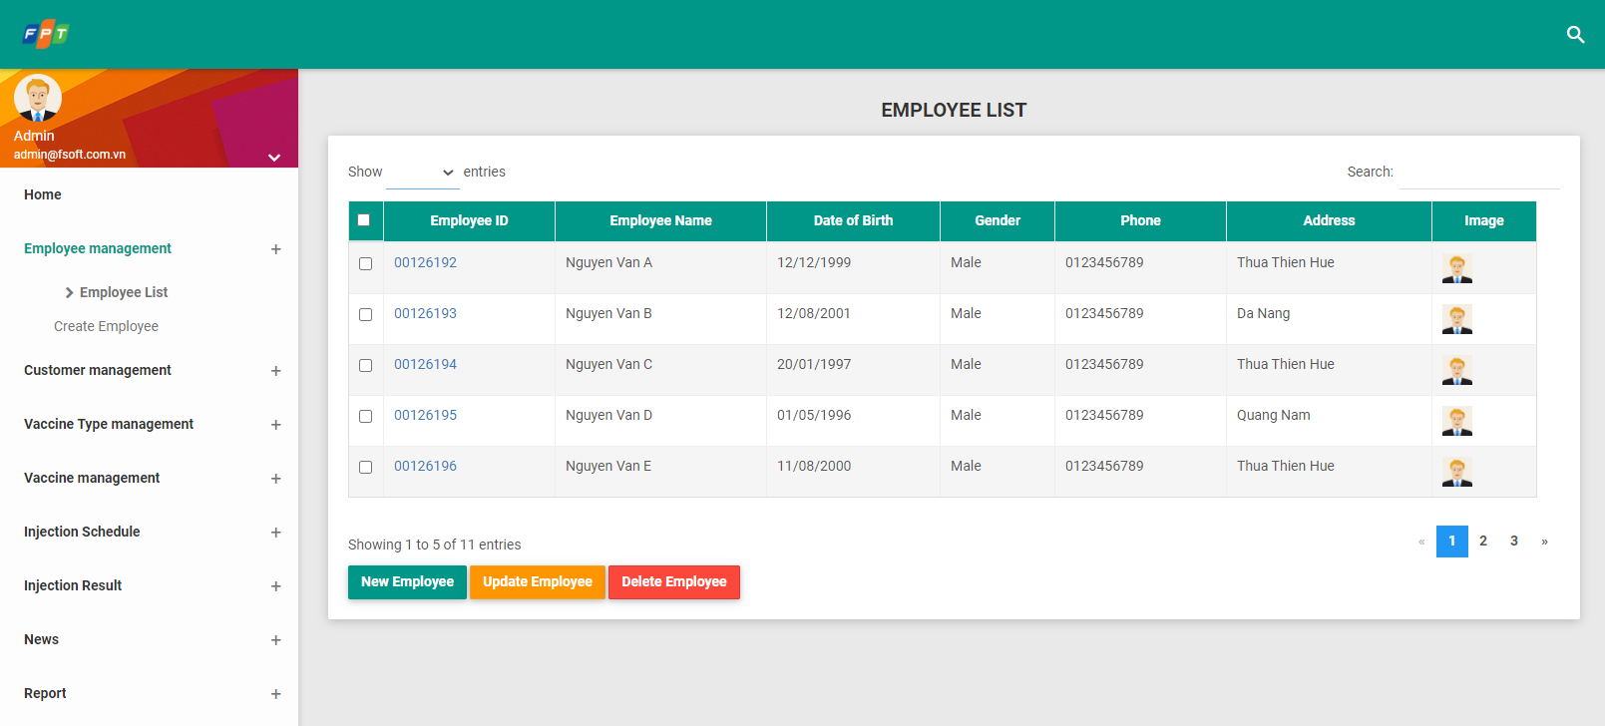

|  |  |  |  |  |  |
| --- | --- | --- | --- | --- | --- |
| **Screen** | | Search for employee information | | | |
| **Description** | | Display search tool, admin inputs name or employee ID, then click “Search”, the system will automatically filter and access from database to display all search employee. | | | |
| **Screen access** | | Admin clicks link “Employee management” -> click “**Employee List**” | | | |
| **Screen content** | | | | | |
| **Item** | | **Type** | | **Description** | |
| Show entries | | Dropdown list | |  | |
| Search | | Search-String (100) | |  | |
| New Employee | | Button | |  | |
| Update Employee | | Button | |  | |
| Delete Employee | | Button | |  | |
| Employee id | | HyperLink | | Once admin clicks on an Empl ID, system will display user to the detailed pop-up of the selected item.  **Detail pop-up of item**: similar to the employee creation form. | |
| Employee name | | Label-String (100) | |  | |
| Date of birth | | Label-Date | |  | |
| Phone | | Label-String(50) | |  | |
| Address | | Label-String(1000) | |  | |
| Image | | Image | |  | |
| **Action screen** | | | | | |
| **Action name** | **Description** | | **Success** | | **Failure** |
| Search | When admin clicks “Search”, the system will filter and display results from database on screen. | | Display results according to inputted keywords. | | If search data does not exist, then display message “**No data found!**” |
| New Employee | When admin clicks “**New Employee**”, the system will allow inputting information of medical employee. | | The system will display windows including related fields to input necessary information. | | When database connection has error -> Display message “**Database connection error**” |
| Update Employee | This button allows user to update a selected employee. | | The system will display windows including related fields to input necessary information. | | When database connection has error -> Display message “**Database connection error**” |
| Delete Employee | This button allows user to delete the selected employee(s). | | System will display a confirmation Pop up as the following:  Snapshot  **OK**: delete selected employee(s).  **Cancel**: back to view listing screen. | | If the user does not select any record and clicks "**Delete Employee**", then display message "**No data deleted!**". |

#### Add employee

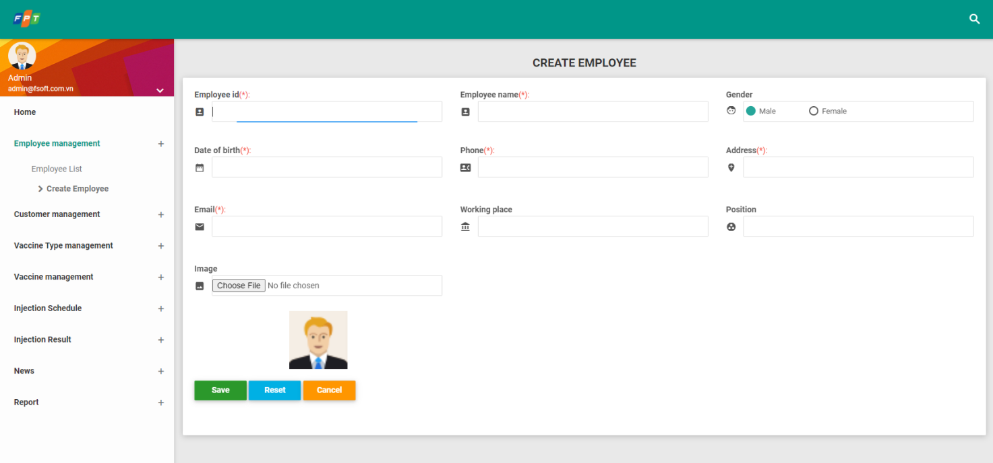

|  |  |  |  |  |  |
| --- | --- | --- | --- | --- | --- |
| **Screen** | | Add employee information | | | |
| **Description** | | Allow admin to add a medial employee including information: employee ID, name, gender, date of birth, phone number, email, address, company, position and avartar. | | | |
| **Screen access** | | Option 1: Admin clicks link “Employee management”-> click “**Create Employee**”  Option 2: Admin clicks link “Employee management” -> click “Employee List” -> Click “**New Employee**” at the list bottom. | | | |
| **Screen content** | | | | | |
| **Item** | | **Type** | **Description** | | |
| Employee id | | Text field-String(12) |  | | |
| Image | |  |  | | |
| Name of health care employee | | Text field-String(100) |  | | |
| Gender | | Dropdown list | Male or Female | | |
| Date of birth | | Date chooser |  | | |
| Phone number | | Text field-Number (50) | Phone number format | | |
| Address | | Text field-String(100) |  | | |
| Email | | Text field-String(100) | Email format | | |
| Working place | | Text field-String(100) |  | | |
| Save | | Button |  | | |
| Reset | | Button |  | | |
| Cancel | | Button |  | | |
| **Action screen** | | | | | |
| **Action name** | **Description** | | | **Success** | **Failure** |
| Save | When admin finishes inputting information of employees, click “**Save**”, then the system will automatically add that information into database. | | | Screen will display message: “**Add successfully!**” | If inputting Date of birth < 18, then display message “**The age is not valid, please check date of birth!**”  If inputting an invalid email, then display message “**Wrong email!**”  If inputting an invalid phone number, then display message “**Wrong phone number!**” |
| Reset | When admin clicks “**Reset**”, inputted information will be deleted. | | | Screen is displayed as the picture. |  |
| Cancel | Click “Cancel” to cancel adding employee into the system. | | | Screen is back to previous page |  |

#### Update employee

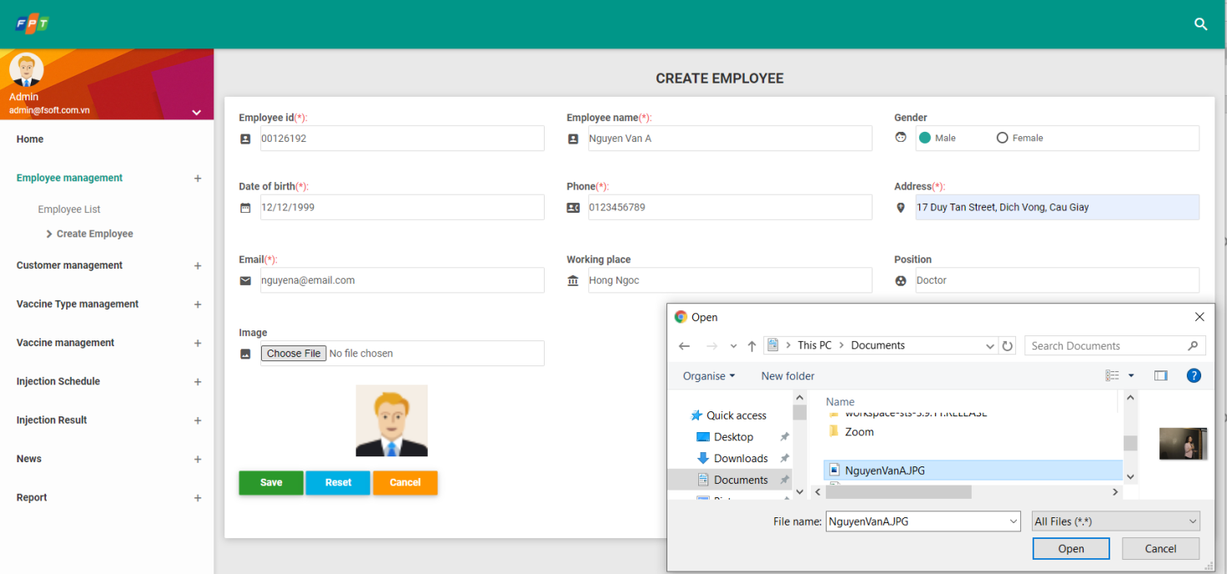

|  |  |  |  |  |  |
| --- | --- | --- | --- | --- | --- |
| **Screen** | | Update employee information | | | |
| **Description** | | Allow admin to add a medial employee including information: employee ID, name, gender, date of birth, phone number, email, address, company, position and avartar. | | | |
| **Screen access** | | Option1: Admin clicks link “Employee management” -> click “Employee List”:   * Step1: Select a employee by selecting on checkbox. * Step2: Click on “**Update Employee**” button.   Option2:   * Step1: Admin clicks on an Empl ID, system will display user to the detailed pop-up of the selected item. * Step2: Click on “**Update Employee**” button. | | | |
| **Screen content** | | | | | |
| **Item** | | **Type** | **Description** | | |
| Employee id | | Text field-String(12) | Readonly | | |
| Image | |  |  | | |
| Name of health care employee | | Text field-String(100) |  | | |
| Gender | | Dropdown list | Male or Female | | |
| Date of birth | | Date chooser |  | | |
| Phone number | | Text field-Number (50) | Phone number format | | |
| Address | | Text field-String(100) |  | | |
| Email | | Text field-String(100) | Email format | | |
| Working place | | Text field-String(100) |  | | |
| Save | | Button |  | | |
| Reset | | Button |  | | |
| Cancel | | Button |  | | |
| **Action screen** | | | | | |
| **Action name** | **Description** | | | **Success** | **Failure** |
| Save | When admin finishes inputting information of employees, click “**Save**”, then the system will automatically add that information into database. | | | Screen will display message: “**Update successfully!**” | If inputting Date of birth < 18, then display message “**The age is not valid, please check date of birth!**”  If inputting an invalid email, then display message “**Wrong email!**”  If inputting an invalid phone number, then display message “**Wrong phone number!**” |
| Reset | When admin clicks “**Reset**”, inputted information will be deleted. | | | Screen is displayed as the picture. |  |
| Cancel | Click “Cancel” to cancel adding employee into the system. | | | Screen is back to previous page |  |

### UC02: Vaccine type management

|  |  |
| --- | --- |
| **Use Case Name** | Vaccine type management |
| **Use Case ID** | UC02 |
| **High Level Requirement Ref** | Allow admin to manage information of vaccine types at Preventive Medicine Center. |
| **Actor** | Admin |
| **Description** | All of information of vaccine type is accessed from database and displayed on screen. All admin can view, add, edit, delete information of vaccine type. |
| **Trigger** | NA |
| **Pre-condition** | Admin logs in successfully into the system, click link “**Vaccine Type management**” |
| **Post-processing** |  |

#### List Vaccine Type

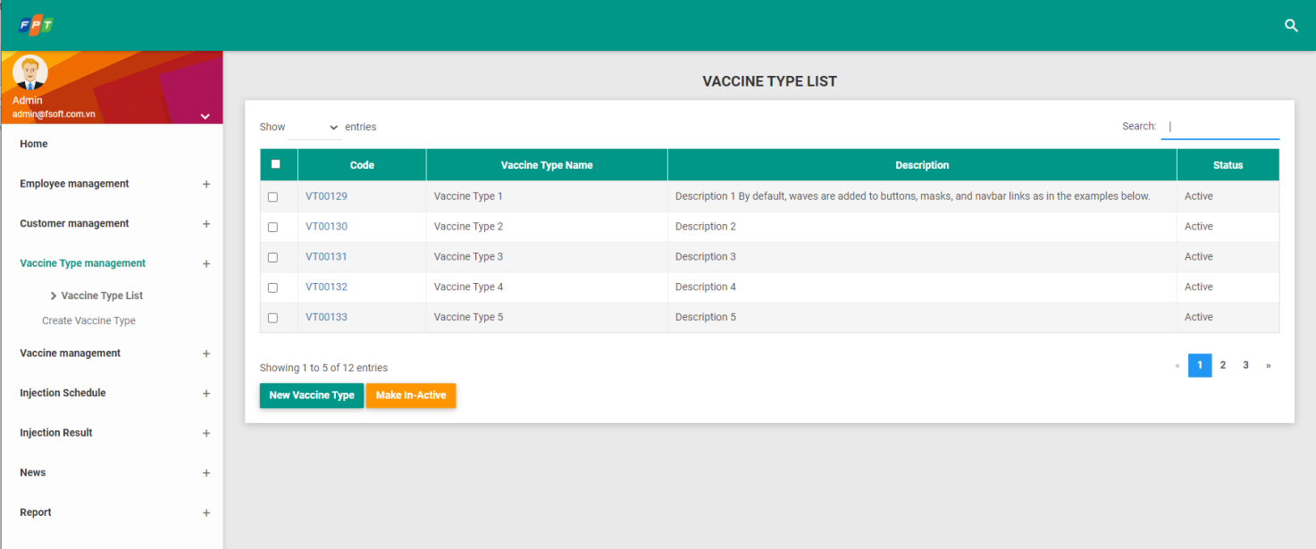

|  |  |  |  |  |  |  |
| --- | --- | --- | --- | --- | --- | --- |
| **Screen** | | List of vaccine type | | | | |
| **Description** | | Display list of vaccine type | | | | |
| **Screen access** | | Admin clicks **Vaccine Type management -> Vaccine Type List** | | | | |
| **Screen content** | | | | | | |
| **Item** | | **Type** | **Data** | | **Description** | |
| New Vaccine Type | | Button |  | |  | |
| Make In-Active | | Button |  | |  | |
| Search | | Search Box |  | |  | |
| Code | | Hyperlink | TypeOfVaccing.Code | | Format: Characters, Numbers, Dash and Underscore  Click here allows admin to update a vaccine type. | |
| Vaccine type | | Label - String (50) | TypeOfVaccine.Name | |  | |
| Description | | Label - String (200) | TypeOfVaccine.Describe | |  | |
| Status | | Label-String (50) | TypeOfVaccine.Status | | ‘Active’ or ‘In-Active’ | |
| **Action screen** | | | | | | |
| **Action name** | **Description** | | | **Success** | | **Failure** |
| Search | When admin clicks “**Search**”, the system will filter and display results from database on screen. | | | Display results according to inputted keywords. | | If search data does not exist, then display message “**No data found!**” |
| New Vaccine Type | When admin clicks “**New Vaccine Type**”, the system will allow inputting information of vaccine type. | | | The system will display windows including related fields to input necessary information. | | When database connection has error -> Display message “**Database connection error**” |
| Make In-Active | This button allows user to make the status is ‘In-Active’ the selected vaccine type(s). | | | System will display a confirmation Pop up as the following: | | If the user does not select any record and clicks "**Make In-Active**", then display message "**No data to make inactive!**".  If the inactive vaccine type(s) selected, then display message “**Invalid data - please recheck your selects**!” |

#### Add Vaccine Type

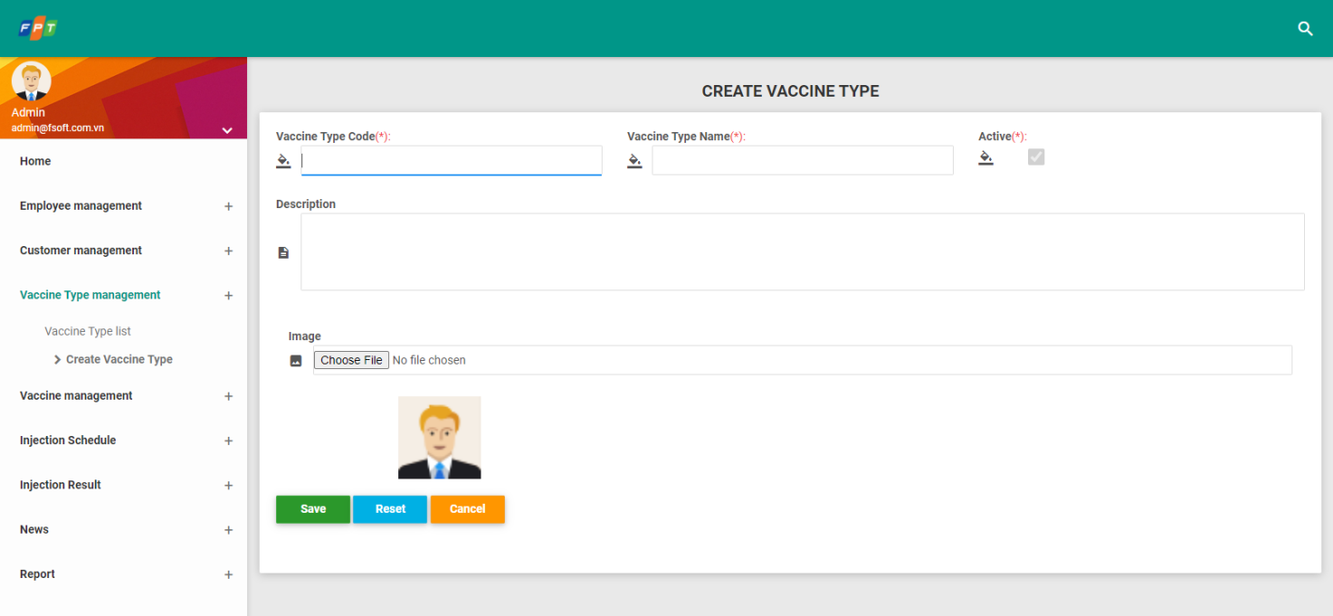

|  |  |  |  |  |  |  |
| --- | --- | --- | --- | --- | --- | --- |
| **Screen** | | Add vaccine type | | | | |
| **Description** | | Allow admin to add one vaccine type | | | | |
| **Screen access** | | Option 1: Admin clicks link “Vaccine Type management”-> click “**Create Vaccing Type**”  Option 2: Admin clicks link “Vaccine Type management” -> click “Vaccine Type List” -> Click “**New Vaccine Type**” at the list bottom. | | | | |
| **Screen content** | | | | | | |
| **Item** | | **Type** | | **Data** | | **Description** |
| Vaccine code | | Text field – String (50) | | TypeOfVaccine.Code | |  |
| Vaccine type | | Text field – String (50) | | TypeOfVaccine.Name | |  |
| Description | | Text Area – String (200) | | TypeOfVaccine.Note | |  |
| Image | |  | | TypeOfVaccine.Image | |  |
| Active | | Checkbox – Boolean | | TypeOfVaccine.Status=TRUE | | Readonly |
| Save | | Button | |  | |  |
| Reset | | Button | |  | |  |
| Cancel | | Button | |  | |  |
| **Action screen** | | | | | | |
| **Action name** | **Description** | | **Success** | | **Failure** | |
| Save | Inputted data is saved into Database | | Back to screen “List of vaccine type” with a new vaccine type from vaccine type list. | | When admin does not input any data into vaccine type box  -> Display message “**Please input name**”  When database connection has error  -> Display message “**Database connection error**” | |
| Reset | When admin clicks “**Reset**”, inputted information will be deleted. | | Screen is displayed as the picture. | |  | |
| Cancel | Close screen “**Add vaccine type**” | | Back to screen “**List of vaccine type**” | |  | |

#### Update Vaccine Type

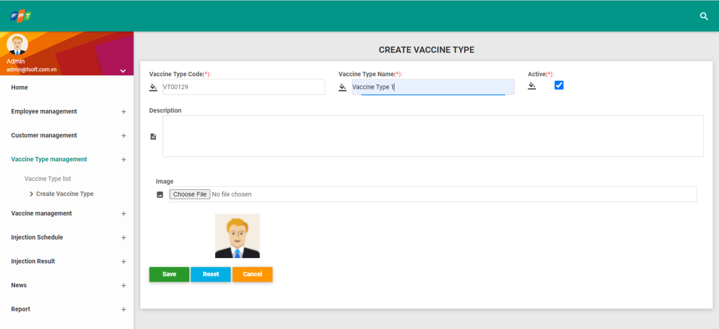

|  |  |  |  |  |  |  |
| --- | --- | --- | --- | --- | --- | --- |
| **Screen** | | Update vaccine type | | | | |
| **Description** | | Allow admin to add one vaccine type | | | | |
| **Screen access** | | Admin clicks link “Vaccine Type ID” at “Vaccine Type List” screen. | | | | |
| **Screen content** | | | | | | |
| **Item** | | **Type** | | **Data** | | **Description** |
| Vaccine code | | Text field – String (50) | | TypeOfVaccine.Code | | Readonly |
| Vaccine type | | Text field – String (50) | | TypeOfVaccine.Name | |  |
| Description | | Text Area – String (200) | | TypeOfVaccine.Note | |  |
| Image | |  | | TypeOfVaccine.Image | |  |
| Active | | Checkbox – Boolean | | TypeOfVaccine.Status | | Can update value |
| Save | | Button | |  | |  |
| Reset | | Button | |  | |  |
| Cancel | | Button | |  | |  |
| **Action screen** | | | | | | |
| **Action name** | **Description** | | **Success** | | **Failure** | |
| Save | Inputted data is saved into Database | | Back to screen “List of vaccine type” with a new vaccine type from vaccine type list. | | When admin does not input any data into vaccine type box  -> Display message “**Please input name**”  When database connection has error  -> Display message “**Database connection error**” | |
| Reset | When admin clicks “**Reset**”, inputted information will be deleted. | | Screen is displayed as the picture. | |  | |
| Cancel | Close screen “**Add vaccine type**” | | Back to screen “**List of vaccine type**” | |  | |

### UC03: Vaccine management

|  |  |
| --- | --- |
| **Use Case Name** | Vaccine management |
| **Use Case ID** | UC03 |
| **High Level Requirement Ref** | Allow admin to manage information of vaccines at Preventive Medicine Center |
| **Actor** | Admin |
| **Description** | All of vaccine information is accessed from database and displayed on screen. All admins can view, add, edit, delete information of vaccine. |
| **Trigger** | NA |
| **Pre-condition** | Admin must successfully log in the system, then click link “Vaccine” |
| **Post-processing** |  |

#### List Vaccine

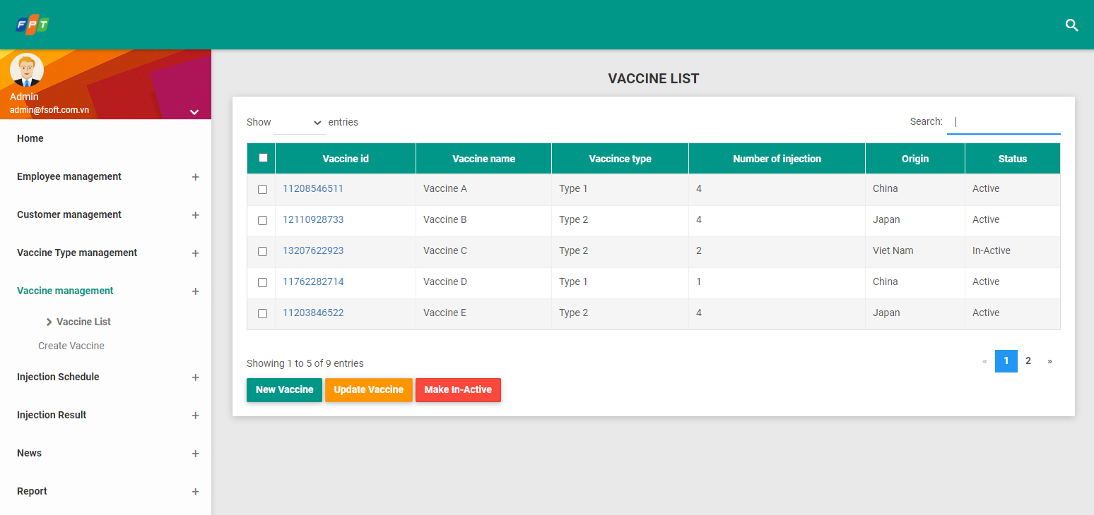

|  |  |  |  |  |  |
| --- | --- | --- | --- | --- | --- |
| **Screen** | List of vaccine | | | | |
| **Description** | Display list of vaccine according to vaccine type that admin clicks | | | | |
| **Screen access** | Admin clicks **Vaccine management -> Vaccine List** | | | | |
| **Screen content** | | | | | |
| **Item** | **Type** | **Data** | | **Description** | |
| Search | Search Box |  | |  | |
| New Vaccine | Button |  | |  | |
| Update Vaccine |  |  | |  | |
| Make In-Active |  |  | |  | |
| Vaccince id | Label – String(10) | Vaccine.VaccineId | | Format: Numbers only  Click here allows admin to update a vaccine. | |
| Vaccine name | Label - String (50) | Vaccine.Name | |  | |
| Vaccine type | Label - String (50) | TypeOfVaccine.Name | |  | |
| Number of injection | Label – Number(15) | Vaccine.Number | |  | |
| Origin | Label - String (50) | Vaccine.Origin | |  | |
| Status | Label – String(50) | Vaccine.Status | | ‘Active’ or ‘In-Active’ | |
| **Action screen** | | | | | |
| **Action name** | **Description** | | **Success** | | **Failure** |
| New Vaccine | When admin clicks “**New Vaccine**” button, the system will display screen “Add vaccine”. | | Display screen “**Add vaccine**”. | |  |
| Search | When admin clicks “Search”, the system will filter and display results from database on screen. | | Display results according to inputted keywords. | | If search data does not exist, then display message “**No data found!**” |
| Update Vaccine | This button allows user to update a selected Vaccine. | | The system will display windows including related fields to input necessary information. | | When database connection has error -> Display message “**Database connection error**” |
| Make In-Active | This button allows user to make the status is ‘In-Active’ the selected vaccine(s). | | System will display a confirmation Pop up as the following: | | If the user does not select any record and clicks "**Make In-Active**", then display message "**No data to make inactive!**".  If the inactive vaccine type(s) selected, then display message “**Invalid data - please recheck your selects**!” |

###### Add Vaccine

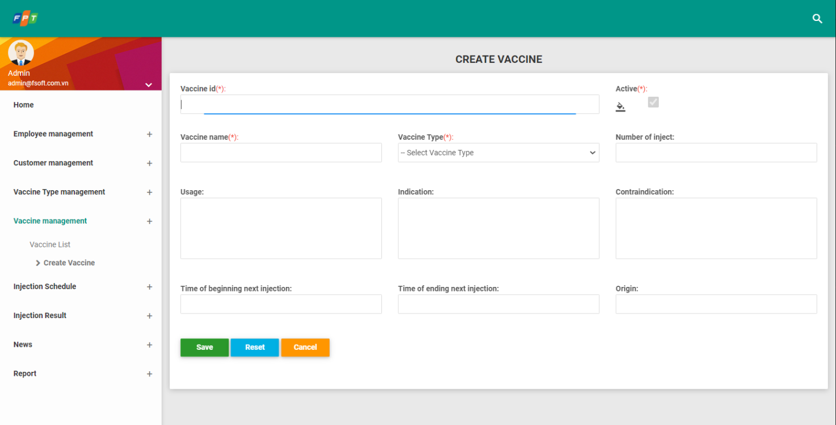

|  |  |  |  |
| --- | --- | --- | --- |
| **Screen** | Add vaccine | | |
| **Description** | Allow admin to add vaccine | | |
| **Screen access** | Option1: Admin clicks **New Vaccine** on screen “List of vaccine”  Option2: Admin clicks **Vaccine management -> Create Vaccine** | | |
| **Screen content** | | | |
| **Item** | **Type** | **Data** | **Description** |
| Vaccince id | Text field – String(10) | Vaccine.VaccineId | Format: Numbers only. |
| Active | Checkbox – Boolean | Vaccing.Status = TRUE | Readonly |
| Vaccine name | Text field – String (50) | Vaccine.Name |  |
| Vaccine type | Dropdown list – String (50) | TypeOfVaccine.Name  Default: “Select” |  |
| Uses | Text Area– String (200) | Vaccine.Effect |  |
| Usage | Text Area– String (200) | Vaccine.Effect |  |
| Indication | Text Area– String (200) | Vaccine.Assign |  |
| Contraindication | Text Area– String (200) | Vaccine.Contraindication |  |
| Number of injection | Text field – Number(15) | Vaccine.Number |  |
| Time of beginning next injection | Date | Vaccine.NextTimeStart |  |
| Time of ending next injection | Date | Vaccine.NextTimeEnd |  |
| Origin | Text field – String (50) | Vaccine.Origin |  |
| Save | Button |  |  |
| Reset | Button |  |  |
| Cancel | Button |  |  |
| **Action screen** | | | |
| **Action name** | **Description** | **Success** | **Failure** |
| Save | Inputted data is saved into Database | Back to screen “**List of vaccine**” with a new vaccine type from vaccine type list. | When admin inputs start time with value greater than end time -> Display message “**Time to start next vaccination must be less than end time**” |
| Reset | When admin clicks “**Reset**”, inputted information will be deleted. | Screen is displayed as the picture. |  |
| Cancel | Close screen “Add vaccine” | Back to screen “**List of vaccine**” |  |

#### Update Vaccine

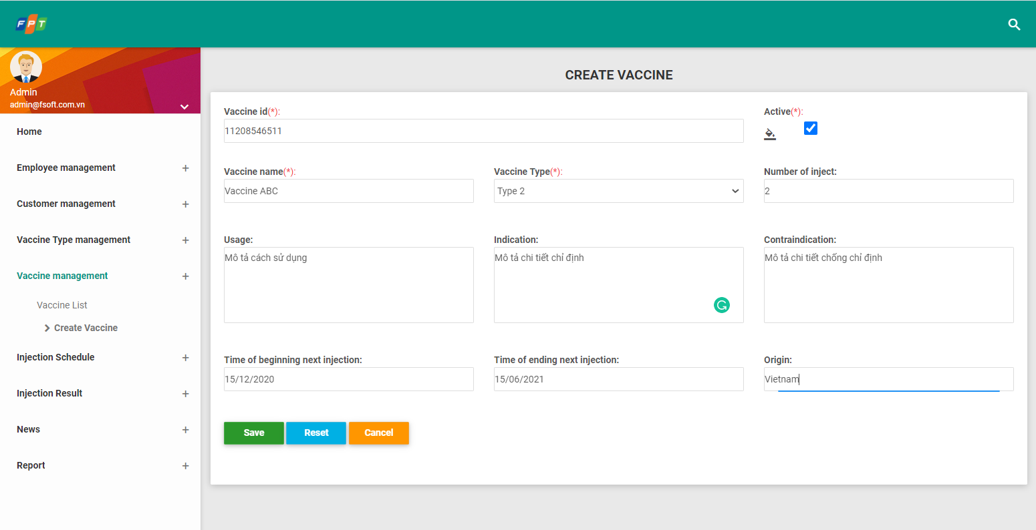

|  |  |  |  |
| --- | --- | --- | --- |
| **Screen** | Update vaccine | | |
| **Description** | Allow admin to add vaccine | | |
| **Screen access** | Admin clicks link “Vaccine ID” at “Vaccine List” screen. | | |
| **Screen content** | | | |
| **Item** | **Type** | **Data** | **Description** |
| Vaccince id | Text field – String(10) | Vaccine.VaccineId | Readonly |
| Active | Checkbox – Boolean | Vaccine.Status | Can update value |
| Vaccine name | Text field – String (50) | Vaccine.Name |  |
| Vaccine type | Dropdown list – String (50) | TypeOfVaccine.Name  Default: “Select” |  |
| Uses | Text Area– String (200) | Vaccine.Effect |  |
| Usage | Text Area– String (200) | Vaccine.Effect |  |
| Indication | Text Area– String (200) | Vaccine.Assign |  |
| Contraindication | Text Area– String (200) | Vaccine.Contraindication |  |
| Number of injection | Text field – Number(15) | Vaccine.Number |  |
| Time of beginning next injection | Date | Vaccine.NextTimeStart |  |
| Time of ending next injection | Date | Vaccine.NextTimeEnd |  |
| Origin | Text field – String (50) | Vaccine.Origin |  |
| Save | Button |  |  |
| Reset | Button |  |  |
| Cancel | Button |  |  |
| **Action screen** | | | |
| **Action name** | **Description** | **Success** | **Failure** |
| Save | Inputted data is saved into Database | Back to screen “**List of vaccine**” with a new vaccine type from vaccine type list. | When admin inputs start time with value greater than end time -> Display message “**Time to start next vaccination must be less than end time**” |
| Reset | When admin clicks “**Reset**”, inputted information will be deleted. | Screen is displayed as the picture. |  |
| Cancel | Close screen “Add vaccine” | Back to screen “**List of vaccine**” |  |

#### Import Vaccine

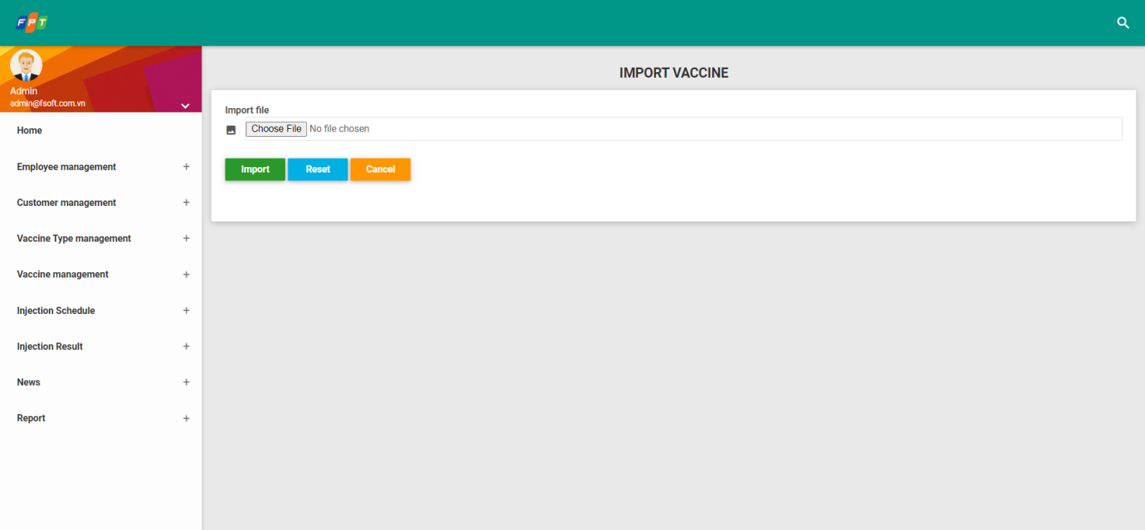

|  |  |  |  |
| --- | --- | --- | --- |
| **Screen** | Import vaccine (excel file) | | |
| **Description** | Allow admin to import vaccine from an excel file. | | |
| **Screen access** | Admin clicks “Import” button at “Vaccine List” screen. | | |
| **Screen content** | | | |
| **Item** | **Type** | **Data** | **Description** |
| Vaccince id | Text field – String(10) | Vaccine.VaccineId | Readonly |
| Active | Checkbox – Boolean | Vaccine.Status | Can update value |
| Vaccine name | Text field – String (50) | Vaccine.Name |  |
| Vaccine type | Dropdown list – String (50) | TypeOfVaccine.Name  Default: “Select” |  |
| Uses | Text Area– String (200) | Vaccine.Effect |  |
| Usage | Text Area– String (200) | Vaccine.Effect |  |
| Indication | Text Area– String (200) | Vaccine.Assign |  |
| Contraindication | Text Area– String (200) | Vaccine.Contraindication |  |
| Number of injection | Text field – Number(15) | Vaccine.Number |  |
| Time of beginning next injection | Date | Vaccine.NextTimeStart |  |
| Time of ending next injection | Date | Vaccine.NextTimeEnd |  |
| Origin | Text field – String (50) | Vaccine.Origin |  |
| Save | Button |  |  |
| Reset | Button |  |  |
| Cancel | Button |  |  |
| **Action screen** | | | |
| **Action name** | **Description** | **Success** | **Failure** |
| Import |  |  |  |
| Reset | When admin clicks “**Reset**”, inputted information will be deleted. | Screen is displayed as the picture. |  |
| Cancel | Close screen “Add vaccine” | Back to screen “**List of vaccine**” |  |

### UC04: Vaccination schedule

|  |  |
| --- | --- |
| **Use Case Name** | Vaccination schedule management |
| **Use Case ID** | UC04 |
| **High Level Requirement Ref** | Alow admin to manage information of vaccination schedule at Preventive Medicine Center. |
| **Actor** | Admin |
| **Description** | All of information of vaccination schedule is accessed from database and displayed on screen. All admin can view, add, edit, delete information of vaccination schedule. |
| **Trigger** | NA |
| **Pre-condition** | Admin logs in successfully into the system. |
| **Post-processing** |  |

#### List Schedule

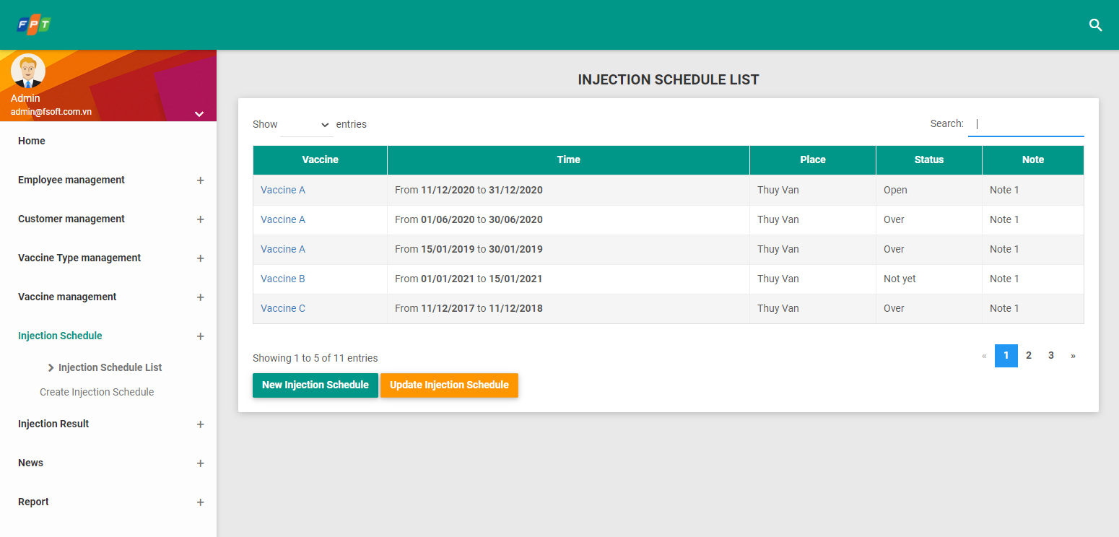

|  |  |  |  |  |  |
| --- | --- | --- | --- | --- | --- |
| **Screen** | List of vaccination schedule | | | | |
| **Description** | Display list of vaccination schedule | | | | |
| **Screen access** | The admin clicks **Inject Schedule -> Inject Schedule List** | | | | |
| **Screen content** | | | | | |
| **Item** | **Type** | | **Data** | **Description** | |
| New Injection Schedule | Button | |  |  | |
| Update Injection Schedule | Button | |  |  | |
| Search | Search Box | |  |  | |
| ID | Label – Number(15) | | Calendar.Id |  | |
| Vaccine | Hyperlink - String (50) | | Vaccine.Name | Once admin clicks on a Vaccine, system will display user to the detailed pop-up of the selected item.  **Detail pop-up of item**: similar to the injection schedule creation form. | |
| Time | Label - String (200) | | Calendar.Time |  | |
| Place | Label – String(100) | | Calendar.Address |  | |
| Status | Label – String(50) | | Calendar.Status | Value list: ‘Not yet’, ‘Open’, ‘Over’. | |
| Note | Label – String (200) | | Calendar.Note |  | |
| **Action Screen** | | | | | |
| **Action name** | **Description** | **Success** | | | **Failure** |
| New Injection Schedule | When admin clicks **New Injection Schedule,** the system will display screen “Create inject vaccination schedule” | Display screen “Create inject vaccination schedule” | | |  |
|  |  |  | | |  |
| Update Injection Schedule | This button allows user to update a selected injection schedule. | The system will display windows including related fields to input necessary information. | | | When database connection has error -> Display message “**Database connection error**” |

#### Add Schedule

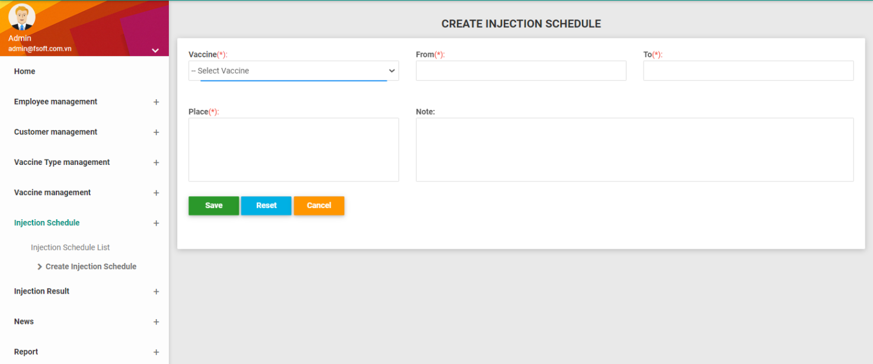

|  |  |  |  |  |  |  |
| --- | --- | --- | --- | --- | --- | --- |
| **Screen** | | Add vaccination schedule | | | | |
| **Description** | | Allow admin to update records | | | | |
| **Screen access** | | Option1: The admin clicks **New Injection Schedule** on screen “List of vaccination schedule”  Option2: The admin clicks **Injection Schedule link** à **Create Injection Schedule** | | | | |
| **Screen content** | | | | | | |
| **Item** | | **Type** | **Data** | | **Description** | |
| Vaccine | | Dropdown list – String (50) | Vaccine.Name  Default ”Select” | |  | |
| From | | Date | Calendar.From | |  | |
| To | | Date | Calendar.To | |  | |
| Place | | Text Area – String (200) | Calendar.Address | |  | |
| Note | | Text Area – String (200) | Calendar.Note | |  | |
| Save | | Button |  | |  | |
| Reset | | Button |  | |  | |
| Cancel | | Button |  | |  | |
| **Action screen** | | | | | | |
| **Action name** | **Description** | | | **Success** | | **Failure** |
| Save | When admin finishes inputting information of injection schedule, click “**Save**”, then the system will automatically add that information into database. | | | Screen will display message: “**Update successfully!**” | | If inputting From > To, then display message “**From date must be less than to date**”. |
| Reset | When admin clicks “**Reset**”, inputted information will be deleted. | | | Screen is displayed as the picture. | |  |
| Cancel | Click “Cancel” to cancel updating injection schedule into the system. | | | Screen is back to previous page | |  |

#### Update Schedule

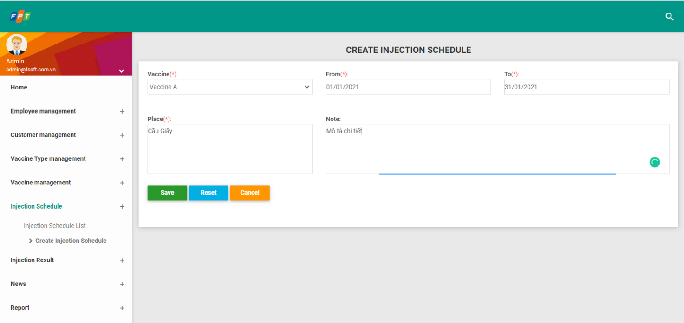

|  |  |  |  |  |  |  |
| --- | --- | --- | --- | --- | --- | --- |
| **Screen** | | Update vaccination schedule | | | | |
| **Description** | | Allow admin to update records | | | | |
| **Screen access** | | Option1: Admin clicks link “Injections Schedule” -> click “Injection Schedule List”:   * Step1: Select a item by selecting on checkbox. * Step2: Click on “**Update Injection Schedule**” button.   Option2:   * Step1: Admin opens schedule detail screen, system will display user to the detailed pop-up of the selected item. * Step2: Click on “**Update Injection Schedule**” button. | | | | |
| **Screen content** | | | | | | |
| **Item** | | **Type** | **Data** | | **Description** | |
| Vaccine | | Dropdown list – String (50) | Vaccine.Name  Default ”Select” | |  | |
| From | | Date | Calendar.From | |  | |
| To | | Date | Calendar.To | |  | |
| Place | | Text Area – String (200) | Calendar.Address | |  | |
| Note | | Text Area – String (200) | Calendar.Note | |  | |
| Save | | Button |  | |  | |
| Reset | | Button |  | |  | |
| Cancel | | Button |  | |  | |
| **Action screen** | | | | | | |
| **Action name** | **Description** | | | **Success** | | **Failure** |
| Save | When admin finishes inputting information of injection shedule, click “**Save**”, then the system will automatically add that information into database. | | | Screen will display message: “**Update successfully!**” | | If inputting From > To, then display message “**From date must be less than to date**”. |
| Reset | When admin clicks “**Reset**”, inputted information will be deleted. | | | Screen is displayed as the picture. | |  |
| Cancel | Click “Cancel” to cancel updating injection schedule into the system. | | | Screen is back to previous page | |  |

### UC05: Customer management

|  |  |
| --- | --- |
| **Use Case Name** | Customer management |
| **Use Case ID** | UC05 |
| **High Level Requirement Ref** | The system helps medical employees manage customers, supervise and follow information of each customer to Preventive Medicine Center |
| **Actor** | Medical Employee |
| **Description** | The system allows medical employees to register vaccination information for customers. |
| **Trigger** | NA |
| **Pre-condition** | The medical employee logs in the system successfully with correct username and password. |
| **Post-processing** |  |

#### Register information of customer

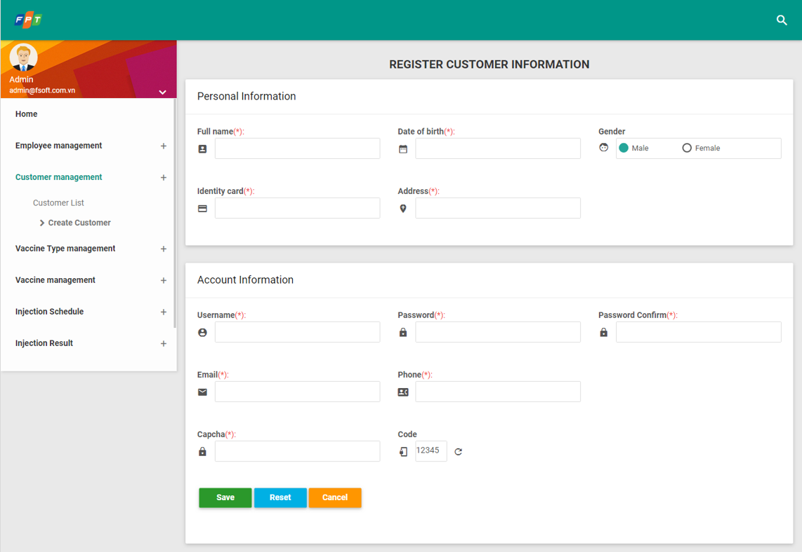

|  |  |  |  |  |  |
| --- | --- | --- | --- | --- | --- |
| **Screen** | Register information of customer | | | | |
| **Description** | Display form to fulfill information such as name, date of birth, sex and identity card… | | | | |
| **Screen access** | Medical employee logs in system successfully, then click item **Customer management** -> **Create Customer** | | | | |
| **Screen content** | | | | | |
| **Item** | **Type** | **Data** | | **Description** | |
| Full name | Text Field – String(100) |  | |  | |
| Date | Date Chooser/Date Picker – Date[100] |  | |  | |
| Gender | Checkbox – boolean |  | |  | |
| Identity card | Text Field – Numeric(10) |  | |  | |
| Native place | Text Field – String(100) |  | |  | |
| User | Text Field – String(10) |  | |  | |
| Password | Text field – String(20) |  | |  | |
| Confirm password | Text field – String(20) |  | |  | |
| Email | Text field – String(25) |  | |  | |
| Phone | Text Field – numberic(11) |  | |  | |
| ID | Text Field – Alpha numberic(6) |  | | Auto Increment. | |
| **Action Screen** | | | | | |
| **Action name** | **Description** | | **Success** | | **Failure** |
| Save | The user clicks Save, the system will add data into database | | Data is registered successfully into database.  Send a notification of successful registration information to the customer. | | Display error messages: - “**You must input information into fields (*)**”.  - “**Exist user in the system**”. |
| Reset | When admin clicks “**Reset**”, inputted information will be deleted. | | Screen is displayed as the picture. | |  |
| Cancel | Click “Cancel” to cancel register information of customer into the system. | | Screen is back to previous page | |  |

#### Search for vaccination customer

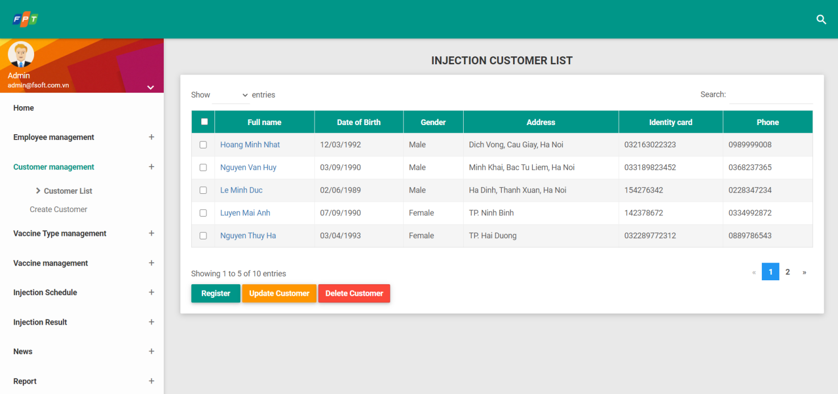

|  |  |  |  |  |  |
| --- | --- | --- | --- | --- | --- |
| **Screen** | Search for vaccination customer | | | | |
| **Description** |  | | | | |
| **Screen access** | Search information on menu bar of the website | | | | |
| **Screen content** | | | | | |
| **Item** | **Type** | **Data** | | **Description** | |
| Full name | Label – String(30) |  | | Admin clicks on cusomter name, system will display user to the detailed pop-up of the selected item.  **Detail pop-up of item**: similar to the customer creation form. | |
| Date of birth | Label – Date |  | |  | |
| Gender | Label – String(20) |  | |  | |
| Address | Label – String(100) |  | |  | |
| Identity card | Label – Numberic(100) |  | |  | |
| ID | Label – Alphanumberic(20) |  | | Auto Increment | |
| Phone | Label – Numberic(50) |  | |  | |
| **Action Screen** | | | | | |
| **Action name** | **Description** | | **Success** | | **Failure** |
| Search | The medical employee inputs information of vaccination customer to search, such as inputting name or customer ID. | |  | | If search data does not exist, display message “**No data found!**” |
| Register | When admin clicks “**Register**”, the system will allow inputting information of customer. | | The system will display windows including related fields to input necessary information. | | When database connection has error -> Display message “**Database connection error**” |
| Update Customer | This button allows user to update a selected customer. | | The system will display windows including related fields to input necessary information. | | When database connection has error -> Display message “**Database connection error**” |
| Delete Customer | This button allows user to delete the selected customer(s). | | System will display a confirmation Pop up as the following:  Snapshot  **OK**: delete selected customer(s).  **Cancel**: back to view listing screen. | | If the user does not select any record and clicks "**Delete Employee**", then display message "**No data deleted!**". |

#### Update information of customer



|  |  |  |  |  |  |
| --- | --- | --- | --- | --- | --- |
| **Screen** | Update information of customer | | | | |
| **Description** | Display form to fulfill information such as name, date of birth, sex and identity card… | | | | |
| **Screen access** | Option1: Medical employee logs in system successfully, then click item **Customer management** -> **Customer List à Update Customer.**  Option2: Clicks “Update Customer” button on Customer Detail screen | | | | |
| **Screen content** | | | | | |
| **Item** | **Type** | **Data** | | **Description** | |
| Full name | Text Field – String(100) |  | |  | |
| Date | Date Chooser/Date Picker – Date[100] |  | |  | |
| Gender | Checkbox – boolean |  | |  | |
| Identity card | Text Field – Numeric(10) |  | |  | |
| Native place | Text Field – String(100) |  | |  | |
| User | Text Field – String(10) |  | |  | |
| Password | Text field – String(20) |  | |  | |
| Confirm password | Text field – String(20) |  | |  | |
| Email | Text field – String(25) |  | |  | |
| Phone | Text Field – Numberic(11) |  | |  | |
| ID | Text Field – Alpha numberic(6) |  | |  | |
| **Action Screen** | | | | | |
| **Action name** | **Description** | | **Success** | | **Failure** |
| Save | The user clicks Save, the system will add data into database | | Data is registered successfully into database.  Send a notification of successful registration information to the customer. | | Display error messages: - “**You must input information into fields (*)**”.  - “**Exist user in the system**”. |
| Reset | When admin clicks “**Reset**”, inputted information will be deleted. | | Screen is displayed as the picture. | |  |
| Cancel | Click “Cancel” to cancel register information of customer into the system. | | Screen is back to previous page | |  |

### UC06: Vaccination result management

|  |  |
| --- | --- |
| **Use Case Name** | Vaccination result management |
| **Use Case ID** | UC06 |
| **High Level Requirement Ref** | The system helps medical employee manage vaccination results of customer, from that, make statistic and report on vaccination process. |
| **Actor** | Medical employee |
| **Description** | The system allows the medical employees to manage vaccination result. |
| **Trigger** | NA |
| **Pre-condition** | The medical employee logs in the system successfully with correct username and password. |
| **Post-processing** |  |

#### Search for vaccination result

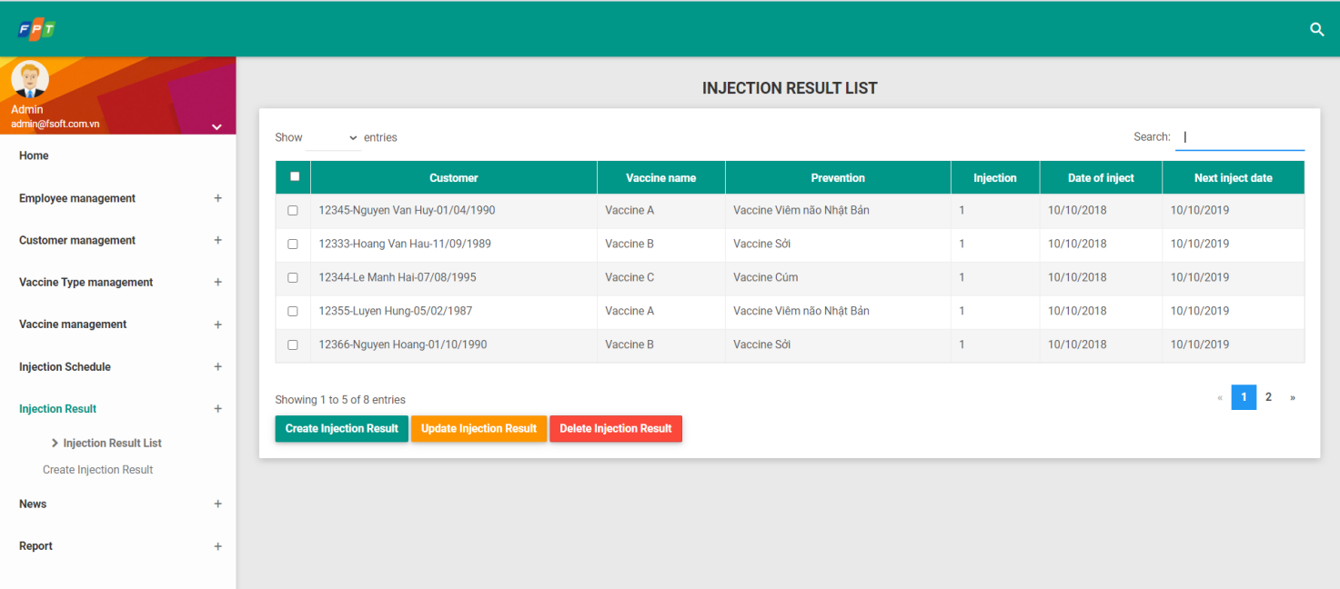

|  |  |  |  |  |
| --- | --- | --- | --- | --- |
| **Screen** | View information of vaccination result | | | |
| **Description** | Display screen of detail information description of customer | | | |
| **Screen access** | Employee click item Customer, then click List of vaccination customer, then click Detail. | | | |
| **Screen content** | | | | |
| **Item** | **Type** | **Data** | **Description** | |
| ID |  |  |  | |
| Prevention |  |  |  | |
| Vaccine type |  |  |  | |
| Injection |  |  |  | |
| Date of injection |  |  |  | |
| Next injection appointment |  |  |  | |
| Place of injection |  |  |  | |
| ID |  |  |  | |
| Full name |  |  |  | |
| Phone number |  |  |  | |
| Identity card |  |  |  | |
| Customer |  |  |  | |
| Vaccine type |  |  |  | |
| Age |  |  |  | |
| Year |  |  |  | |
| **Action screen** | | | | |
| **Action name** | **Description** | | **Success** | **Failure** |
| Search | When user clicks Search, the system will search detail information and display into list. | | Display search information. | If search data does not exist, display message “**No data found!**” |

#### Add vaccination result

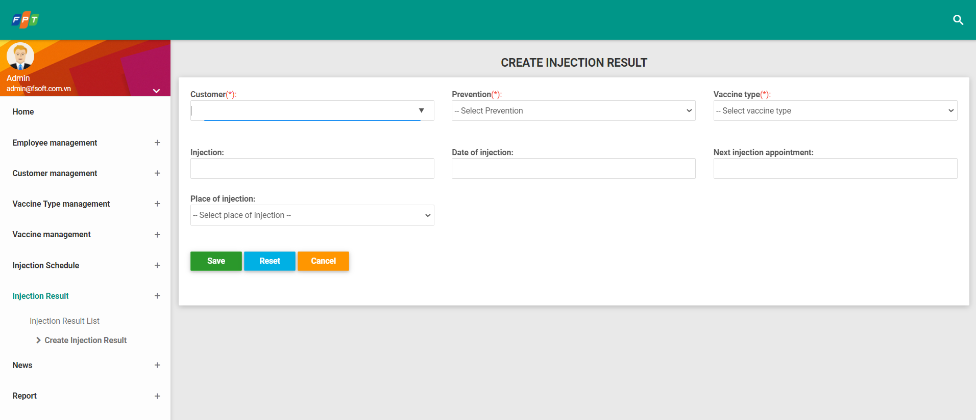

|  |  |  |  |  |  |
| --- | --- | --- | --- | --- | --- |
| **Screen** | Add vaccination result | | | | |
| **Description** | Display screen of process description of creating vaccination result | | | | |
| **Screen access** | The employee clicks item vaccination result management, then click Add vaccination result. | | | | |
| **Screen content** | | | | | |
| **Item** | **Type** | **Data** | | **Description** | |
| ID | Text Field – String (100) |  | |  | |
| Prevention | ComboBox – String(10) |  | |  | |
| Vaccine type | Label – Date(50) |  | |  | |
| Injection | Text Field – Numberic (10) |  | |  | |
| Date of injection | Date Chooser – String(50) |  | |  | |
| Next injection appointment | Date Chooser – String(50) |  | |  | |
| Place of injection | ComboBox- String(100) |  | |  | |
| **Action screen** | | | | | |
| **Action name** | **Description** | | **Success** | | **Failure** |
| Reset | When user clicks Reset, all inputted data on form automatically reset into default value. Then, re-input from the beginning. | |  | |  |
| Save | When user clicks Save, the system confirms saving result into database. | | Display message “**Successful operation**”. | | In case, input “Date of vaccination” with value less than the current date, display message “**Please input Date of vaccination with value greater or equal the current date**”  In case, input “Next date of vaccination” with value less than or equal “Date of vaccination”, display message “**Please input Next date of vaccination with value greater than Date of vaccination**” |
| Cancel | Click “Cancel” to cancel register information of customer into the system. | | Screen is back to previous page | |  |

#### Update vaccination result



|  |  |  |  |  |  |
| --- | --- | --- | --- | --- | --- |
| **Screen** | Update vaccination result | | | | |
| **Description** | Display screen of process description of creating vaccination result | | | | |
| **Screen access** | The employee clicks “**Update Injection Result**” button | | | | |
| **Screen content** | | | | | |
| **Item** | **Type** | **Data** | | **Description** | |
| ID | Text Field – String (100) |  | |  | |
| Prevention | ComboBox – String(10) |  | |  | |
| Vaccine type | Label – Date(50) |  | |  | |
| Injection | Text Field – Numberic (10) |  | |  | |
| Date of injection | Date Chooser – String(50) |  | |  | |
| Next injection appointment | Date Chooser – String(50) |  | |  | |
| Place of injection | ComboBox- String(100) |  | |  | |
| **Action screen** | | | | | |
| **Action name** | **Description** | | **Success** | | **Failure** |
| Reset | When user clicks Reset, all inputted data on form automatically reset into default value. Then, re-input from the beginning. | |  | |  |
| Save | When user clicks Save, the system confirms saving result into database. | | Display message “**Successful operation**”. | | In case, input “Date of vaccination” with value less than the current date, display message “**Please input Date of vaccination with value greater or equal the current date**”  In case, input “Next date of vaccination” with value less than or equal “Date of vaccination”, display message “**Please input Next date of vaccination with value greater than Date of vaccination**” |
| Cancel | Click “Cancel” to cancel update information of customer into the system. | | Screen is back to previous page | |  |

### UC07: News

|  |  |
| --- | --- |
| **Use Case Name** | News management |
| **Use Case ID** | UC07 |
| **High Level Requirement Ref** | Allow admin to manage information of news posted on the system |
| **Actor** | Admin |
| **Description** | All of news information is accessed from database and displayed on screen |
| **Trigger** |  |
| **Pre-condition** | Admin must successfully log in the system |
| **Post-processing** |  |

#### Search news

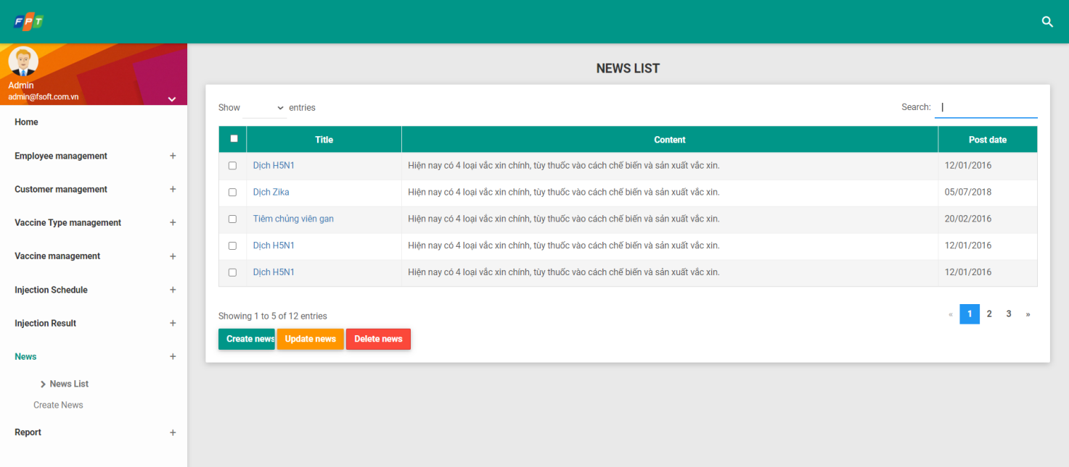

|  |  |  |  |  |  |
| --- | --- | --- | --- | --- | --- |
| **Screen** | Search news | | | | |
| **Description** | Display search tool, manage inputting name or employee ID, then click Enter, the system will automatically filter and accessed from database to display news. | | | | |
| **Screen access** | Admin clicks link “News” -> Click “List of news”  Click form “Search” to search news | | | | |
| **Screen content** | | | | | |
| **Item** | **Type** | **Data** | | **Description** | |
| Input keyword | Text field- String (100) |  | |  | |
| Search | Button |  | |  | |
| Create news | Button |  | |  | |
| Update news | Button |  | |  | |
| Delete news | Button |  | |  | |
| Title | Hyperlink- String (100) |  | | Click to preview | |
| Post date | Date |  | |  | |
| View | Link |  | |  | |
| **Action screen** | | | | | |
| **Action name** | **Description** | | **Success** | | **Failure** |
| Search | When admin clicks “Search”, the system will filter and display results on the screen | | Display results with news according to inputted conditions. | | If Search data does not exist, display message “No data found!” |
| Create news | The admin clicks “**Create news**”, the system will allow adding information of medical employee into system | | Display windows containing related fields to input data. | | When database connection has error -> Display message “**Database connection error**”.  Screen still displays the current page. |

#### Add news

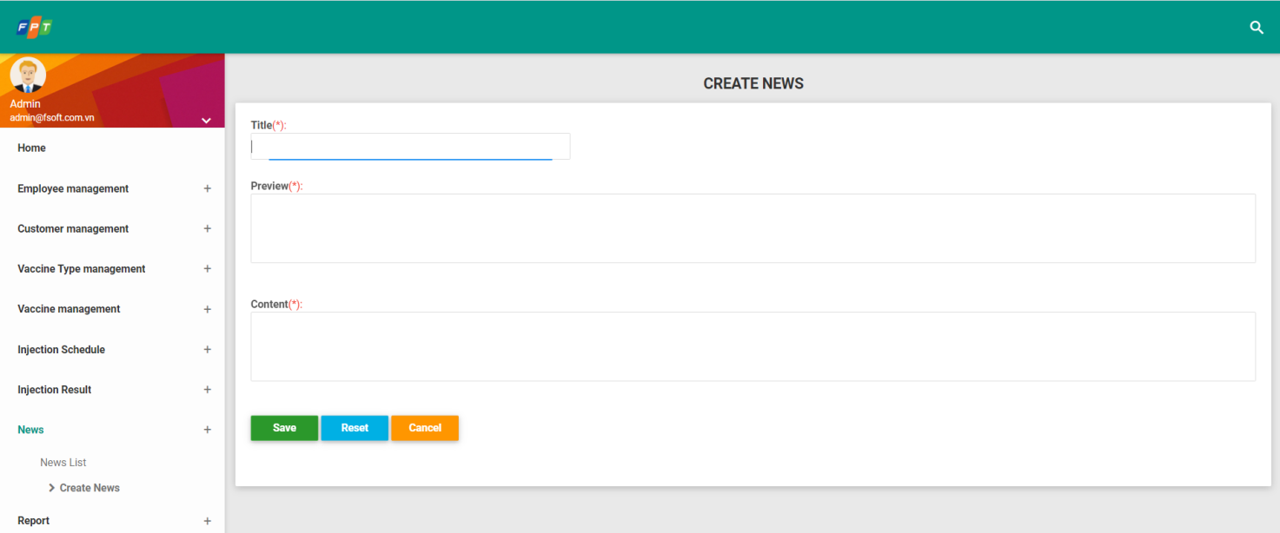

|  |  |  |  |  |
| --- | --- | --- | --- | --- |
| **Screen** | Add news | | | |
| **Description** | Allows admin to add a news including information: image, title, preview, content. | | | |
| **Screen access** | Option 1: Admin clicks link “News”-> click “List of news” -> click “Add” at the top of news list  Option 2: Admin clicks link “News” -> Click “Add” | | | |
| **Screen content** | | | | |
| **Item** | **Type** | **Data** | **Description** | |
| Image |  |  |  | |
| Title | Text field- String (300) |  |  | |
| Preview | Text field- String (4000) |  |  | |
| Content | Text area-String |  |  | |
| Add | Button |  |  | |
| Reset | Button |  |  | |
| Cancel | Button |  |  | |
| **Action screen** | | | | |
| **Action name** | **Description** | | **Success** | **Failure** |
| Add | When admin finishes inputting information of news, click “Add”, then the system will automatically add that information into database. | |  |  |
| Reset | When admin clicks “Reset”, inputted information will be deleted. | | Screen displays the previous information |  |
| Cancel | Click “Cancel” to cancel adding news into the system | | Screen is back to previous page |  |

### UC08: Reports

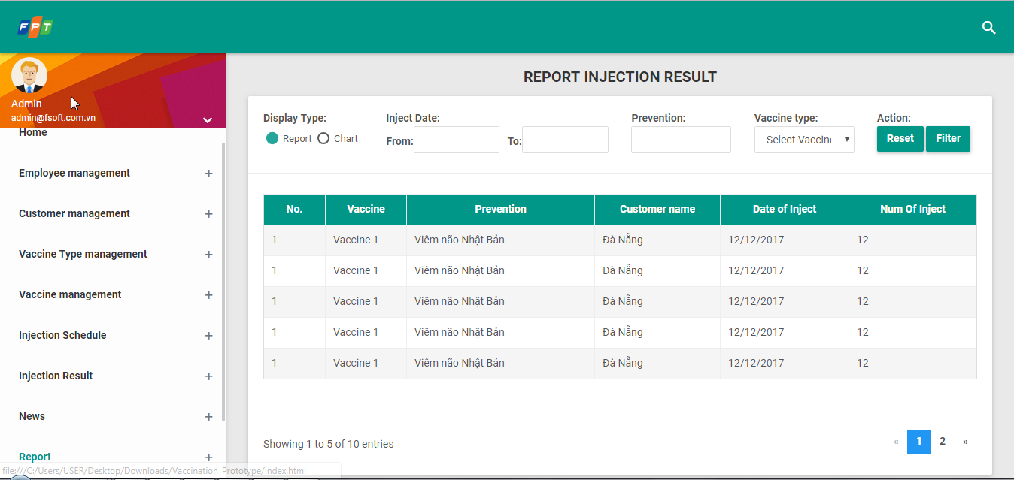

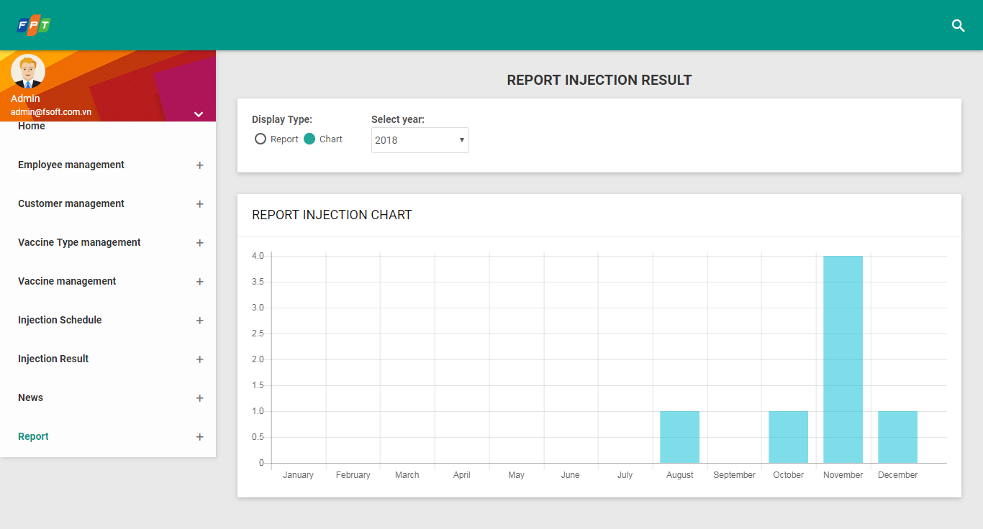

|  |  |  |  |  |  |
| --- | --- | --- | --- | --- | --- |
| **Use Case Name** | | Report | | | |
| **Use Case ID** | | UC08 | | | |
| **High Level Requirement Ref** | | The system helps medical employee admin report on vaccination status, so that get the suitable solutions for next vaccination. | | | |
| **Actor** | | Medical employee | | | |
| **Description** | | The system gives an overview report on vaccine and customer, and helps medical employees help filter and make statistic into list of customers, vaccine type which have been used and not used. | | | |
| **Trigger** | | NA | | | |
| **Pre-condition** | | Medical employee logs in system successfully with correct username and password. | | | |
| **Post-processing** | |  | | | |
| **Screen** | | Report on injection | | | |
| **Description** | | Allows admin to create and finalize report on vaccination, vaccine and customer. | | | |
| **Screen access** | | Admin clicks item “Statistic”at homepage. | | | |
| **Screen content** | | | | | |
| **Item** | **Type** | | **Data** | **Description** | |
| No. | Label- String (30) | |  |  | |
| ID | Label- String (40) | |  |  | |
| Full name | Label – String(100) | |  |  | |
| Date of birth | Label – Date | |  |  | |
| Native place | Label – String(500) | |  |  | |
| Number of injection | Label – Numberic[10] | |  |  | |
| Customer | Label – String(100) | |  |  | |
| **Action screen** | | | | | |
| **Action name** | **Description** | | | **Success** | **Failure** |
| Report | When user clicks item Diagram, display report on vaccination result with detail information table. | | | Display successful “Report on vaccination result” |  |
| Chart | When user clicks item Diagram, display chart of vaccine, customer. | | | Screen displays successfully “Chart” |  |
| Age | The user clicks ComboBox, then clicks customer group to filter customers in that group. | | | Display successfully charge or diagram. |  |
| Time | User clicks ComboBox, then clicks time to filter result from that time until current time. | | | Display successfully chart or report |  |
| Vaccine type | User clicks Vaccine type, then clicks vaccine group to filter result related to vaccine type. | | | Display successfully chart or report |  |

#### Report on vaccination customer

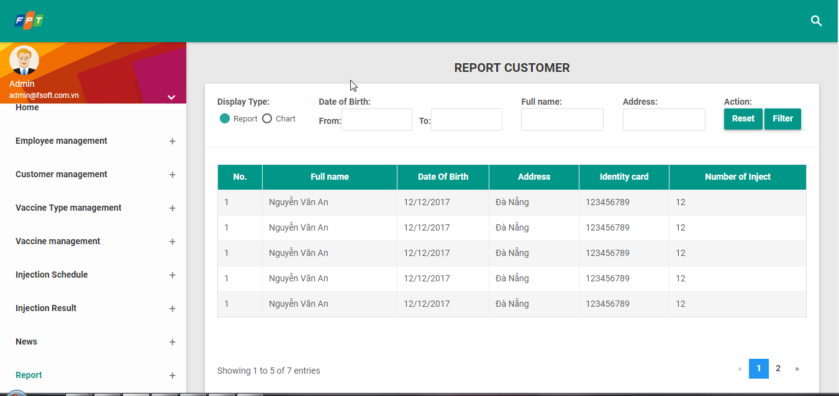

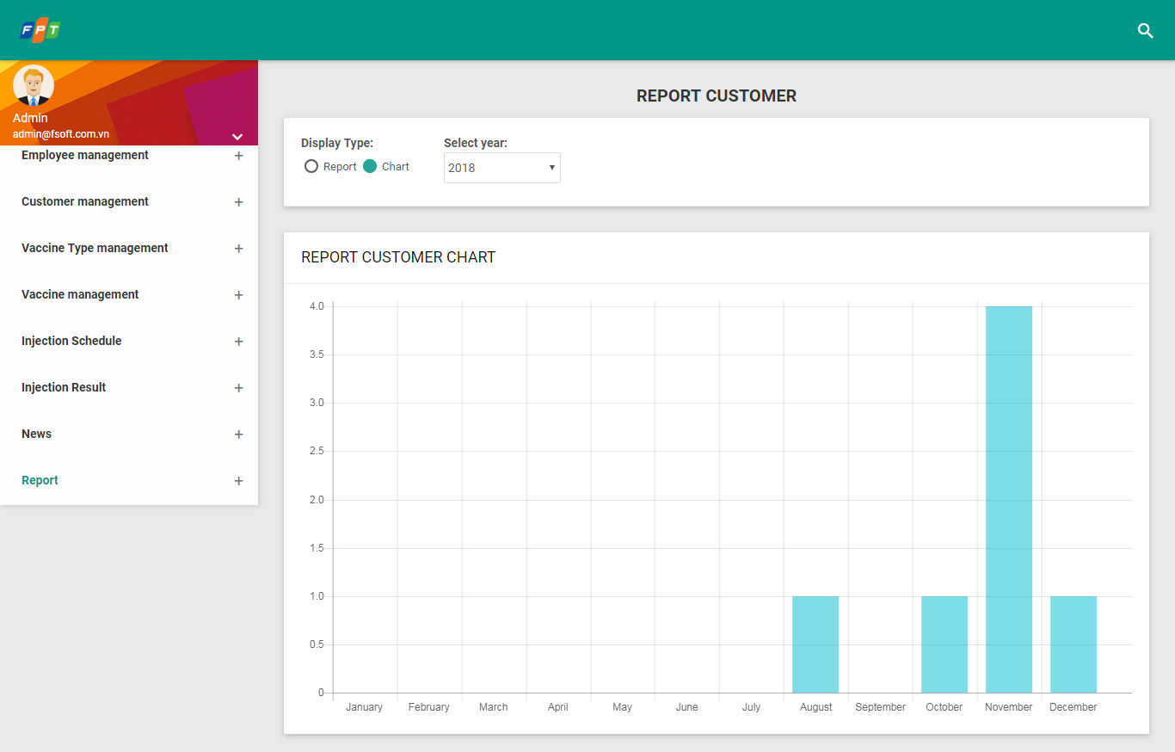

|  |  |  |  |  |
| --- | --- | --- | --- | --- |
| **Screen** | Report on vaccination customers | | | |
| **Description** | Allows admin to view description of report on vaccination customer at center and vaccine imported and used. | | | |
| **Screen access** | The admin clicks “Statistic”, then clicks Report on customer. There are 2 options, click Report to display screen 1 and click Chart to display Screen 2. | | | |
| **Screen content** | | | | |
| **Item** | **Type** | **Data** | **Description** | |
| No. | Text Field – Number(10) |  |  | |
| Full name | Label - String (300) |  |  | |
| ID | Label - String (4000) |  |  | |
| Date of birth | Label – Date |  |  | |
| Native place | Label – String(100) |  |  | |
| Identity card | Label – Numberic(10) |  |  | |
| Customer | Label – String(10) |  |  | |
| Report | Button |  |  | |
| **Action screen** | | | | |
| **Action name** | **Description** | | **Success** | **Failure** |
| Report | When admin clicks “Report”, screen will display relevant information. | |  |  |

#### Report on vaccination customers

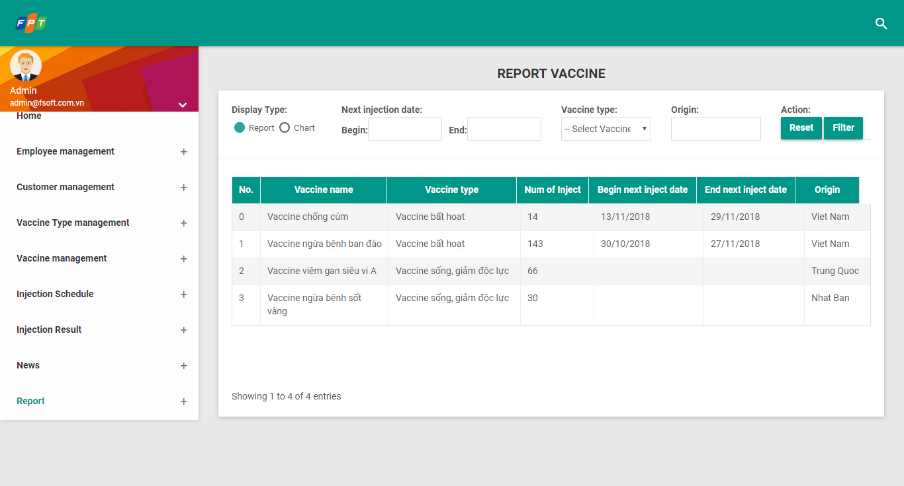

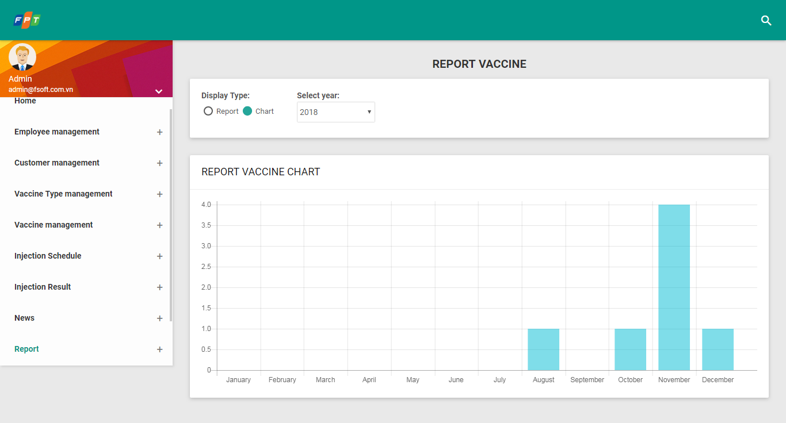

|  |  |  |  |  |
| --- | --- | --- | --- | --- |
| **Screen** | Report on vaccine | | | |
| **Description** | Allows admin to view description of report on vaccine at center. Creating report on vaccine quantity which has been used and not yet used. | | | |
| **Screen access** | Admin clicks “Statistic”, then clicks Report on vaccine. There are 2 options, clicks Report to display screen 1, and clicks Chart to display screen 2. | | | |
| **Screen content** | | | | |
| **Item** | **Type** | **Data** | **Description** | |
| No. | Text Field – Number(10) |  |  | |
| Vaccine name | Label - String (300) |  |  | |
| Vaccine type | Label - String (400) |  |  | |
| Number of injection | Label – Numberic(10) |  |  | |
| Origin | Label – String(100) |  |  | |
| Function | Label – Numberic(10) |  |  | |
| Age | Label – String(10) |  |  | |
| Report | Button |  |  | |
| **Action screen** | | | | |
| **Action name** | **Description** | | **Success** | **Failure** |
| Report | When admin clicks “Report”, screen will display relevent information. | |  |  |

## Detailed Non-Functional Requirements

### Logical Structure of the Data

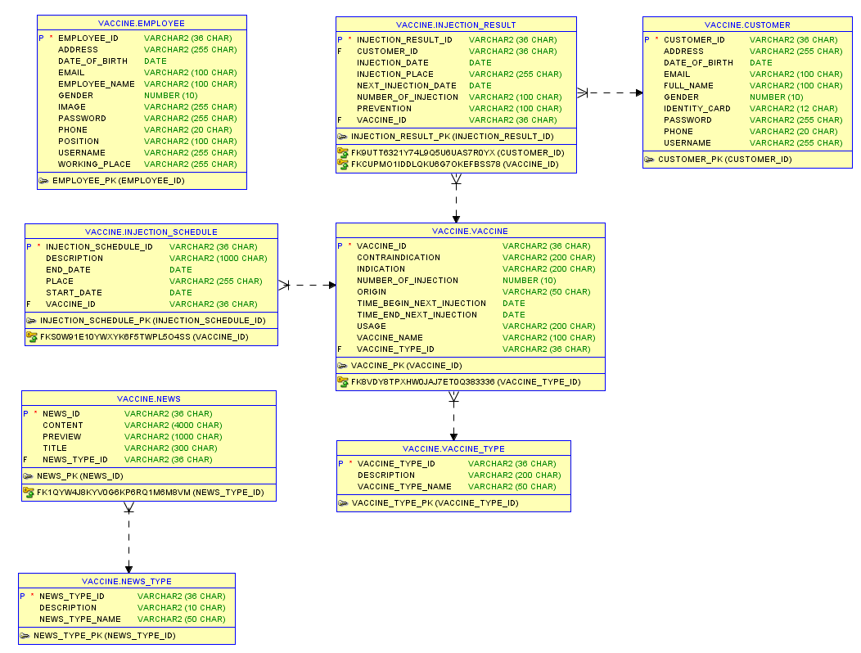

### Security

TBD

### Performance

TBD

# Other Requirements

<Define any other requirements not covered elsewhere in the SRS. This might include database requirements, internationalization requirements, legal requirements, reuse objectives for the project, and so on. Add any new sections that are pertinent to the project.>

# Integration

<Describe external system(s) which integrates with the system>

# Data Migration

*<Describe data migration scope and requirements.*

*In case SRS for data migration in a separated SRS, note down this point: e.g. detailed requirements for Data Migration part will be described on separated SRS. The data migration SRS and the functional SRS will be a couple of documents to fulfil the whole requirements for SSS migration.>*

## Migration Scope

This section is to define the scope of data migration. It contains the list of data objects or the specific condition to define the set of data which will be migrated.

## Data Mapping

This section shows the mapping for migrated data. It contains the data properties on the old platform and the corresponding properties on the new platform. Data conversion and data patching rules are also described if any.

# Appendices

## Messages List Refs

|  |  |  |  |
| --- | --- | --- | --- |
| **#** | **Message Code** | **Message** | **Description** |
|  | MSG 1 | Sorry, your username or password is incorrect. Please try again! | * Type = Error Message * Message displays as a warning message with red text above the form when user inputs wrong username or password. |
|  | MSG 2 | Username must be not empty! | * Type = Error Message * Message displays as a warning message with red text above the form when user selects to log in without inputting username. |
|  | MSG 3 | Password must be not empty! | * Type = Error Message * Message displays as a warning message with red text above the form when user selects to log in without inputting password. |
|  | MSG 4 | You must input all required fields! | * Type = Error Message * Message displays as a warning message above the form and borders the inputted area with red line if any field marked with asterisk left blank when user does action such as Submit, etc. |
|  | MSG 5 | Wrong format. | * Type = Error Message * Message displays as a warning message above the form and borders the inputted area with red line if the value of field having format is inputted with wrong format. |
|  | MSG 6 | Please input number only. | * Type = Error Message * Message displays as a warning message above the form and borders the inputted area with red line if the value of field having Component Type as “Numeric” is not number. |
|  | MSG 7 | “Expected Start Date” must not be later than “Expected End Date”. | * Type = Error Message * Message displays as a warning message above the form and borders the inputted area with red line if the value of [Expected End Date] field is earlier than the value of [Expected Start Date] field. |
|  | MSG 8 | Nothing found. | * Type = Error Message * Message displays as a red text above the screen if there is no satisfied result when user select to search. |
|  | MSG 9 | You must start phone number with “0”. | * Type = Error Message * Message displays as a warning message above the form and borders the inputted area with red line if the value of [Phone] field doesn’t start by “0” number. |
|  | MSG 10 | Cannot input future date. | * Type = Error Message * Message displays as a warning message above the form and borders the inputted area with red line if the value of field having description as “Cannot input future date” is in the future. |
|  | MSG 11 | Cannot input past date. | * Type = Error Message * Message displays as a warning message above the form and borders the inputted area with red line if the value of field having description as “Cannot input past date” is in the past. |
|  | MSG 12 | Please select a file. | * Type = Error Message * Message displays as a warning message above the form and borders the inputted area with red line if user does not select any file to upload. |
|  | MSG 13 | This trainee is already existed. | * Type = Error Message. * Message displays as a warning message above the form if the inputted trainee profile is existed in the system. |
|  | MSG 14 | “Start Date” must not be later than “End Date”. | * Type = Error Message * Message displays as a warning message above the form and borders the inputted area with red line if the value of [End Date] field is earlier than the value of [Start Date] field. |
|  | MSG 15 | “Topic” must be unique. | * Type = Error Message. * Message displays as a warning message above the form when user clicks on “Submit” button and the inputted value for [Topic] field is not unique. |
|  | MSG 16 | “Passing Score” must not be greater than “Max Score”. | * Type = Error Message. * Message displays as a warning message above the form and borders the inputted area with red line if the value of [Passing Score] field is greater than the value of [Max Score] field. |
|  | MSG 17 | “Score” must not be greater than “Max Score”. | * Type = Error Message. * Message displays as a warning message above the form and borders the inputted area with red line if the value of [Score] field is greater than the value of [Max Score] field. |
|  | MSG 18 | “Date” must be in “Milestone”. | * Type = Error Message. * Message displays as a warning message above the form and borders the inputted area with red line if the value of [Date] field is not in the selected value of [Milestone] field. |
|  | MSG 19 | 0 ≤ “Bonus Point” ≤ 20. | * Type = Error Message. * Message displays as a warning message above the form and borders the inputted area with red line if the value of [Bonus Point] field is not in the range from 0 to 20. |
|  | MSG 20 | 0 ≤ “Penalty Point” ≤ 20. | * Type = Error Message. * Message displays as a warning message above the form and borders the inputted area with red line if the value of [Penalty Point] field is not in the range from 0 to 20. |
|  | MSG 21 | “Start Date” must be later than “Committed Working Start Date”. | * Type = Error Message. * Message displays as a warning message above the form and borders the inputted area with red line if the value of [Start Date] field is earlier than the value of [Committed Working Start Date] field. |
|  | MSG 22 | Update successfully. | * Type = Notification Message. * Message displays as a green text above the form if all validation rules are passed when user clicks on “Submit” button. |
|  | MSG 23 | Create successfully. | * Type = Notification Message. * Message displays as a green text above the form if all validation rules are passed when user clicks on “Submit” button. |
|  | MSG 24 | 0 ≤ “Phone” ≤ 20 | * Type = Error Message. * Message displays as a red text under the field and borders the inputted area with red line if the value of [Phone] field is not between [10;14] characters. |
|  | MSG 25 | Please choose an excel file to import. | * Type = Error Message. * Message displays as a yellow text above the screen if user upload wrong type of file. |
|  | MSG 26 | Submit successfully. | * Type = Notification Message. * Message displays as a green text above the form when user clicks on “Submit” button in view mode. |
|  | MSG 27 | Approve successfully. | * Type = Notification Message. * Message displays as a green text above the form when user clicks on “Approve Class” button in view mode. |
|  | MSG 28 | Accept successfully. | * Type = Notification Message. * Message displays as a green text above the form when user clicks on “Accept Class” button in view mode. |
|  | MSG 29 | Start successfully. | * Type = Notification Message. * Message displays as a green text above the form when user clicks on “Start Class” button in view mode. |
|  | MSG 30 | Finish successfully. | * Type = Notification Message. * Message displays as a green text above the form when user clicks on “Finish Class” button in view mode. |

## 