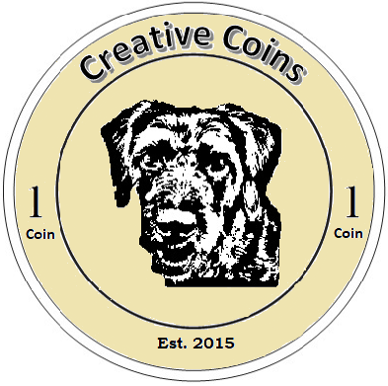
Congratulations!

Congrats, <NameHere>, your <CoinHere> coin(s) earned you:
<BoughtItemHere>

