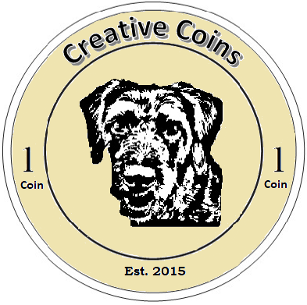
Congratulations!

Congrats, Test Child, your <CoinHere> coin(s) earned you:
<BoughtItemHere>

