

**HCMC UNIVERSITY OF TECHNOLOGY AND EDUCATION**

Faculty For High Quality Training

-----🙞🙜🕮🙞🙜-----

**FINAL PROJECT REPORT**

**GANTT VIEW PROGRAM**

**GANTT VIEW PROGRAM**

**CLASS ID: WIPR230579E_19_2_02CLC**

**(Tuesday, period 7-10)**

**STUDENT INVOLVEMENT:**

**Nguyễn Đình Long 18110027**

**Dương Võ Nhật Duy 18110006**

**TUTOR:**

**PhD. Huỳnh Xuân Phụng**

**Ho Chi Minh City**

**June / 2020**

**HCMC UNIVERSITY OF TECHNOLOGY AND EDUCATION**

Faculty For High Quality Training

-----🙞🙜🕮🙞🙜-----

**FINAL PROJECT REPORT**

**GANTT VIEW PROGRAM**

**GANTT VIEW PROGRAM**

**CLASS ID: WIPR230579E_19_2_02CLC**

**(Tuesday, period 7-10)**

**STUDENT INVOLVEMENT:**

**Nguyễn Đình Long 18110027**

**Dương Võ Nhật Duy 18110006**

**TUTOR:**

**PhD. Huỳnh Xuân Phụng**

**Ho Chi Minh City**

**June / 2020**

SCORE

|  |  |  |  |
| --- | --- | --- | --- |
| CRITERION | CONTEXT | PRESENTATION | TOTAL |
|  |  |  |  |

TUTOR’S COMMENT

ASSESSMENT:

* Nguyễn Đình Long:
* Dương Võ Nhật Duy:

Instructor

PREAMBLE

A completed study would not be done without any assistance. Therefore, the author, who have completed this project, gratefully gives acknowledgement to the support and motivation during the time of doing this research as a requirement of completing my Windows Programming.

First of all, we would like to express our endless gratefulness to our lecturer, PhD.Huynh Xuan Phung. His support and advices went through the process of completion of our thesis. His encouragement and comments had significantly enriched and improved our work. Without his motivation and instructions, the thesis would have been impossible to be done effectively.

Our special thanks approve to all of teachers in Faculty For High Quality Training with having assistances and motivating us for our thesis. We also would like to explain our thanks to our classmates for their support.

At last, we wish all of teachers more health, happiness and always success in the teaching path

Ho Chi Minh, June 21, 2020

Our group

Contents

**List of tables** 1

**Chapter 1: Program overview** 3

***1.*** ***General Introduction*** 3

***1.1*** ***Our project is*** 3

***1.2*** ***Our project for*** 3

***1.3*** ***Mode of implement*** 3

**Chapter 2: Plan of operation** 4

***1.*** ***Plan*** 4

***2.*** ***Task divisions*** 5

**Chapter 3: Design program** 6

***1.*** ***Design form*** 6

***2.*** ***Design database*** 7

***3.*** ***Fields*** 7

***4.*** ***Design interface*** 9

**Chapter 4: Setting and Testing** 10

**Chapter 5: Conclusion and development path** 17

***1.*** ***Conclusion*** 17

# **List of tables**

Table 1: Weekly plan 4,5

Table 2: Task divisions in teams 5

**List of images**

Image 1: Appointments 11

Image 2: Resources 11

Image 3: TaskDependencies 12

Image 4: Appointment form 12

Image 5: Gantt Chart form 13

Image 6: Run the program 14

Image 7: Click add new Appointment 14

Image 8: Appointment form 15

Image 9: Set-alarm form 15

Image 10: Alarm announcement 16

Image 11: You can click go to Today or a Date you enter to quickly go to it…………...16

Image 12:You can also click in recurrence button in appointment to setting it, this is recurrence form…………………………………………………………………………..17

# **Chapter 1: Program overview**

# ***General Introduction***

***1.1 Our project is***

* Our product is object-oriented and written mainly by C# which is mainly used for peoples that need to scheduled process of the project in an easier way.

***1.2 Our project for***

* Allow users to create, manage their working process by directly interacting with our program.
* Allow users to check, edit or change the plan for project.

## ***Mode of implement***

* Build object-oriented program by C#: inheritance, escapsulation
* Apply DevExpress to create program interface for users
* Connect with SQL for data saving

# **Chapter 2: Plan of operation**

# ***Plan***

|  |  |
| --- | --- |
| Time | Task |
| 10/5 – 12/5 | Try using Gantt Chart program to understand more about it in order to managed which are needed to be developed. |
| 13/5 | Divide tasks work for group members |
| 14/5 – 20/5 | Create user interface:   * Add SchedulerControl and Resource Tree to form * Get Sample Database for Gantt View from SchedulerControl * Linked form with SQL for data saving |
| 23/5 – 8/6 | Create simple Gantt project:   * Coding in SQL for resource tree data * Adding SQL data source to SchedulerControl * Modifying data that added * Designed the resource tree by chosing propeties and primary key * Facing bug and problem |
| 9/6 – 15/6 | First report:   * Receive comment from lecture * Fixing problem and debug * Add saving function to the form |
| 16/6 – 19/6 | Second report:   * Answer question from lecture * Continue research in Gantt View to understand more about it * Complete program |
| 20/6 –  22/6 | Write report and report our project |

#### Table 1: Weekly plan

# ***Task divisions***

|  |  |  |  |
| --- | --- | --- | --- |
|  | Name | Task description | Distribution |
| 1 | Nguyễn Đình Long | * Give tasks for members * Write functions:   + Create appointment   + Edit appointment   + Delete appointment * Check and fix bugs * Give idea for interface * Write Report | 50% |
| 2 | Dương Võ Nhật Duy | * Plan and give more ideas about further project * Disscuss about which function should be add to form * Design interface, Gantt View and add appointment form * Write Report | 50% |

#### Table 2: Task divisions in teams

**Chapter 3: Design program**

# ***Design form:***

List of methods:

public Form1()

void Form1_Load(object sender, EventArgs e)

void schedulerDataStorage1_AppointmentsChanged(object sender, PersistentObjectsEventArgs e)

void schedulerDataStorage1_AppointmentsDeleted(object sender, PersistentObjectsEventArgs e)

void schedulerDataStorage1_AppointmentsInserted(object sender, PersistentObjectsEventArgs e)

void CommitTask()

void schedulerDataStorage1_AppointmentDependenciesChanged(object sender, PersistentObjectsEventArgs e)

void schedulerDataStorage1_AppointmentDependenciesDeleted(object sender, PersistentObjectsEventArgs e)

void schedulerDataStorage1_AppointmentDependenciesInserted(object sender, PersistentObjectsEventArgs e)

void CommitTaskDependency()

void appointmentsTableAdapter_RowUpdated(object sender, SqlRowUpdatedEventArgs e)

void CommitSql()

void Dispose(bool disposing)

void InitializeComponent()

public GanttTestDataSet()

GanttTestDataSet(global::System.Runtime.Serialization.SerializationInfo info, global::System.Runtime.Serialization.StreamingContext context)

void InitializeDerivedDataSet()

global::System.Data.DataSet Clone()

bool ShouldSerializeTables()

bool ShouldSerializeRelations()

void ReadXmlSerializable(global::System.Xml.XmlReader reader)

global::System.Xml.Schema.XmlSchema GetSchemaSerializable()

void InitVars()

void InitVars(bool initTable)

void InitClass()

bool ShouldSerializeAppointments()

bool ShouldSerializeResources()

bool ShouldSerializeTaskDependencies()

void SchemaChanged(object sender, global::System.ComponentModel.CollectionChangeEventArgs e)

GetTypedDataSetSchema(global::System.Xml.Schema.XmlSchemaSet xs)

# ***Design database***

- Table 1 : Appointment  
Purpose of table: This table uses for saving information of appointment .  
- Table 2 : Resources  
Purpose of table: This table uses for showing resource tree descriptions.

- Table 3 : TaskDependencies

Purpose of table: This table uses for linking each appointment together.

# ***Fields***

- Table 1 : Appointments

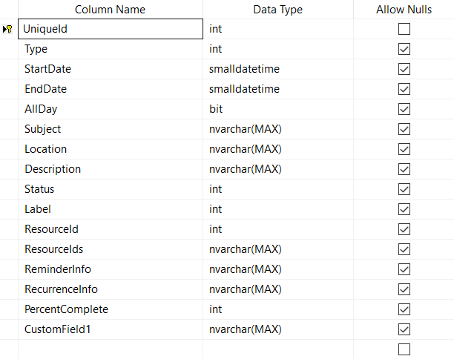

*Image 1: Appointment*

UniqueId for saving appointments ID; Type for showing working resource; StartDate, EndDate, AllDay for saving work day; Subject, Location, Description for saving work subject; Status for showing work time as; Label to change the label of the work; …

- Table 2: Resources

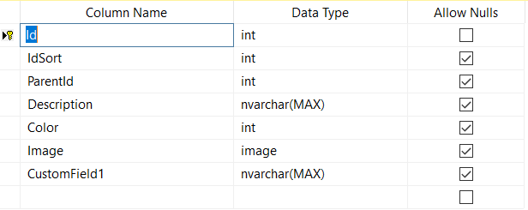*Image 2: Resources*

This table for showing resources tree description.

- Table 3 Name: TaskDependencies

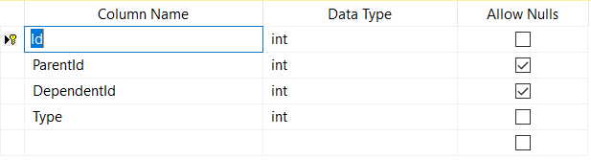

#### Image 3: TaskDependencies

This table uses for linking each appointment together.

# ***Design interface***

* + Appointment form:

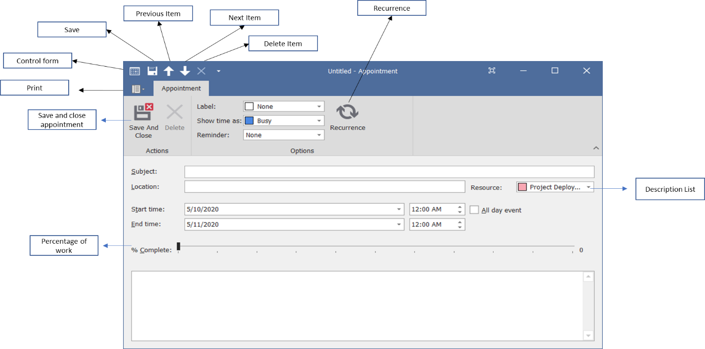

#### Image 4: Appointment form

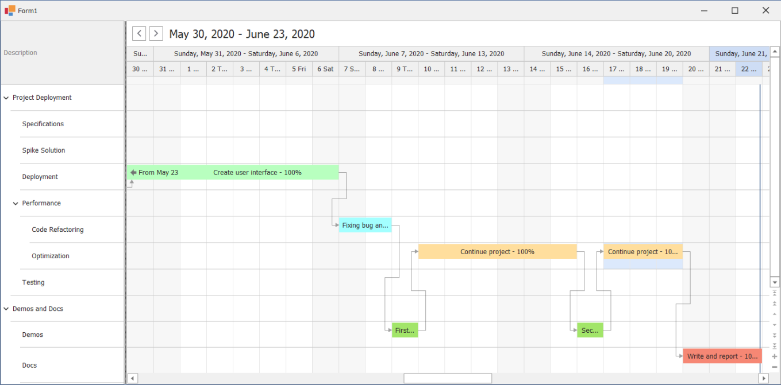

#### Image 5: Gantt Chart form

# **Chapter 4: Setting and Testing**

#### 

#### Image 6: Run the program

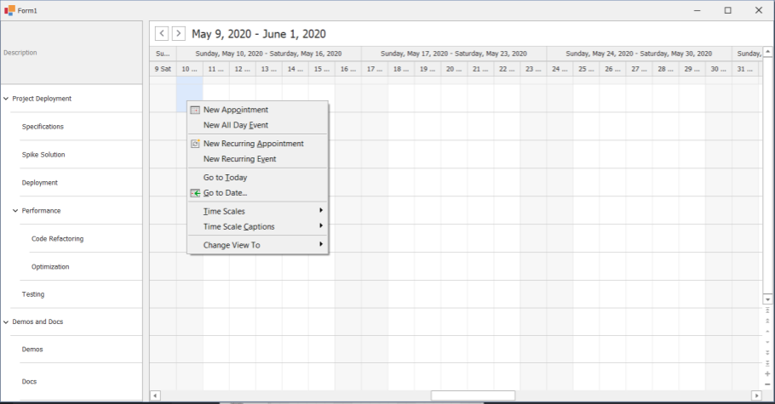

Click here to add appointmenent

#### Image 7: Click add new Appointment

#### 

#### Image 8: Add appointment form

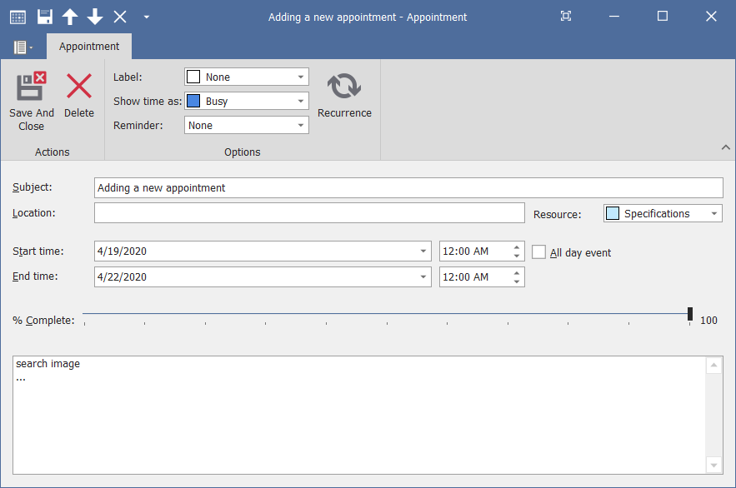

#### Image 9: Enter data

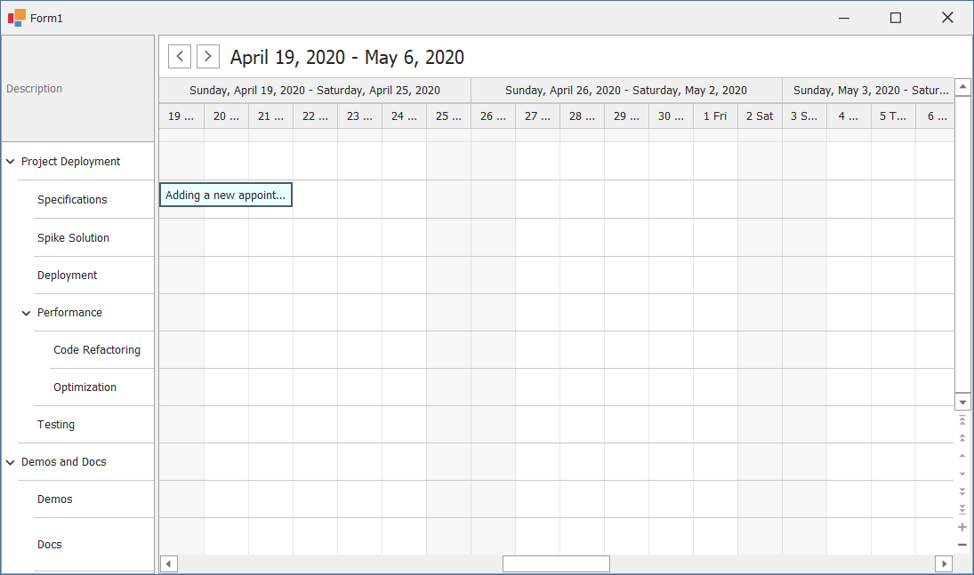

#### Image 10: Gantt Chart after adding data

*Image 11: You can click go to Today or a Date you enter to quickly go to it*

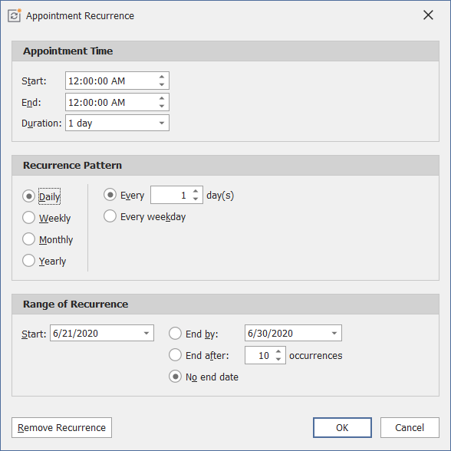

#### Image 12: You can also click in recurrence button in appointment to setting it, this is recurrence form

# **Chapter 5: Conclusion and development path**

# ***Conclusion***

In general, our group has basically created a simple Gantt View project. And to be evaluated, our project has some advantage and its opposite side:

* Advantages:
  + - The program can move flexibly appointment
    - It is easy to control their working scheduler
    - Has % completed so that people can see how their work is going on
    - Can create dependency to managed working step and which work should be done first
    - The display form is simple and easy for everyone to use
* Disadvantages:
  + - The program is just for 1 work schedule at a time.
    - Can not use Vietnamese or Unicode in the programme, the program just aim to user who use English.

- Future development:

* + - Developed app for phone users
    - Adding register account method
    - Linking with email method