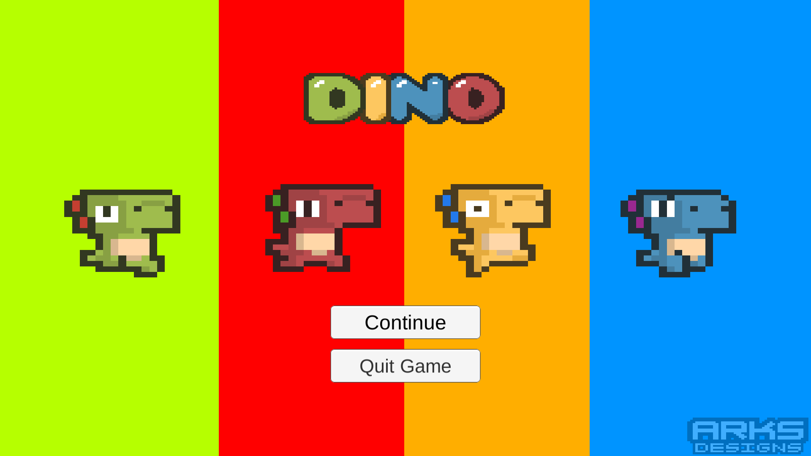

**DINO**

Lê Sỹ Duy – 1724801030022

Trần Ngọc Hoài – 1724801030045

Hồ Phương Chi – 1724801030013

Game Design Document

Version 2.0

**TABLE OF CONTENTS**

I. STORYLINE 3

II. CONTROL MECHANISM 3

III. TECHNICAL REQUIREMENTS 5

**1. Physical properties 5**

**2. Map 5**

**3. Screenplay 5**

**4. Cheating while playing 5**

IV. LOGO GAME 5

V. THE SCREEN START 6

VI. GAME FLOWCHART 9

VII. GAME CAMERA 9

VIII. HUD SYSTEM 9

IX. PLAYER METRICS 10

X. PLAYER SKILLS 10

XI. HEALTH 10

**1. Show HUD 10**

**2. Warning 11**

XII. REWARDS AND ECONOMY 11

XIII. GAME MAPS 11

XIV. MUSIC AND SFX 13

# STORYLINE

In the planet Qipuking - the world of dinosaurs, ten billion light-years from Earth. In 969, King Dorabita the Nine, who possessed all his money, fame, and power, wanted to find a dinosaur worthy of his treasure, he organized a martial arts competition to find the strongest dinosaur. "Only the strongest deserve my inheritance!", the saying that thousands of dinosaurs flocked to Jupin where the largest martial arts event ever held by the planet Qipuking.

*Introducing the character of the game:*

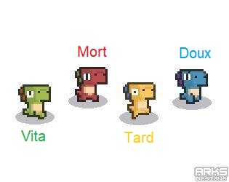

# CONTROL MECHANISM

With horizontal screen combat mechanism, the game has simple controls with virtual keys moving in two directions left – right of the screen, virtual keys for jumping and virtual keys for attack. The battle process is very fun because the system plays online with other players, characters with cute and funny designs, skills to fight back colors live and perfect combo. Besides, the design of each level is also focused with beautiful and diverse context.

Controls in the game:

* Move.



* Jump.

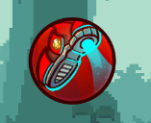

* Attack.

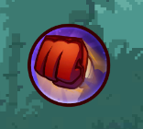

* Skill

|  |  |
| --- | --- |
| * Doux: | * Mort |
| * Tard | * Vita |

# TECHNICAL REQUIREMENTS

## Physical properties

The physics of the game is generally expressed when the character jumps up and down, when the character runs and stops.

The physics in the game in particular is shown through each different screen, because each screen character will fight in each different terrain. For example, when the character is fighting where there is ice, the move will be difficult to slip or when the character is in the water level, the movement will be resistant to the water, so moving will also be slower than the screens are on the mainland.

## Map

In the game, players will be role-playing as a dinosaur with the task of trying to destroy other players and accumulating points to win the final. Players will experience a fun horizontal screen action combat mechanic in classic style.

The game includes 3 different game maps: Jungle, Snow, and Volcano.

## Screenplay

At the start of the game, each player will be initialized a character and the player must control his character to destroy other players to accumulate points (kill other players +10 points, fall down the cliff deep -10 points). The first player to score 100 will be the winner.

## Cheating while playing

When the score is equal to 0 if it falls to the cliff, the score is not negative.

# LOGO GAME

Producer: CHD Team.

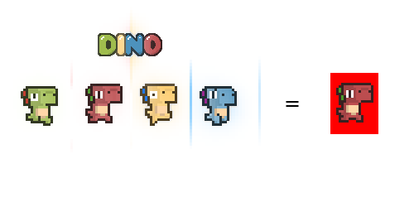

# THE SCREEN START

When the player chooses to enter the game, the game start screen will appear. The screen to start the game includes: the background image is the logo with the name of the game, below is the button "Continue" and "Quit Game”.

The screen start game:



When the player selects the "Quit Game" button, the screen will appear a message confirming the exit of the game.

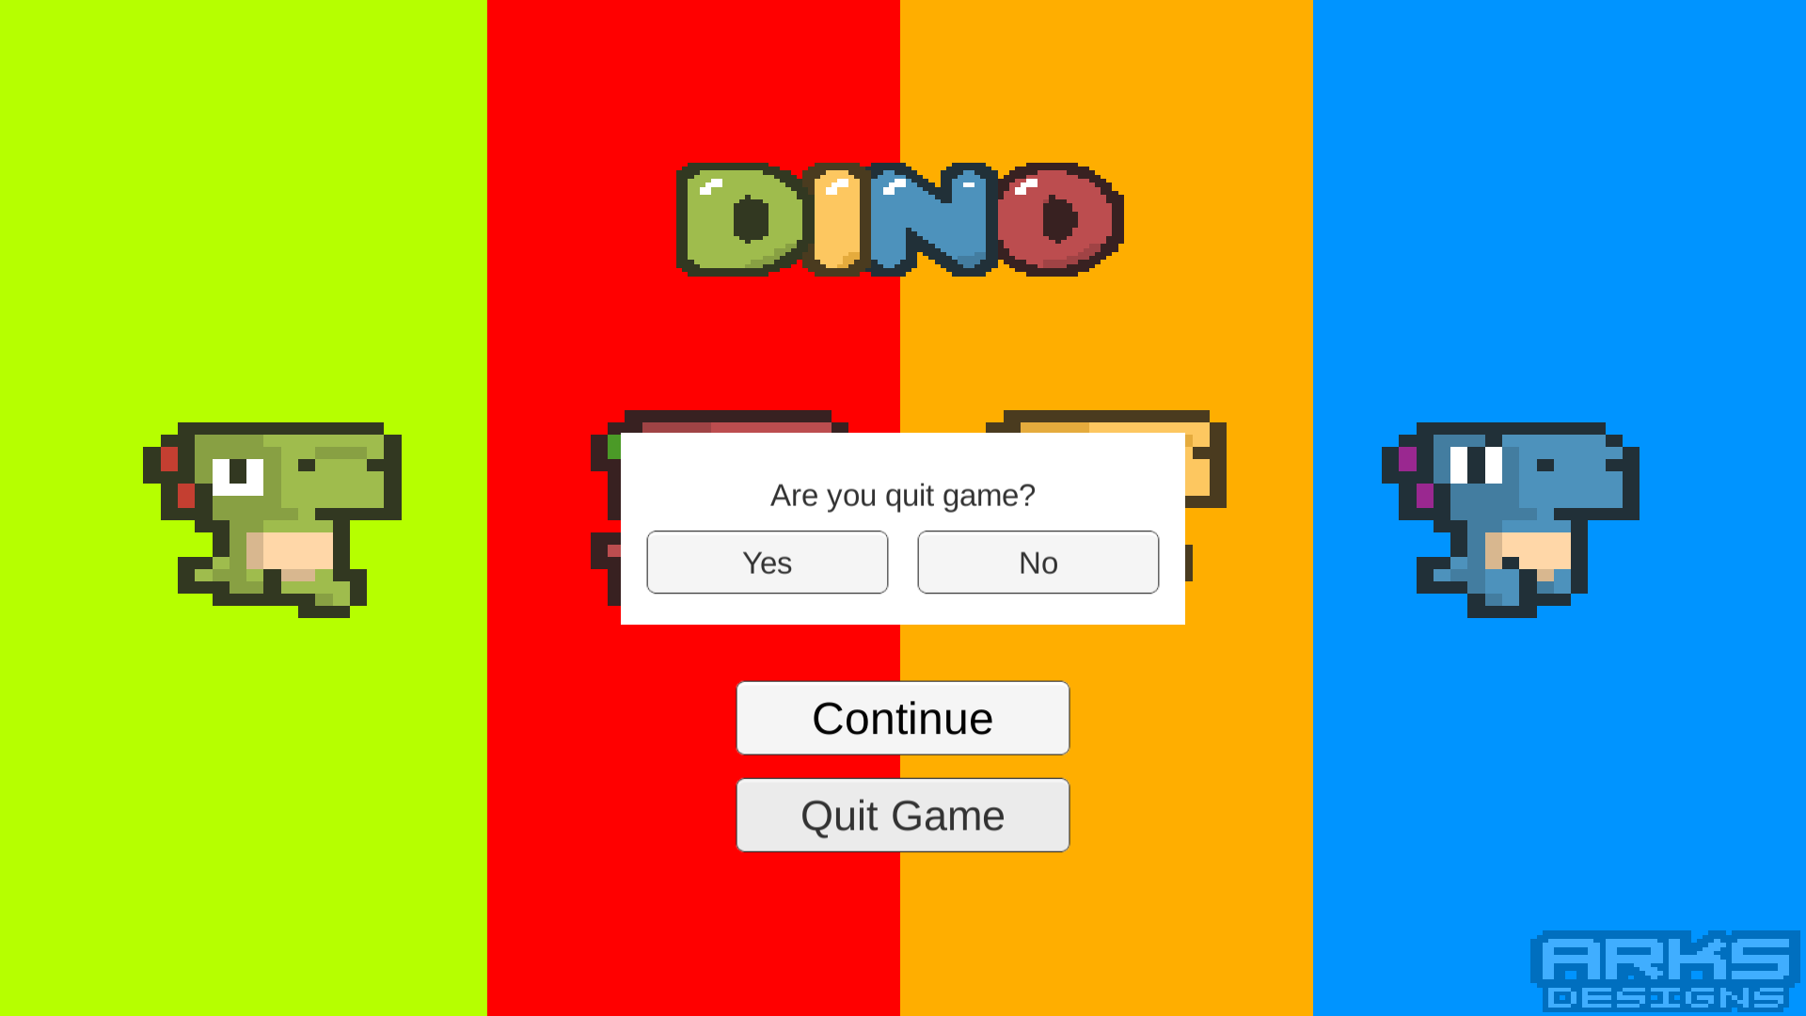

When the player selects the "Continue" button, the game switches to the character naming screen (The required character name is 2 characters or more in length).

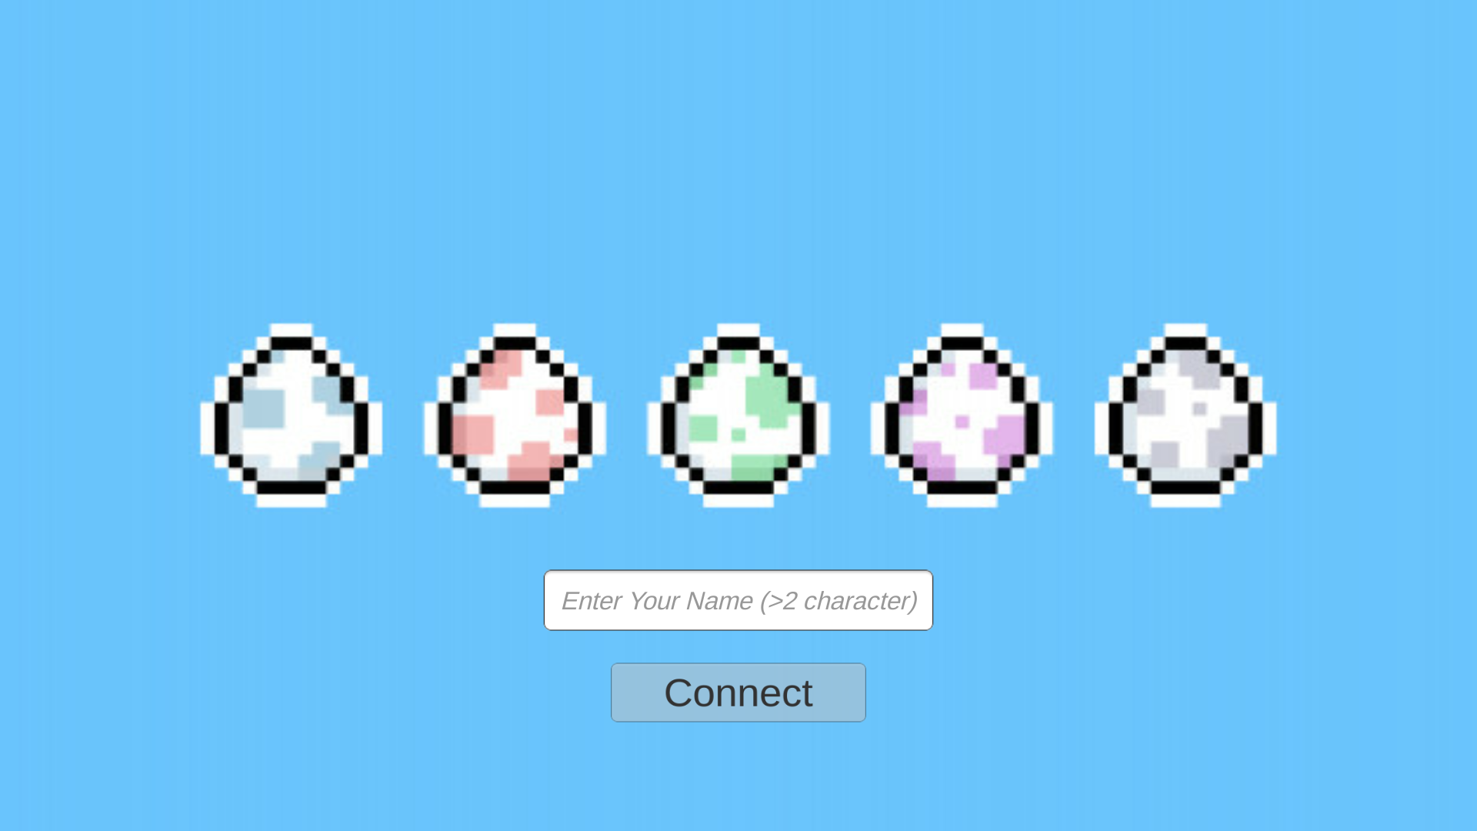

After entering the Character Name and pressing the "Connect" button, if the connection to the server fails, the screen will report an error as shown below and there is a "Reconnect" button.

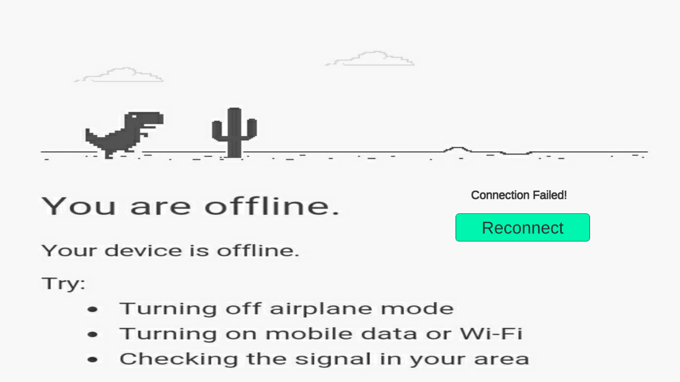

After entering the Character Name and pressing the "Connect" button, if the connection to the server is successful, the screen switches to the lobby interface. The interface will include an existing Room Name display, two text fields, a "Create Room" button, a "Join Room" button.

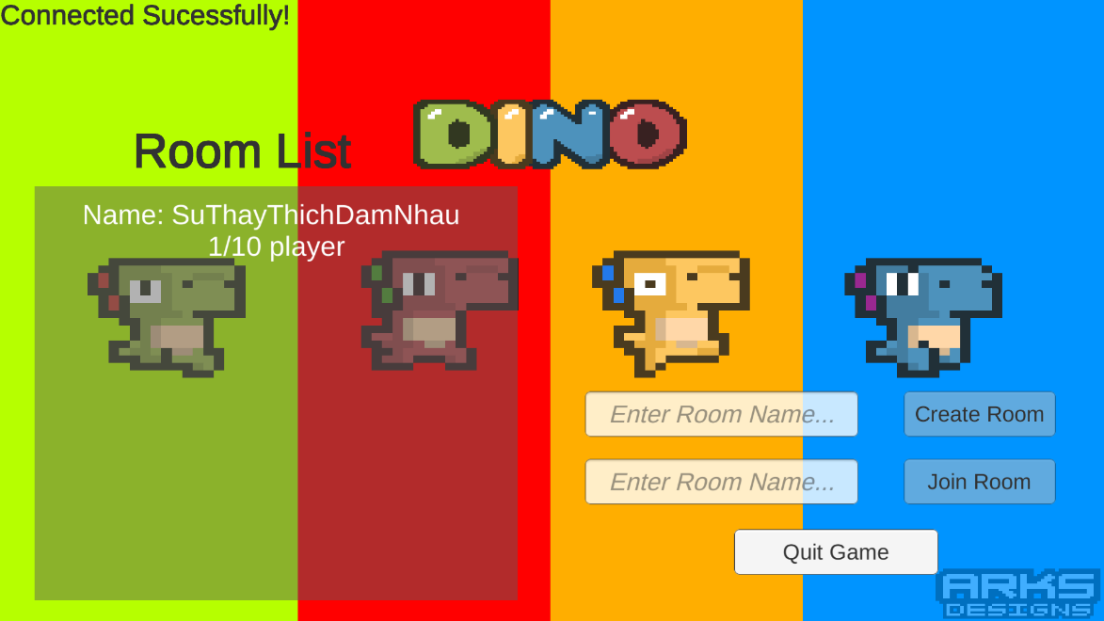

After joining any play room, the play room interface will look like the one below, including: a mission guide, a screen showing each player's name in the room, a "Start Match" button, a "Leave Room" button.

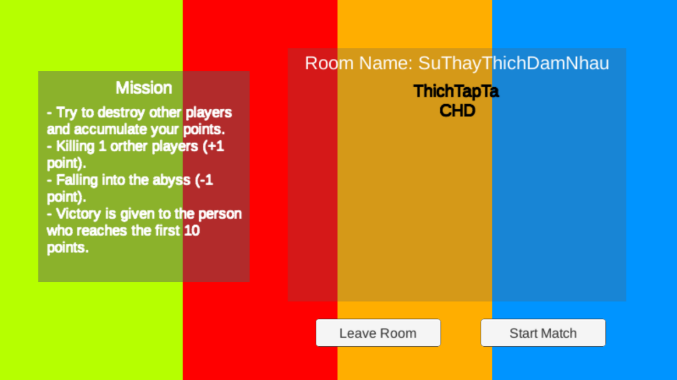

Sound effects are an important part, indispensable in any game. It contributes greatly to the effect as well as the nature of the whole game and in each scene. It contributes greatly to the effect as well as the nature of the whole game and in each scene. Each skill, when the player uses any weapon, there will be a specific noise of that weapon. Accompanied by the sound effects that make players will really be attracted.

# GAME FLOWCHART

After winning, the honor screen will appear with the winner's name and crown showing the worthy position of Strongest Dino.

# GAME CAMERA

Third person camera

With this view, players can easily observe the surroundings to easily avoid, take out timely actions as well as use the right moves to face obstacles and destroy other players.

# HUD SYSTEM

Information presented on the screen includes: Player's name, red blood bar, character move joystick, jump button, attack button, and skill button.

* Player name, red blood bar: at the beginning of the game, the player will have 100% blood.

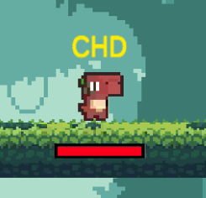

* Joystick moves characters, jump buttons, attack buttons and skill buttons:

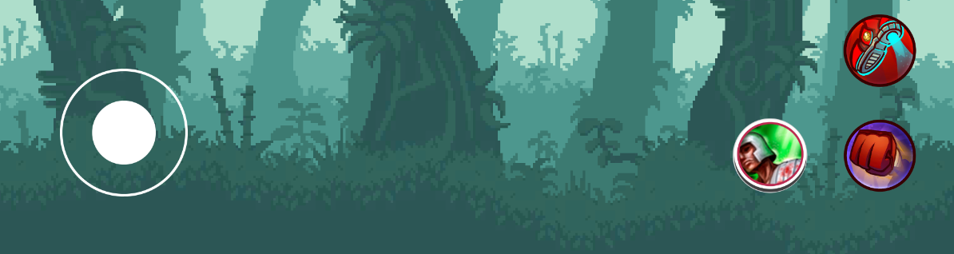

# PLAYER METRICS

The size of all players will be equal..

Player's moves: go left, go right, jump up, kick, ramm. The player will only go straight forward or backwards, with no other direction.

# PLAYER SKILLS

At the beginning of the game, players will also be given 100% blood, three simple moves (“Kick” and “Skill”).

* Doux:
  + Kick: Kick the foot forward, dealing 10 damage if it hits an opponent.
  + Skill: shoot the small piece of ice forward, dealing 10 damage if it hits an opponent.
* Mort:
  + Kick: Kick the foot forward, dealing 10 damage if it hits an opponent.
  + Skill: create a ring of fire around himself, dealing 10 damage if it hits an opponent.
* Tard:
  + Kick: Kick the foot forward, dealing 10 damage if it hits an opponent.
  + Skill: Slide forward a short distance, can press the button again to return to the original position.
* Vita
* Kick: Kick the foot forward, dealing 10 damage if it hits an opponent.
* Skill: Heal 50 for yourself.

During the game, players will move in the form of: go left, go right and jump up.

# HEALTH

## Show HUD

The red (blood) bar located below each character represents the survival of the playing character.

* At the beginning of each level, the player will have 100% blood.
* When there is 0% blood, the player is dead and re-revived with 100% blood after 3 seconds in a random position on the map.

## Warning

When the character's blood is 0%, the screen will appear dead and a countdown to the time of revival.

# REWARDS AND ECONOMY

After each match, the winner is awarded 100 bananas (in-game currency).

# GAME MAPS

In the game, each match is one of the three maps below:

* **Map Forest**

This is a murky and vast forest with ingested rock slopes, moderate players move skillfully, avoid falling into a moderate cliff destroying other players to accumulate scores.

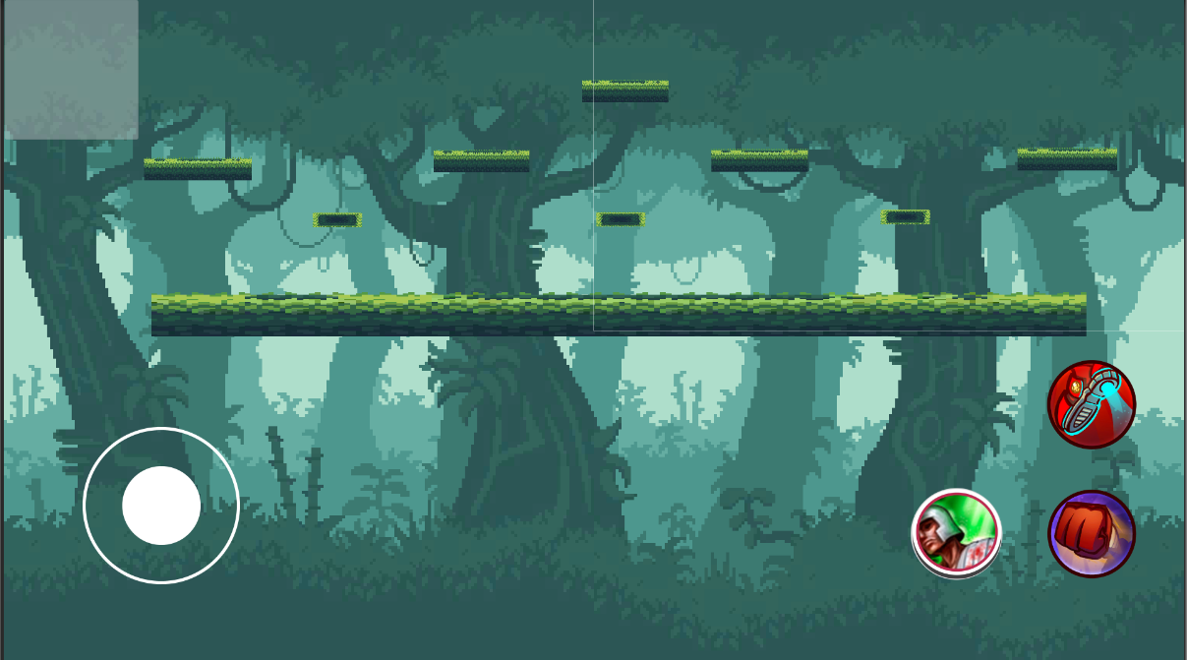

* **Map Snow**

It's a cold mountainous region all year round, rocky slopes and unexpected blizzards, moderate players move skillfully, avoiding falling into a moderate cliff destroying other players to accumulate scores.

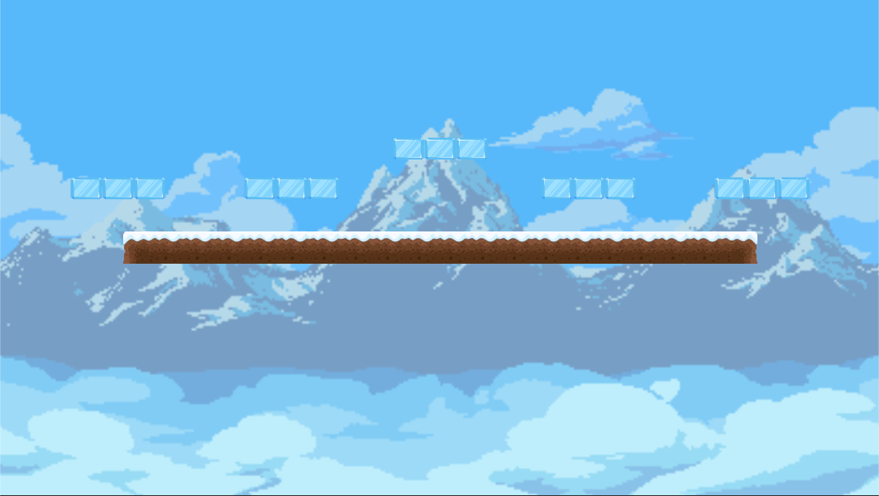

* **Map Volcano**

This is a volcano that has been dodd for 500 years. The ring is located right in the middle of the crater, moderate players move skillfully, avoiding falling into a moderate cliff destroying other players to accumulate scores.

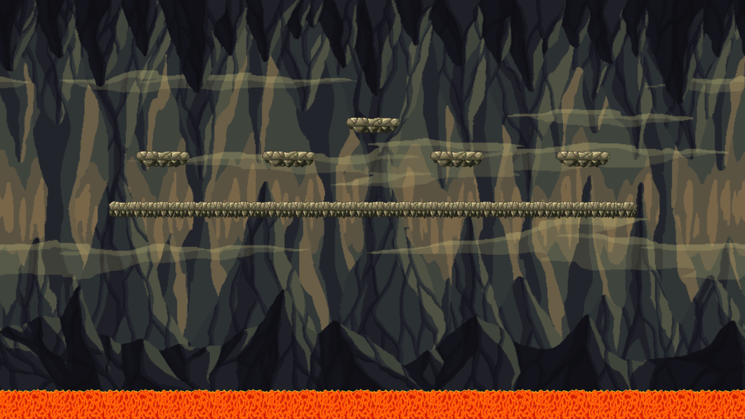

# MUSIC AND SFX

Sound effects are an important part, indispensable in any game. It greatly contributes to the effect as well as shows the properties of the entire game and in each scene.

The whole game will have a main song, but in the game scene, when it is gentle, slowly, when deciding to make a commitment, the music will change the appropriate songs, when mentoring, when each game intense.

In each attack, when the user uses any old food, there will be a specific voice of that weapon. Accompany it is the sound effects that make the player really attracted.