**UBND TỈNH BÌNH DƯƠNG**

**TRƯỜNG ĐẠI HỌC THỦ DẦU MỘT**

**VIỆN KỸ THUẬT – CÔNG NGHỆ**

**--------------------------**



**BÁO CÁO TIỂU LUẬN MÔN HỌC**

**LẬP TRÌNH GAME TRÊN DI ĐỘNG**

**ĐỀ TÀI**

**DINO ONLINE**

**Ngành :** Công nghệ thông tin

**Chuyên ngành :** Kỹ thuật phần mềm

**Giảng viên hướng dẫn :** ThS. Hồ Đắc Hưng

**Sinh viên thực hiện :** Lê Sỹ Duy – 1724801030022

Hồ Phương Chi – 1724801030013

Trần Ngọc Hoài- 1724801030045

Phạm Thị Thu An - 1724801030001

***Bình Dương, 4/2021***

# TABLE OF CONTENTS

**TABLE OF CONTENTS ii**

**IMAGE TABLE OF CONTENTS iii**

**I. STORY 1**

**II. CONTROL MECHANISM 1**

**III. TECHNICAL REQUIREMENTS 3**

**1. Physical properties 3**

**2. Map 3**

**3. Screenplay 3**

**4. Cheating while playing 4**

**IV. LOGO GAME 4**

**V. THE SCREEN STARTS 4**

**VI. LOADING SCREEN 8**

**VII. GAME FLOWCHART 9**

**VIII. GAME CAMERA 9**

**IX. HUD SYSTEM 9**

**X. PLAYER METRICS 10**

**XI. PLAYER SKILLS 10**

**XII. HEALTH 11**

**1. HUD display 11**

**2. Warning 11**

**XIII. GAME MAPS 11**

**XIV. MUSIC AND SFX 13**

# IMAGE TABLE OF CONTENTS

Image 1. Character of the game 1

Image 2. Joystick movement 2

Image 3. Button Jump 2

Image 4. Button Attack 2

Image 5. Doux’s Skill 2

Image 6. Mort’s Skill 2

Image 7. Tard’s Skill 3

Image 8. Vita’s Skill 3

Image 9. Logo 4

Image 10. Interface when starting the game 4

Image 11. Interface when click “Quit game” button 5

Image 12. interface to set character’s name 5

Image 13. Interface when disconnecting from the server 6

Image 14. Interface displayed when connecting to the server successfully 6

Image 15. Create room 7

Image 16. Join room 7

Image 17. Interface after joining the room successfully 8

Image 18. Interface when disconnecting from the server 7 8

Image 19. Interface displayed when connecting to the server successfully 9

Image 20. Character ingame 10

Image 21. control button 10

Image 22. Map Forest 12

Image 23. Map Snow 12

Image 24. Map Volcano 13

# I. STORY

In the planet Qipuking - the world of dinosaurs, ten billion light-years from Earth. In 969, King Dorabita the Nine, who possessed all his money, fame, and power, wanted to find a dinosaur worthy of his treasure, he organized a martial arts competition to find the strongest dinosaur. "Only the strongest deserve my inheritance!", the saying that thousands of dinosaurs flocked to Jupin where the largest martial arts event ever held by the planet Qipuking.

*Introducing the character of the game:*

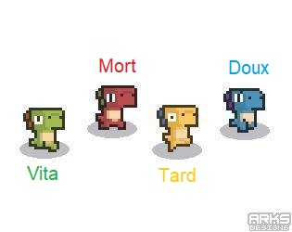

Image 1. Character of the game

# II. CONTROL MECHANISM

With horizontal screen combat mechanism, the game has simple controls with virtual keys moving in two directions left – right of the screen, virtual keys for jumping and virtual keys for attack. The battle process is very fun because the system plays online with other players, characters with cute and funny designs, skills to fight back colors live and perfect combo. Besides, the design of each level is also focused with beautiful and diverse context.

Controls in the game:

* Move.



Image 2. Joystick movement

* Jump.

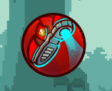

Image 3. Button Jump

* Attack.

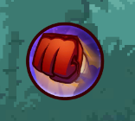

Image 4. Button Attack

* Skill

|  |  |
| --- | --- |
| * Doux:     Image 5. Doux’s Skill | * Mort     Image 6. Mort’s Skill |
| * Tard     Image 7. Tard’s Skill | * Vita     Image 8. Vita’s Skill |

# III. TECHNICAL REQUIREMENTS

## **1. Physical properties**

The physics of the game is generally expressed when the character jumps up and down, when the character runs and stops.

The physics in the game in particular is shown through each different screen, because each screen character will fight in each different terrain. For example, when the character is fighting where there is ice, the move will be difficult to slip or when the character is in the water level, the movement will be resistant to the water, so moving will also be slower than the screens are on the mainland.

## **2. Map**

In the game, players will be role-playing as a dinosaur with the task of trying to destroy other players and accumulating points to win the final. Players will experience a fun horizontal screen action combat mechanic in classic style.

The game includes 3 different game maps: Jungle, Snow, and Volcano.

## **3. Screenplay**

At the start of the game, each player will be initialized a character and the player must control his character to destroy other players to accumulate points (kill other players +10 points, fall down the cliff deep -10 points). The first player to score 100 will be the winner.

## **4. Cheating while playing**

When the score is equal to 0 if it falls to the cliff, the score is not negative.

# IV. LOGO GAME

Producer: CHD Team.

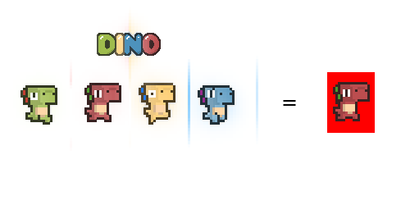

Image 9. Logo

# V. THE SCREEN STARTS

When the player chooses to enter the game, the game start screen will appear. The screen to start the game includes: the background image is the logo with the name of the game, below is the button "Continue" and "Quit Game”.

The screen start game:

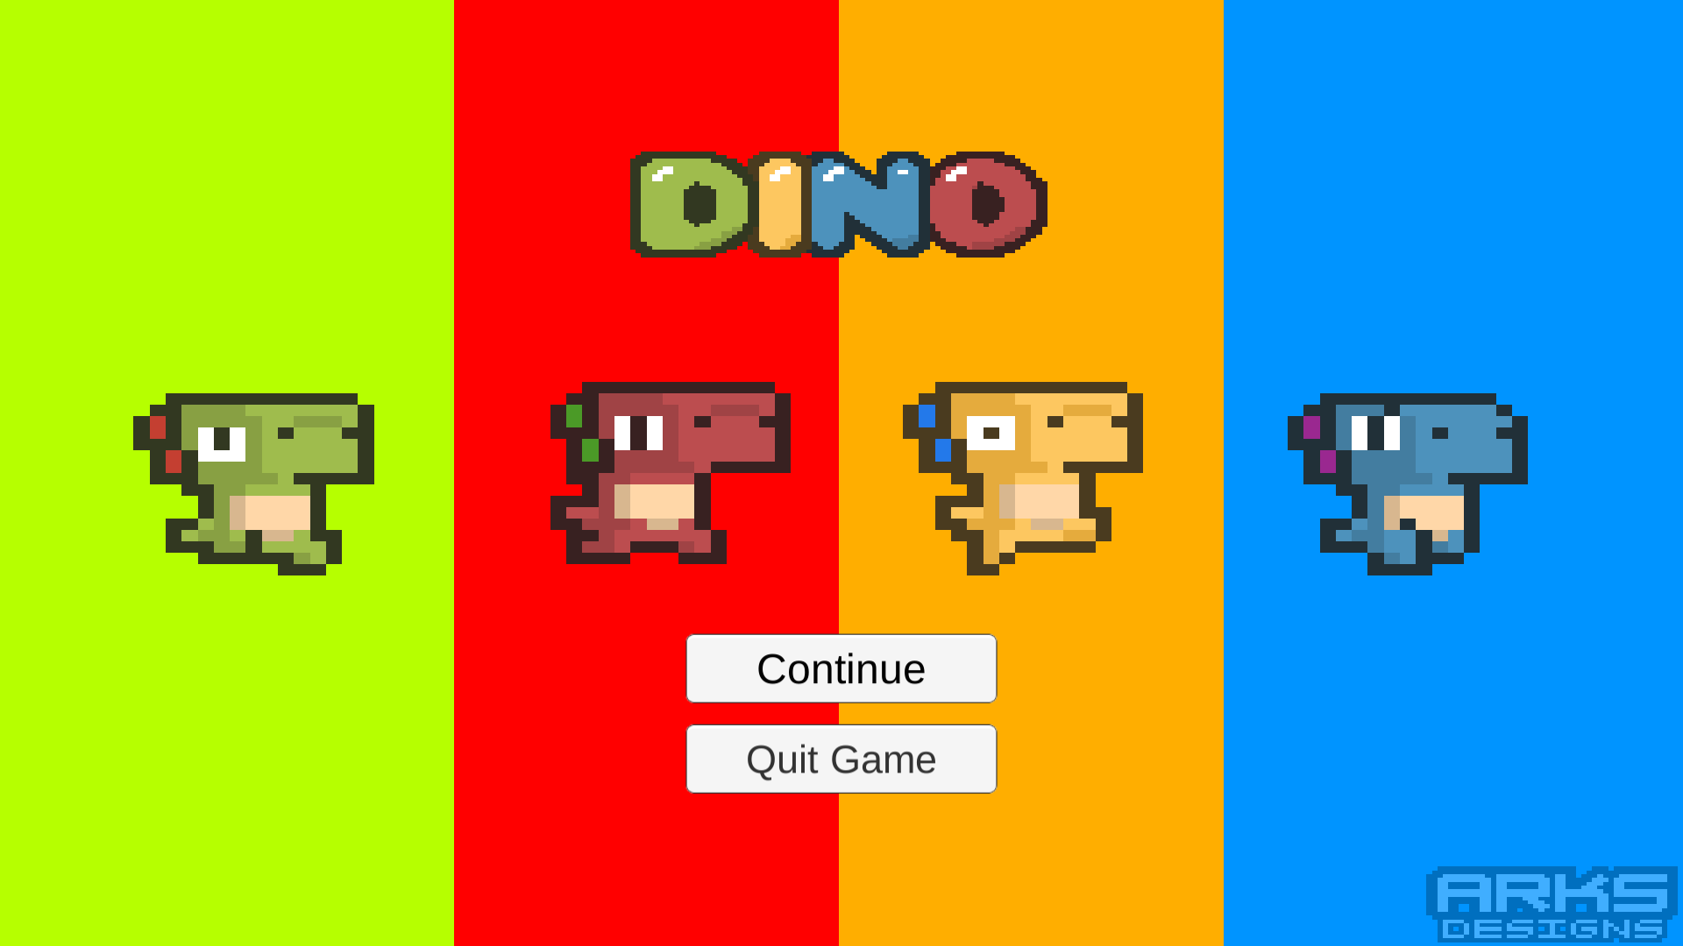

Image 10. Interface when starting the game

When the player selects the "Quit Game" button, the screen will appear a message confirming the exit of the game.

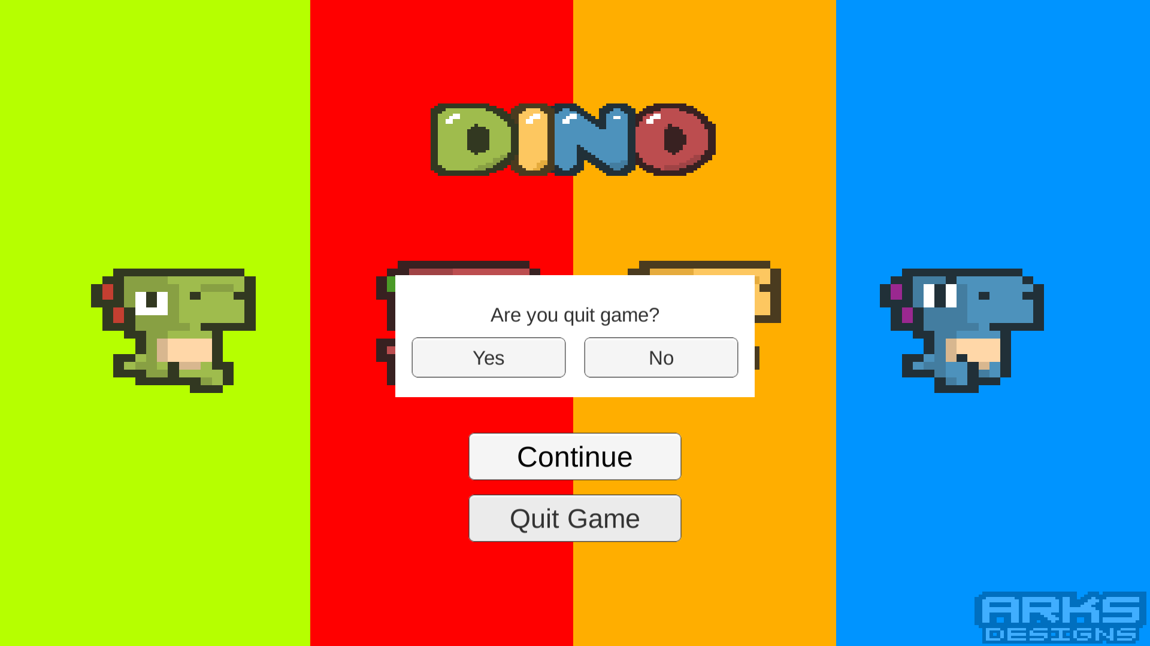

Image 11. Interface when click “Quit game” button

When the player selects the "Continue" button, the game switches to the character naming screen (The required character name is 2 characters or more in length).

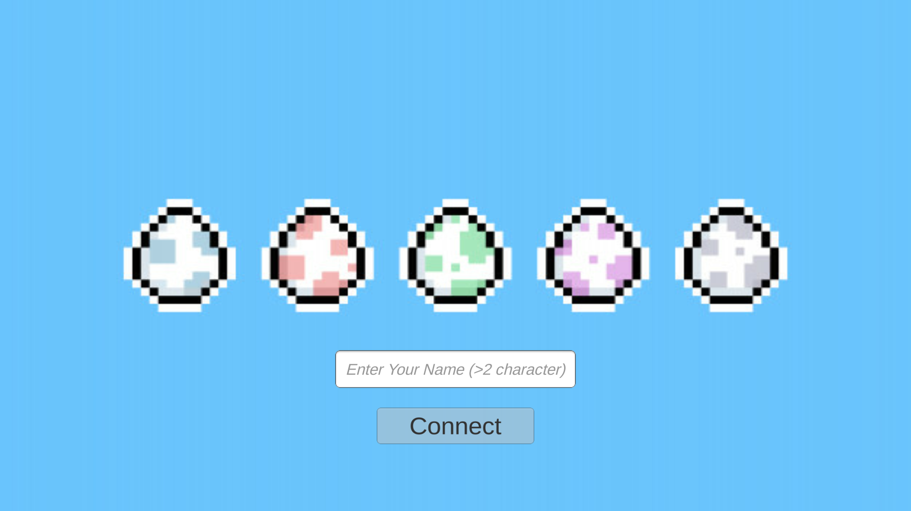

Image 12. interface to set character’s name

After entering the Character Name and pressing the "Connect" button, if the connection to the server fails, the screen will report an error as shown below and there is a "Reconnect" button.

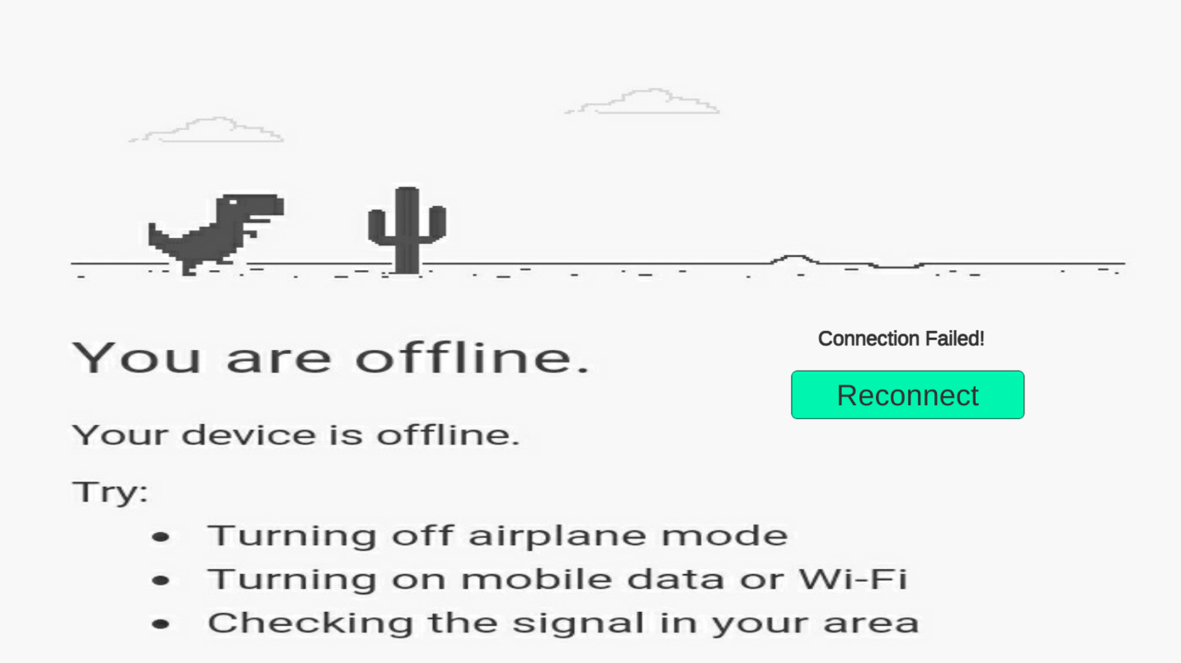

Image 13. Interface when disconnecting from the server

After entering the Character Name and pressing the "Connect" button, if the connection to the server is successful, the screen switches to the lobby interface. The interface will include an existing Room Name display, two text fields, a "Create Room" button, a "Join Room" button.

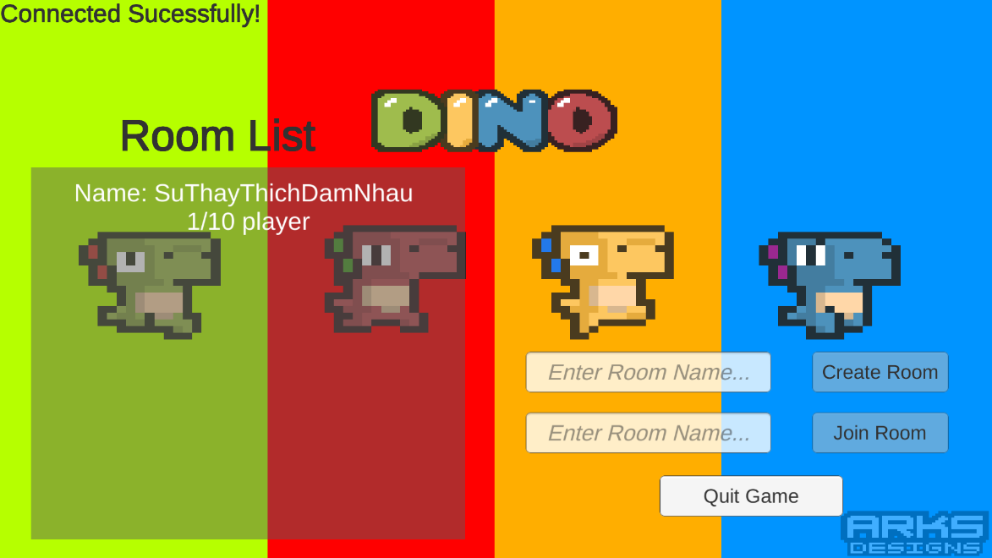

Image 14. Interface displayed when connecting to the server successfully

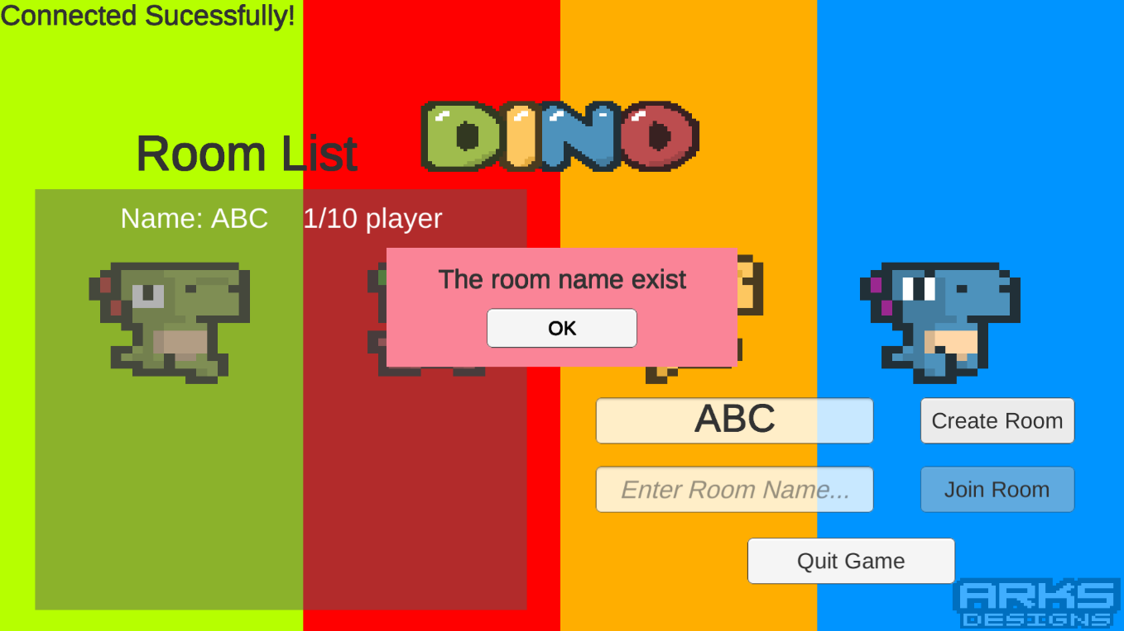

Image 15. Create room

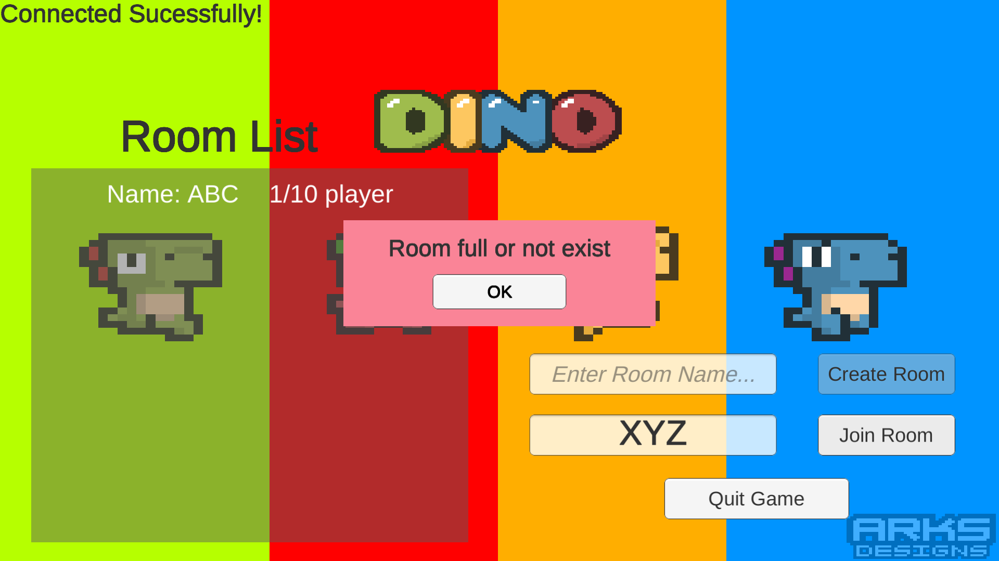

Image 16. Join room

After joining any play room, the play room interface will look like the one below, including: a mission guide, a screen showing each player's name in the room, a "Start Match" button, a "Leave Room" button.

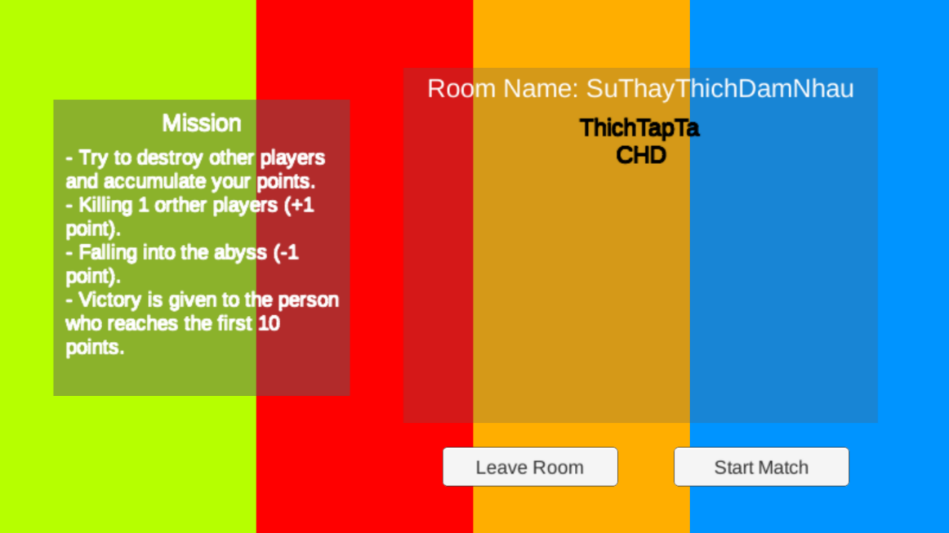

Image 17. Interface after joining the room successfully

Sound effects are an important part, indispensable in any game. It contributes greatly to the effect as well as the nature of the whole game and in each scene. It contributes greatly to the effect as well as the nature of the whole game and in each scene. Each skill, when the player uses any weapon, there will be a specific noise of that weapon. Accompanied by the sound effects that make players will really be attracted.

# VI. LOADING SCREEN

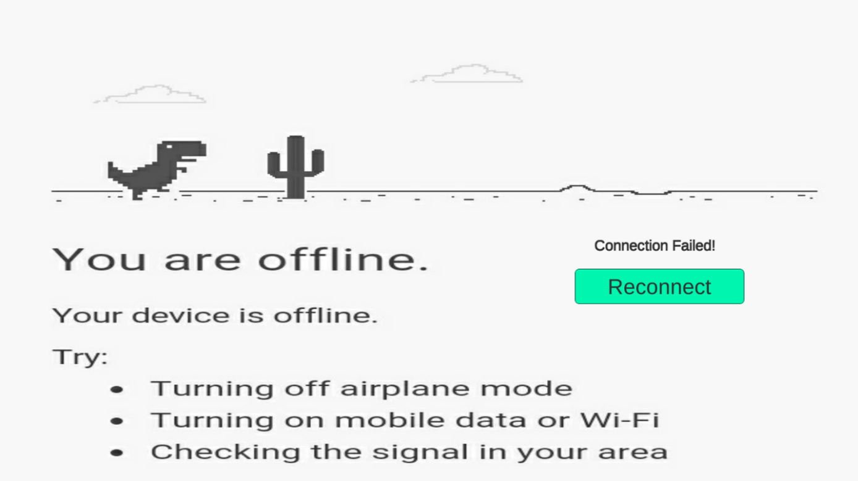

Image 18. Interface when disconnecting from the server 7



Image 19. Interface displayed when connecting to the server successfully

# VII. GAME FLOWCHART

After winning, the honor screen will appear with the winner's name and crown showing the worthy position of Strongest Dino.

# VIII. GAME CAMERA

Third person camera

With this view, players can easily observe the surroundings to easily avoid, take out timely actions as well as use the right moves to face obstacles and destroy other players.

# IX. HUD SYSTEM

Information presented on the screen includes: Player's name, red blood bar, character move joystick, jump button, attack button, and skill button.

* Player name, red blood bar: at the beginning of the game, the player will have 100% blood.

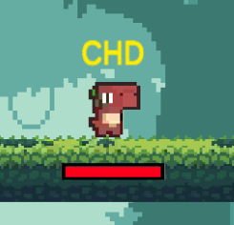

Image 20. Character ingame

* Joystick moves characters, jump buttons, attack buttons and skill buttons:

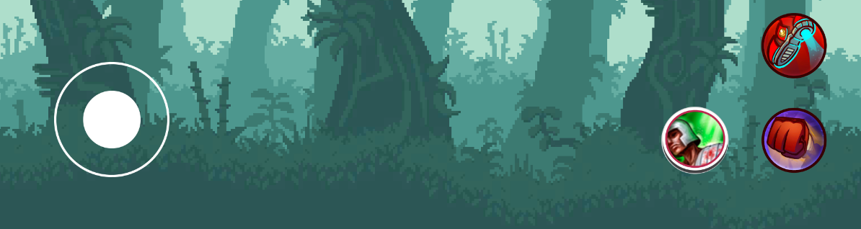

Image 21. control button

# X. PLAYER METRICS

The size of all players will be equal..

Player's moves: go left, go right, jump up, kick, ramm. The player will only go straight forward or backwards, with no other direction.

# XI. PLAYER SKILLS

At the beginning of the game, players will also be given 100% blood, three simple moves (“Kick” and “Skill”).

* Doux:
  + Kick: Kick the foot forward, dealing 10 damage if it hits an opponent.
  + Skill: shoot the small piece of ice forward, dealing 10 damage if it hits an opponent.
* Mort:
  + Kick: Kick the foot forward, dealing 10 damage if it hits an opponent.
  + Skill: create a ring of fire around himself, dealing 10 damage if it hits an opponent.
* Tard:
  + Kick: Kick the foot forward, dealing 10 damage if it hits an opponent.
  + Skill: Slide forward a short distance, can press the button again to return to the original position.
* Vita
* Kick: Kick the foot forward, dealing 10 damage if it hits an opponent.
* Skill: Heal 50 for yourself.

During the game, players will move in the form of: go left, go right and jump up

# XII. HEALTH

1. **HUD display**

The red (blood) bar located below each character represents the survival of the playing character.

* At the beginning of each level, the player will have 100% blood.
* When there is 0% blood, the player is dead and re-revived with 100% blood after 3 seconds in a random position on the map.

1. **Warning**

When the character's blood is 0%, the screen will appear dead and a countdown to the time of revival.

# XIII. GAME MAPS

In the game, each match is one of the three maps below:

* **Map Forest**

This is a murky and vast forest with ingested rock slopes, moderate players move skillfully, avoid falling into a moderate cliff destroying other players to accumulate scores.

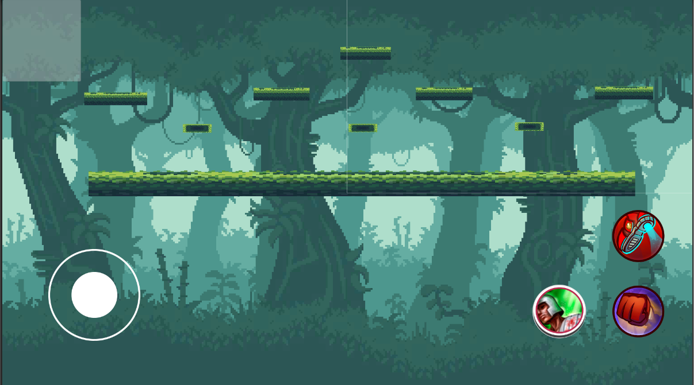

Image 22. Map Forest

* **Map Snow**

It's a cold mountainous region all year round, rocky slopes and unexpected blizzards, moderate players move skillfully, avoiding falling into a moderate cliff destroying other players to accumulate scores.

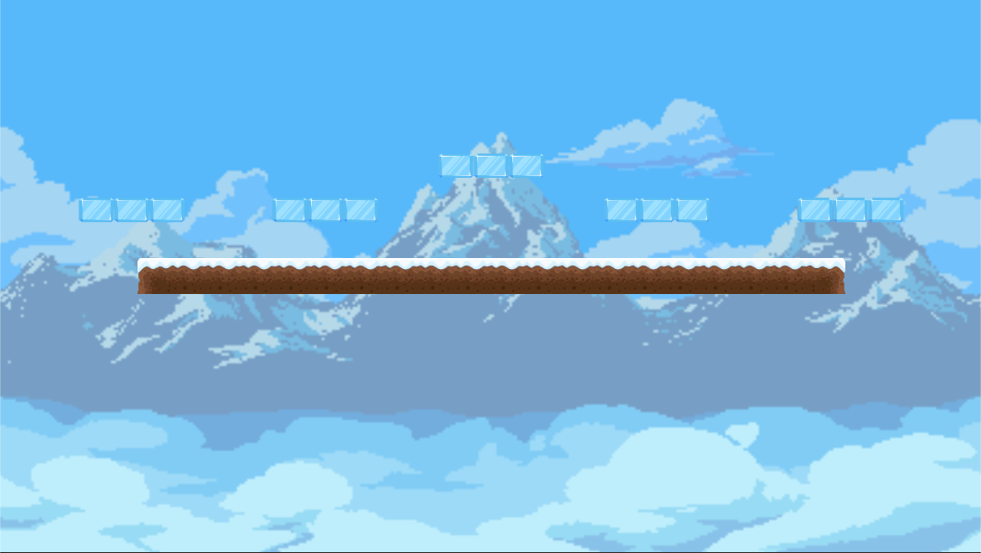

Image 23. Map Snow

* **Map Volcano**

This is a volcano that has been dodd for 500 years. The ring is located right in the middle of the crater, moderate players move skillfully, avoiding falling into a moderate cliff destroying other players to accumulate scores.

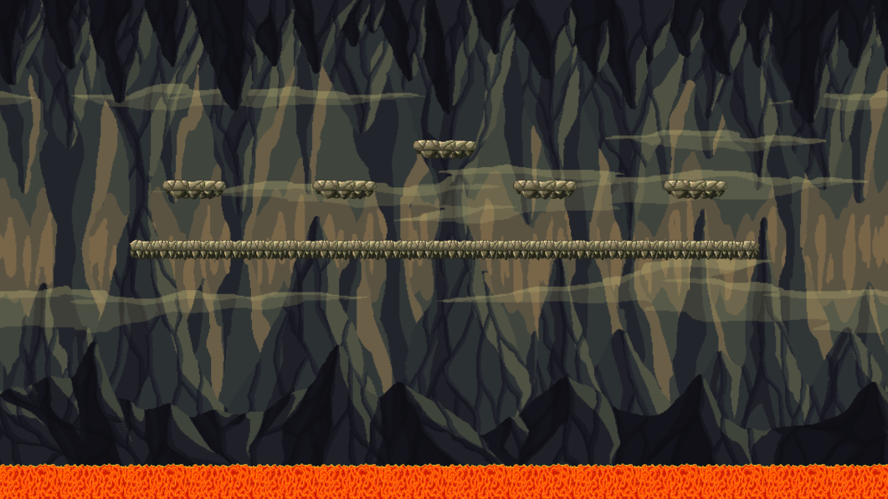

Image 24. Map Volcano

# XIV. MUSIC AND SFX

Sound effects are an important part, indispensable in any game. It greatly contributes to the effect as well as shows the properties of the entire game and in each scene.

The whole game will have a main song, but in the game scene, when it is gentle, slowly, when deciding to make a commitment, the music will change the appropriate songs, when mentoring, when each game intense.

In each attack, when the user uses any old food, there will be a specific voice of that weapon. Accompany it is the sound effects that make the player really attracted.