Lab 4 . Authenticate with Firebase (Contacts App)

- Tài liệu tham khảo
https://firebase.google.com/docs/flutter/setup?platform=android
https://pub.dev/packages/cloud_firestore
https://pub.dev/packages/google_sign_in
https://pub.dev/packages/firebase_auth
- Thiết kế gồm các màn hình sau:
login_page.dart
sign_up_page.dart
home.dart
add_contact_page.dart
update_contact.dart

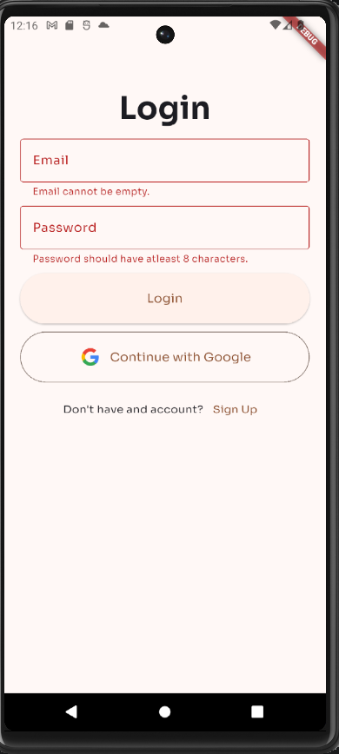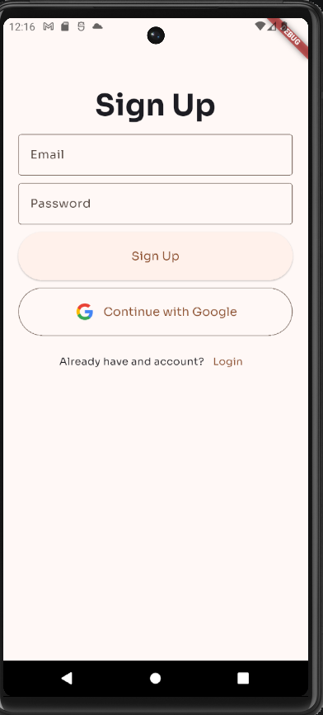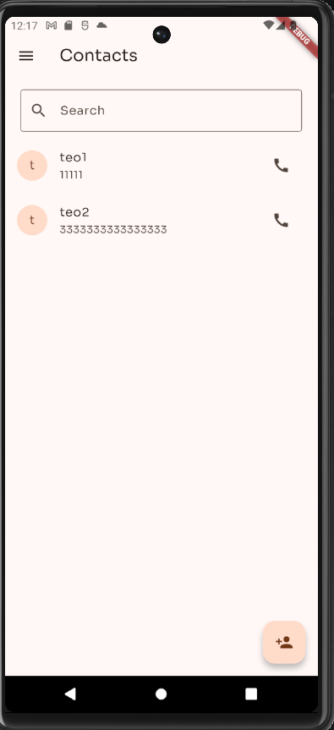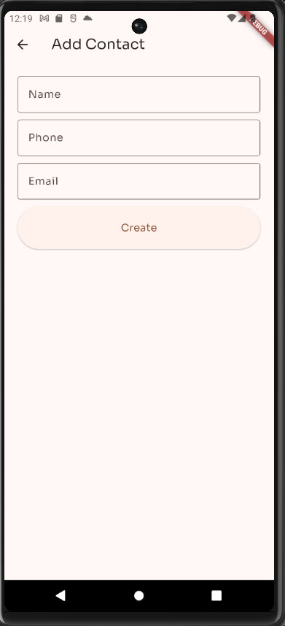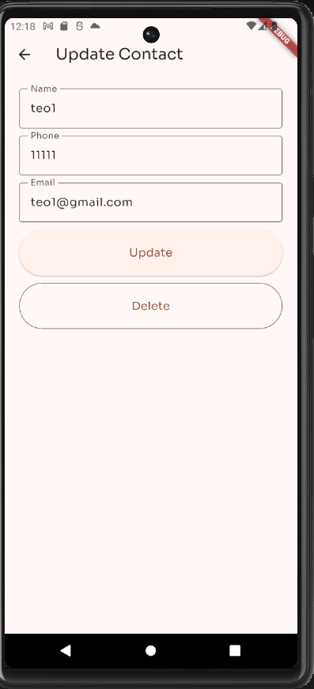

1. Install Pakage
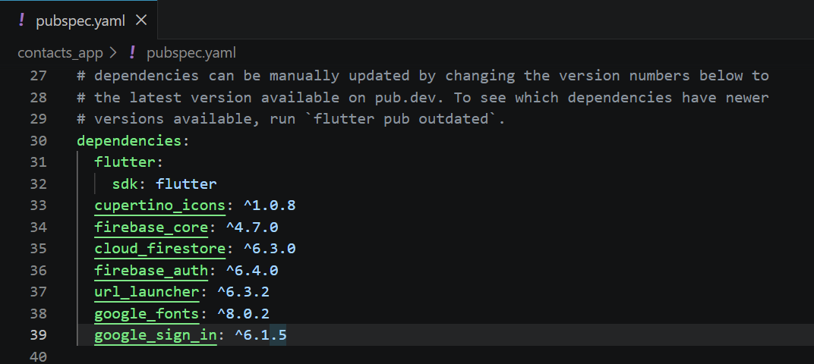
>flutter pub get
2. Android Setup
Firebase console: https://console.firebase.google.com/
Create Project: TodosApp -> Create app Android
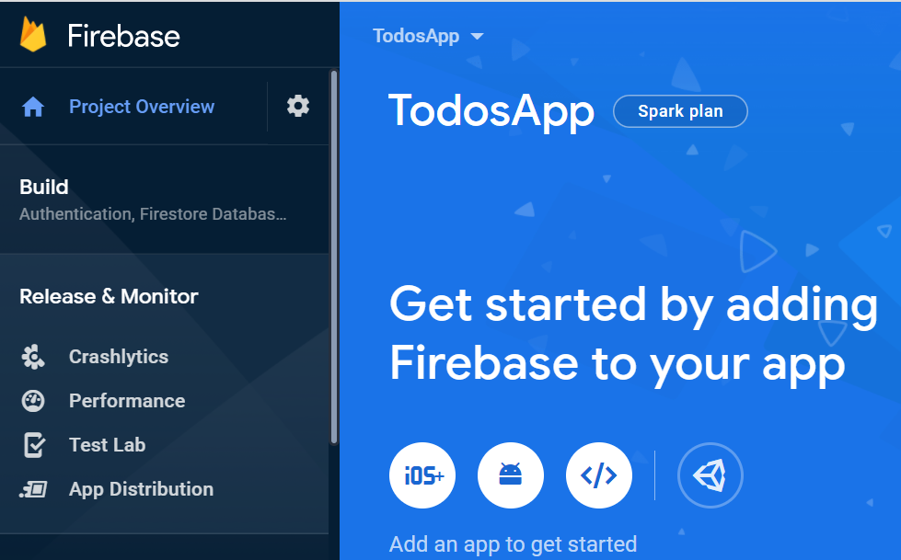

Xác định Package name
/android/app/build.gradle.kts
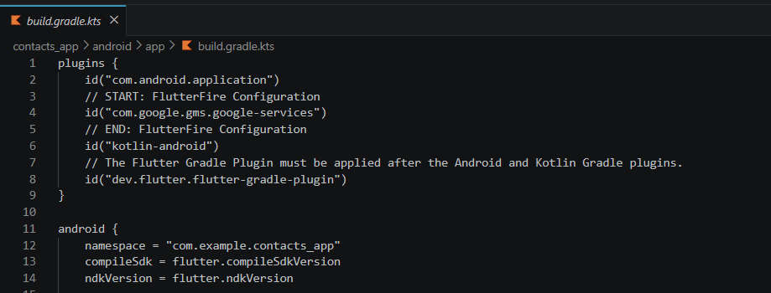
Generate a certificate
> cd Android
> ./gradlew signingReport
Copy both 'SHA1' and 'SHA-256' keys that belong to the 'debugAndroidTest' variant key option. Then, you can add those keys to the 'SHA certificate fingerprints' on your app in Firebase console.
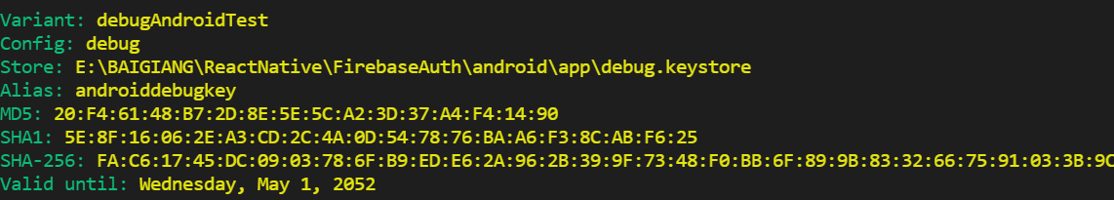

Create app Android
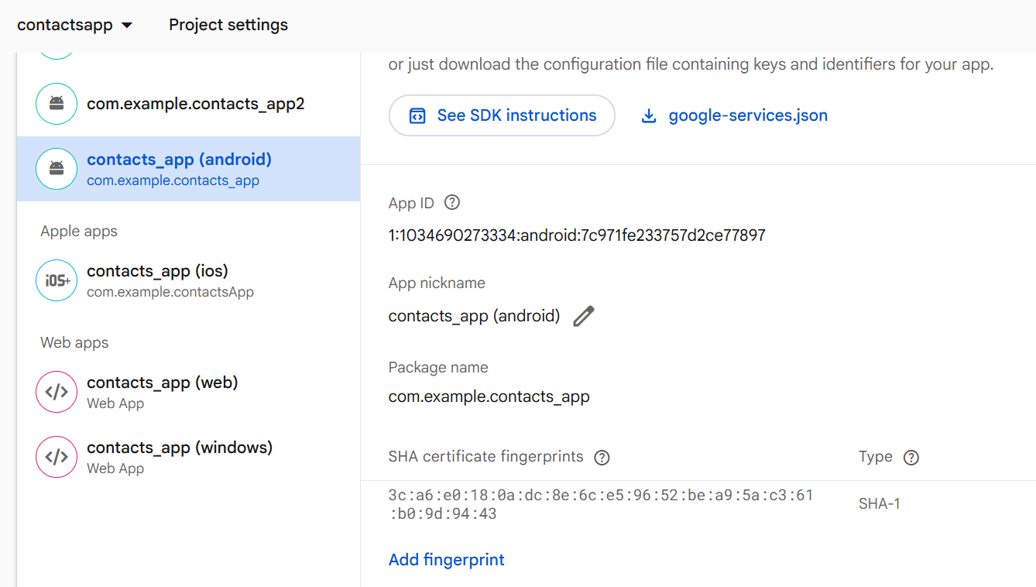
Download the google-services.json file and place it inside of your project at the following location: /android/app/google-services.json

Create Sign-in providers with Email/Password
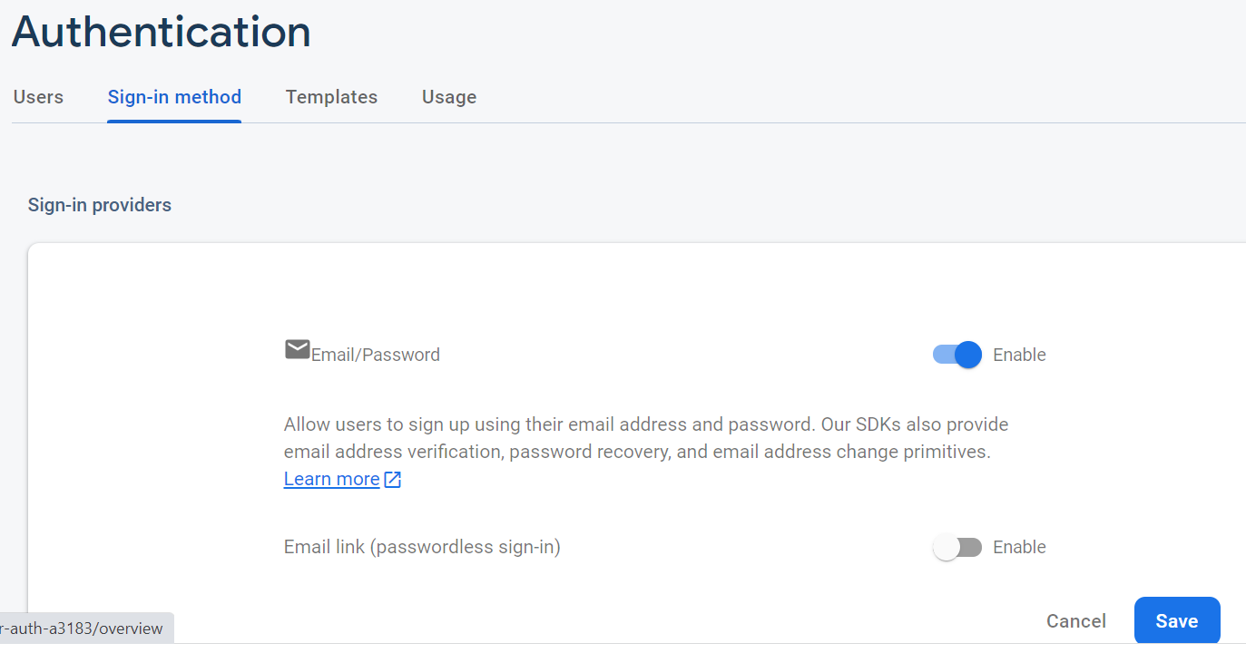
Tương tự cho google
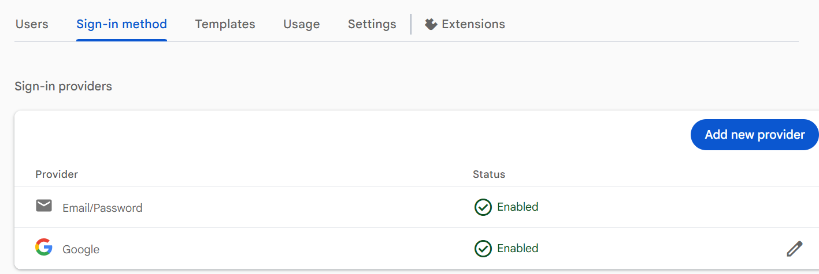
5. lib/controllers/auth_services.dart
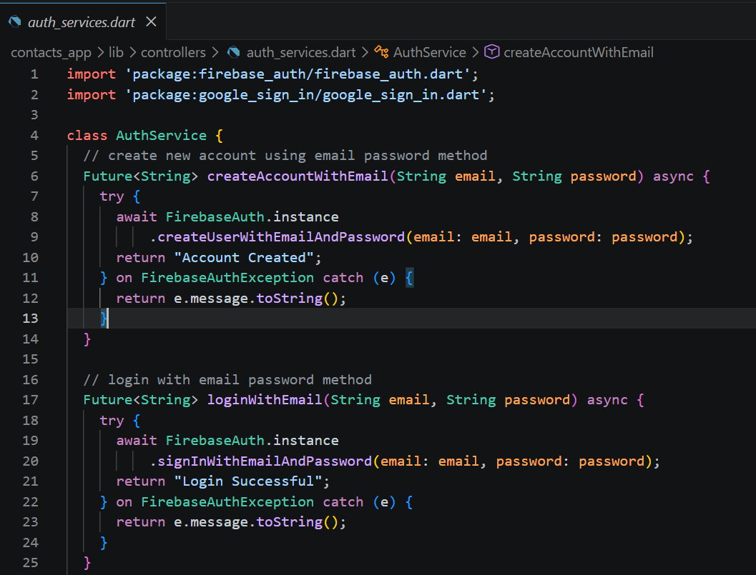
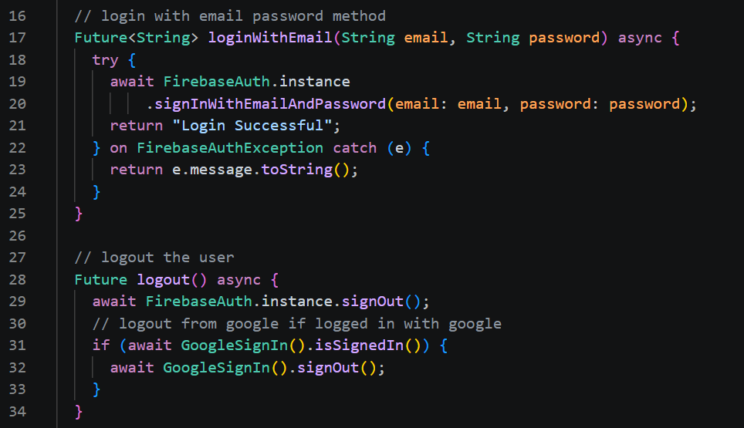
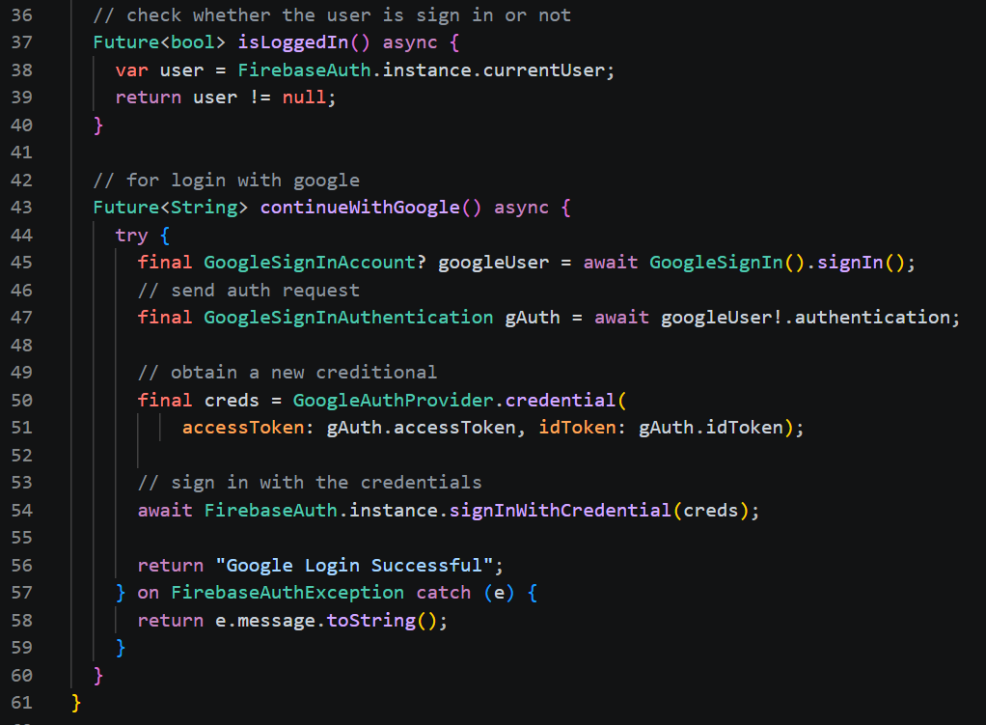
5. lib/controllers/crud_services.dart
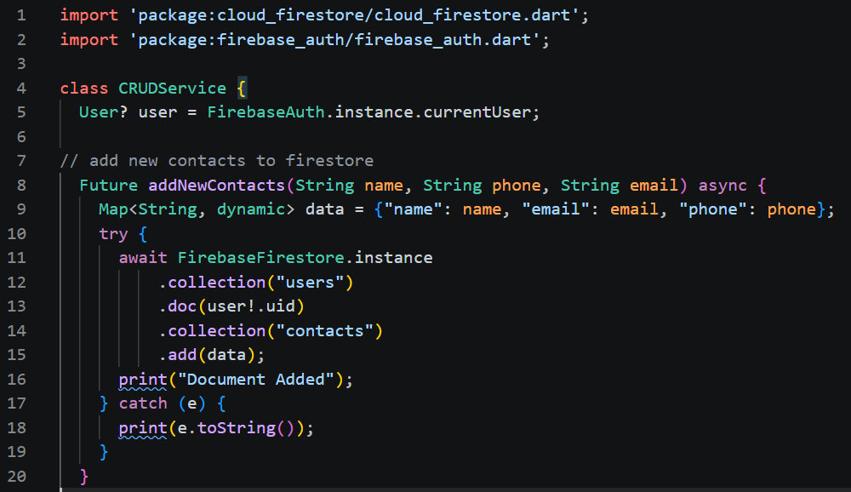
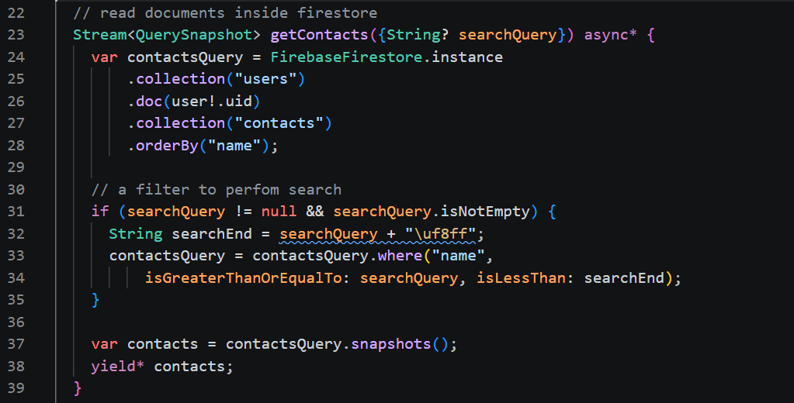
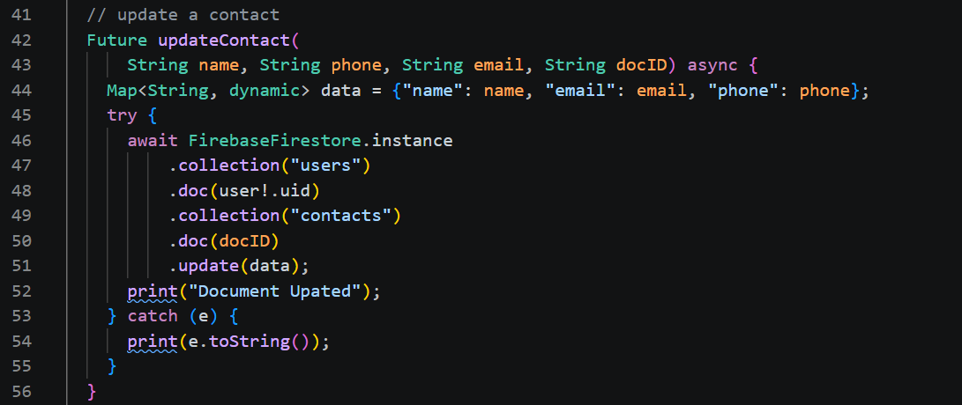
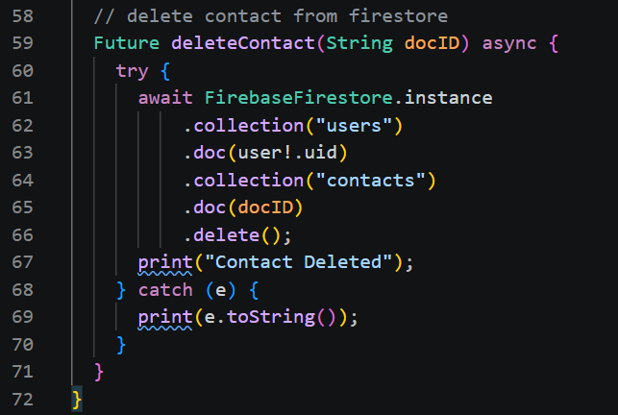

5. main.dart
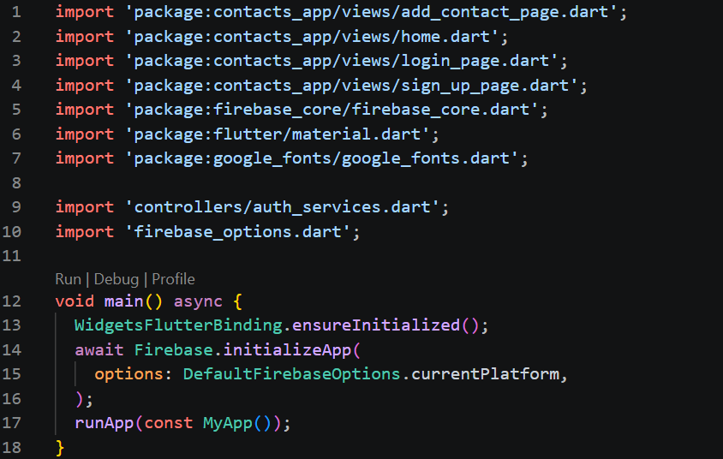
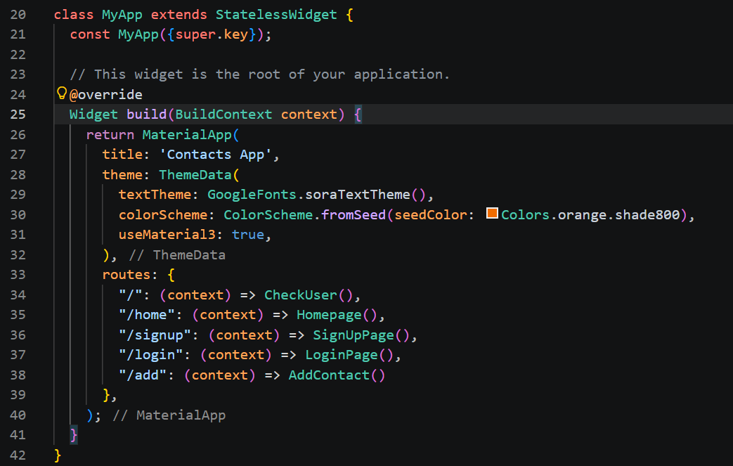
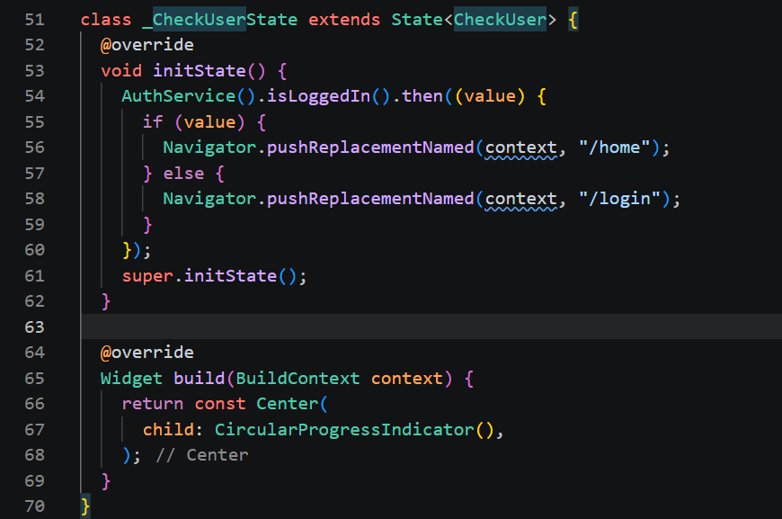

./viewa/login_page.dart
