PERSONAL PROJECT REPORT
BUILDING AN ADMISSIONS CONSULTING CHATBOT
USING RAG
(RETRIEVAL-AUGMENTED GENERATION)
Full name: Nguyen Huy Anh Duy
Short description:
The system is an automated admissions consulting chatbot for the University of Transport and Communications, using a Large Language Model (LLM) combined with Retrieval-Augmented Generation (RAG) to retrieve admissions data and generate context-aware, accurate responses.
Technologies used:
• Python
• LangChain
• ChromaDB
• Sentence Transformers
• Ollama (Llama 3)
• Streamlit
Role:
Requirements analysis, system design, vector database construction, RAG pipeline development, interface development, and system testing.

TABLE OF CONTENTS
CHAPTER 1: OVERVIEW 3
1.1. Rationale for Choosing the Topic 3
1.2. Research Objectives 3
1.3. Research Subject and Scope 3
1.4. Research Methodology 4
1.5. Report Structure 4
CHAPTER 2: THEORETICAL FOUNDATIONS 5
2.1. Chatbots and Their Applications in Education 5
2.1.1. Definition of Chatbots 5
2.1.2. Applications in Education 6
2.2. Natural Language Processing (NLP) 6
2.3. Large Language Models (LLMs) 7
2.3.1. Definition 7
2.3.2. Transformer Architecture 7
2.3.3. Limitations of Standalone LLMs 7
2.4. Retrieval-Augmented Generation (RAG) 8
2.4.1. Definition 8
2.4.2. RAG Workflow 8
2.4.3. Advantages of RAG 9
2.5. Vector Database 9
CHAPTER 3: SYSTEM ANALYSIS AND DESIGN 11
3.1. Requirements Analysis 11
3.1.1. Functional Requirements 11
3.1.2. Non-Functional Requirements 11
3.2. System Architecture 11
3.3. Processing Flow Design 12
CHAPTER 4: IMPLEMENTATION AND EXPERIMENTAL RESULTS 13
4.1. Implementation Environment 13
4.2. Building the Knowledge Base 13
4.2.1. Functional Requirements 13
4.2.2. Building the Vector Database 13
4.2.3. Building the Retrieval Module 14
4.2.4. Building the Generation Module 14
CHAPTER 5: IMPLEMENTATION AND EXPERIMENTAL RESULTS 16
5.1. Conclusion 16
5.2. Limitations 16
5.3. Future Development Directions 16

CHAPTER 1: OVERVIEW

1.1. Rationale for Choosing the Topic
In the context of increasingly rapid digital transformation, universities face a major challenge in providing timely and accurate admissions information to thousands of applicants every year. The University of Transport and Communications—one of the leading universities in transportation and engineering in Vietnam—is no exception.
In practice, the university receives tens of thousands of questions from applicants and parents each year about issues such as admission scores, enrolment quotas, training programmes, admission requirements, and enrolment procedures. Manually answering these questions requires significant human resources and time, while also making it difficult to ensure information consistency.
The emergence and development of Large Language Models (LLMs) such as GPT and Gemini, together with Retrieval-Augmented Generation (RAG), have created opportunities to build intelligent chatbot systems capable of providing accurate answers based on the university’s actual data. This is the motivation for this project.

1.2. Research Objectives
The project aims to achieve the following specific objectives:
- Research the theoretical foundations of RAG, Large Language Models, and vector databases.
- Build a Knowledge Base from actual admissions data of the University of Transport and Communications.
- Design and implement an admissions consulting chatbot using the RAG technique.
- Experiment with and evaluate system effectiveness, and compare it with an approach without RAG.

1.3. Research Subject and Scope
The research subject is the RAG technique for building question-and-answer chatbots and applying it to the admissions consulting problem at the University of Transport and Communications (UTC).
The research scope includes admissions data from the 2025 admissions project document (PDF format) prepared in advance, including information about training programmes, admission scores, and enrolment procedures.

1.4. Research Methodology
The project combines the following research methods: studying literature and theory on NLP, LLMs, and RAG; analysing and collecting actual data from the university’s admissions information sources; designing and programming the system in Python; and conducting experiments, evaluating results, and making comparisons.

1.5. Report Structure
The report is organised into five chapters: Chapter 1 presents an overview of the project; Chapter 2 presents the theoretical foundations; Chapter 3 analyses and designs the system; Chapter 4 presents the implementation process and experimental results; and Chapter 5 presents the conclusion and future development directions.

CHAPTER 2: THEORETICAL FOUNDATIONS

2.1. Chatbots and Their Applications in Education

2.1.1. Definition of Chatbots
A chatbot (chat robot) is a computer program designed to simulate human conversation through text or voice. Modern chatbots use Artificial Intelligence (AI) and Natural Language Processing (NLP) techniques to understand and respond to users’ natural language flexibly.
Chatbots can be broadly classified into two main types: rule-based chatbots and machine-learning-based (AI-based) chatbots. Rule-based chatbots operate according to predefined scenarios, whereas AI-based chatbots can learn and generalise from data, allowing them to handle situations that were not explicitly programmed in advance.
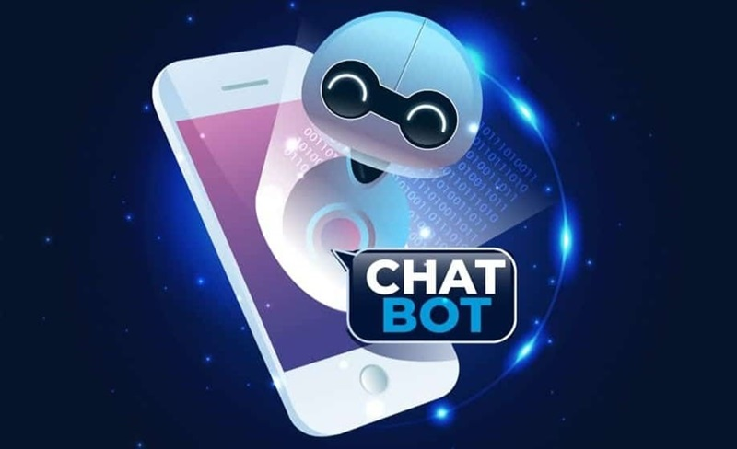
Figure 2.1

2.1.2. Applications in Education
In education, chatbots are widely used for purposes such as admissions consulting, learning support, administrative enquiries, and providing learning resources. Research indicates that chatbots can significantly reduce the workload of advisory departments while improving the experience of students and applicants.

2.2. Natural Language Processing (NLP)
Natural Language Processing (NLP) is an interdisciplinary field spanning computer science, artificial intelligence, and linguistics. It focuses on enabling computers to understand, interpret, and generate human language.
Basic NLP tasks include parsing, Named Entity Recognition (NER), text classification, machine translation, text summarisation, and question answering. In this project, NLP plays an important role in understanding user questions and generating appropriate responses.

Figure 2.2

2.3. Large Language Models (LLMs)

2.3.1. Definition
Large Language Models (LLMs) are deep learning models trained on enormous amounts of text data and capable of understanding and generating natural language with high quality. Representative LLMs include GPT-4 (OpenAI), Gemini (Google), LLaMA (Meta), and Claude (Anthropic).
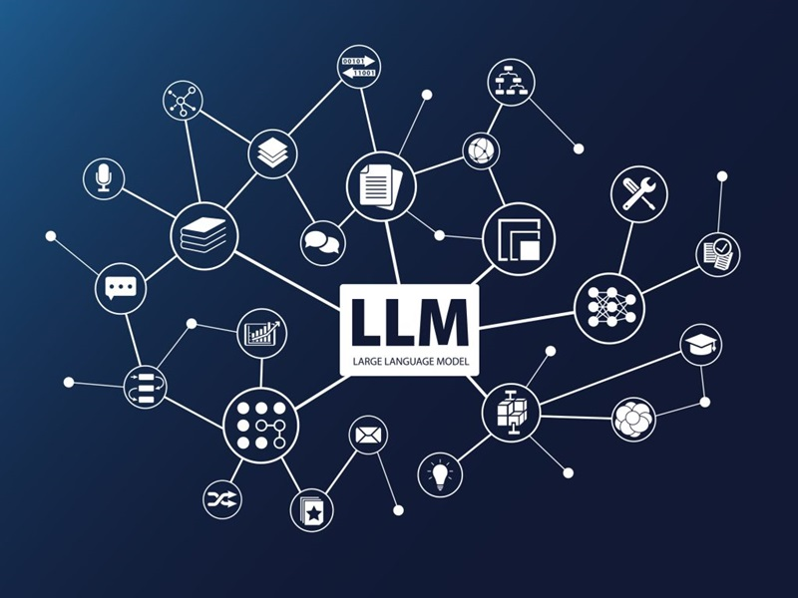
Figure 2.3

2.3.2. Transformer Architecture
Most modern LLMs are based on the Transformer architecture introduced by Vaswani et al. (2017). This architecture uses the Self-Attention mechanism to capture relationships among words in a sentence, enabling the model to understand context more effectively than traditional RNN and LSTM architectures.

2.3.3. Limitations of Standalone LLMs
Although standalone LLMs are highly capable of generating language, they have several important limitations: their knowledge is constrained by the training data (knowledge cutoff), they cannot automatically update information in real time, and they tend to produce “hallucinations”—that is, inaccurate information that sounds plausible. These limitations are a key reason why RAG was developed.

2.4. Retrieval-Augmented Generation (RAG)

2.4.1. Definition
Retrieval-Augmented Generation (RAG) is a technique that combines information retrieval and natural language generation. Instead of relying solely on the knowledge embedded in an LLM’s parameters, RAG allows the model to retrieve relevant documents from an external knowledge base before generating an answer.
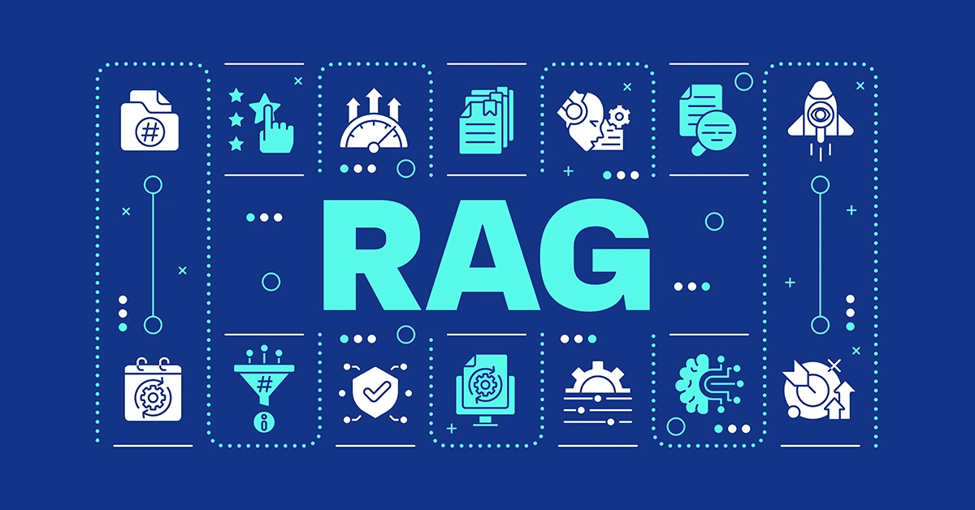
Figure 2.4

2.4.2. RAG Workflow
The RAG system operates in two main stages:
- Source data (from websites and PDF files) is preprocessed to remove noise and standardise the content. The data is then divided into smaller segments (chunks). Each chunk is converted into a vector using an embedding model and stored in a Vector Database.
- When a user asks a question, the question is converted into an embedding vector. The system searches for the chunks with the highest similarity in the Vector Database. These text segments are then included in the prompt together with the user’s question and sent to the Large Language Model (LLM) to generate the final answer.
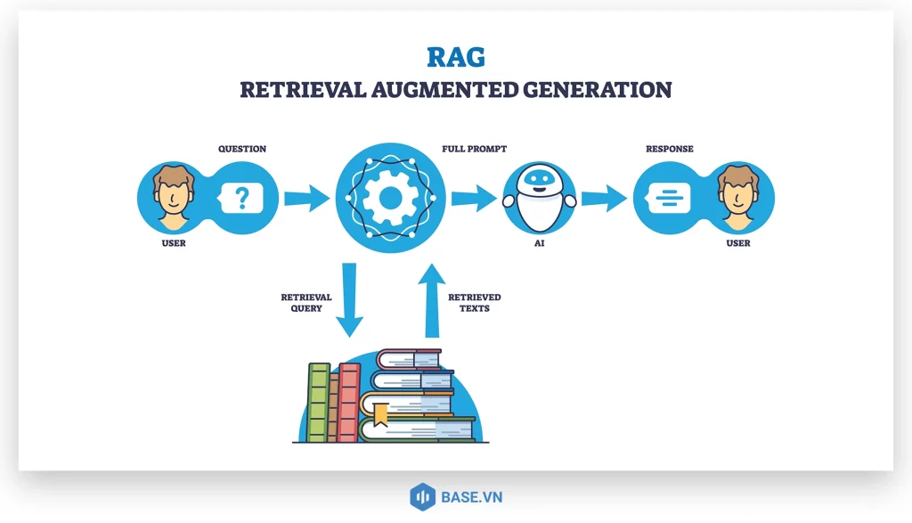
Figure 2.5

2.4.3. Advantages of RAG
- Reduces hallucinations because responses are grounded in actual data.
- Makes it easy to update knowledge without retraining the model.
- Has lower deployment costs than LLM fine-tuning.
- Can cite the sources of information, thereby increasing reliability.

2.5. Vector Database
A Vector Database is a specialised storage system optimised for storing and searching high-dimensional numerical vectors. Unlike traditional relational databases, which search based on exact values, Vector Databases use Approximate Nearest Neighbour (ANN) algorithms to search by semantic similarity.
In this project, the system uses ChromaDB—a lightweight, open-source vector database that is easy to integrate with frameworks such as LangChain. ChromaDB enables efficient storage and querying of embedding vectors, making it suitable for semantic search applications such as an admissions consulting chatbot.
Compared with other solutions, ChromaDB does not require complex configuration, supports local persistence, and provides built-in mechanisms for fast vector querying. This makes the system easy to deploy and suitable for the moderate data scale of the project.

Criterion | FAISS | ChromaDB | Pinecone
Open source | Yes | Yes | No (SaaS)
Ease of installation | Medium | Easy | Very easy
Scalability | Good | Good | Very good
Suitable for demos | Yes | Yes | Limited
Table 2.1: Comparison of Popular Vector Databases

CHAPTER 3: SYSTEM ANALYSIS AND DESIGN

3.1. Requirements Analysis

3.1.1. Functional Requirements
The admissions consulting chatbot must satisfy the following core functional requirements:
- Accept natural-language questions from users in Vietnamese.
- Search for relevant information in the UTC admissions Knowledge Base.
- Provide accurate answers to questions about study programmes, admission scores, and enrolment quotas.
- Provide an intuitive and easy-to-use chat interface.
- Display reference sources together with each answer.

3.1.2. Non-Functional Requirements
- Response time of less than 10 seconds for each question.
- Answer accuracy of more than 70% compared with the ground-truth information.
- The system should be stable, easy to maintain, and easy to update with new data.

3.2. System Architecture
The system is designed as a RAG Pipeline consisting of three main components:
Component 1 – Data Ingestion: The system collects data from sources such as the admissions project PDF and related documents. The data is then preprocessed (cleaned and stripped of unnecessary characters) and divided into text segments (chunks) of an appropriate length. Each chunk is converted into an embedding vector using a sentence-transformers model. These vectors are stored in the ChromaDB vector database, enabling fast retrieval based on semantic similarity.
Component 2 – Retrieval Engine: When the user enters a question, the system converts the question into a corresponding embedding vector. ChromaDB is then used to search for the most similar chunks (top-k, typically k=2). The relevant text segments are combined to form the context used as the information basis for answer generation.
Component 3 – Generation: The system uses a Large Language Model (LLM) running locally through Ollama (e.g., LLaMA 3 or Phi-3). The model receives a prompt containing the context and the user’s question, and generates a complete answer in Vietnamese. This approach helps keep responses grounded in actual data while reducing the risk of model hallucination.

3.3. Processing Flow Design
The system processing flow when a user asks a question consists of the following sequential steps:
- The user enters a question through the Streamlit interface.
- The question is converted into an embedding vector using the embedding model (HuggingFace Embeddings).
- The system uses ChromaDB to search for the text chunks with the highest similarity to the question (top-k).
- The relevant text segments are combined into a context.
- The system constructs a prompt by combining the context with the user’s question.
- The Large Language Model (LLM – using Ollama) generates an answer based on the provided information.
- The answer and its source documents are displayed to the user in the interface.

CHAPTER 4: IMPLEMENTATION AND EXPERIMENTAL RESULTS

4.1. Implementation Environment
The system was developed and deployed on a personal computer with the following configuration:
- Operating system: Windows 10/11
- CPU: Intel Core i5 or equivalent
- RAM: 8 GB or higher
- Programming language: Python 3.10+
- Development tools: PyCharm / VS Code
Libraries used:
- Streamlit (user interface development)
- LangChain (RAG pipeline processing)
- Sentence-Transformers (embedding vector generation)
- ChromaDB (vector database storage)
- Ollama (running the local language model)
The system is installed using the pip package manager and runs in a virtual environment to ensure isolation.

4.2. Building the Knowledge Base

4.2.1. Functional Requirements
The system input consists of admissions documents from the University of Transport and Communications in PDF format.
Data processing steps:
- Read the contents of the PDF file using the PyMuPDF library.
- Extract all text from the pages.
- Clean the data (remove unnecessary characters and line breaks).
- Split the text into appropriately sized chunks.

4.2.2. Building the Vector Database
After the data is split into chunks, the system performs the following steps:
- Use the sentence-transformers embedding model to convert each text segment into a numerical vector.
- Store these vectors in ChromaDB using local persistence.
Using ChromaDB optimises information retrieval based on semantic similarity while simplifying deployment.
Code implementing the above tasks:
splitter = RecursiveCharacterTextSplitter(
chunk_size=500,
chunk_overlap=150
)
embeddings = HuggingFaceEmbeddings(
model_name="sentence-transformers/paraphrase-multilingual-MiniLM-L12-v2"
)
vectorstore = Chroma.from_documents(
documents=chunks,
embedding=embeddings,
persist_directory="vectorstore"
)

4.2.3. Building the Retrieval Module
When the user enters a question:
- The question is converted into an embedding vector.
- The system queries ChromaDB to find the most relevant text segments (top-k).
- These segments are combined to create the context.
Code implementing the above tasks:
def retrieve(question, vs):
docs = vs.max_marginal_relevance_search(
question,
k=4,
fetch_k=10
)
context = "\n\n".join([d.page_content for d in docs])
sources = list(set([d.metadata.get("source", "?") for d in docs]))
return context, sources

4.2.4. Building the Generation Module
The system uses a locally hosted Large Language Model through Ollama (e.g., LLaMA 3).
- Input: context + question
- Output: answer in Vietnamese
The prompt is designed to ensure that it:
- Uses only the information contained in the context.
- Avoids incorrect or “fabricated” information.
Code implementing the above tasks:
def generate(question, context):
prompt = f"""
You are an admissions consulting assistant for the University of Transport and Communications.

RULES:
1. Answer only based on the provided INFORMATION.
2. Do not speculate or add knowledge that is not contained in the data.
3. If the INFORMATION is insufficient to answer, say:
"No relevant information was found in the data."
4. For questions involving numerical data (quotas, tuition fees, subject combinations, or programme codes), provide the answer exactly according to the data.
5. Answer concisely and clearly in Vietnamese.

INFORMATION:
{context}

QUESTION:
{question}

ANSWER:
"""
response = ollama.chat(
model="llama3",
messages=[
{
"role": "system",
"content":
"You are a RAG chatbot. Use only the provided context."
},
{
"role":"user",
"content": prompt
}
]
)

return response["message"]["content"]

CHAPTER 5: IMPLEMENTATION AND EXPERIMENTAL RESULTS

5.1. Conclusion
The project successfully researched and developed an admissions consulting chatbot for the University of Transport and Communications based on the RAG (Retrieval-Augmented Generation) technique. The implementation achieved the following specific results:
- Successfully researched and presented the theoretical foundations of NLP, LLMs, RAG, and Vector Databases.
- Built a Knowledge Base from actual admissions data of the University of Transport and Communications.
- Successfully implemented and demonstrated a RAG chatbot with an intuitive Streamlit interface.
- The system can answer basic admissions-related questions; however, the response time is still relatively slow (typically more than 10 seconds per question).
- Answer accuracy is approximately 60%–65%, which remains relatively low compared with the initial expectation.
- RAG initially helps reduce hallucinations compared with a standalone LLM, but its effectiveness is not yet optimal.
Overall, the results demonstrate that the system is feasible; however, further improvements are still required to better meet real-world requirements.

5.2. Limitations
Despite the results achieved, the system still has several limitations that need to be addressed:
- First, response time is still slow, which affects the user experience, especially when a local model is used or computing resources are limited.
- Second, accuracy is not yet high (approximately 60%–65%), mainly due to the quality of retrieval and an embedding model that is not optimised for Vietnamese.
- Third, the Knowledge Base data is mainly static and is not updated in real time.
- Fourth, the system does not handle complex questions or tasks requiring multi-step reasoning effectively.
However, the system is generally stable, experiences few operational errors, and is easy to extend and maintain.

5.3. Future Development Directions
To improve the system in the future, the project proposes the following development directions:
- System performance optimisation: Apply techniques such as caching, reducing context size, or using a lighter model to reduce response time to below 10 seconds.
- Accuracy improvement: Combine Hybrid Search (Semantic + BM25) to improve retrieval quality and thereby increase answer accuracy.
- Embedding improvement: Use embedding models specialised for Vietnamese to improve semantic understanding.
- Real-time data integration: Connect directly to the university’s admissions data system to keep information up to date.
- Practical deployment: Integrate the chatbot into the official website and a mobile application to serve applicants.
- Multimodal expansion: Develop chatbot capabilities for voice interaction and image processing to improve the user experience.

