Word Count

Team Weebs

Duy Anh Vuong (Jeff) - 102603197  
Minh Vu Nguyen (Brian) - 102838229  
  
Tutorial Time: 10:30am – 12:30am  
  
Semester 1 - 2022

ENERGY USAGE IN AUSTRALIA

[link to website]

Table of Contents

Introduction 2

Background and Motivation 2

Visualization Purpose 2

Project Schedule 2

Data 3

Data Source 3

Data Processing 3

Requirements 3

Must-have features 3

Optional features 3

Visualization design 4

Method of data display: 4

Validation 10

Conclusion 10

# Introduction

## Background and Motivation

Nowadays, in Australia, the prevalent method of generating energy is by burning fossil fuels, while more renewable, cleaner energy options being much lower compared to fossil fuels(cite). Burning fossil fuels are one of the causes of global warming and it is directly causing the worsening environment state in Australia (cite), but at the time of this visualization’s creation, renewables have not become more dominant compared to the old energy generation source. This visualization is targeted towards the public, and in particular, the population that is conscious about the state of the environment, along with the proportion of their energy use coming straight from a non-renewable way. By creating this visualization, the biggest goal is to raise awareness on how much the energy proportion has not changed a great deal in the past few years, along with informing people on how important

## Visualization Purpose

This data visualization website aims to investigate the energy generation and consumption of Australia, highlighting all the sources that contribute to the energy economy of Australia. From that information, focus our lens on the disproportional energy distribution, calling to action a drive to reduce fossil fuel burning and focusing on the renewables sector.

## Project Schedule

Week 9:

* Tutorial time:
  + Work on finalizing ideas for the aim of the visualizations
  + Conceptualize and research about energy production and consumption in Australia
  + Practice creating a choropleth, and looked at online works of visualization for inspiration
* Weekends:
  + Try in creating preliminary designs for the base visualizations
  + Make a functional choropleth map, colour scheme and enhancements not finalized

Week 10:

* Finished choropleth, added extra visualization to choropleth for more detailed information for each state
* Finished pie chart and area chart, with some degree of interactivity added
* Added more information to the process book

Week 11:

* Finished every visualization, enhance visuals (CSS) and add extra functions for User-Centered reasons
* Add overlays, tooltips, sectional parts to website
* Add more to process book

Week 12:

* Finish up enhancements to website
* Finish Google Forms for User-Centered Design Questionnaire

# Data

## Data Source

### Pie chart

***Pie chart source:***

<https://assets.cleanenergycouncil.org.au/documents/resources/reports/clean-energy-australia/clean-energy-australia-report-2021.pdf>

***Method of data collection:***

* The data collected is a table of data taken from the Clean Energy Council. This dataset is a categorical dataset, presenting the data from several categories of technologies in electrical generation in Australia in 2021.
* The data in the visualization is categorical (technology) and ratio (percentage)
* Number of households powered over the course of the year will not be added due to data not being relevant to the purpose of the visualization (to show the proportions of different types of energy generation compared to the whole)

### Choropleth

***Data source:***

<https://www.energy.gov.au/publications/australian-energy-update-2021>

***Choropleth source:***

<https://gist.github.com/GerardoFurtado/02aa65e5522104cb692e#file-aust-json>

***Method of data collection:***

* Data collected is taken from a spreadsheet (table O) of data from the Australian Government’s Department of Industry, Science, Energy and Resources and comes from their 2021 Australian Energy Update. This spreadsheet contains electricity generation by fuel types and by physical units for Australia, and its states.
* Data from the table composes a mostly categorical/numerical dataset used for the visualization, which is then presented through visualization in through categorical and numerical (ratio) data.
* Most data from the document are added, only some refactoring to the final document to be able to visualize the data using D3.JS.

### Area chart:

***Data source:***

<https://www.energy.gov.au/publications/australian-energy-update-2021>

***Method of data collection:***

* Like the choropleth, data collected is taken from a spreadsheet (table O) of data from the Australian Government’s Department of Industry, Science, Energy and Resources and comes from their 2021 Australian Energy Update. The spreadsheet mentioned electricity generation by fuel types and by physical units for Australia and its states
* Data from the table (the used data) is mostly categorical and numerical data, with some interval data type to represent time.
* Most data are added, with some refactoring in the final document to visualize the data through D3.JS

## Data Processing

In the beginning, our team expected to have to deal with a great amount of data clean-up, since the dataset we got was not visualization-friendly and requires a great amount of conversion from numerical data to percentage data and vice versa to get to a point where D3.JS can visualize it on the SVG canvas. All the data was processed by us, due to them not having a great number of steps to get to the required number, only requiring a minimal number of calculations and visual conversion, and in addition, derivation of variables are only required whenever a certain data is named without regard to our already established naming convention in the code.

### Pie charts:

* Ratio data for the pie chart was converted into percentage through using the formula:

x 100%

* Data is then refactored, so that “technology” becomes “type” in the final code for succinctness, percentages shown only as a number and deleted the % sign, and the “number of households powered over course of the year” data column is deleted due to not being too related to the main goal of the visualization.

### Choropleth:

* Changing the STATE_CODE as numbers from the base JSON file to abbreviations (i.e., QLD, VIC…) to represent these data on the map as abbreviated state names
* The spreadsheet originally does not present data in a way that is visualization-friendly hence, it is necessary to take this data to convert them into a simpler CSV file.

* After this data is converted from this large block of data into manageable and visualizable files, the axes had to be flipped, and then the file gets to the point where it is manageable and appropriate for our visualization. In addition, after adding the data into the CSV file, a code-appropriate naming scheme is set for each data set, with a “Dictionary” function within the JavaScript file to convert these Code-Centered naming schemes into User-friendly names (i.e., natural_gas to Natural Gas)

### Area chart:

* Because the Area Chart and the Choropleth uses a similar data set, they both require the data from the original spreadsheet to be reformatted to a separate CSV file for visualization. Similarly, data after added to a separate CSV file will have to go through an axis flip, then a different set of names are given to the different energy types for easier access during programming. In the JavaScript file, a Dictionary function is also added to convert these names into User-friendly names.

# Requirements

## Must-have features

Must have features in our visualizations include:

* Choropleth
  + With hovering effects to show either another visualization, or interactive methods to show data
* Pie chart
  + Pie chart showing all data in a clear and visible way, with legend explaining colour choice and polylines to indicate specific data in each chords/sector
* Area chart
  + Colours used are distinct and easy to see
  + Usage of buttons to shift between charts with/without animation to show data from different regions

## Optional features

Optional features in our visualizations include:

* Choropleth
  + Having smoother transitioning to show data, cutting down on unnecessary code-based processes that might slow down the visualization
  + Have the visualization presented on the final touched-up website in a professional way that does not stand out too much from the website
* Pie chart
  + Pie charts allow users to hover over and having the chord highlighted/pop out to show specific data in the centre of the donut chart or the outside.
  + Have the visualization presented on the final touched-up website in a professional way that does not stand out too much from the website
* Area chart
  + Allow for users to see data in the entire line of the line graph
  + Have a better way to show depreciated/not shown datasets that is normally not seen on an area graph
  + Have the visualization presented on the final touched-up website in a professional way that does not stand out too much from the website

# Visualization design

## Method of data display:

The way we plan to show our data is through 3 visualizations:

1. Choropleth
   1. General ideas
      * Using a choropleth, we want to show energy generation/consumption data in specific states, shown to the user from the user hovering their mouse on top of specific regions on the map. By doing this, our goal is to introduce an appropriate amount of interactivity to the visualization, along with communicate with the audience that “the visualization is about Australia, and about the states in Australia” without having to state it outright.
      * In addition, the colours used in the visualization would be distinct enough for the audience to make out differences in hues and saturation to make out the difference in data.
   2. Sketches and iterations

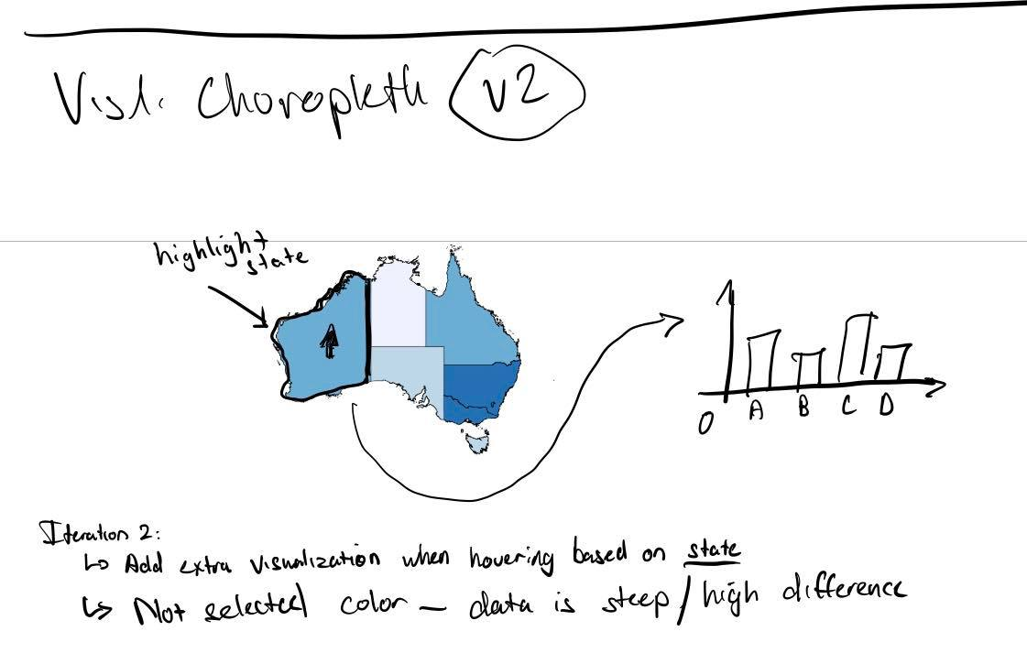

* 1. Alternative ideas
     + The same data can be represented using just a bar chart with alternating buttons to cycle between states, but this is not as interactive and does not clearly show the region and the states within the region of focus, and it also does not allow us to also change the colours of each state to show another type of data. Having a choropleth is more flexible in that way.
     + The same data can also be represented using only a choropleth with polylines showing up when mouse hovers on it, but the amount of data shown is pale in comparison to having a mouse hover and showing another chart for each state. To encompass all the data, it is better to utilize the way proposed above.
     + 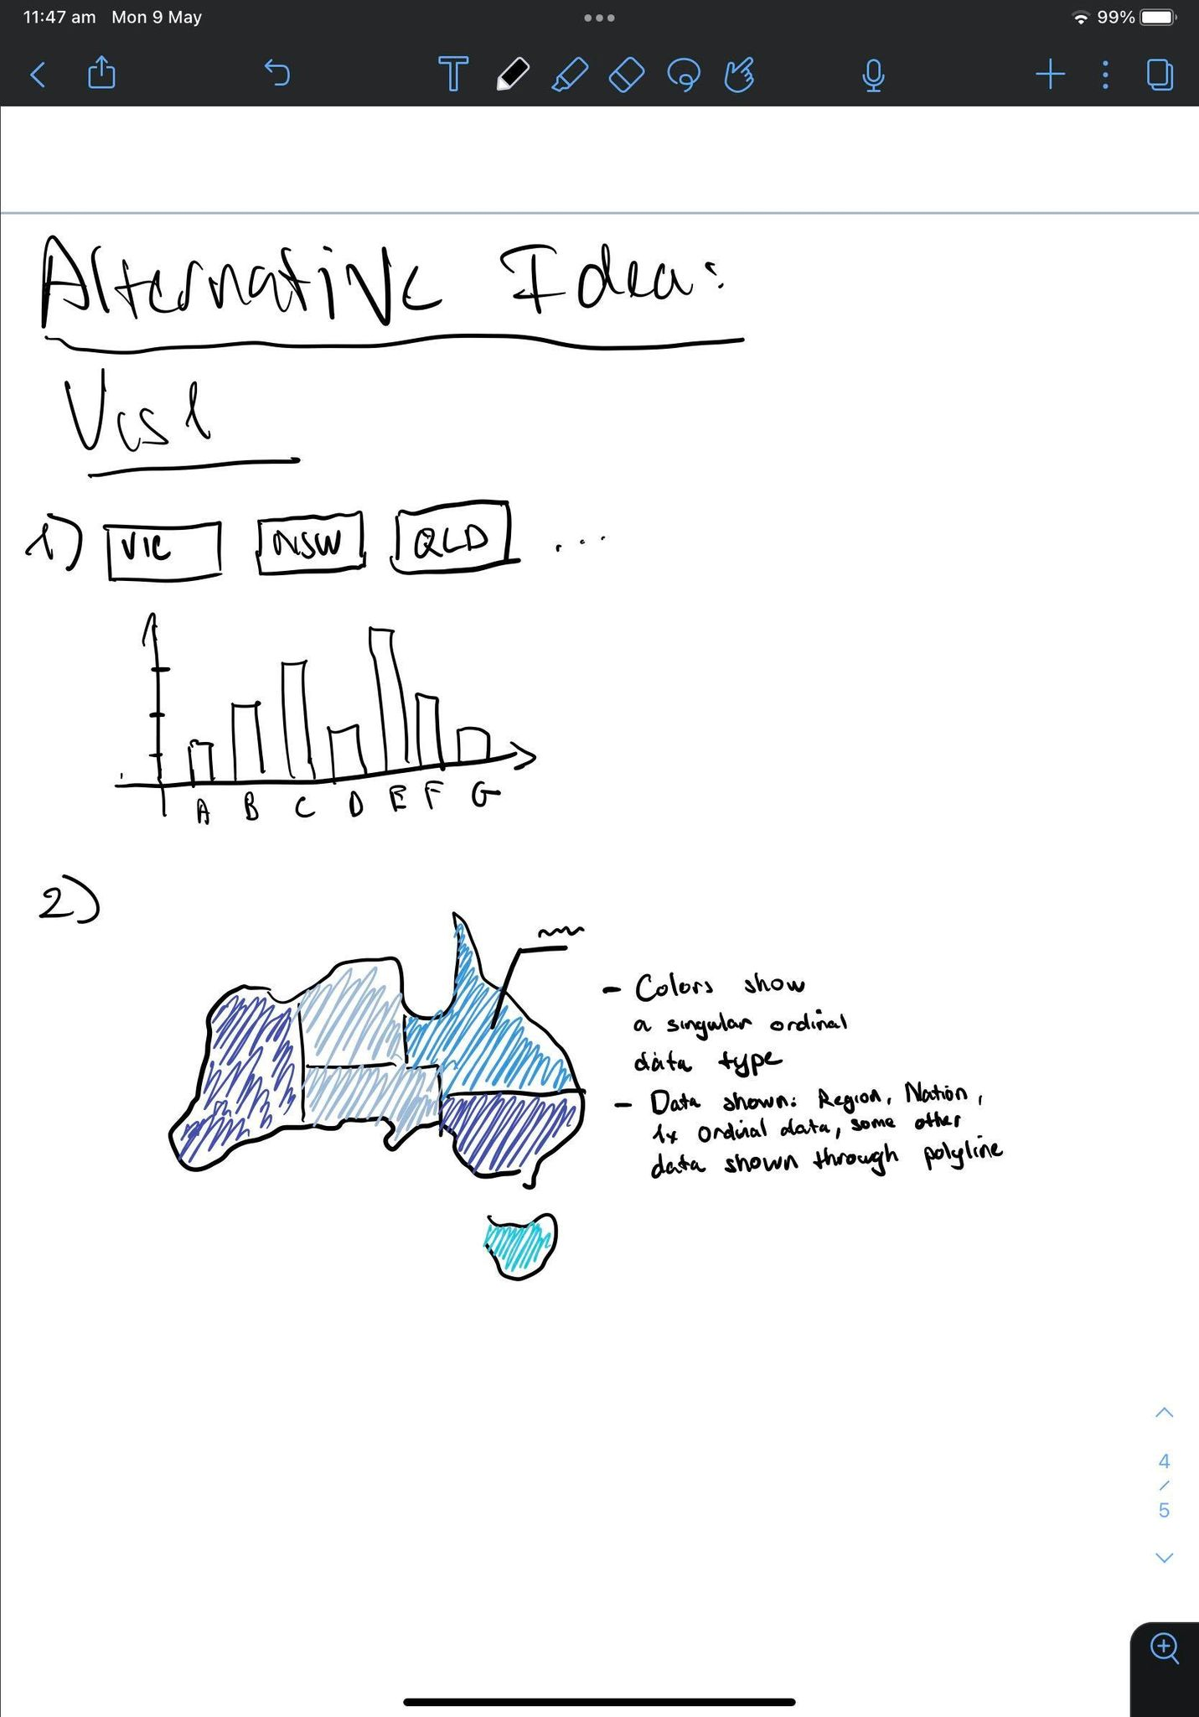
  2. Visual encoding and idioms
     + The idiom utilized within this visualization is the combination of a choropleth map and the bar chart. With the combination of these two methods of data visualization, a great number of data is encoded visually to pack as much information into the visualization as much as possible. Using the choropleth succinctly shows the location in which the data is being taken out of, and in addition, using bar charts show a clear difference represented through heights of the drawn bars. The main types of data shown in the choropleth chart is nominal data, but ordinal data is also shown using colour hues. The bar chart shows ordinal data through the difference in height and the numerical data shown on each bar.
     + The utilized visual encoding techniques include:
       - Using colour saturation and hues to represent the amount of power generated within a state compared to others, along with the different types of nominal data represented by individual bars in the bar chart.
       - Using the thickness of lines along with colours saturation for visualizing the currently viewed state’s data by surrounding that state’s border on the choropleth using a thicker and different colour of outline.

1. Pie charts
   1. General ideas
      * We needed to show percentage data of how much renewable energy contribute to total energy consumption/generation in Australia, so we went through several types of graphs to represent percentage data, but we landed on pie charts to show our data.
   2. Sketches and iterations

* 1. Alternative ideas
     + It is possible to represent our data in stacked bar charts to show percentages, but we have only 1 category, so it is not 100% appropriate
     + It can also be shown using area charts but is not appropriate as well since we are not looking to showing time progression.

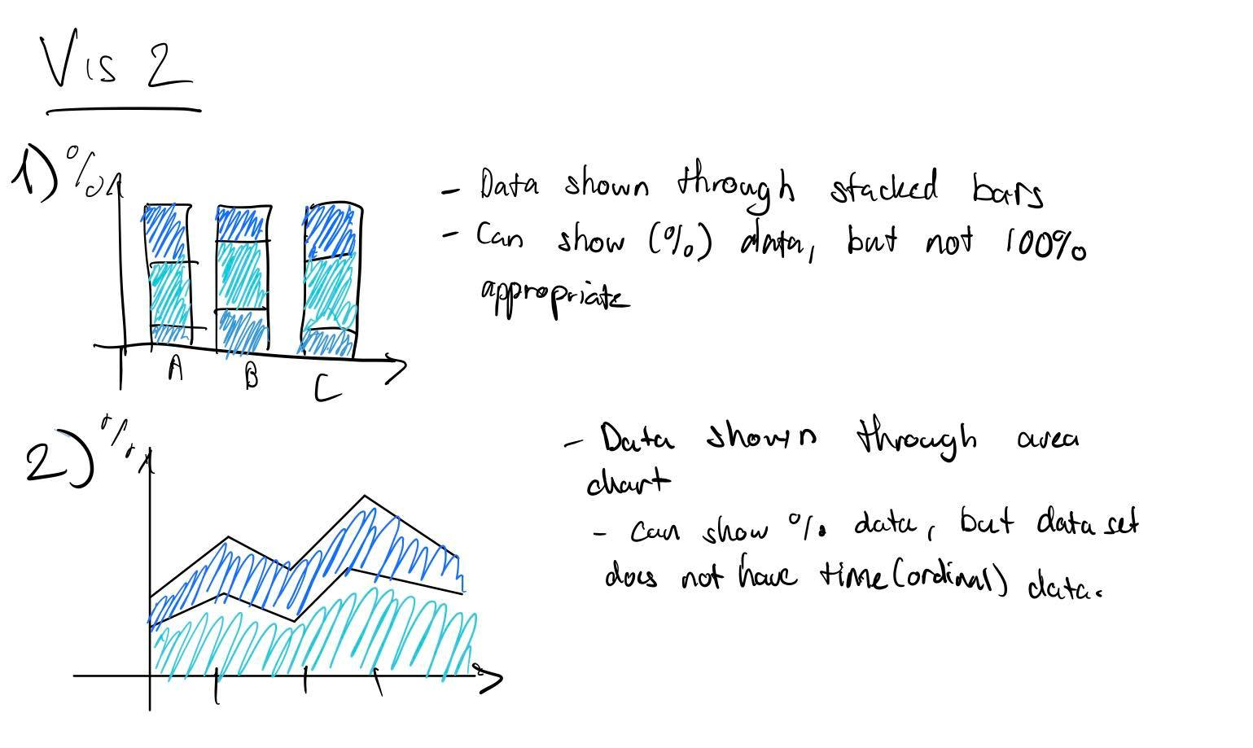

* 1. Visual encoding and idioms
     + The idiom utilized within this visualization is the pie chart, with the main goal is to show the proportion of a certain data compared to the whole, as well as helping users compare that one data to another. Using different colours, the graph shows nominal data, while using various interactivities, the graph can also show specific ordinal ratio data as well.
     + The utilized visual encoding techniques include:
       - Colour hues and saturation to represent the different nominal data that is represented in the visualization, along with deeper hues to represent a chord being highlighted when mouseover.
       - Lines and circular chords to represent different sectors within the graph, showing proportionality between the specific sector versus the whole or other sectors.

1. Area chart
   1. General ideas
      * Using an area chart to not only show the proportions of different types of energy generated, but also showing how the total changes per unit time,
   2. Sketches and iterations

* 1. Alternative ideas

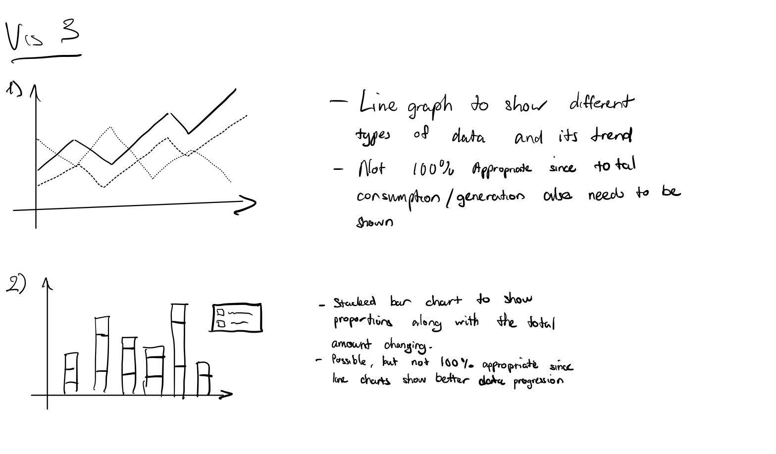

* 1. Visual encoding and idioms
     + The idiom utilized in this visualization is an area graph, with the main goal of not only showing progression of data through time through representation of interval data in the x-axis, but also shows the proportional change of represented data through time, whether if its change compared to the total, or compared to the other data represented. The main types of data shown is interval though the x-axis representing time progression, and ratio data represented by the y-axis.
     + The utilized visual encoding techniques include:
       - Colour hues and saturation for different areas shown on the graph to highlight the difference between different types of data, and with that also improve visibility and distinctiveness of the data shown. It shows nominal data in an effective way by visually showing the difference in colour saturation.
       - Using the data channel of lines and area to communicate the changes through time, along with the trends that are shown through the lines and area going up and down. Lines are also used to represent the axes in which the graph is drawn in and is used to show accurately what the area and lines show through numerical values.

# Validation

Test your visualization with users and report the results

# Conclusion

Provide a summary of the project and what you learnt from doing it.