**Spike:** Spike 4

**Title:** Emergent Group Behaviour

**Author:** Duy Anh Vuong - 102603197

**Goals / deliverables:**

Create a group agent steering behaviour simulation that can demonstrate distinct modes of emergent group behaviour. In particular, the simulation must:

• Include cohesion, separation and alignment steering behaviours

• Include basic wandering behaviours

• Use a weighted sum to combine all steering behaviours

• Support the adjustment of parameters for each steering force while running

* Code seen in /11/Spike – Emergent Group Behaviour

**Technologies, Tools, and Resources used:**

* Given code for Lab 08 and Lab 09
* Canvas Materials
* Visual Studio Code
* Python
* “The Nature of Code” – Chapter 6: Autonomous Agents (https://natureofcode.com/book/chapter-6-autonomous-agents/)

**Tasks undertaken:**

This task requires repurposing the given Autonomous Moving Agents

Initially, I cleaned the unnecessary lines for this task to avoid run-time conflicts as well as improve the performance of the program.

After all cleaned, I began to implement the TagNeighbors() method for the agents, based on the suggestion from the given PDF.

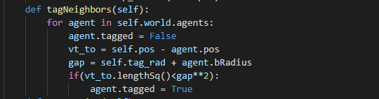

Moving on to the first mode of emergent group behaviour – Separation(). The idea is to make the agents in one group flee from others. While implementing this behaviour, I noticed that if I write the code as suggested in the document, the behaviour failed to work, which took me several days to conclude that the “return” value in the document was actually the “desired” vector, not the actual “steering” force.

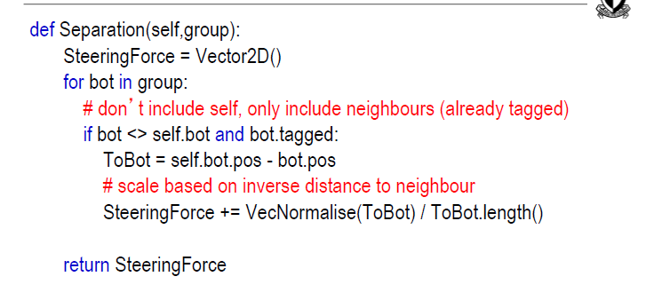

Based on that conclusion, I went on alter the code, by normalising the calculated vector, multiplying it by max_speed and finally subtract it by the velocity to get the final steering force.

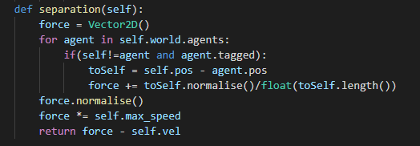

I am not so sure if my implementation was legitimate, but it worked (the result will be shown later 😊).

After that, the Alignment() behaviour would be implemented. The idea is to align the heading of all members of the group to the average heading. Indeed, the document only shows how to get the heading without mentioning how to apply the force:

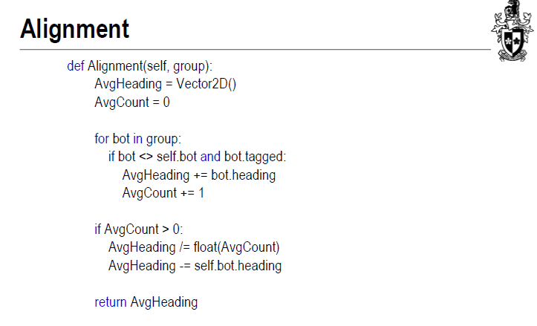

Hence, I decided to normalise the heading (as a vector) and multiply it by the max speed to apply the force:

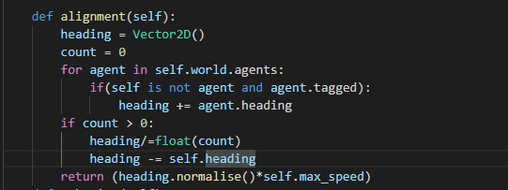

The final key task is to write the Cohesion() behaviour, the idea is to find the center position of a group then let the agent seek the target. I followed the instruction from the document and it worked as expected (again, the result is shown later 😊):

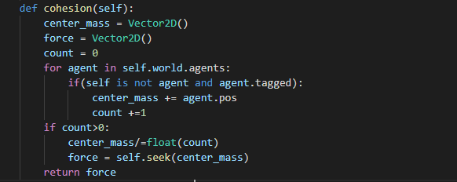

Combine it with Wander(), we have the final Weighted Sum behaviour (could be considered as Weighted Truncated Sum as the total force will be truncated to max force in the update method):

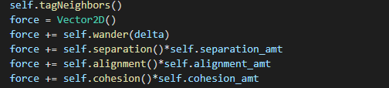

To control and weight how much each of the forces contribute to the resulted force, I multiply them with amount indexes that are controlled by the World Class:

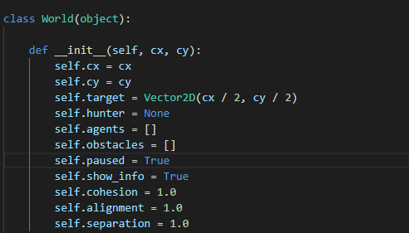

*In World class*

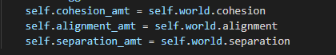

*__init__*

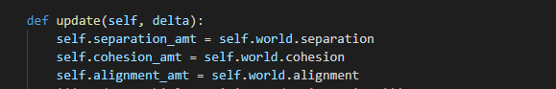

*update()*

In main.py, I added some keyboard inputs to modify the mentioned parameters:

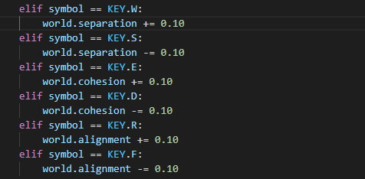

All set! The final thing to do is to render the parameters to the terminal:

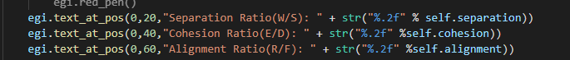

*world.render() method*

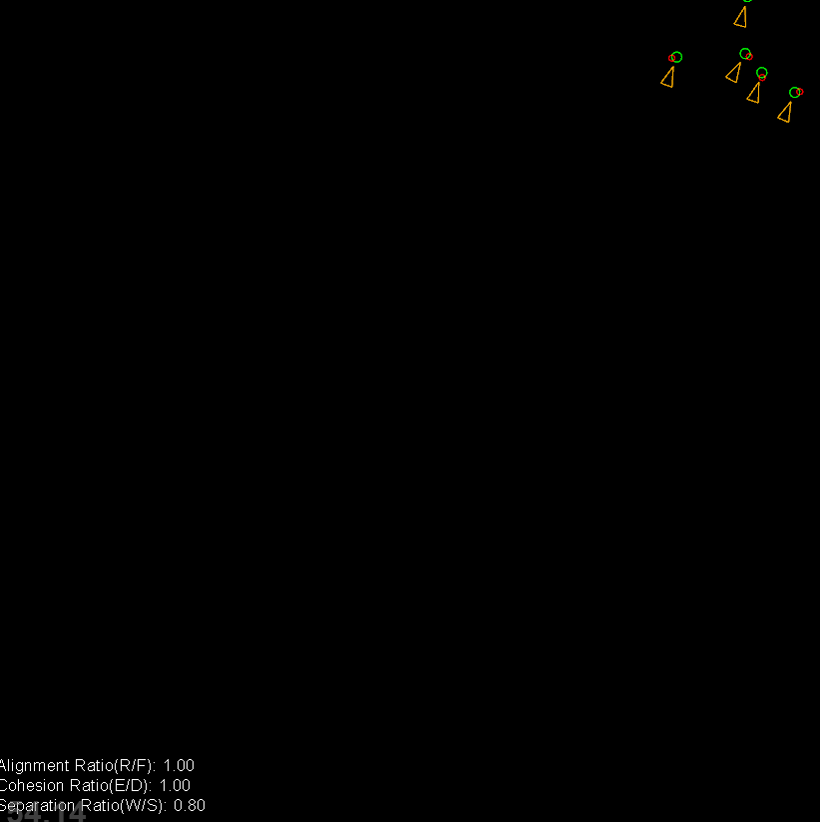

*Result*

Also, I drew the tag radius around the final agent in the list for observation. The reason is that this agent will always be considered tagged at the end of each rendered frame, and as I set the “tagged” agents’ color to red, its tagged agents will also be colored the same:

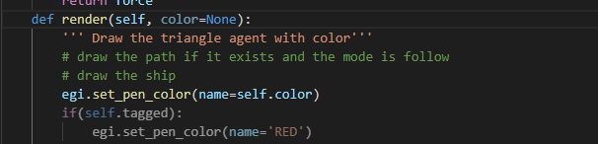

*agent.render() method*

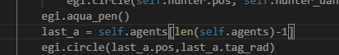

*world.render() method*

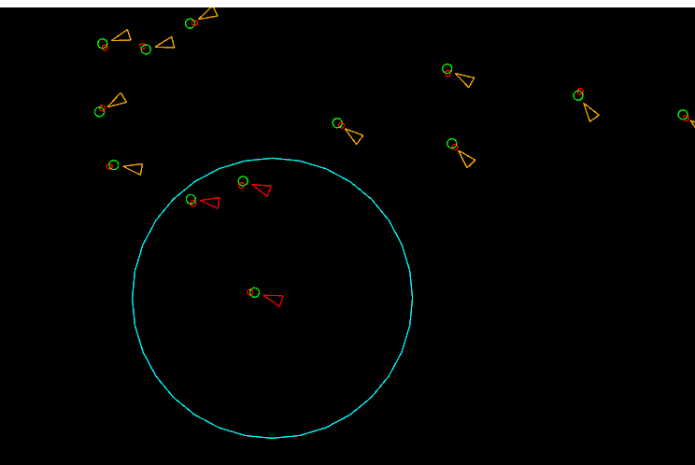

*Terminal*

**What we found out:**

1. Separation:

To observe this behaviour, I zeroed **alignment** and **cohesion** amount:

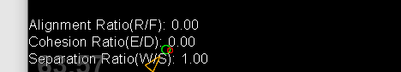

As can be seen in the following figure, the agents will keep a certain distance from each other by steering away from its group members:

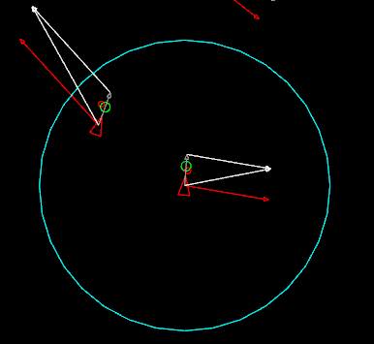

*2 agents are steering away from others in its group*

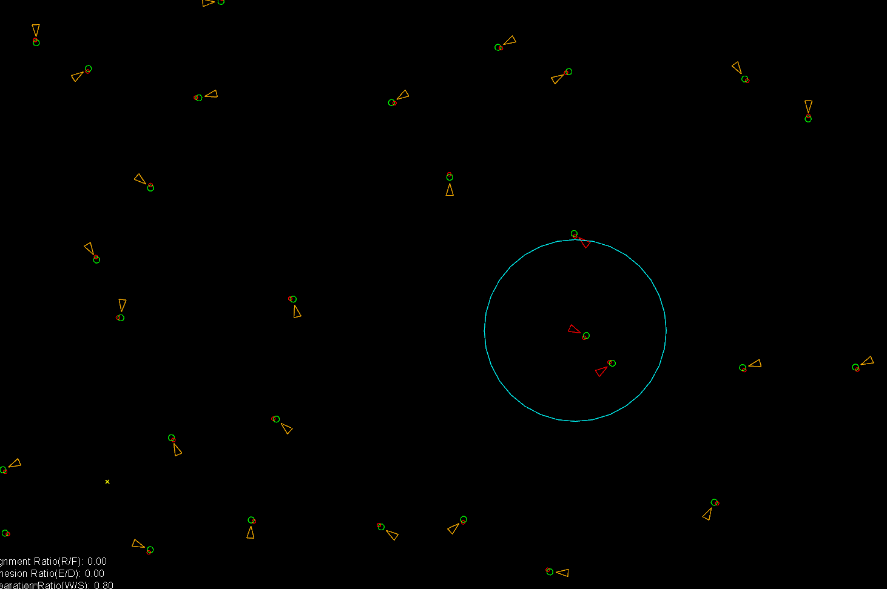

*The agents are “distancing” (Covid-19 flashback 😊)*

In my view, separation is used in group behaviour for avoiding collision among agents, as it will generate a force to “pull” the agent out of the crowd.

1. Cohesion:

Again, to see how cohesion individually works, I zeroed other amounts:

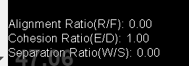

The observed behaviour is, well, very interesting. The agents will keep seeking the centre point, yet as the centre point changes over time, it results in a circulation which is very fun to watch 😊:

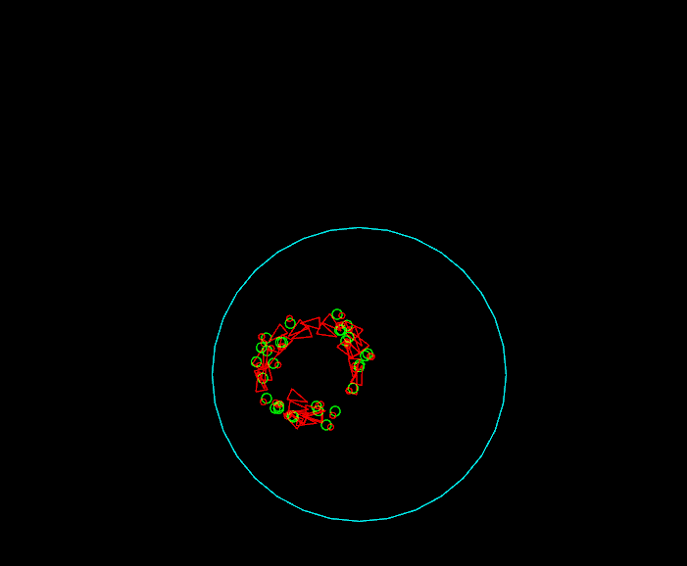

*Agents circulating the centre mass*

From my perspective, Cohesion is used to keep the members inside the radius of the group, as it will “pull” the agents into the centre of the crowd.

1. Alignment:

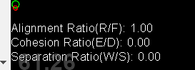

*Repeat the same step to observe*

Alignment alone gives the agents the same direction for them to head to so that they could look more like a flock:

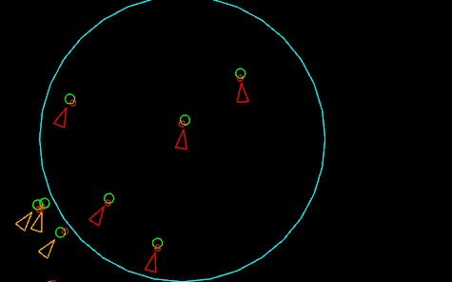

*Agents trying to move in the same direction*

From the observation, I suppose that Alignment is used to neutralize cohesion and separation, as it will prevent the collision of agents and keep them in a group by driving them along a uniform heading.

1. Weighted Sum and Behaviour Combination:

When combined with the Wander() behaviour, we have a group of randomly moving agents. When they are weighted the same in the calculation, the result shows a rather neat moving group of agents:

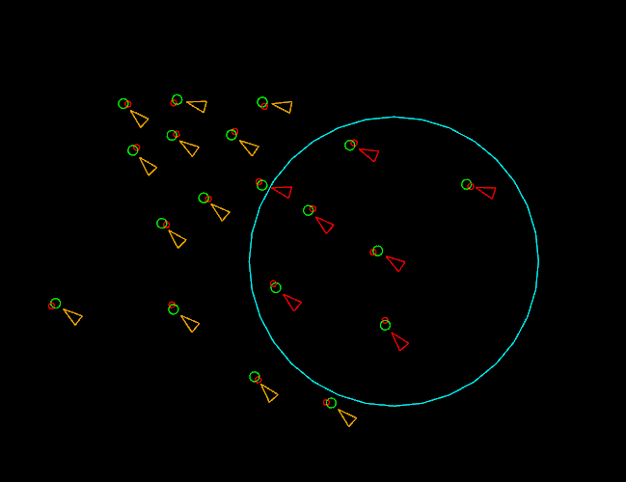

But what happened when the parameters are altered? I will explain shortly with a few words for each (as the report has been too wordy).

1. Heavier-weighted Cohesion: The crowd will collide at the center and behave the same.

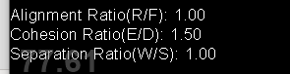

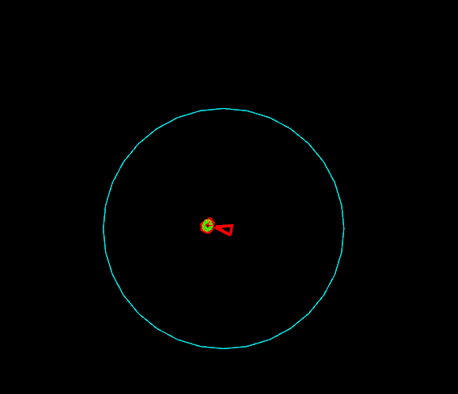

*Agents overlapping each other*

1. Heavier-weighted Alignment: The agents will behave more consistently with less “steering”

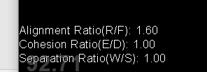

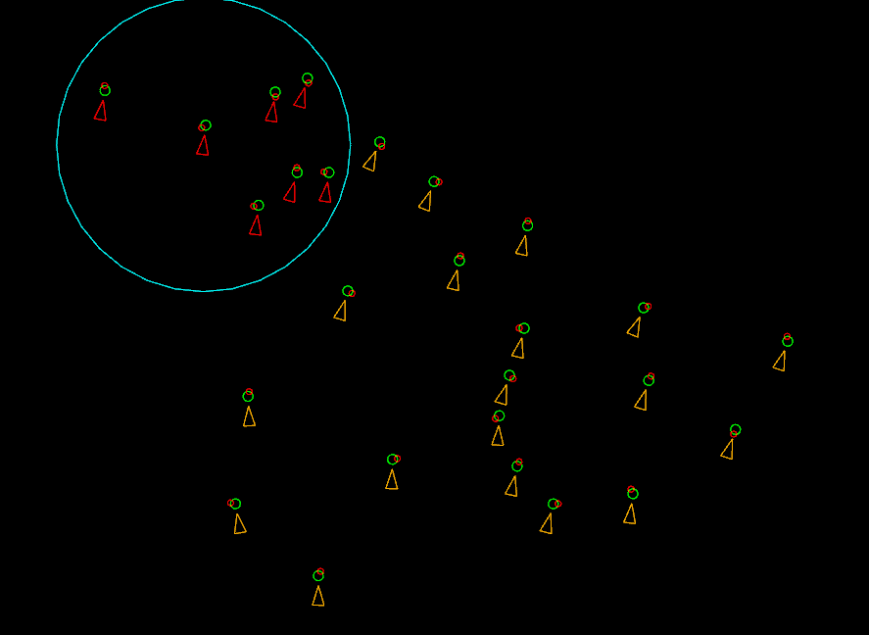

*Agents’ headings are nearly the same*

1. Heavier-weighted Separation: The agents will behave in a more separated way propotional to the ratio, as well as there will be more groups with fewer agents

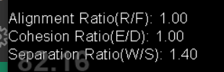

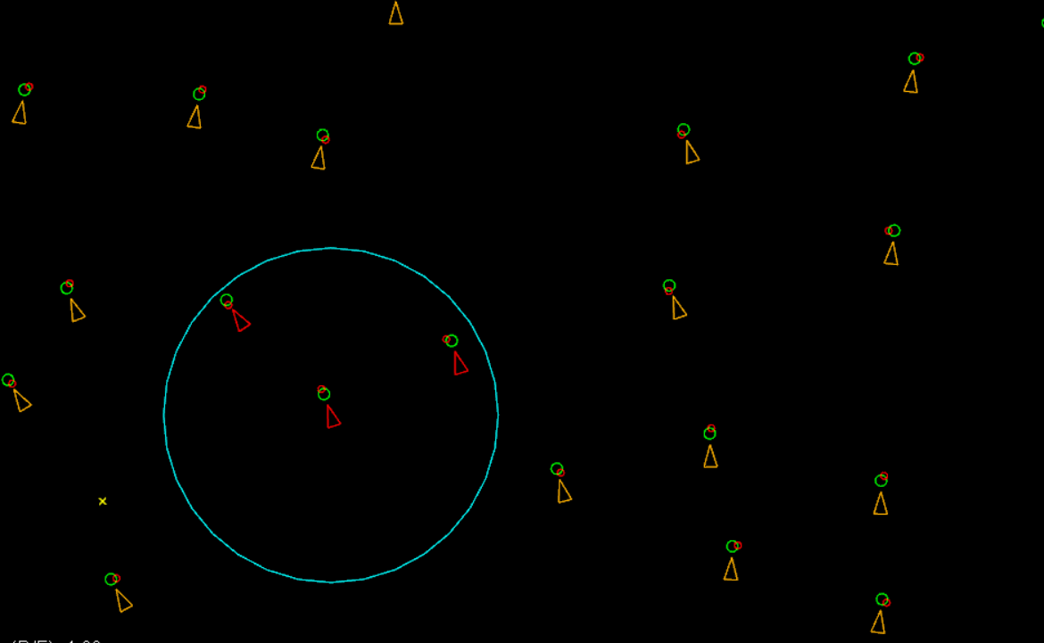

*More groups with fewer agents*

Extensions

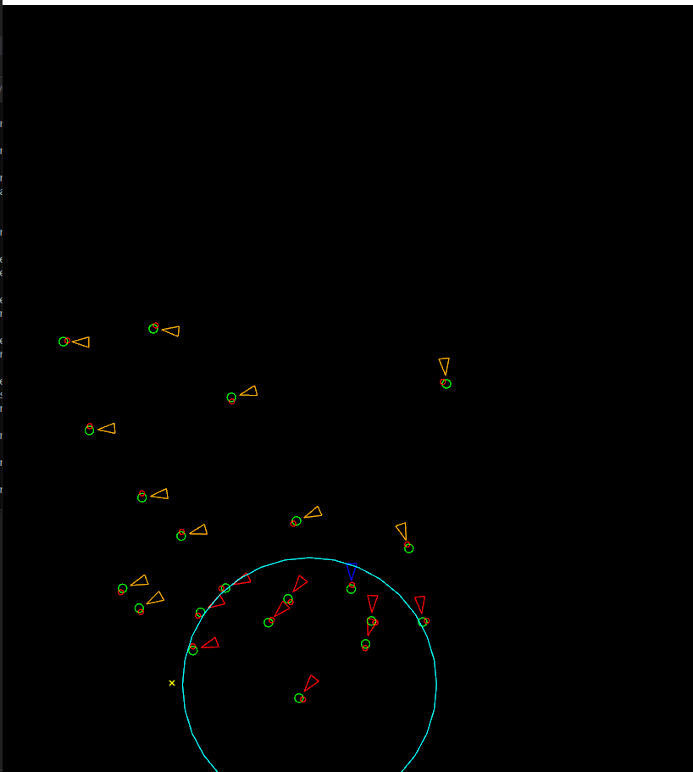

*Hunter agent that other agents flee from*

**Open issues/risks:**

* There are extensions that could be added to the program, yet as I invested too much time into bug-spotting, I failed to extend it
* If the cohesion is weighted too heavily, agents will surely overlap, yet on the other hand if separation is weighted in the same way, the agents’ movement will not be uniform. Hence, I failed to find the perfect amount to erase the mentioned weaknesses.