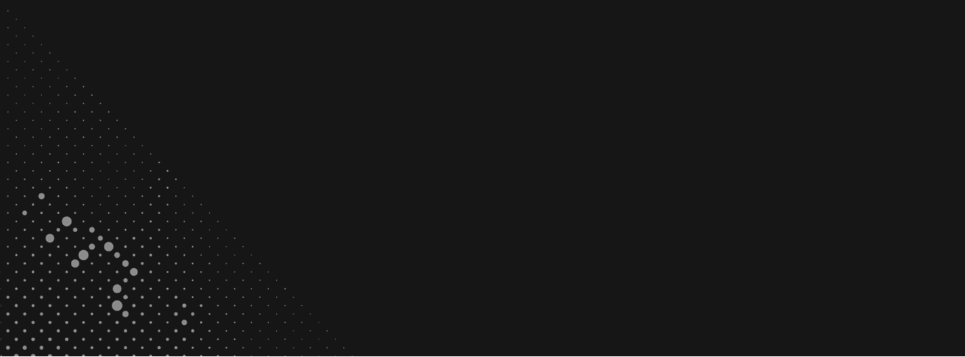

**CURRICULUM VITAE**

**NGUYEN DUY BANG**

Embedded Software Engineer

*https://bangnguyendev.github.io*



Male

duybang140494@gmail.com

0784-140494

|  |  |
| --- | --- |
| EDUCATION HISTORY | |
| 09/2015- 09/2019 | Ho Chi Minh City University of Technology and Education, Vietnam.  Major: Telecommunication - Electronics |

|  |
| --- |
| SUMMARY INFORMATION |
| * 2 years of experience in C or C++ programming. |
| * 1 years of experience in programming with Python. |
| * Good English communications skills, both verbal and writing. |
| * Working knowledge of processor architectures (ARM/ARM64, x86). |
| * Good at embedded system design methodology. |
| * Programming in C on Automotive Domain. |
| * Good Knowledge on micro-controller architecture and low-level device driver development. |
| * Expertise in Operating System Programming Languages Tools & Technology:   + AutoCAD, Altium, VHDL.   + Microsoft Office: Word, Excel, PowerPoint.   + C/C++, C#, Visual Basic (VBA), Python, Bash Shell.   + SVN, Git ([*https://bangnguyendev.github.io/*](https://bangnguyendev.github.io/)).   + Win, Linux. |

|  |  |
| --- | --- |
| WORKING HISTORY | |
| 06/2019 – present: | **Ban Vien Co., Ltd**  **(Onsite at RVC, BOSCH)** |
| 12/2018 – 6/2019: | **FPT Telecom** |

**PROJECT REFERENCE AND SKILL SET**

|  |  |  |
| --- | --- | --- |
| PROJECT NAME: | Full Phase – MCAL drivers – AUTOSAR (RVC) | |
| **Position:** | Team member |
| **Responsibilities:** | Clarify requirements with Project Manager  - Running project follows V-model.  - Test API with Davinci, Cantata,  - Microsoft tools, AMDC, Enterprise Architect.  - Use project tracking tool – Redmine, Jira  - Experience in QA/QC workflow |
| **Duration:** | 10/2020 – present |

|  |  |  |
| --- | --- | --- |
| PROJECT NAME: | ASW/PSW – MCAL drivers – AUTOSAR (BOSCH) | |
| **Position:** | Team member |
| **Responsibilities:** | Clarify requirements with Project Manager  - Write test case, checklist and data to test.  - Test API with Cantata, ASCET (support by Bash, Python…)  - Microsoft tools, Daily report  - Updated file to SharePoint, TCM sever.  - Experience in QA/QC workflow |
| **Duration:** | 02/2020 – 9/2020 |

|  |  |  |
| --- | --- | --- |
| PROJECT NAME: | D1x – MCAL drivers – AUTOSAR (RVC) | |
| **Position:** | Team member |
| **Responsibilities:** | Clarify requirements with Project Manager  - Write test case, checklist and data to test  - Test API with postman tool  - Test API with Davinci, Cantata,  - Microsoft tools, AMDC, Enterprise Architect.  - Use project tracking tool – Redmine, Jira  - Experience in QA/QC workflow |
| **Duration:** | 09/2019 – 2/2020 |

|  |  |  |
| --- | --- | --- |
| PROJECT NAME: | U2A – MCAL drivers – AUTOSAR (RVC) | |
| **Position:** | Team member |
| **Responsibilities:** | Clarify requirements with Project Manager  - Write test case, checklist and data to test  - Test API with postman tool  - Test API with Davinci, Cantata,  - Microsoft tools, AMDC, Enterprise Architect.  - Use project tracking tool – Redmine, Jira  - Experience in QA/QC workflow |
| **Duration:** | 06/2019 – 09/2019 |