1.

Mkdir –p Homeworks

Mkdir –p Project

Sudo chgrp LinuxClass Homeworks

Sudo chgrp LinuxClass Project

a. sudo chmod 1770 Homeworks

b.sudo chmod 2770 Project

c. sudo chmod 1070 Homeworks

sudo chmod 2070 Project

2. sudo usermod –G LinuxClass student1

sudo usermod –G LinuxClass student2

3. sudo groupadd –g 601 MathClass

sudo useradd –m superman

sudo usermod –G MathClass superman

4. sudo login student1

5 cd /Homeworks

mkdir Student1

cat> Student1/homework1.txt

this is home work1

6. cd /Project

mkdir mathproject

cat > mathproject/progress.txt

this is progress text file

7. su severus

sudo login student2

8. cd /Homeworks

mkdir Student2

cat> Student2/homework2.txt

this is homework2

9. cd /Homeworks/Student1

cat homework1.txt

Yes I can

10. Can’t create mathproject because it already existed.

cat /Project/mathproject/progress.txt



11 su severus

Sudo login superman

12 cd /Homeworks

13 cd /Project

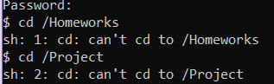

Ex3:

1. ls -l | grep "\->"

2. find . –perm /4000

3. find . –perm /2000 > ~/result.txt

Ex4:

sudo apt update

sudo apt install build-essential

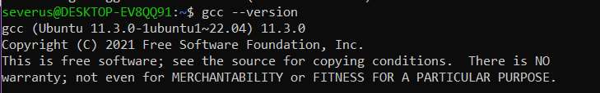

nano helloprogram.c

gcc helloprogram.c –o helloprogram

./helloprogram

