## 2. Database Design

### a. Database Schema

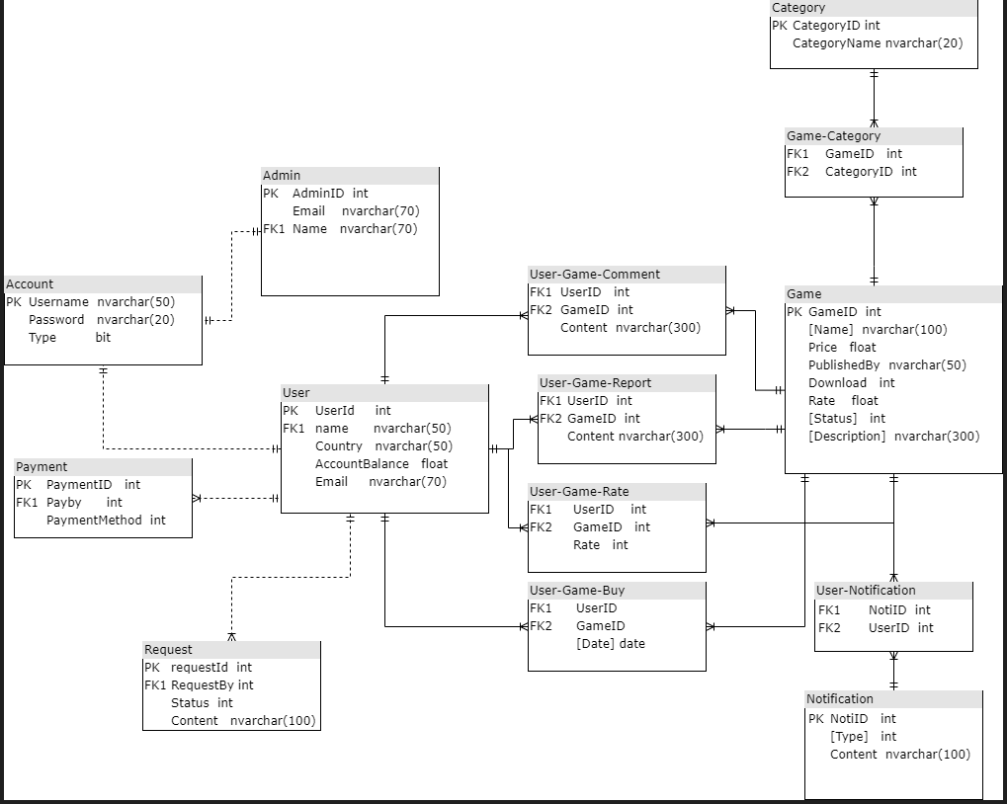

### b. Table Description

|  |  |  |
| --- | --- | --- |
| **No** | **Table** | **Description** |
| *01* | *Account* | *Table have username (Primary key ) , password and Type* |
| *02* | *Admin* | *Table have AdminId(Primarykey) , Email, Name (froreign key) refrerence to [Username] in table Account* |
| *03* | *User* | *Table have UserId(Primary key), Name (froreign key) refrerence to*  *[Username] in table Account , Country, AccountBalance, Email* |
| *04* | *Payment* | *Table have PaymentID , PaidBy (froreign key) refrerence to*  *[UserID] in table User , PaymentMethod* |
| *05* | *Request* | *Table have RequestID (Primary key), RequestBy (froreign key) refrerence to [UserID] in table User , Status, Content* |
| *06* | *Notification* | *Table have NotiID (Primary key), Type , Content* |
| *07* | *User-notification* | *NotiID (froreign key) refrerence to [NotiID ] in table Notification, UserID (froreign key) refrerence to [UserID] in table User* |
| *08* | *Game* | *GameID(Primary key ) , Name, Price, PublishedBy , Download, Rate,Status, Description* |
| *09* | *User-Game-Comment* | *UserID (froreign key) refrerence to [UserID] in table User, GameID (froreign key) refrerence to [GameID] in table Game, Content* |
| *10* | *User-game-Rate* | *UserID (froreign key) refrerence to [UserID] in table User, GameID (froreign key) refrerence to [GameID] in table Game , Rate* |
| *11* | *User-game-Report* | *UserID (froreign key) refrerence to [UserID] in table User, GameID (froreign key) refrerence to [GameID] in table Game, Content* |
| *12* | *User-game-Buy* | *UserID (froreign key) refrerence to [UserID] in table User, GameID (froreign key) refrerence to [GameID] in table Game, Date* |
| *13* | *Category* | *CategoryID(Primary key) , categoryName* |
| *14* | *Game-Category* | *GameID (froreign key) refrerence to [GameID] in table Game, CategoryID(froreign key) refrerence to [CategoryID] in table Category* |