SOFTWARE REQUIREMENTS SPECIFICATION
Karaoke Chain Booking & POS System
Prepared as part of: AI-Assisted System Design Exercise
Version 1.0
Date: 2026-07-01

Table of Contents

1. Introduction

1.1 Purpose
This Software Requirements Specification (SRS) document describes the functional and non-functional requirements for the Karaoke Booking & POS System, a management system designed for a chain of karaoke lounges. The document is intended to guide the design and implementation of a backend RESTful API for the system.

1.2 Scope
The system supports three core modules: Room Booking, Order & POS (food and beverage), and Billing/Invoice. It enables customers to reserve karaoke rooms, receptionists to manage bookings and in-room orders, and branch managers to configure rooms, menu items, and view revenue reports.
Out of scope: online payment gateway integration, multi-language support, mobile application, and loyalty/membership programs. These may be considered in future iterations.

1.3 Actors
- Customer - end user who books karaoke rooms and views invoices.
- Receptionist - front-desk staff who manages bookings, check-in/out, and orders.
- Manager - branch manager who manages rooms, pricing, menu, staff, and reports.

2. Functional Requirements

2.1 Module: Room Booking
ID | Requirement | Description | Actor
FR-01 | Search rooms | Search available rooms by branch, date/time range, and room type | Customer, Receptionist
FR-02 | Create booking | Create a new room booking for a selected time slot | Customer, Receptionist
FR-03 | Modify/cancel booking | Update or cancel an existing booking before check-in | Customer, Receptionist
FR-04 | Check-in / Check-out | Mark a booking as checked-in when the customer arrives, and checked-out when the session ends | Receptionist
FR-05 | Room status tracking | Track room status: Available, Booked, InUse, Cleaning | Receptionist, Manager
FR-06 | View booking history | View past and upcoming bookings | Customer, Receptionist, Manager

2.2 Module: Order & POS
ID | Requirement | Description | Actor
FR-07 | View menu | Browse available food and beverage menu items | Customer, Receptionist
FR-08 | Create order | Add food/drink items to an active booking | Receptionist
FR-09 | Update order | Modify quantity or remove items from an active order | Receptionist
FR-10 | Manage menu items | Add, edit, disable menu items and prices | Manager

2.3 Module: Billing / Invoice
ID | Requirement | Description | Actor
FR-11 | Generate invoice | Calculate total charge (room fee by duration + order fee) at checkout | Receptionist
FR-12 | Confirm payment | Mark invoice as Paid and record payment | Receptionist
FR-13 | View invoice | View invoice detail and history | Customer, Manager
FR-14 | Revenue report | View aggregated revenue by branch/date range | Manager

3. User Stories

3.1 Customer
- As a customer, I want to search for available rooms by time slot, so that I can find a suitable room to book.
- As a customer, I want to create a booking, so that I can reserve a room in advance.
- As a customer, I want to cancel my booking, so that I am not charged if my plan changes.
- As a customer, I want to view my invoice after the session, so that I can verify the charges.

3.2 Receptionist
- As a receptionist, I want to check-in a customer, so that the room status updates to InUse.
- As a receptionist, I want to add food/drink orders to a booking, so that all charges are tracked in one place.
- As a receptionist, I want to generate an invoice at checkout, so that the customer can pay accurately.
- As a receptionist, I want to confirm payment, so that the booking is marked as completed.

3.3 Manager
- As a manager, I want to manage room list and pricing, so that pricing stays up to date across branches.
- As a manager, I want to manage menu items, so that the POS reflects current offerings.
- As a manager, I want to view revenue reports, so that I can evaluate branch performance.
- As a manager, I want to manage staff accounts, so that only authorized staff can access the system.

4. Use Case Diagram
The diagram below illustrates the interactions between the three actors (Customer, Receptionist, Manager) and the system use cases across the three core modules.
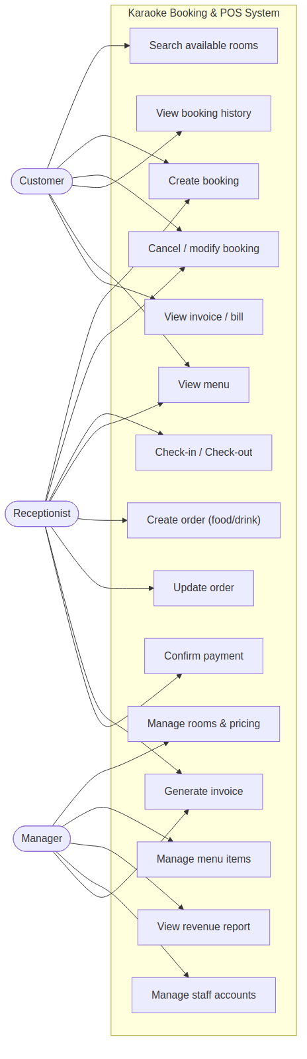

5. Entity Relationship Diagram (ERD)
The ERD below defines the core data entities and their relationships. Booking has a 1-to-N relationship with Room (a room can have many bookings over time) and with Order Item. The many-to-many relationship between Booking and Menu Item is resolved through the Order Item junction table.
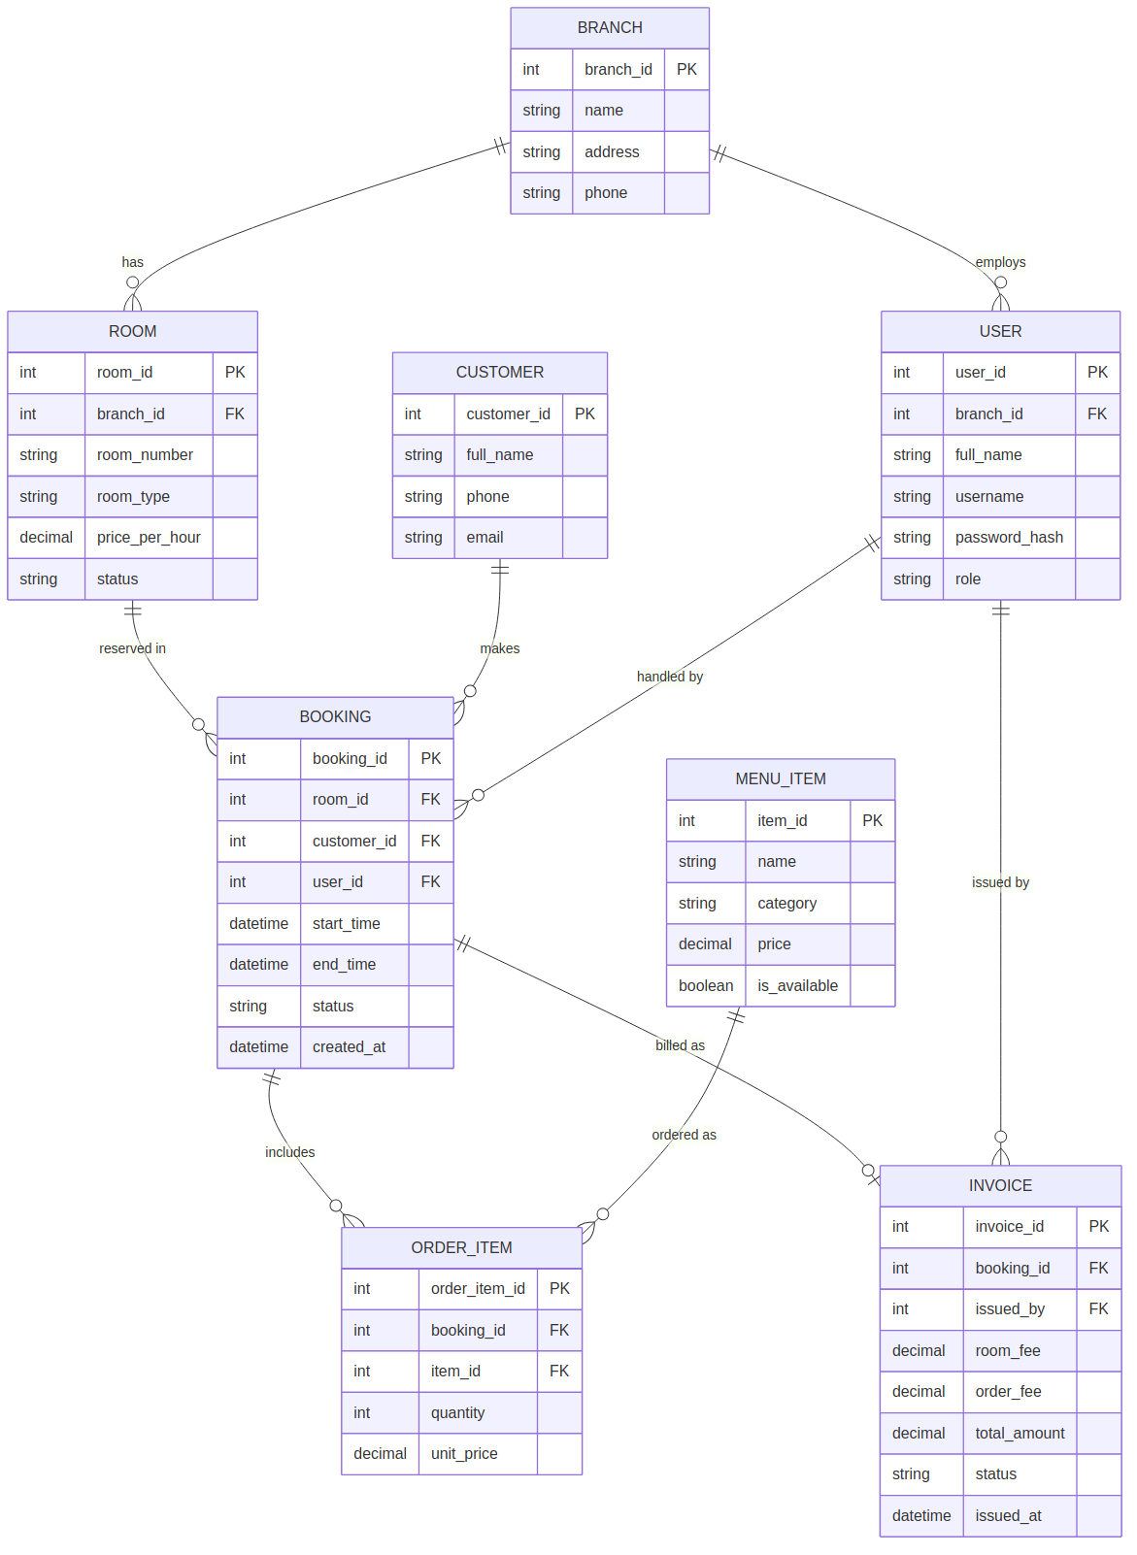

6. Non-Functional Requirements
Category | Requirement
Performance | API responses should return within 500ms under normal load (single branch, <100 concurrent users).
Security | All endpoints except login require a valid JWT token. Passwords are stored hashed (bcrypt).
Availability | System should support 99% uptime during business hours (10:00-24:00).
Scalability | Data model supports multiple branches; architecture allows horizontal scaling of the API layer.
Usability | API responses use consistent JSON structure with clear error messages and HTTP status codes.

7. RESTful API Endpoints

7.1 Authentication
Method | Path | Description | Actor
POST | /api/auth/login | Login with username/password, returns JWT | All staff
POST | /api/auth/register | Create a staff account (Receptionist/Manager) | Manager

7.2 Room Booking Module
Method | Path | Description | Actor
GET | /api/rooms | List rooms, filter by branch/status | All
POST | /api/rooms | Create a room | Manager
PUT | /api/rooms/:id | Update room info/pricing/status | Manager, Receptionist
GET | /api/bookings | List bookings, filter by date/status | Receptionist, Manager
POST | /api/bookings | Create a booking | Customer, Receptionist
PUT | /api/bookings/:id | Update/cancel a booking | Receptionist
POST | /api/bookings/:id/checkin | Check-in a booking | Receptionist
POST | /api/bookings/:id/checkout | Check-out a booking | Receptionist

7.3 Order & POS Module
Method | Path | Description | Actor
GET | /api/menu-items | List menu items | All
POST | /api/menu-items | Create a menu item | Manager
PUT | /api/menu-items/:id | Update/disable a menu item | Manager
POST | /api/bookings/:id/orders | Add order item to a booking | Receptionist
PUT | /api/orders/:id | Update quantity of an order item | Receptionist
DELETE | /api/orders/:id | Remove an order item | Receptionist

7.4 Billing / Invoice Module
Method | Path | Description | Actor
POST | /api/bookings/:id/invoice | Generate invoice (room fee + order fee) | Receptionist
PUT | /api/invoices/:id/pay | Confirm payment, set status Paid | Receptionist
GET | /api/invoices/:id | View invoice detail | Customer, Manager, Receptionist
GET | /api/reports/revenue | Aggregated revenue by branch/date range | Manager

8. Appendix
This SRS was produced using an iterative AI-assisted prompting process. The full sequence of prompts used to generate this document and the accompanying backend source code is provided in the accompanying file History_Prompts.txt.

