Link git repositories:
https://github.com/duydzht/RJS101-p1
Setting git repositories:
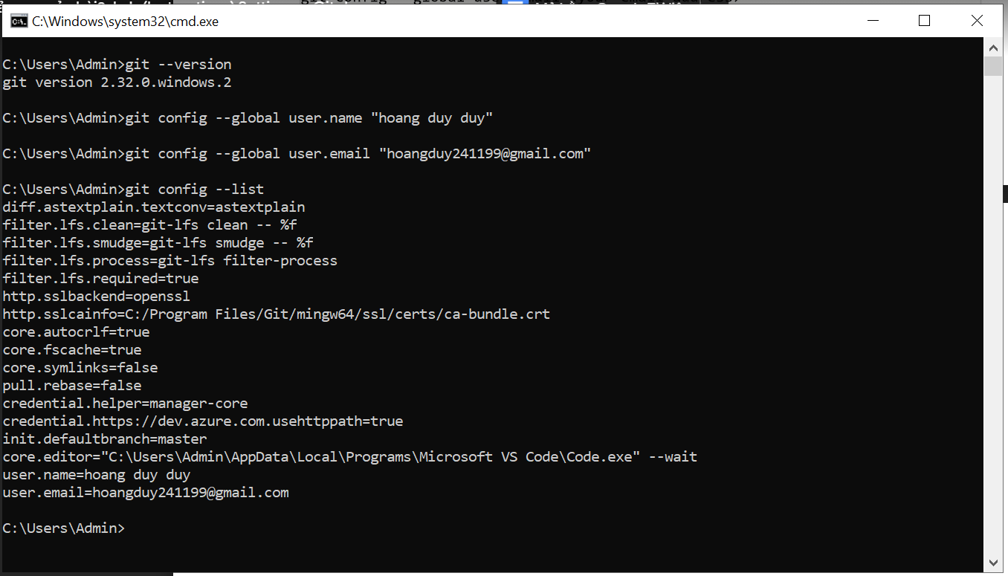

Setting Nodejs:
