Singapore Singapore and To Singapore To Singapore

Ultimate AdventUre Get to know Immerse yourself Leaving

Singapore Introduction Spot

►Get to know Singarore ► Singapore Introduction

##### singapore muscle

Before you go to Singapore, it's useful to know Recommended information Enjoy your trip in advance A to Z for Singapore! Know the passages and enjoy properly!

### Enjoy 1〇〇 times

Basic Information Recommended Imformation Useful Information

Welcome to

**Singapore!**

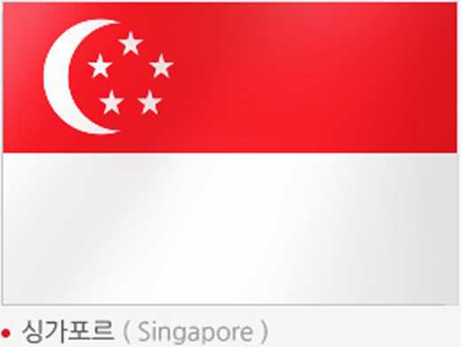

Singapore, a vibrant international city with a world-class living environment with grievances and gardens! Meet Chun's Face Singapore.

. + . 聲

4,627 KM

Currency : User Singapore Dollar (SGD or S $) Population: about 5.55 million I Area: about 679 square kilometers **SGD 5,56M**

Flight Distance: 4,627 km, 6 hours 10 miinutes  
Time difference: 1 hours slower than Korea

Exchange Rates: SG icons KRW 806 (as of December 2017) GDP: $ 283.7 billion (based on 2013 IMF)

|  |  |
| --- | --- |
| Capital | I Singapore |
| politics | I Constitutional Republic, President's six-year term, Prime Minister I |
| language | I Malay, Chinese, English |
|  | Religion I Islam, Buddhism, Taoism, Christianity, Hinduism |
| Dial | | +65 |
|  | Voltage I 220 240 V, 3-pin plug |
|  | Visa I Koreans may enter the country without a visa for travel purposes |
|  | climate | Subtropical climate with high humidity and temperature throughout the year (average temperature: 24-32 , highest in June-August, with frequent squalls during the November-season rainy season) |

|  |  |  |  |
| --- | --- | --- | --- |
| Singapore Ultimate adventure  COPYWGHTO2015 | PM\cn  Mddt  Possible |  | CHANbl sinA^ % CONTACT  •PC41 |
| SINGAPORE A供UNES ALL RKSHTS RESERVED. |  |  |  |