101446598

Mia Truong

1. MongoDB Console Screenshots:A screenshot of a computer

   AI-generated content may be incorrect.A screenshot of a computer

   AI-generated content may be incorrect.
2. Login Success

1. Login Fail

1. Signup Success

1. Signup Fail

1. Add EmployeeA screenshot of a computer

   AI-generated content may be incorrect.
2. Add Employee (Unauthorized)A screenshot of a computer

   AI-generated content may be incorrect.

Duplicate Mail -> Fail

1. Get All EmployeeA screenshot of a computer

   AI-generated content may be incorrect.
2. Get All Employee (Fail Unauthorized)A screenshot of a computer

   AI-generated content may be incorrect.
3. Search Employee by ID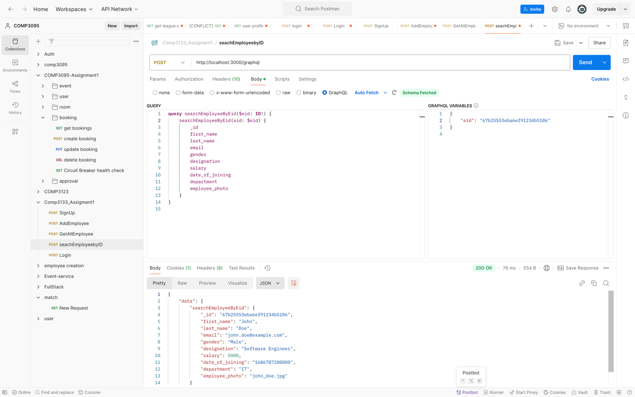
4. Search Employee by Field

By Designation

1. Update Employee by ID

1. Delete Employee by ID

