1. Security
1.1 Two-Factor Authentication (2FA)
To enhance account security, the team implemented Two-Factor Authentication (2FA) on important platforms such as Google and GitHub. This method requires users to verify their identity using two steps: a password and a second verification method, such as a one-time code sent to a mobile device.
The team enabled 2FA using Google’s 2-Step Verification feature. After entering the password, users must input a verification code received via SMS or generated by an authentication application.
In addition, 2FA was also enabled on GitHub accounts to secure the team’s repository. This ensures that only authorized members can access and modify the project resources.

1.2 Password Policy
The team established a password policy to maintain strong security standards. All members are required to follow these rules:
- Password must be at least 8 characters long
- Include uppercase and lowercase letters
- Include numbers and special characters
- Passwords must not be shared
- Passwords should be changed regularly
This policy helps reduce the risk of unauthorized access and protects the team’s shared data and accounts.

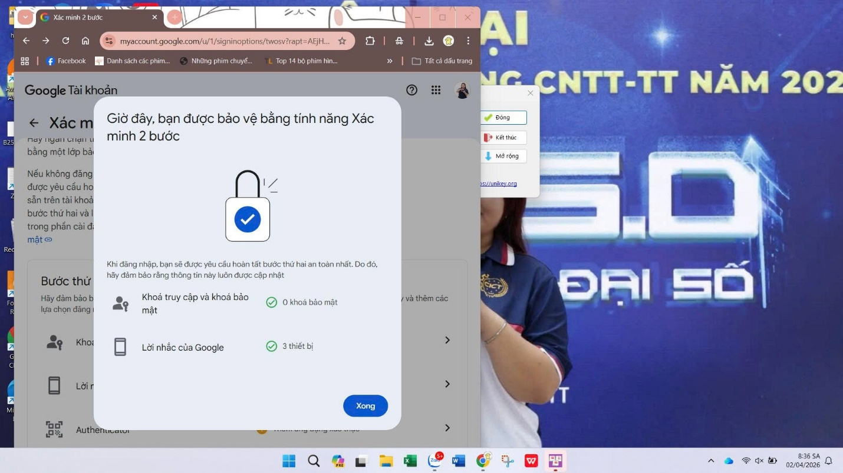
Google

Github
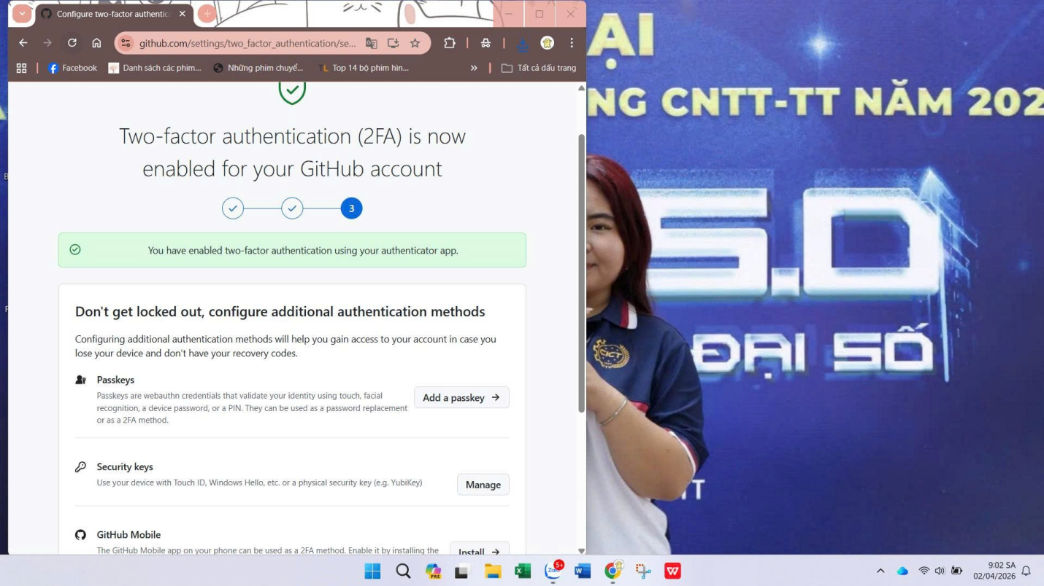

2. Ergonomics
Each team member provided a photo of their personal workspace. The setups follow basic ergonomic principles to ensure comfort and reduce physical strain during long working hours.
The team applied the following standards:
- Monitor positioned at eye level
- Straight sitting posture
- Comfortable hand placement on keyboard and mouse
- Proper lighting to reduce eye strain
These practices help improve productivity and prevent health issues such as back pain, neck strain, and eye fatigue.
All workspace images are included in the report with annotations explaining how ergonomic principles are applied.
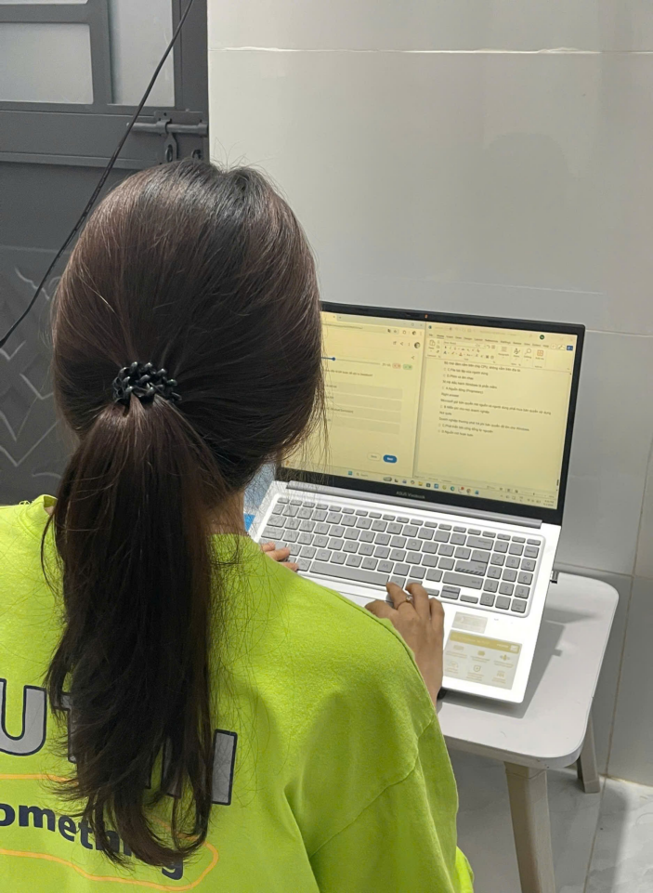


3. AI Disclosure
During the development of this project, the team used AI tools such as ChatGPT to support various tasks, including writing SQL queries, generating report content, and improving grammar.
All AI-generated content was carefully reviewed and verified by the team. The verification process included testing SQL queries, cross-checking information with reliable sources, and manually editing the content to ensure accuracy.
This ensures that the final work meets academic integrity standards and maintains high quality.

