University of Science and Technology of Hanoi



Final Project Report

Advanced Programming with Python

**Clothes Store Information Management System**

**Group 1:**

Lê Duy

Phạm Ngọc Mai Lâm

Đào Trọng Lê Thái

Phạm Tuấn Thành

Phạm Chí Trung

**Contents:**

1. **Introduction**
2. Description
3. Why do we need this software?
4. **Analysis**
5. **Design**
6. Python packages and classes
7. Database diagram
8. UI structure
9. **Purposes**
10. **Conclusion**
11. **Introduction**
12. **Description**

Software used to manage clothing store data. More specifically, managing of customers, employees, item information and transaction history

1. **Why do we need this software?**

To manage a large number of customers, items, employees' salaries, etc. It is almost impossible to take notes and do it manually because the amount of data is too large. If we do it manually, it will be very easy to affect the store. Therefore, the reason that we made this management software is to makes the above problems to be solved quickly and scientifically.

1. **Analysis**

The software uses Tkinter library to configure the user interface

Fully object-oriented programming

The software includes the following functions:

* Add objects to the tables
* Edit objects
* Remove objects
* Search for objects
* Sort the list in tables
* Refresh the tables
* Exit the program

1. **Design**
2. **Python packages and classes**

We devide the component classes into 3 following packages:

* Model: data storage classes

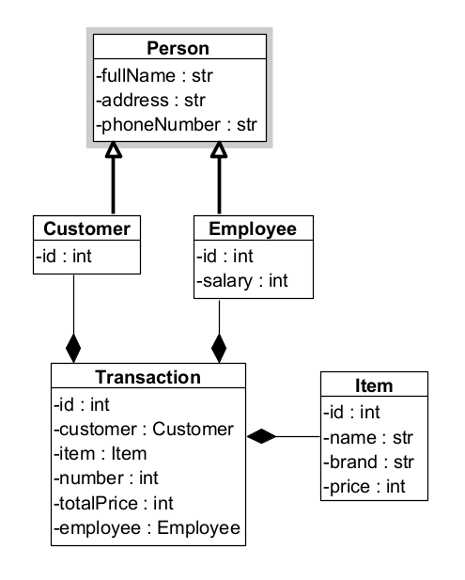

Class Person contains information about the person, including fullName, address and phoneNumber

Class Customer class that inherits from Person has more information about customerId

Class Employee class inheriting from Person has more information about EmployeeId and salary

Class Item class contains information about the item, including itemId, name, brand and price

Class Transaction class contains customer information, items, quantity, total price and employee information to make the payment

* View: GUI classes

This is an object created from the HomeFrm class, which is the software 's main window configuration class.

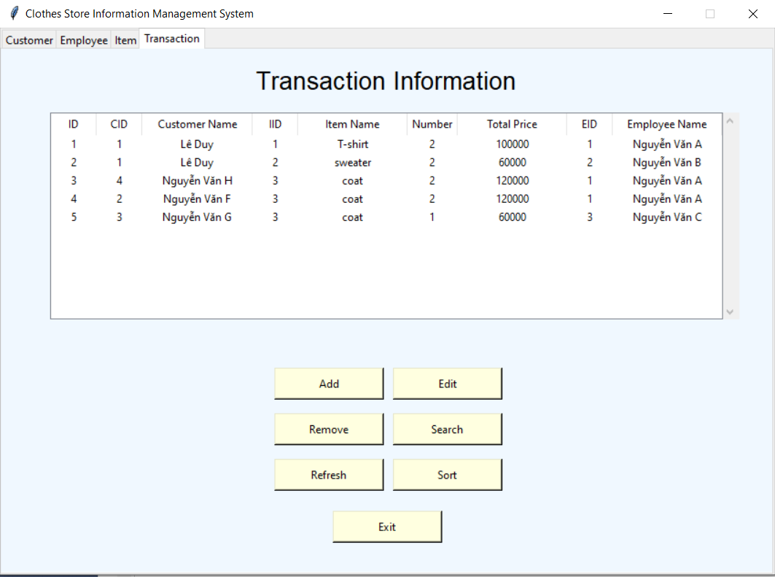

HomeFrm

Here's an object created from a Dialog class that adds an object to the table.

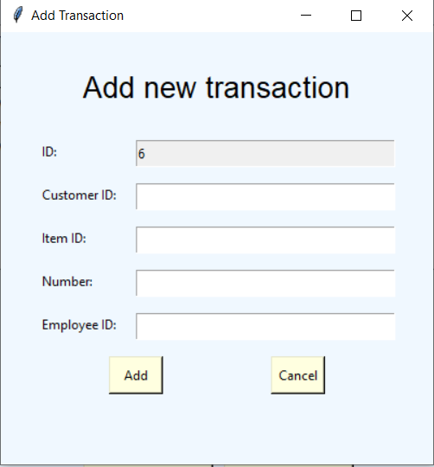

Dialog

* Controller: classes that work with databases

Class SQLConnection: contains the methods that read and write data into the database

1. **Database diagram**

This is the database diagram corresponding to the classes in the model package

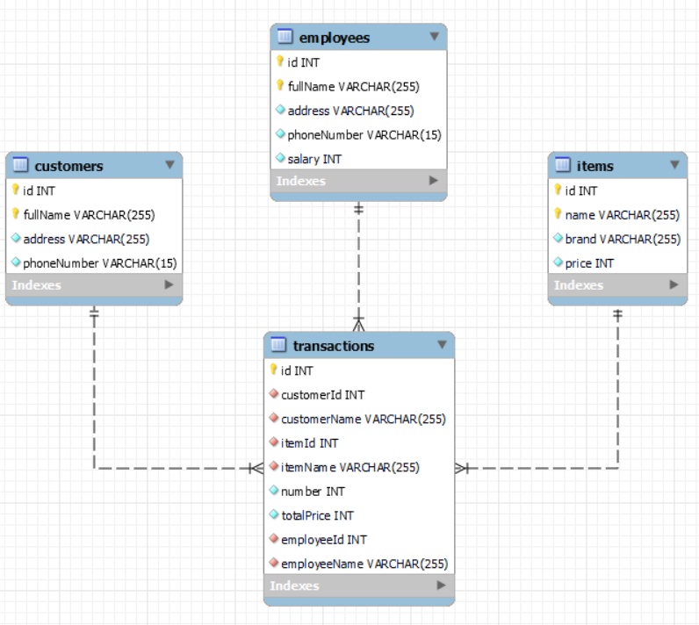

Database diagram

1. **UI structure**

* 4 tabs: Customer, Employee, Item and Transaction
* 4 tables correspond to 4 tabs
* 6 buttons each tab and an Exit button

1. **Purposes**

* Improve algorithmic thinking and ability to use Python language
* Have experience to carry out other topics
* Practice object-oriented programming
* Better understand the MVC development model

1. **Conclusion**

This software is still incomplete so there are still some bugs. For example, exceptions are not completely handled. In addition, the interface design is not intuitive and scientific. However, through this project, we have gained a lot of experience for ourselves to carry out even bigger projects